25th July 2025
Thank You
Thank you for your support and tolerance this week with the two late starts due to the icy road conditions. It is much appreciated. I understand that it can be a bit confusing as often the conditions here are very different from in town and Mosgiel, although not so much this week to be fair. We will always endeavour to get the message out as quickly as possible. Skool Loop and Facebook seem to be the most efficient. If you are unsure, please message me on 021 2134316.
Thank you for all of the kind and rather embarrassing messages for something called Principal Day. As always in these situations, it is nice to hear and see all of the messages from the children, whanau, staff and Board, and very humbling. However, I see the kind words as a reflection of the hard work and enthusiasm by all of the staff, children, whanau and Board, and that makes me incredibly grateful.
Otago Polyfest
It was very exciting to see and hear our younger members of the ropu starting their Pasifika rehearsals this week. The children were buzzing afterwards. Then today, our Māori performance also got off to a flying start. The energy and enthusiasm that Litea and Dennis bring is very infectious. It was still rocking when the flag came down.
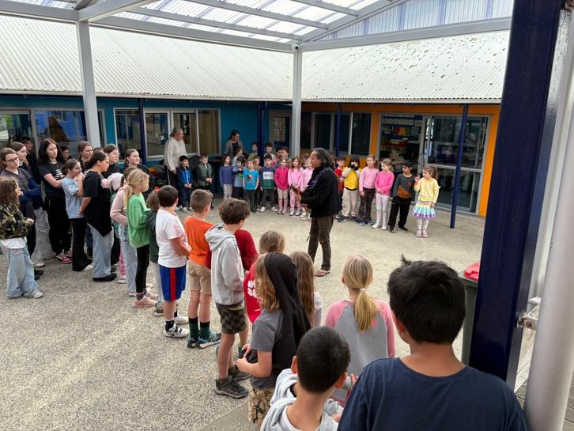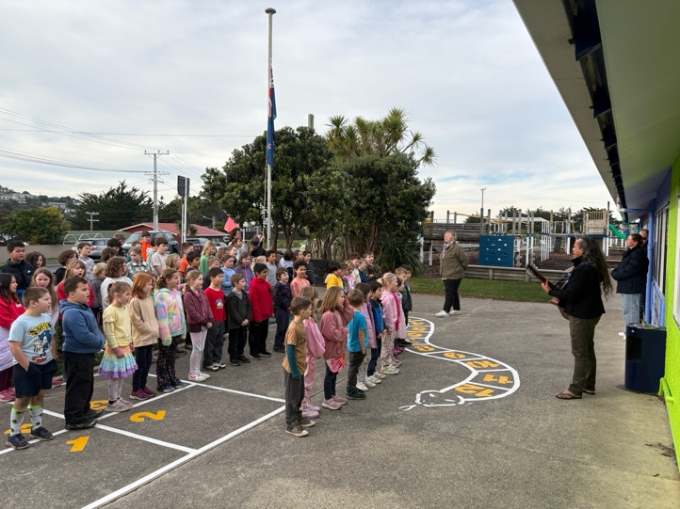
Winter Illnesses
To add to the winter colds’ and flus, we now have norovirus doing the rounds, which effects both ends, if you know what I mean. It is pretty unpleasant. Can we please ask that children stay away from school for 48 hours after the last ‘event’ please.

Congratulations
Well done to the following players on earning player of the day for their respective sports teams.
Big Rock Hoopsters – Annabel Free
Big Rock Shooters -- Cecil Williams
Big Rock Coasters – Jaxon Skerratt
Big Rock Dolphins -- Flynn Blanchard
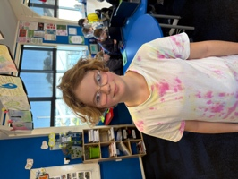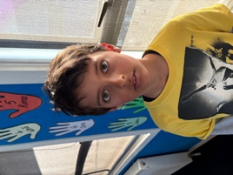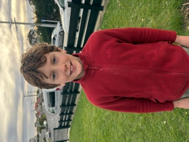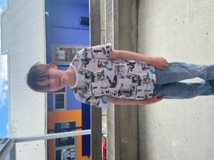
Bravo the following players on earning Player of the Day for their rugby teams.
Maci Kippenberger—Brighton Mini Gulls
Arlo Pfyl -- Brighton Red Gulls
Stella Brown -- Pirates
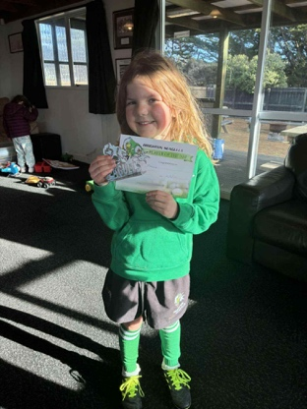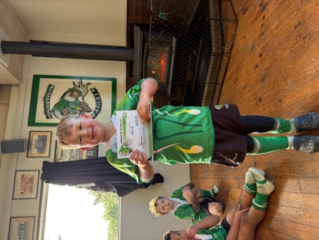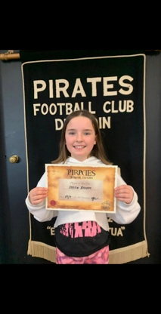
New Programmes
This week we launched two new programmes for Year 5 – Year 8. The programmes being The Gastronaut Food Science programme and Science Explorer and Science Badges programme.
The Gastronaut programme is a Food Science programme that incorporates Food Science, Digestive System and Taste Buds, Food Safety and Hygiene, Kitchen Safety (Hot and sharp), Preparation and Cooking, Cultural significance of food, Understanding allergies, Cooking in the outdoors and Financial planning that includes purchasing, prepping, cooking and selling. This programme is a 100% Big Rock curriculum initiative, is hands-on and 100% user friendly for all of the children. My thanks to Dr Lisa Daniels, Nutritionist and Lecturer in Human Nutrition at the University of Otago, and award winning chef, Michael Tomlinson for the much valued assistance in developing the programme. The Gastronaut programme will be educational, relevant and meaningful, as well as fun. In fact it will be out of this world!

This week Room Five have completed their Big Rock Kitchen, Food Safety and Hygiene work. This work needed to be completed and ‘passed’ before they were able to start the next cooking session. Today they prepped, made and cooked wontons with amazing results. The photos do not do it justice.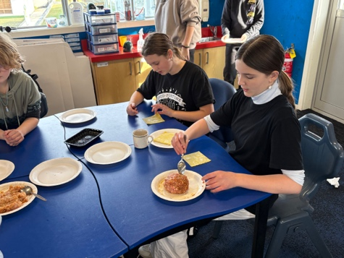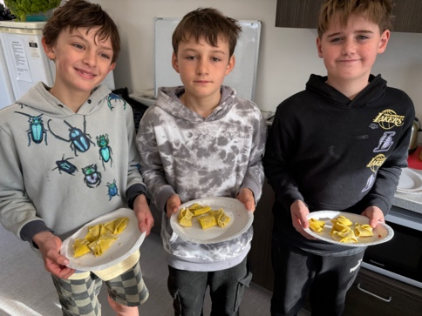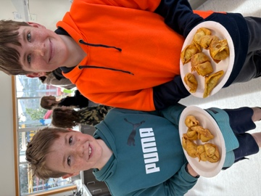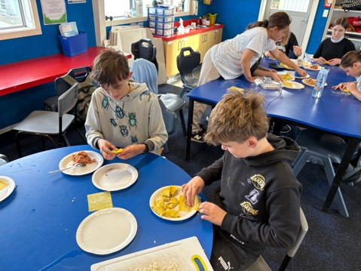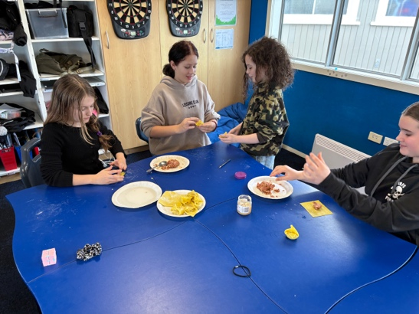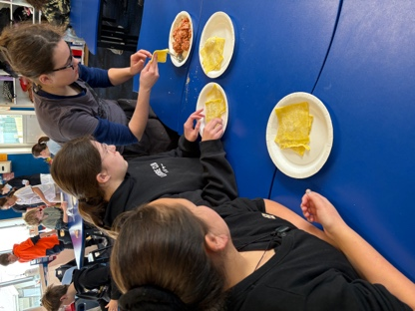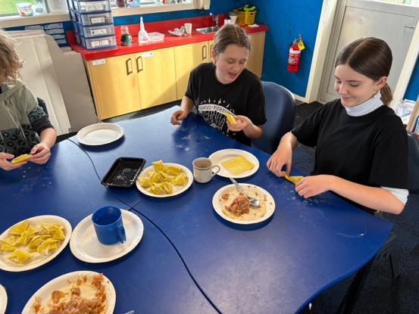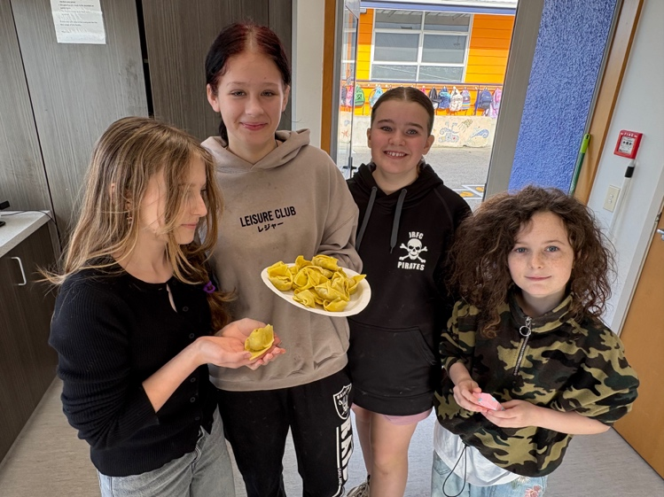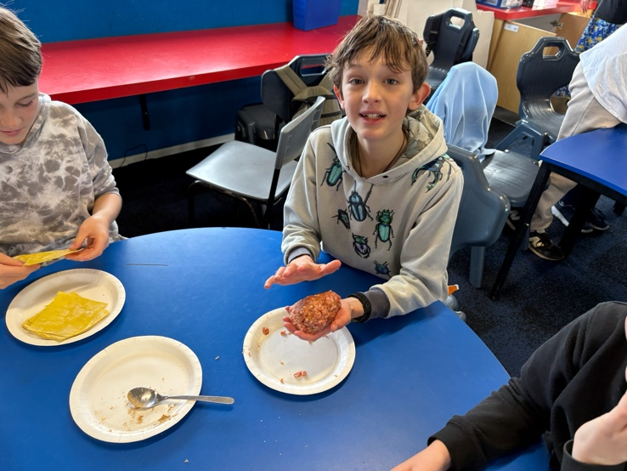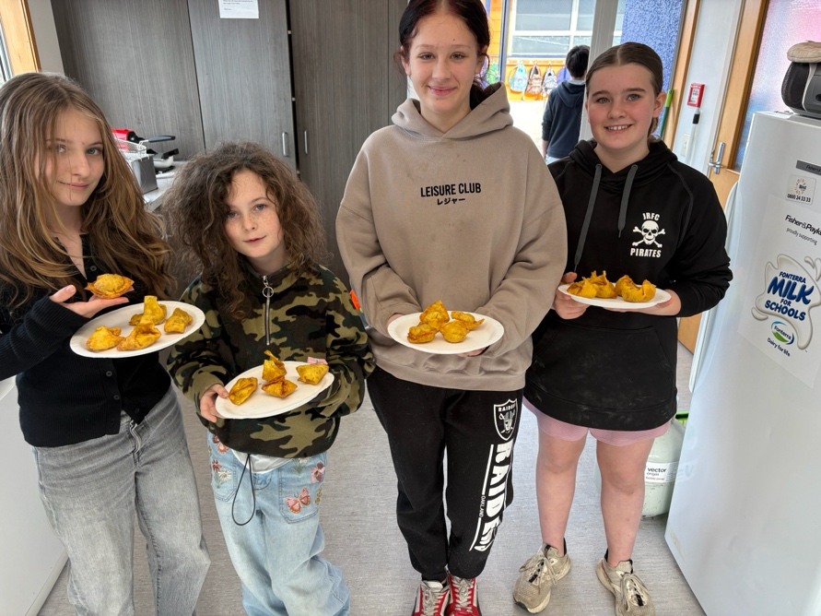
Science Explorer and Science Badges Programme (Year 5-8)
This is a programme developed by the leading high school science teachers. From around New Zealand. It is a great link to high school science.
In essence the children work through a range of different challenges, that they are able to select themselves. Year 5-6 complete the challenges from the different strands of the Science curriculum, Planet Earth and Beyond, Material World, Physical World and the Living World.
The senior class choose a field of science to focus on. There are 32 different options from Agriculture to Zoology.
One of the many strengths of the Science Badges programme is that the children can follow their own pace of learning and choose a field of science that interests them. Our senior class started last week and they have selected Geology, Marine Biology, Food Science, Sports Science, Agriculture, Energy, Psychology and Forensic Science. It is very impressive when you walk into a classroom and everyone is focused on their own work, some researching, some preparing for presentation, a couple using microscopes as they focus on their forensic research. Very cool.
Room Four will begin their Science Badges work on Tuesday.
I am absolutely delighted with how these programmes have come together and the success and engagement that will follow close behind.
Engagement plus attendance = achievement.
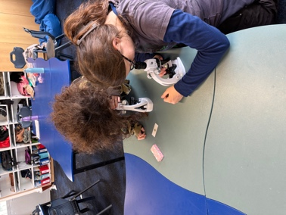
Malaika and Bo-Lili as Forensic Scientists
Have a great weekend
David Grant

Principal

