24th October 2025
Closure Due to Industrial Action
Thank you to everyone for your support yesterday. We realise that it would have been a real inconvenience for some and a nuisance for others. I am delighted say that as a staff we faced no criticism or hostility, or even friendly jibes from anyone in the school community. If we had, , we would have understood. Regrettably, we are not allowed to share our feelings about the action.
I do need to apologise however to you all about my own messaging of what was the upcoming strike. In the days building up to it I should have provided more regular reminders, and a hardcopy home with the children. I hoped it wouldn’t go ahead.
Wild Weather
Firstly, I hope everyone got through the wild weather okay. I hope there was not too much damage at your homes and properties. I imagine that the lack of power for many presented its own challenges as well. Hopefully none of the younger people were scared or anxious by the high winds, and if they were it is 100% understandable. If they were, I am sure they are happy to see it pass.
If anyone is going away for Labour Weekend, hopefully the wild weather has not derailed your plans.
I would like to thank Colin Driver for taking the time to come down and check to see if there was any damage at your school, I am delighted to advise you that there wasn’t. I would also like to thank Cavan Jenkinson for doing the same thing, and ensuring our wheelie bins didn’t disappear. Thanks guys.
Congratulations
Well done to the following players on earning Player of the Day for their respective futsal teams.
Big Rock Dolphins--- Fletcher Cockburn
Big Rock Orca --- Vienna Garth
Big Rock Stingray--- Josh de Thierry
Big Rock Dolphins—Flynn Blanchard
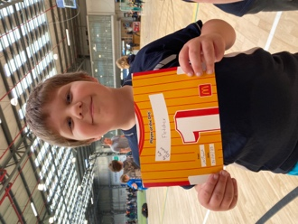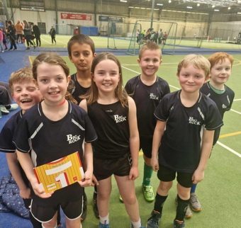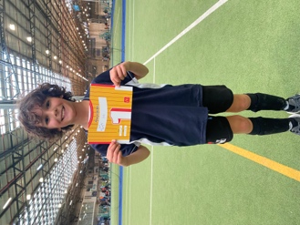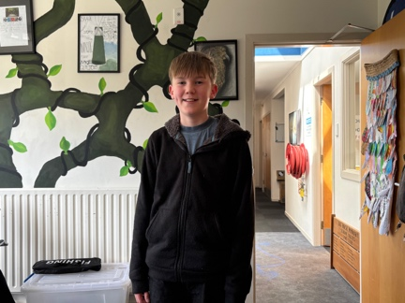

Trophies
A reminder that we need the trophies listed last week, returned to school as soon as possible please. If they have not been engraved yet, don’t worry, we will take care of that.
Homework Heroes
Today we had our first Homework Heroes Lucky Ticket Raffle Draw (Not a particularly snappy name). The enthusiasm from so many was truly infectious.
We will do it all again next week, and the week after. New prizes will be added weekly.
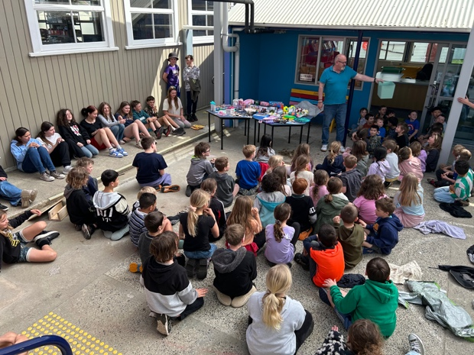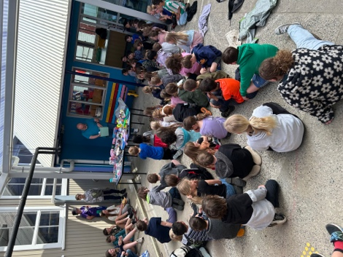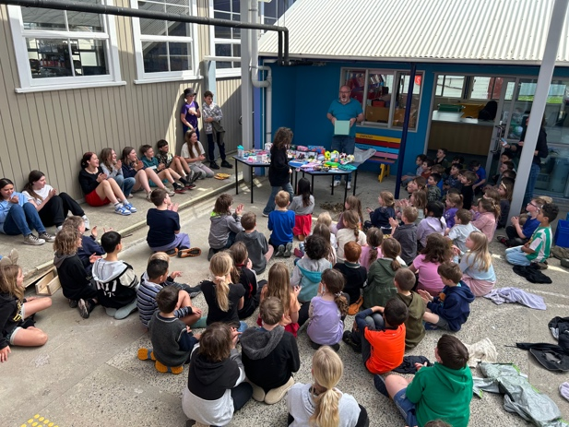
Go OTAAAAGGGOOOOOOO
Good luck to the men in blue and gold tomorrow, as the travel to Christchurch to contest the NPC Final against Canterbury. If anyone is travelling up, travel safe and cheer them on. I am travelling up for it, hoping to become one of the few who has been to the last final they won and this one.
Lastly a tentative connection for the school- former students Ollie and Courtney McNair’s cousin is rising sensation Dylan Pledger. Tentative I know, but there you go.
Have a great long weekend.
Go OOOOOTTTAAAAGGGGOOO
David Grant
Principal
