24th November 2023
Futsal Draw
Next week’s futsal draw:
Tuesday Futsal
Big Rock Dolphins v Liberton court 9 at 3:45
Big Rock Stingray v Balaclava court 13 at 4:45
Big Rock Barracuda v Green Island court 19 at 4:45
Big Rock Marlin v Columba court 4 at 5:45
Wednesday Futsal
Big Rock Orca v Carisbrook court 11 545
Big Rock Sharks v Liberton court 16 at 5:15
Resilience and Independence
Over the last few weeks, I have had the pleasure of attending different class camps at different levels and in different capacities. One of the key aims of these camps is to help the children develop personal and physical resilience as well as building on their independence. Part of the school’s Vision is to help the children become resilient, independent, lifelong learners.
Having been on three camps at three different age levels, as opposed to just one in isolation, it becomes very obvious, that the plan is working. When you watch the youngest ones, although excited and a wee bit nervous, through to the oldest knowing what to do, how to look after themselves, know where their stuff is (mostly), and being prepared for every activity with energy and enthusiasm, the progression is great. Of course the development of those two qualities translates to confidence and achievement in the classroom and the playground, and hopefully other aspects of day to day life. The support and encouragement the Big Rock children receive from all of the parents ties it all together beautifully. Next week, the senior class have the now traditional Survivor Camp, where they really need to be independent and resilient to ‘survive’:)
As I mentioned, I was on camp again this week, this time with Room Four. Amazing weather, incredible children, superb parents, broad range of experiences, excellent enthusiasm all round and awful mossies!
The children kayaked, orienteered, crazy swung, push carted, rafted (including building) built bivouacs, initiative course, confidence course, search and rescue (Tracked escaped prisoners) flew on a flying fox, water sild and did it all with a smile, with bucket loads of encouragement and support from parent helpers. Thank you Graeme, Dallas, Rowan, Sasha, Ant, Tracy, Susannah, Marina, Joe and Simon.
I was talking to a couple of parents on camp about how great the children were and they were in full agreement. I know that when I write such things in the newsletter that some people think it is some sort of propaganda thing, I assure you it isn’t and that there was plenty of proof earlier in the week.
Lastly, thank you Mrs Van for the planning, energy and enthusiasm, that makes it all work.
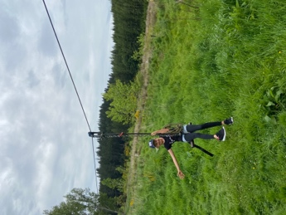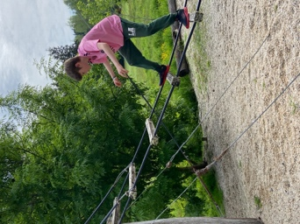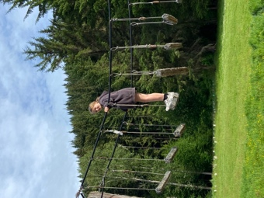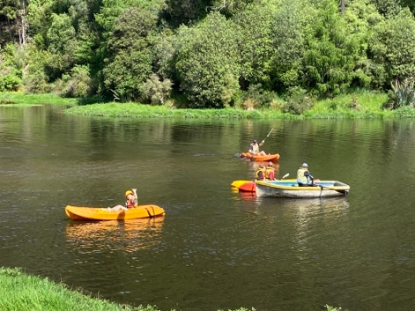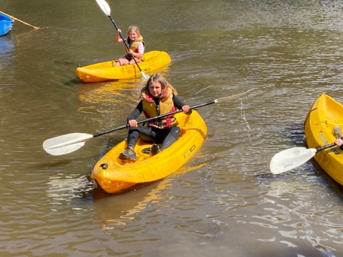
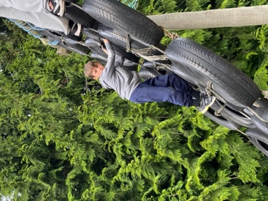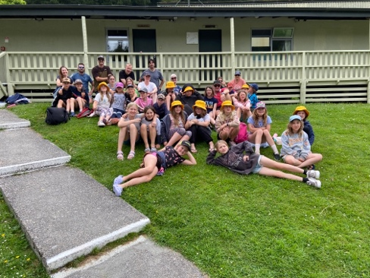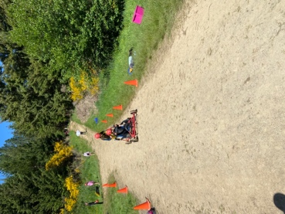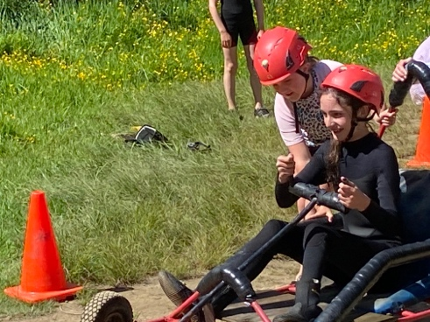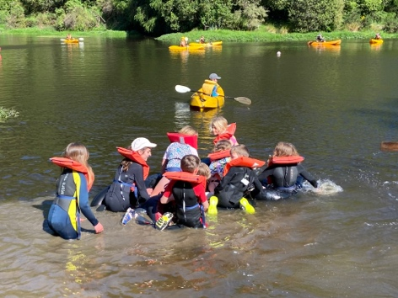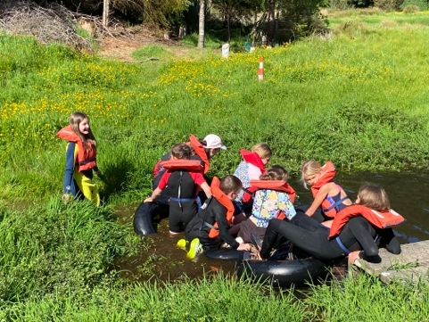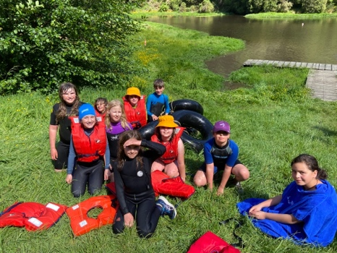
Gumboot Day
Earlier in the term we postponed our involvement in Gumboot Day. However we know what an incredible service that the good people at I am Hope and the organisers of Gumboot Day offer by providing free counselling for young people all over New Zealand. In support of this, On Wednesday we will be having a sausage sizzle to raise some funds for Gumboot Day. Sausages will be $3, I know it’s gone up but it is the only way we can raise funds. All funds raised will go directly to I am Hope. Sausages will be available for children with different dietary needs, such as vegetarian, vegan or cultural requirements and all cultural requirements will be followed and respected.
I have a funny feeling that there might also be a very cool visitor at lunch time as well.

Pool Keys
Pool keys are now available and are flying out of the office. Please call in and see Kelly if you would like one. They will go out to the wider community on the 7th December.
School Accounts
As we approach the end of the school year, can we please ask that school accounts are settled before December 14th please. We understand that there will be the odd After School Care account that may take a wee bit longer. We greatly appreciate everyone’s support with this.
Have a great weekend
David Grant
Principal

