Good afternoon Big Rock families/whānau.
A Big Big Rock welcome
I would like to offer a big Big Rock welcome to Arthur Bennett, Kaylee Stewart, Billie Bright and Jonny Bright, Murphy Brownlie, Hine Dick, Mae Dick and Ripeka Ratapu. It is fantastic to have you and your whanau join us.
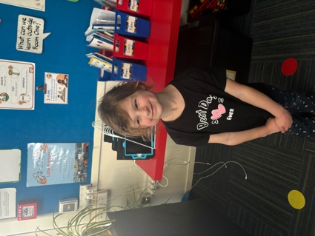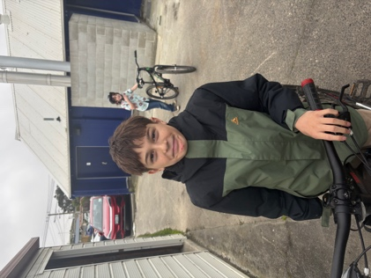
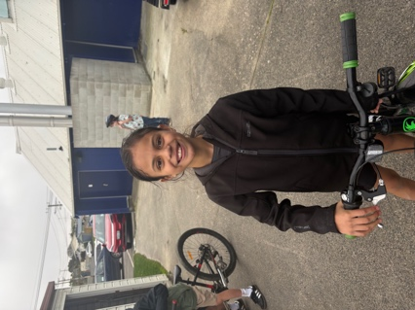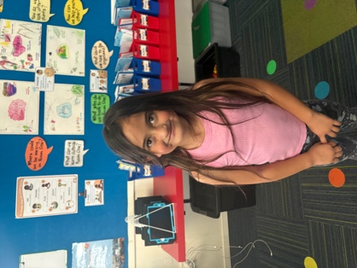

MISSING
Yesterday after school, a black skateboard went missing or was inadvertently taken by mistake. It is a flexi long board, it is black with grip tape. If you know of it’s whereabouts, please get in touch or drop it off back at school.
Thanks
Attendance
As you may know and possibly even frustrated by all the Attendance messaging etc. We fully understand. If your child is away for a certain number of days or late, you will receive an autogenerated letter from the Ministry of Education. If you do, please come and talk to me and I will clarify the significance. If the school has a real and genuine concern about attendance levels or patterns, I will be in touch by phone, personally.
Sad Farewell
It is with deep sadness that we bid farewell to Su Keen. Su has been our outstanding New Entrant teacher for three and a half years. However, Su’s connection with the school goes much deeper than that, with Su’s nieces and nephews, Bella, Jack, Maddie and William all being Big Rock alumni, and Su’s sister, Jo, serving on the Board for 9 years. Weirdly they were never here together.
Su’s contribution has been immense and one that will be greatly missed. Aside from day-to-day classroom school stuff, (which was superb by the way). Su has also been fully involved in fundraising events such as the Brighton Trail Ride, our stall at Gala Day (even helping with the whitebait supply). Playing a key role at Pet days, Art Extravaganza and Alice in Wonderland. However, what I will miss the most is what I valued the most and that is Su’ dedication to the children, the school and fully embracing being part of the team.
Su, your endeavour and commitment will be remembered for a long time. We are sad to see you go, but pleased we got three and a half years.
We all wish you the very best in your new role and hope that they realise how privileged they are to have you.
Kia waimare koe, kia manaakitia hoki e te Atua, good luck and God bless
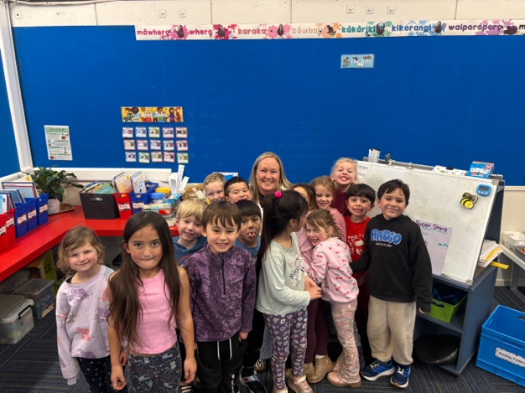
Parent Interviews
A reminder that bookings for these are now active on Skool Loop. If you have any problems, please do not hesitate to get in touch. Also, if those days are not suitable, contact your child’s teacher to make a time that works for both of you.
FIFA World Cup Winners
As you may recall, we had a wee competition for families to participate in. All you had to do was pick then four semi-finalists. There was going to be one winner, with all correct entries going into a draw. However, we had 10 winners, and I am a big softie. I met with the winners, and they decided they would rather have a smaller prize each than one person getting a big prize. Congratulations to Rhys Shayler, Leon and Jaxon Skerratt, Georgia and Hugo Stewart, Liliana Hebberd, Charlie Rackham, Leo Zhang, Leo Garth and Brianna Jones. (Both Leos and Brianna missed the photo)
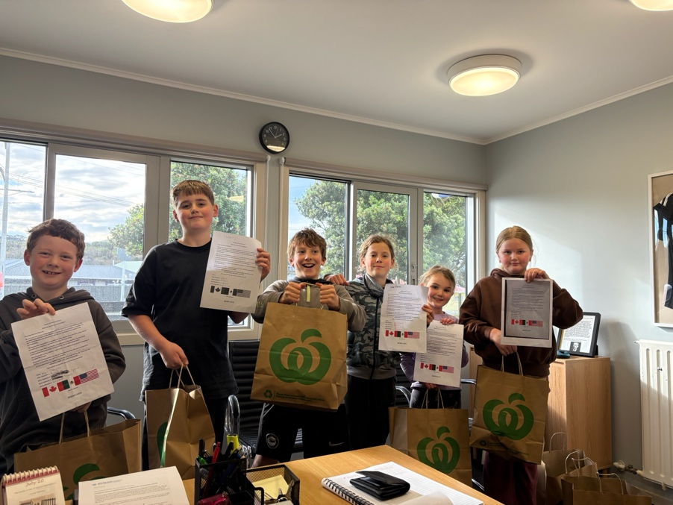
Food for Thought
‘Injustice anywhere is a threat to justice everywhere’ Martin Luther King
Listening, Laughing, Learning and Looking After Others
Stella Brown- sorting things out at the rope swing
Arlo, Greyson, Rhys and Fletcher C- managing outside interference in their game
Sports Roundup
Congratulations to Jed Grey on earning Player of the Day for the Big Rock Hoopsters in their 30-5 triumph.
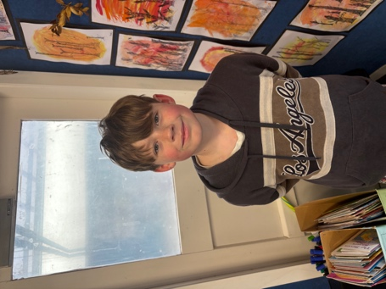

David Grant
Principal
Keith from Project Excavation Landscape is responsible for our school looking so smart. If you have any
landscaping or excavation projects we highly recommend using his services.
Reminders
Sushi
Sushi is available for lunch every second Wednesday. You can order this by using the Kindo/Ezlunch app.
Term 3 sushi.
Wednesday 22 nd July. 5 th , 19 th August. 2 nd , 16 th September.
Knowing if your child is well enough to go to school — guidance for parents and caregivers.
If you are not sure if your child is well enough to go to school, the Ministry of Health have a quick guide where you can check your child’s symptoms to make an informed decision.
Google – knowing if your child is well enough to go to school.
After School Care
Bookings or cancellations for After School Care can be made by texting 021 082 50863 or by emailing
asc@bigrock.school.nz.
Office Hours
Monday and Wednesday – 8.45am – 3.15pm
Tuesday, Thursday and Friday – 8.45am – 12.15pm
Kelly is only in the office between these hours.
Please note that if your call goes to the answer phone, leave us a message. Staff may not be able to answer the phone at that timebut will check the machine as soon as they can.
Lunch Orders
These can be made at the shop on a Friday or dropped at the school office before 9.00am.
Lost Property
This is located in the library.
2 Bath St • Brighton • Dunedin 9035
Ph 03 481 1781
email: office@bigrock.school.nz
Absences
Thank you for getting your absences and late notifications in before 8.50am on Skool Loop.
It saves us a lot of time if we don’t have to chase these up.
The new Stepped Attendance Response Regulations from the Ministry of Education and what they mean.
An automatic email will be sent from EDGE, as per Ministry requirements, when absences reach 4.5 half days
in a term.
Any absence must be recorded in accordance with the Ministry of Education attendance guidelines.
You can find further information about this on the Big Rock Primary School website under policies.

