24th August 2024
On behalf of everyone I would like to offer a big Big Rock welcome to Maci Kippenberger and her family. Also, a big welcome to Kyla Dey-Smart (Photo to come) and your family. It is fantastic to have you all on board.
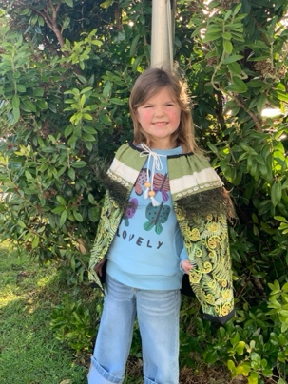
Congratulations
Plenty of variety in this week’s congratulations. Firstly, a big congratulations to former Big Rock student, Marissa Conway, who along with her band ‘The Nutmegs’ finished a brilliant third in Otago’s BandQuest with their self-composed song Runner Boy. They now get to record in a professional studio. You will recall Marissa as an outstanding Peter Pan in the school production. Well done, Marissa, putting the rock in Big Rock. (We will be having another musical production in 2025- watch this space for the next star(s)
Keeping with the Arts, congratulations to Sol Why on getting third in the Junior Ballet Championships, which is an outstanding effort. I think the photo tells the story of how happy Sol is and the hard work that went in.
On a slightly different front, congratulations to Billie McNab 0n winning the President’s Trophy at the recent Brighton Rugby Club prizegiving, outstanding Billie.
On a completely different track (sorry for the pun), well done to Max Ashton on his early success in the high-octane sport of go karting. Max is having great success, with plenty of podium finishes. Max has also been very successful in BMX racing. Keep an eye out for this young speedster!
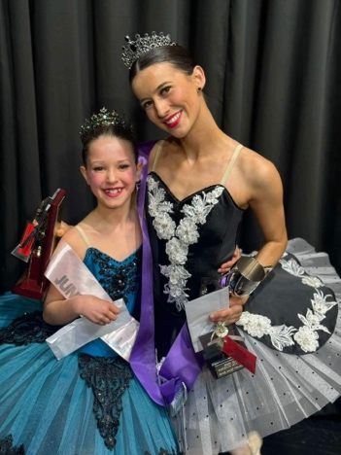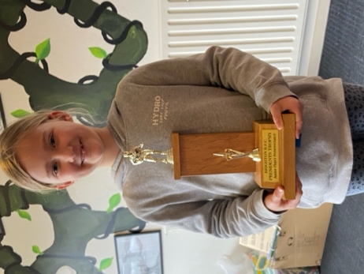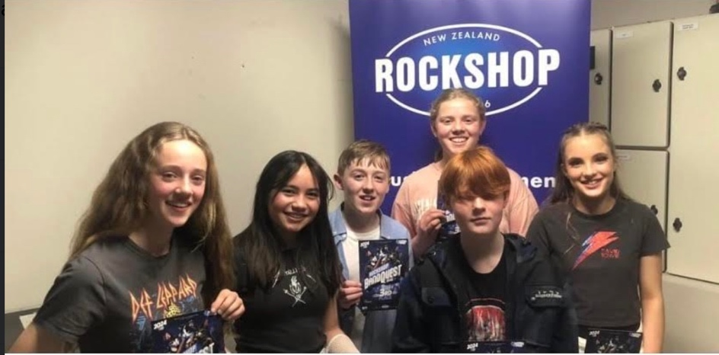
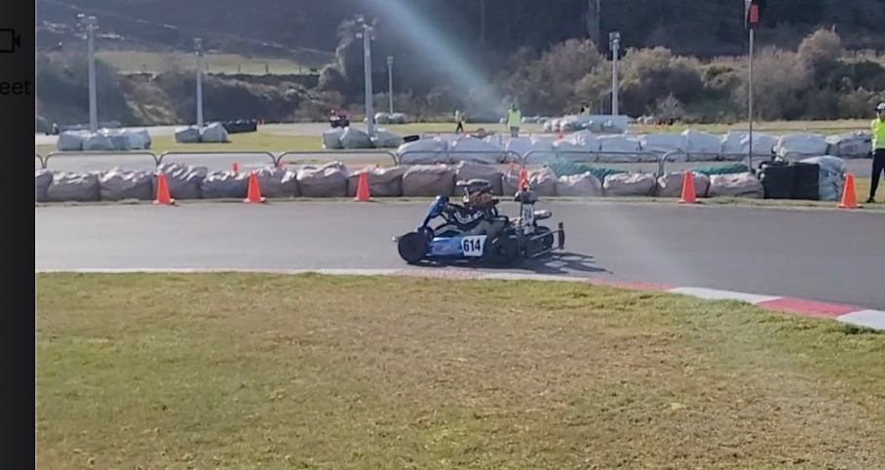
Max Ashton in action
Cross Country
Yesterday, we had the pleasure of hosting the Greater Green Island Cross Country Championships. This year we held it at Beachland’s Speedway and the surrounding area. Firstly, I want to congratulate all the athletes, from all the schools who competed. Cross Country racing is a tough event and requires grit, to put yourself out there, with so many parents, and children from other schools watching, takes real courage. I want to congratulate all the Big Rock athletes who raced and did themselves, their families and school proud. Well done Kade Hancock, Lilly Hamilton, Malachi Turner, Leith Conway, Sol Why, Kypton Garner, Baily Jenkinson, Isaac Lucking, Aliza Johnston, Taylor Matthews, George Wetherall, Ruben Van Tonder and Cameron Walters. Champions everyone of you. A number have qualified for the Otago Champs in a couple of weeks. I will confirm those next week. Thank you to Room Five for setting up the course, marshalling, recording results and dismantling the course at the end. Superb. Thank you to Kara Walters, Sasha Turner and Shane Turner, Scott Weatherall and Di Hamilton for helping with transport, photos and cheering.
Lastly, a massive thank you to the amazing people at Beachland’s Speedway for making it so easy to have the event at your facility. Easily the best I have ever dealt with, in making it happen. Unreal.
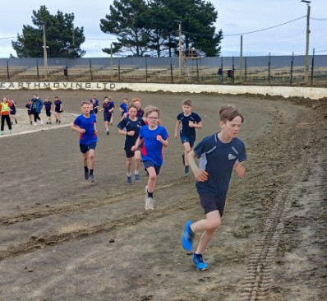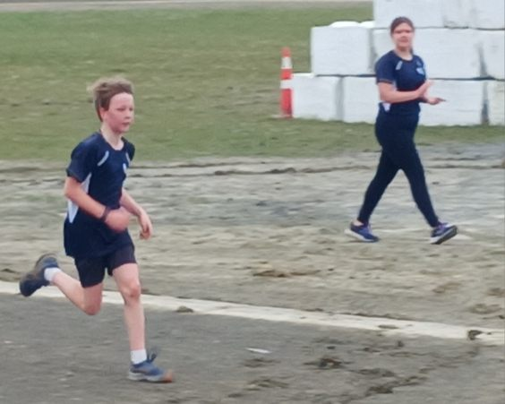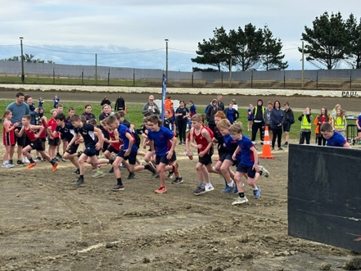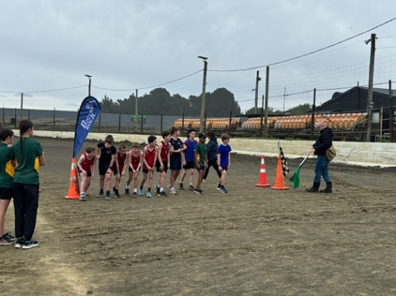
School Sports Uniforms
Can we please have all school sports uniforms back ASAP please. Even if your child is planning on playing futsal next term, we need them all back. I have had a number of people telling me they have 2, 3 and even 4 at home. Can you please check drawers etc and get them all back in please. Thank you, much appreciated.
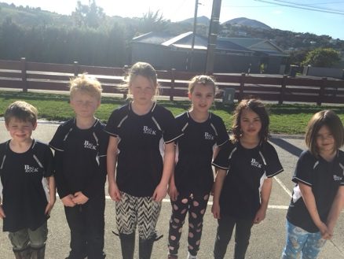
Room 5 Pasty Baking Competition
As part of their Mathematic’s programme, Room Five are having a Pasty Baking Competition. Here are some photos from the first few entries. A few more next week. Senior maths must be meaningful, and if possible, edible
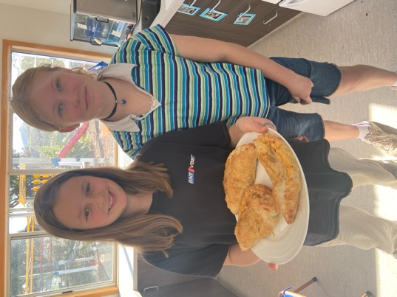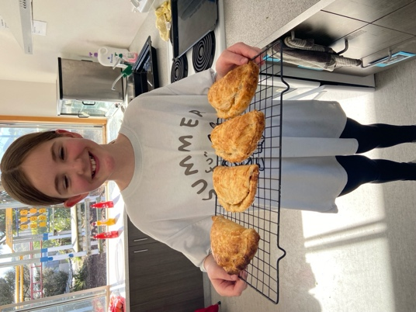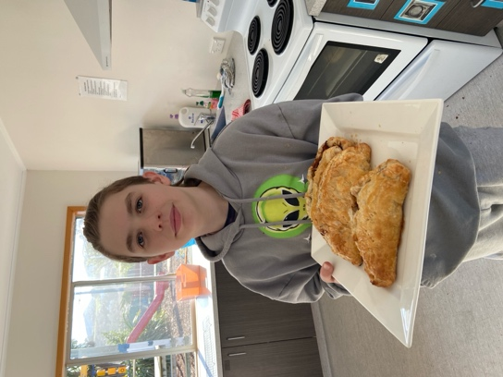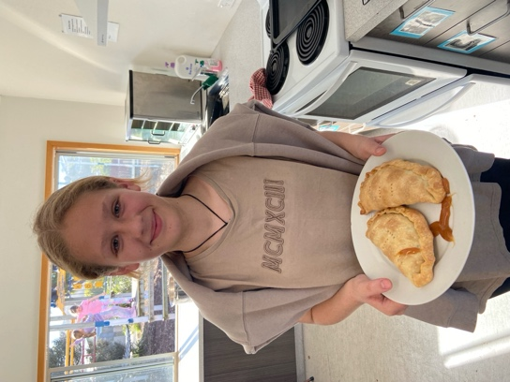
Have a great weekend
David Grant
Principal

