23rd May 2025
Congratulations
Well done to the following players on earning Player of the Day for their respective basketball teams.
Big Rock Shooters – Cecil Williams
Big Rock Coasters – Flynn Blanchard
Big Rock Hoopsters – Beau Mansfield (20 points)
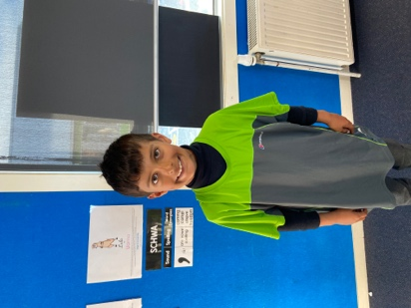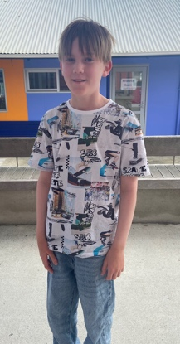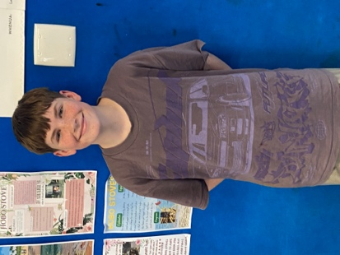
I would also like to congratulate the following for earning Player of the Day for the mighty Brighton Seagulls.
Brighton Mini Gulls – Ada McIver
Red Gulls -- Arlo Pfyl
Mini Gulls – Ari Isaksson
Red Gulls – Korbyn Parata-Walters
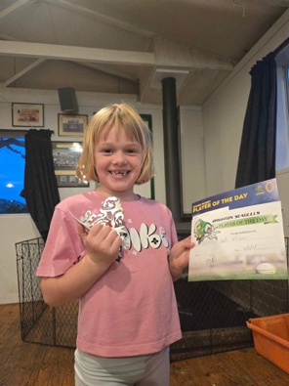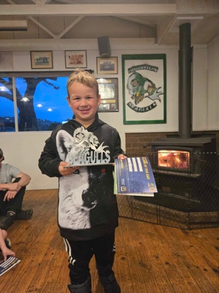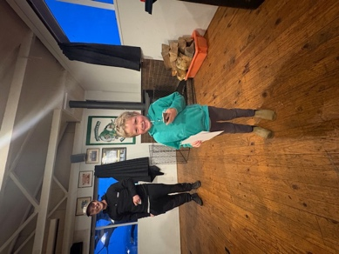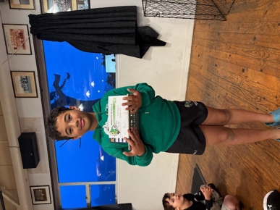

I would also like to off a massive congratulations to Fin Ramsay and his 10th Grade Green Island Raptors wining their section at the recent Green Island Football 7 a-side tournament, featuring clubs from all over. Top work Fin!
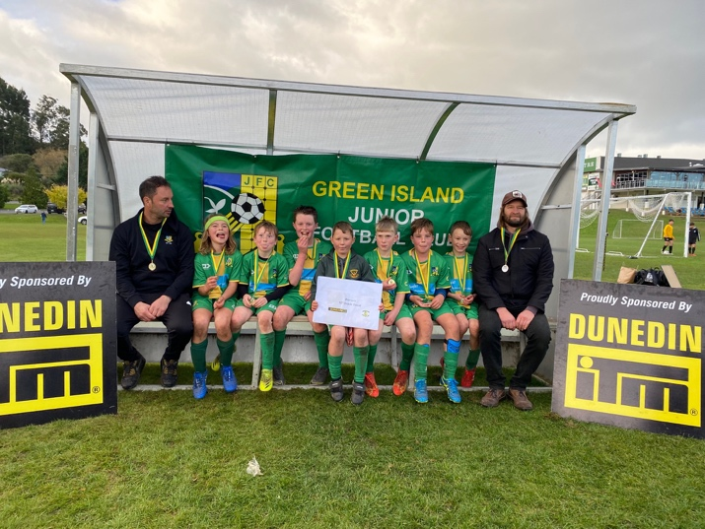

Netball
Good luck to our netballers with your first game next week. Thank you, Marina Conway, for kindly volunteering to be the gameday coach.
Your first game is at 3:30 on court 15 v MHS Green
Room Four went Walkabout
On Wednesday I had the pleasure of accompanying Room Four on their Dunedin Walkabout Tour. On the tour the had to employ their map reading skills and problem-solving skills and travel around the city area learning about different historic sites and places in Dunedin. Followed up by a bit of lunch at the Meridian.
As always, we need to celebrate their attitude and behaviour while out and about. The children are aware that it is their positivity that makes these trips not only possible but successful and fun.
Many thanks to Sarah Ramsay, Tania Blanchard, Sally Scott, Julie Tutgun, Tania McIlroy and Gayle Woodford for helping with transport and tour guiding
Massive thank you to Jude van Aalst for letting me tag along.
Yesterday information went home regarding Room Three’s History Spies Adventure! I have been in touch with MI-5 and their spy kits are on their way. The names Hollands, Quinn Hollands- Secret Agent.
Room 1 and 2 information will come home next week, but I can confirm the date as June 9th.
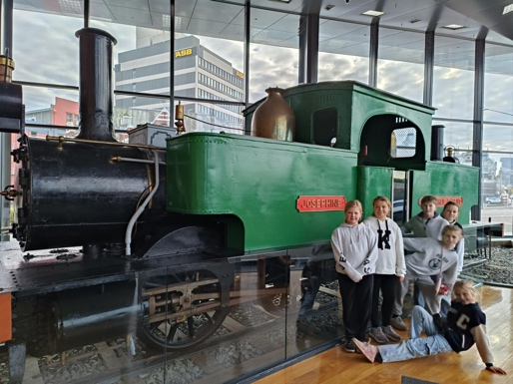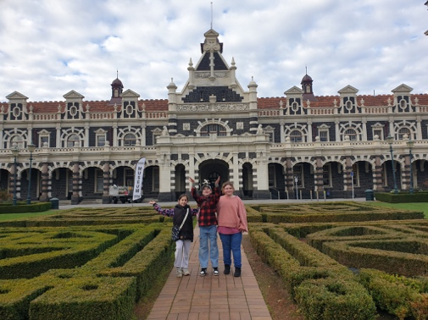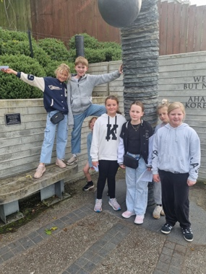
Matariki Celebration
This important school event is just over a month away. On Wednesday 27th June we will again celebrate with Mana Whenua and Tangata Whenua. Also as part of our celebration we think it is important to acknowledge all of the different nationalities and cultures within our community. As part of this we like to fly the flag of every country represented within our school. If you are not sure if we have your flag, can you please let us know asap so that we can either confirm or make amends.
On the day the school will be providing:
- Spit roast lamb
- Whitebait patties/fritters
- Sausage sizzle
- Vegetarian/Vegan curry
- Potentially spit roasted pork.
The new school rock band will also debut on the night.
More information will come out again nearer the time.

Room 5 Out and About
Earlier today the senior class, a spart of their Science and Nature School focus on Food Science, enjoyed a visit to Salmond and Knox Colleges to see an industrial kitchen in action. They both cater for 250 university students three time a day. The children not only got to enjoy the tour and see what was happening, they also got to jump the lunch queue and dine with all of the students. They begged me not to show a photo with the hair nets so…
A massive thank you to Michael Tomlinson and Nick Bates and the team at Salmond College and to Michael O’Brien and Lok Ng form Knox College, unreal team.
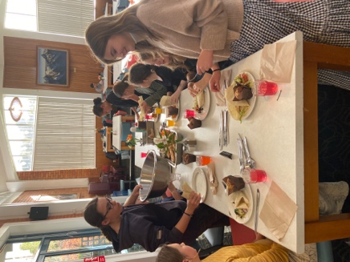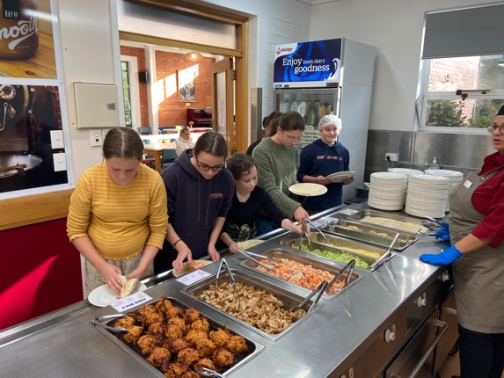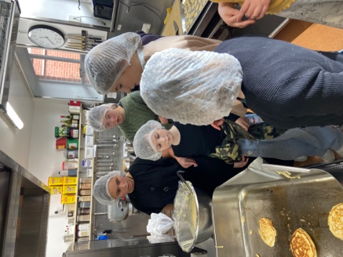

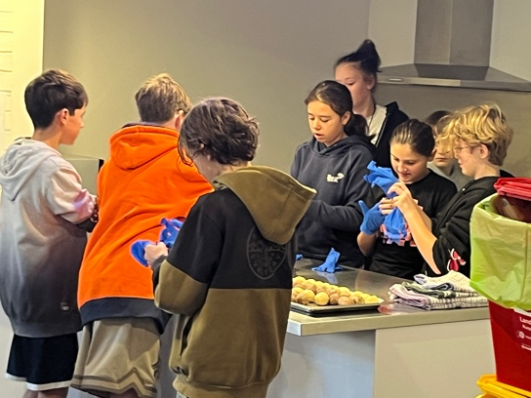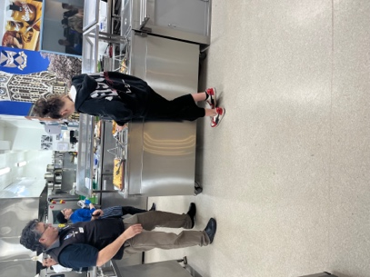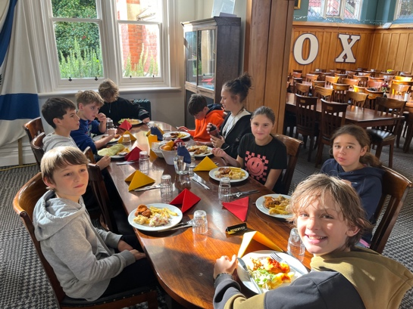
Pink Ribbon Afternoon
Tomorrow afternoon at the Brighton Club there is the Pink Ribbon Afternoon that is raising funds and awareness for breast cancer. The event begins at 12:30 and goes through to 4:30. $10 entry with a glass of bubbles on arrival and nibbles. Lots of raffles, prizes and laughs. It will be an awesome day.
Having had breast cancer in my family and knowing how awful it is, well done to Annette Hogg and Sally Scott for organising such an important event.
Have a great weekend

David Grant
Principal

