23rd June 2023
Matariki and New Zealand Histories Evening and Shared Meal
Firstly, thank you to everyone for making Wednesday night such a special night and one that went way beyond my expectations. The aim was to honour local Tangata Whenua as well as recognising and celebrating the many different cultures within our school community and contribute to making it, I think, a pretty special place, both the school and the wider community. The sharing of food, and what magnificent food it was, plentiful and gorgeous, is wonderful way to enjoy each others company and is as old as time. We hope that everyone felt welcome and part of it.
The buzz in the hall was amazing, as were the dozens of positive comments that the staff received. Thank you. It is so valuable sharing the children’s work and achievements with you, as it is not only is great for their self-esteem and personal confidence it also demonstrates that as adults and parents, we value their work and their education.
So many thanks to all of the children, for their endeavour, thank you to all of the staff for making it all work, thank you Scott and Shane for cooking the barbeque, thank you Kim and Diane Rapley for your generosity with the lamb and the venison, thank you for all of the amazing food. Thank you to everyone for making it work. We are always looking at improving or making changes, if you have any thoughts for improvement, or changes for next time, please let me know.
The quiz results will come out on Monday.
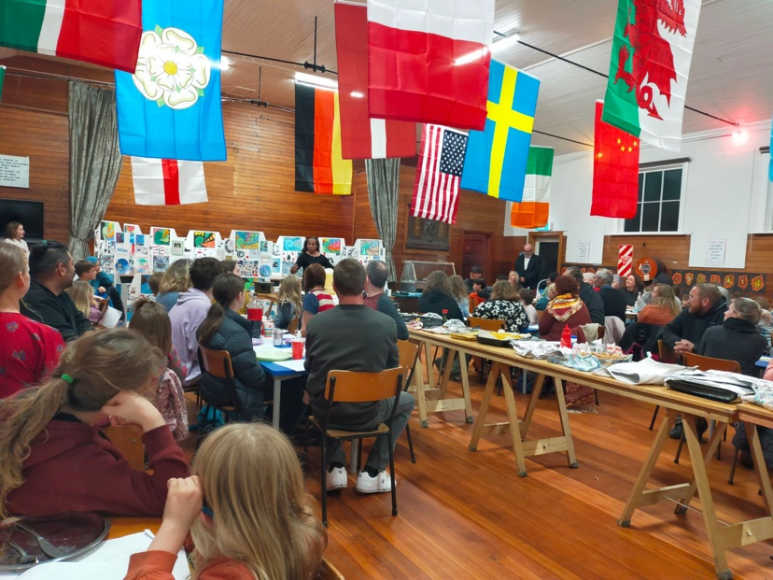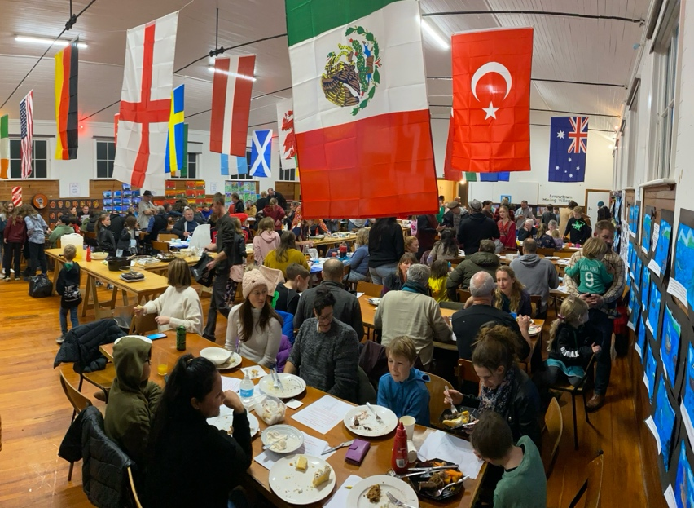
Thank you Lauren and Shane for the photos.

Sports Round-Up
Netball
Congratulations to Bo-Lilli Andrews (Photo to come) on earning Player of the Day for the Big Rock Dolphins in a tough game against a much taller opposition.
Equally well done to Bella Yeoman on earning Player of the Day for the Big Rock Rockets in their Tuesday night game.
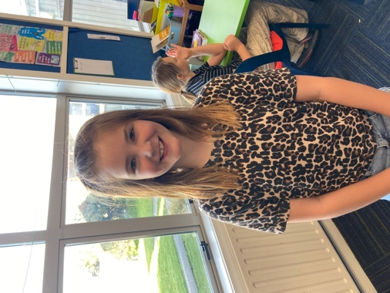
Basketball
Well done to Leon Skerratt, on earning MVP for the Big Rock Shooters in their hard fought victory.
Outstanding general play in a very tough game against Carisbrook, saw Beau Mansfield earn MVP in the Big Rock Coasters 15-12 victory.
Lastly, well done Stevie Kahui on earning MVP for the Big Rock Hoopsters in their 34-10 victory against Kaikorai Valley College. Making it a clean sweep for basketball this week.
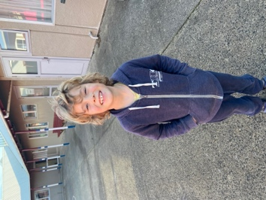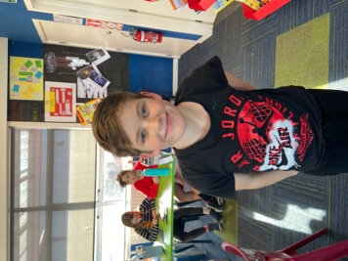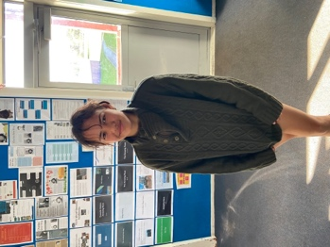
Football
Bravo to Leith Conway on earning Player of the Day for the Green island Cobras on Saturday. Good work Leith.
Brighton Seagulls
Yay Quinn Hollands and Daisy Brownlie on earning Player of the Day for their respective Brighton Seagulls rugby teams. Also well done to Bryn Little on earning Most Improved.
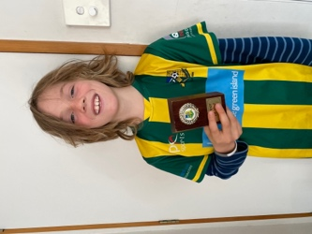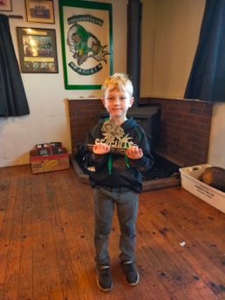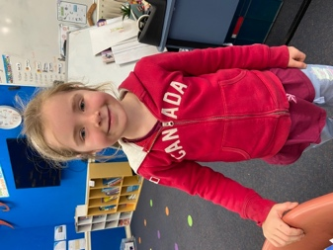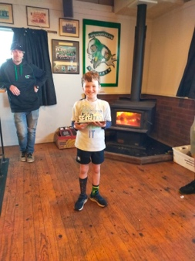
Bingo Fundraiser
On Wednesday night at the Green Island Rugby Club, it is our turn to host a Bingo fundraiser to raise money for the Senior Class Stewart Island Camp in October. It is a great night out and they have an amazing collection of raffle prizes as well as all the loot in the bingo itself. It will be fun, and ultimately successful for lots of people. (Flyer attached below)
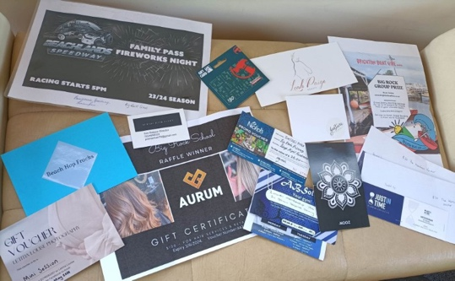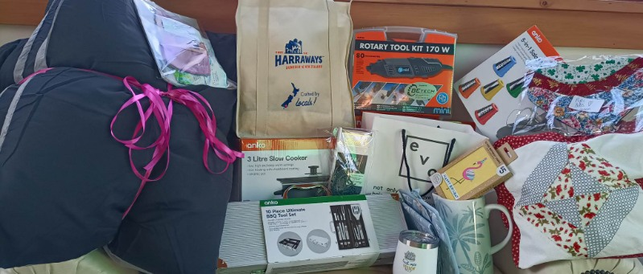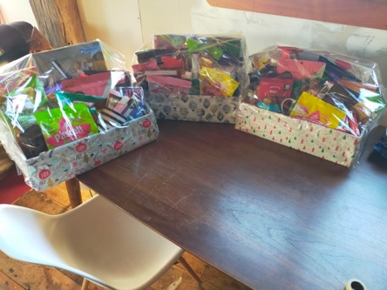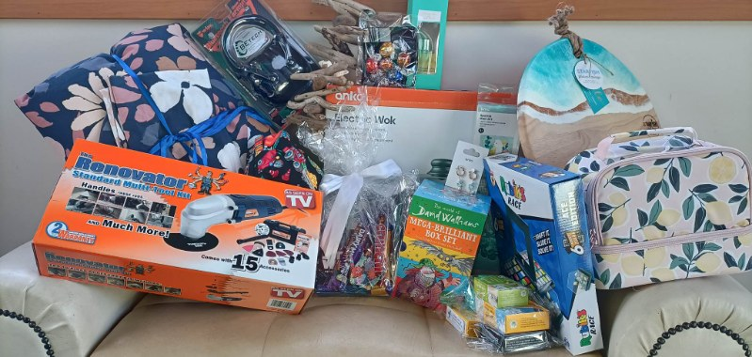
Some of the Raffle Prizes
Library Books
We are currently surveying the children on new library books, so as to ensure we stock the library with high interest books. I have managed to secure $4000 of funding from the great people at Bendigo Valley Sports and Charitable Foundation, which is obviously fantastic. A massive thank you to them. Please have a chat with your child about books or reading material they might like to see in the library. Please let us know how you get on.

Have a great weekend.
David Grant
Principal

