23rd February 2024
Good Luck
All the best to George Weatherall as he heads up to Mount Maunganui ‘The Mount’ to compete in New Zealand National Surf Lifesaving Championships. A big event George, and a big challenge, but you are just the man for the job. Good luck to you!
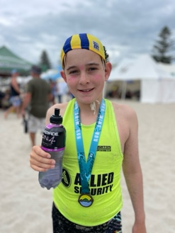
Pet Day Extravaganza
Thank you everyone for making this year’s Pet Day Extravaganza a great one, maybe our best one. The work that went on at home in making the scarecrows, which were quite extraordinary, the level of baking was, as always, incredibly high. The feedback we received throughout the day from parents was incredible. Our two guest visitors, Steve Turnbull (Concord School) and Mark Tuton, our Community Police Officer, were mighty impressed, not just with the work but with the children in general in the chats they had at the different games etc. A big thank you to Kimberley Ashton and Shane Turner for helping us with different activities.
The event itself has become quite a thing and I know for a fact that other schools are wanting to do something similar to ours, but on a smaller scale. (Big Rock-the clue is in the name)
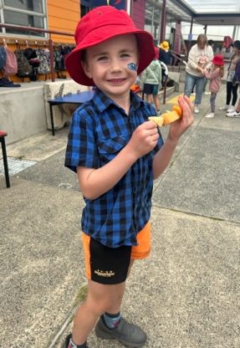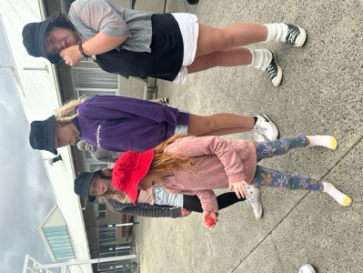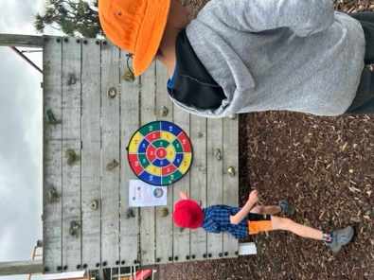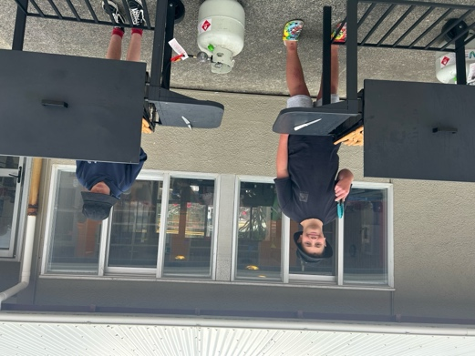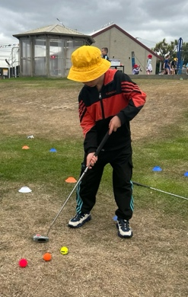

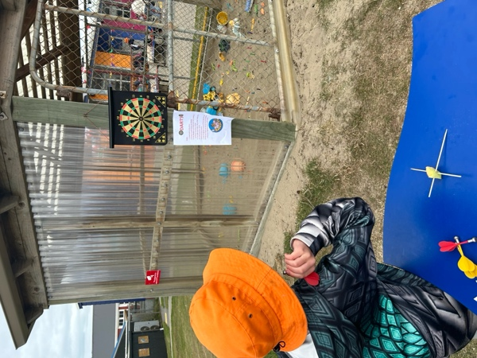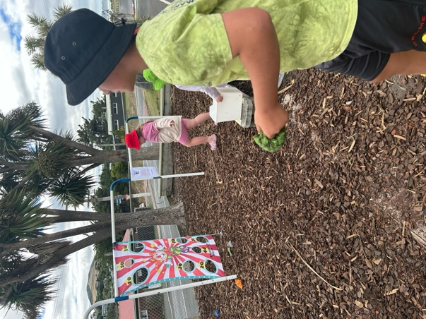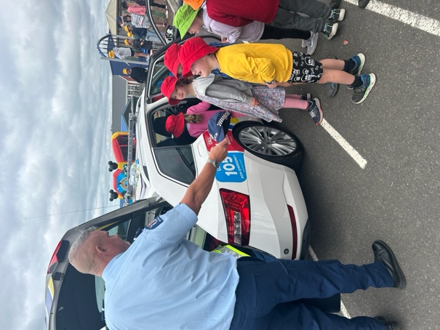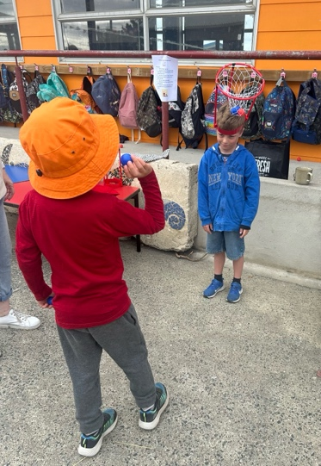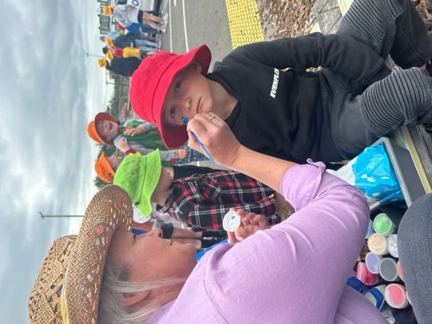

Taieri Mouth Adventure
Now that Pet Day is over, we can talk about our upcoming Taieri Mouth Adventure. Firstly, thank you to everyone who has returned their permission slips. Also, thank you to those who can help, and those who are able to help us out with kayaks, paddle boards and lifejackets. It is going to be great.
The day will go as follows:
- Rooms 3 and 4 will leave school at 9:15 and return to school by 1:00 (Leave Taieri Mouth approx. 12:40)
- Room 5 will leave school at 10:00 and return by 2:45
- Rooms 1 and 2 will leave school at 12:00 and return to school by 3:00
Most children will be travelling by bus.
All children will need to bring:
- A large lunch and snacks
- A refillable drink bottle
- Togs/towel (Wetsuit if they have one)
- Lifejacket (If they have one and clearly named please)
- Jacket and school hat.
There will be a sausage sizzle and juicies. Rooms 1-4 will have their sausages at school, either after the adventure or before leaving.
While there are activities in and on the water, your child’s safety is our priority. All children will be closely monitored, and we will have appropriate adult to child ratios.
Our main goals of the day are to get all of the children in a kayak, on a paddleboard, in the water and go for a speed boat ride up the river, all in our beautiful local environment.
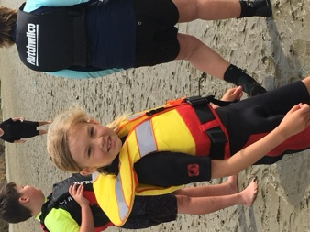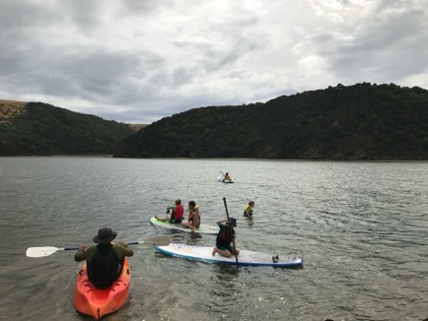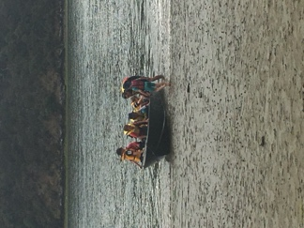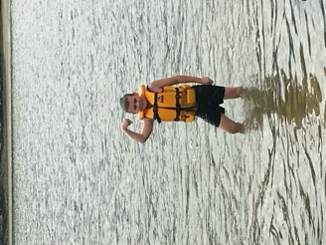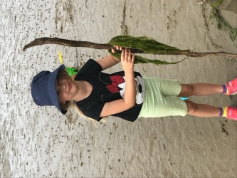
Futsal
Congratulations to the following players on earning Player of the Day this week.
Big Rock Dolphins – Greyson Farquar
Big Rock Stingray- Jed Grey
Big Rock Starfish- Zachary Nielsen
Big Rock Barracuda- Baily Jenkinson
Big Rock Sharks- Ruben Van Tonder
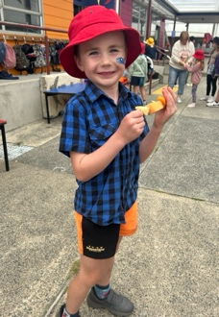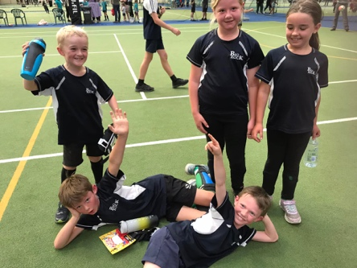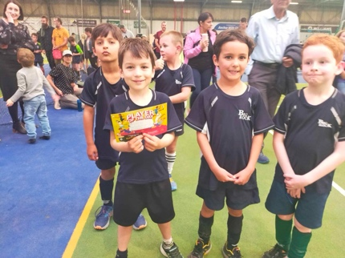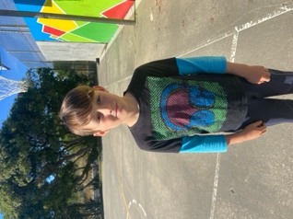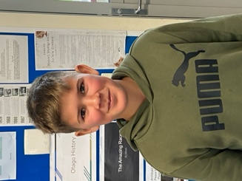
Weetbix Tryathlon
Only a week to go, if your child is keen, there is still time to register. It is a great event for the children.
Have a great weekend
David Grant

