22nd October 2023
Futsal
Well done to all the teams who got under way in the futsal last week. It seems that there was a lot of confusion regarding the draw. Having checked what I sent out; it was correct based on what Southern Football sent me. It would seem that the draw is prone to change, late, which is not particularly helpful but there is not much we can do about it.
To find the draw on the Southern Football website:
- Google Southern Football
- Go to the Southern Football website
- On the Southern Football website click on the Futsal tab at the top of the page, near the middle
- Click on School Fixtures and Results and select the appropriate level for your child and locate your child’s team
I will endeavour to post the draw on a Sunday, but if it is subject to change it might be a good idea to double check.
From the information I have seen and received, well done to Pearl Mansfield and Dion Mooyman on earning Player of the Day for the Big Rock Barracuda, excellent stuff.
Well done to Kolton Haggerty-Walker on earning Player of the Day for the Big Rock Dolphins, outstanding stuff Kolton!
Bravo, Josh de Thierry on earning Player of the Day for his Stingrays team. Top work Josh.
Congratulations to Malachi Turner on earning Player of the Day for the Big Rock Orca in a stunning 4-0 victory.
Also, a great performance saw Charlie Hughes earn Player of the Day for the Big Rock Marlin.
This week’s draw as of today
Tuesday Futsal
Big Rock Dolphins v GB on court 8 at 4:15
Big Rock Stingray v GSNS on court 5 at 5:45
Big Rock Marlin v SFX on court 19 at 5:15
Big Rock Barracuda v SPC on court 5 at 5:15
Wednesday Futsal
Big Rock Orca v MHS court 19 at 3:45
The Big Rock Sharks do not appear to be in the draw. I am not sure what is happening at Southern Football. The team was entered in time, we received confirmation from Southern Football and have paid the bill. I have emailed twice and had zero reply. It is very frustrating.

Congratulations
Congratulations to the Tutgun, Turner and Hamilton families on correctly picking 3 of the 4 Rugby World Cup semi-finalists. Sadly, no one picked all four, yet if any of the three winners had faith in the All Blacks they would have won on their own. Yes, that is correct, rather disappointingly, none of the picked the All Blacks to make the semis
Your share of the prize will be available on Tuesday.
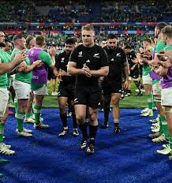
I would also like to congratulate Amelie Laing, Addison Johnston and Dusty Andrews who won the Room Four Maths Probability RWC pick, by correctly picking the winner and the margin of victory in the All Blacks v Ireland quarter final. (They had faith in the All Blacks). Your prizes will be available on Tuesday.
Stewart Island Camp
Last week I had the pleasure of travelling down and spending the week with our Senior class on the biennial pilgrimage to Stewart Island for their class camp. What a week. The weather nearly played ball, but it was wet and windy a lot of the time. However, from a pretty rugged crossing on Monday morning to a smooth crossing in between, the children took everything in their stride, and we achieved most of what we wanted to do, with everyone fully involved. My thanks to the parents for your work and support ‘on the island’. Thank you, Scott Weatherall, Ange Hancock, Paddy Patterson, Paul Marsh, Elise Velenski, Lauren Mooyman, Jo Henderson, Laurie Duval, Kara Walters, Morrie McCleod and Viktoria Kahui, as well as Cheryl and Roger! Without you we couldn’t have done it. A massive thank you to Richard Murray for all of your work in making it happen.
Lastly, thank you to all the children for your endeavour and enthusiasm, you rock.
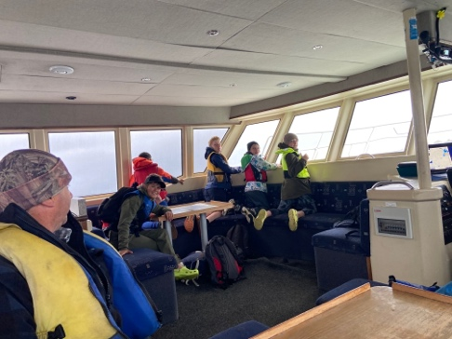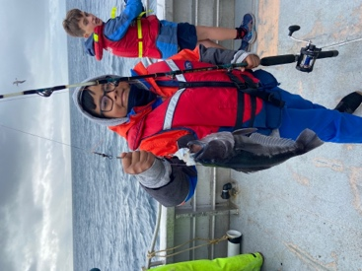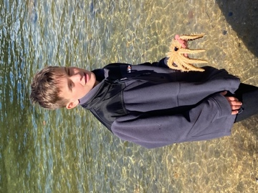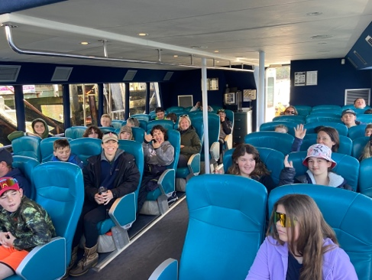
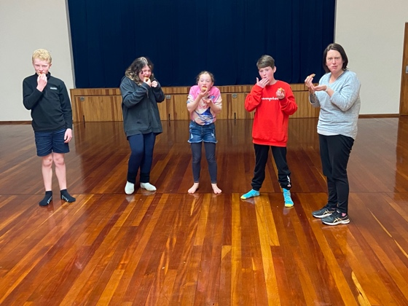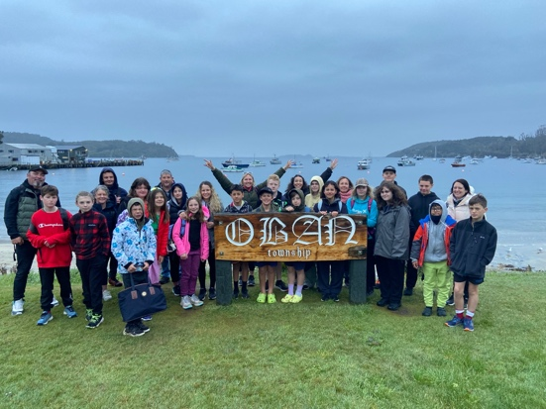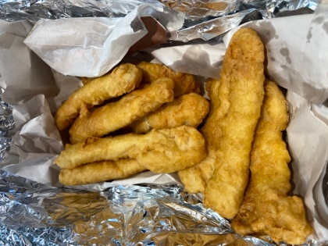
A Busy Week Ahead
Wednesday
All classes have St John visiting for basic first aid training that is age appropriate
Greater Green Island Athletics on Wednesday. All children competing need to be at school by 8:20. (They will have received a notice home in the first week of school)
Rooms Four and Five have football with Southern Football
Friday
Year 5-8 girls (Those who were registered) have their Multisport Fern Fever Day.
A reminder that school is closed tomorrow, with it being Labour weekend.
David Grant
Principal

