22nd March 2024
Welcome
I would like to offer a massive Big Rock welcome to Braxton Parata-Walters, Korbyn Parata-Walters, Alex Judd, Barnaby Ryhne-Slijkerman and Ayan Polarpu.
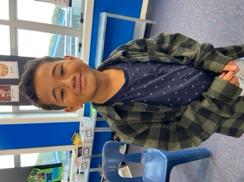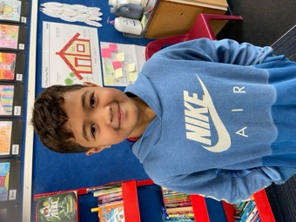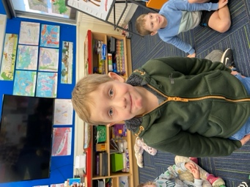
Good Luck
Good luck to Addison Johnston who is competing in the Otago Bowls Champ. Go get them Addison. ‘Shot bowl Johnston!’. This follows on from George Weatherall competing in the South Island Under 14 Mountain Bike Championships. Two completely different sports both having competitors wearing Big Rock colours. Stunning!
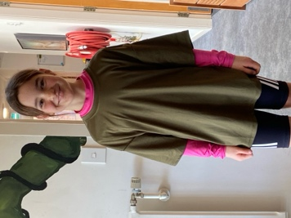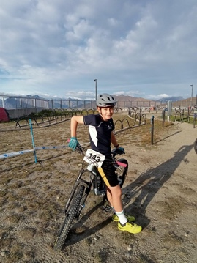
Hot off the press---- Addison finished an excellent 4th. Top work Addie.
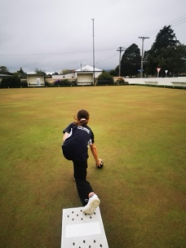
Out and About
It has been a big week with our two senior classes being Out and About as part of our on-going EOTC programmes. On Tuesday 21 of our senior girls (Year 5-8) took part in the Fern Fever event. This is put on by Otago Cricket, Dunedin Hockey, Otago Rugby and Southern Football. It is aimed at encouraging, promoting and celebrating girls in sport. An awesome event where the girls take part in modified games linked to the sports organisations running it. Thank you Jude Van Aalst for organising and taking the girls on the day with support from Angie Hancock, Di Hamilton, Lisa Russell and Kara Walters.
On Wednesday Room Four has their Goldfields bike trip, 22 enthusiastic riders facing a cold morning and a hot afternoon (Central Otago is hard to beat) and riding 18-34km, on at times challenging terrain. Some were even brave enough to go on the rope swing into Pinder’s Pond, into water that could only be described as refreshing, or for our new man, Braxton from Gisborne, cooooooooold! The grit and determination of all of the riders was immense. Many thanks to Mel (Mrs Van) and Jude (Miss Van Aalst) for making it work. A big thank you to Tony Mansfield, Graeme Egan, Dallas Hamilton, Kirsty Rackham and Justin Rackham for helping transport children and riding with them. Thank you Cavan Jenkinson for taking bikes in your van and towing the school bike trailer, much appreciated.
Last day of surfing for the term with Room 5 today. Learning in Paradise.
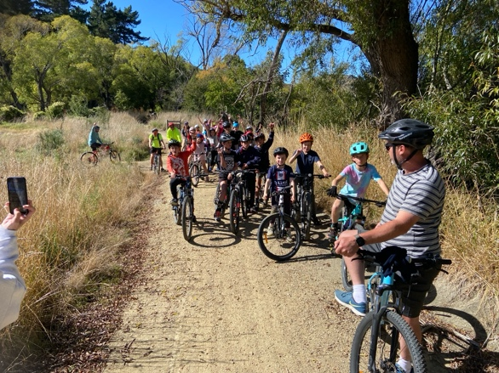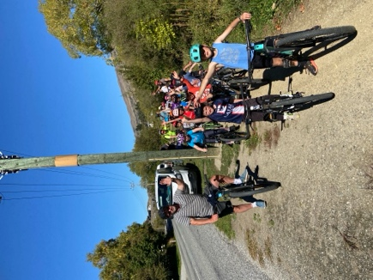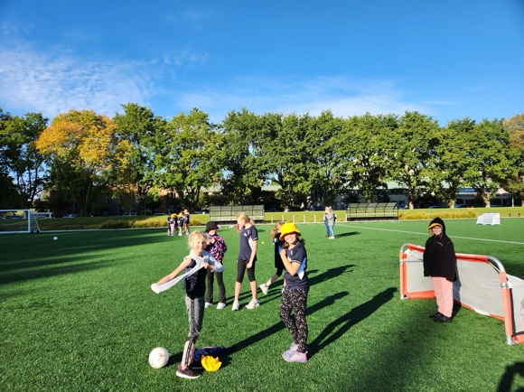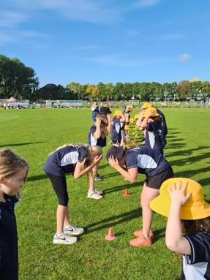
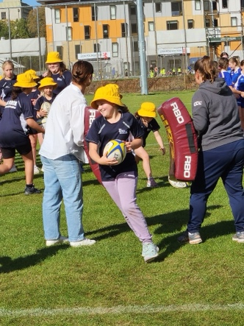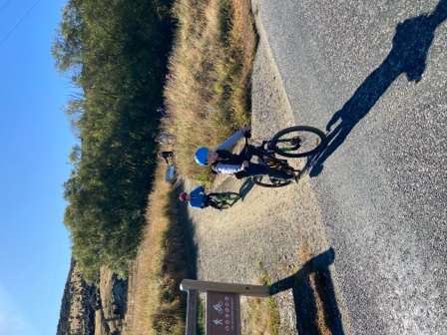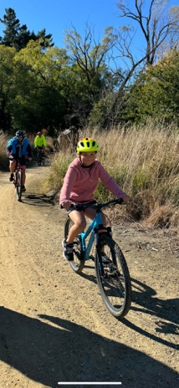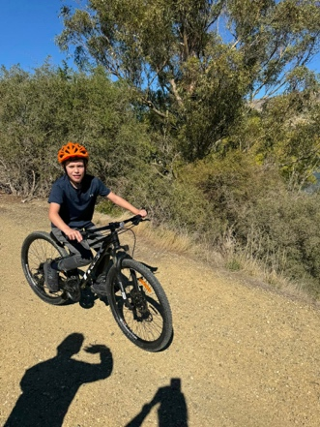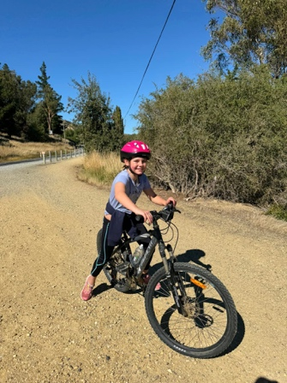
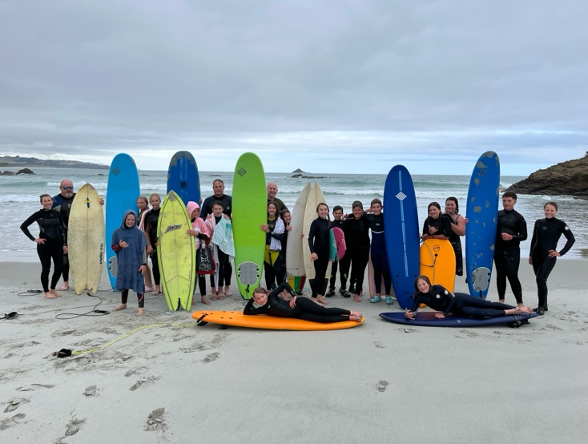
Room Two Biking
On Tuesday Room Two will have their first biking session of the year. The session will focus on safety, skills and some simple maintenance. If everyone in Room Two, who has a bike can bring it along on Tuesday, along with their helmet that would be fantastic. Please do not rush out and buy one if you do not have one.
If anyone has a bike at home that has been outgrown, we need to talk. We are looking at getting bikes for the junior school, and getting ones that are no longer required would seem a good place to start. So if you have any… please.
Futsal
Congratulations to the following athletes who earned Player of the Day for their teams this week.
Big Rock Dolphins— Rhys Shayler
Big Rock Starfish – Josh de Thierry
Big Rock Stingray – Jed Grey
Big Rock Sharks – Kade Hancock
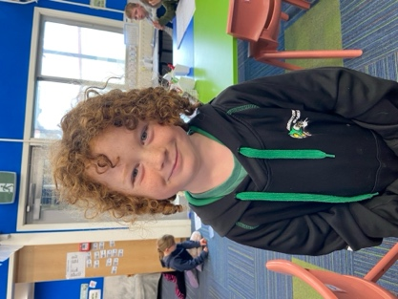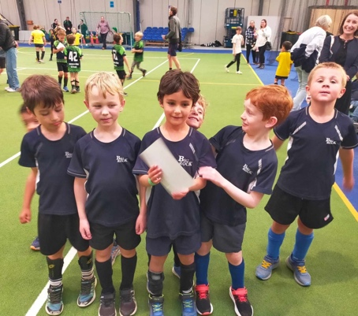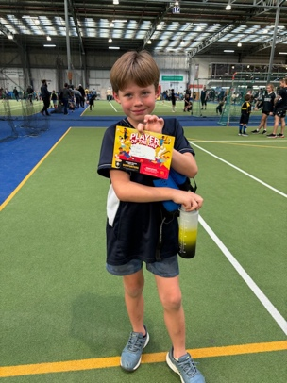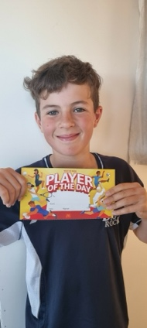

Otago Anniversary Day
School is closed on Monday as we celebrate the incredible province we live in, Otago. The mighty Blue and Gold. C’mon Otago.
Netball and Basketball
All names needed by next week please.
Buddy Reading
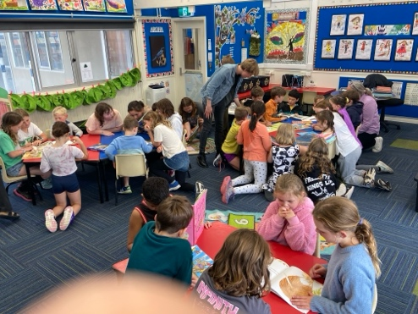
Room’s One and Four Buddy Reading.

Have a great long weekend.
David Grant
Principal

