21st November 2025
Swimming Pool
I am delighted that the swimming pool is now open. I appreciate that this year’s opening has taken a couple of weeks longer than anticipated but there was no way around that. The most important thing is that it is now open, ready for a long hot summer .
Teacher’s will advise of what days classroom swimming will be happening. On most days the pool will be open at lunchtimes. Usually this is for Rooms 3, 4 and 5. This is for safety reasons and the amount of time the younger ones take to get dressed afterwards. There will however be lunchtimes when the pool is open only for Room 1 and 2 in the interests of fairness.
Pool keys will be available to school families from Wednesday 24th November. Pool keys can be picked up between 8:45 and 10:00 every day or 2:45-3:15 on Mondays and Wednesdays. Alternately you can pay online to the school account and advise Kelly, and she will have keys and paperwork available for pick-up after school. This year we have reduced the cost to school families. The price is $60 plus a $10 key bond. ($70). It is Board policy that school accounts must be paid in full before pool keys are available.
Keys will become available to community members on Wednesday 3rd December at a cost of $100 with a $15 bond ($115 total).
There is a limited supply of pool keys and school families and whanau will be given priority.
You may not notice a lot of the work that has been done. The work completed includes:
- A heated shower (Luxury!)
- A new, more efficient and reliable water heater
- An industrial clean inside the pool building
- Major repairs to the masonry
The pool will be repainted at the end of the season in the cooler months (Less humid). Our goal is to future proof the pool for future generations.

Futsal
Congratulations to the following players who earned Player of the Day this week.
Big Rock Dolphins — Evie Hollands
Big Rock Stingray --- Leo Henderson
Big Rock Orca--- Quinn Hollands
Big Rock Sharks --- Jed Grey

Rising Star
This week our rising Star is Year 8 student Esme Grey, our very own Drama Queen. Esme is fast becoming an accomplished performer on the stage. You will remember her singing and dancing as the Cheshire Cat and as the Mad Hatter in our production of Alice the Musical. Esme is currently in rehearsal as a lead in a Christmas production of Santa Weighs In. Esme also performed last year in another Christmas production. Esme is on track to become an accomplished singer and performer on stage. I recommend you keep an eye (and ear) out.

Naseby Nightriders
Over the last couple of days a team of enthusiastic and adventurous senior mountain bikers spent their time riding around the tracks of Naseby. They rode morning, noon and night. Lots of determination and grit, as well as sweat, spills and smiles.
A massive thank you to Mr Murray and Angie Hancock for leading this adventure, ably supported by Justin Rackham and Shea Davie.
A special thank you to Scott and Justine Weatherall, and Tony and Shelley Martin who helped us greatly with accommodation.
This event is a combination of our Senior Mountain Bike programme and Science and Nature School.
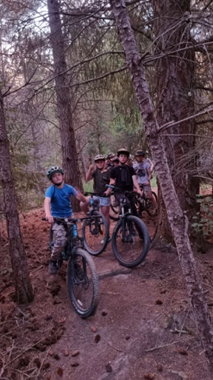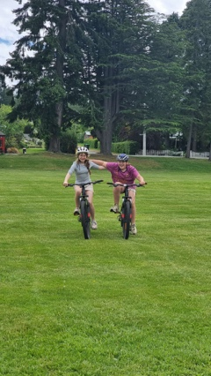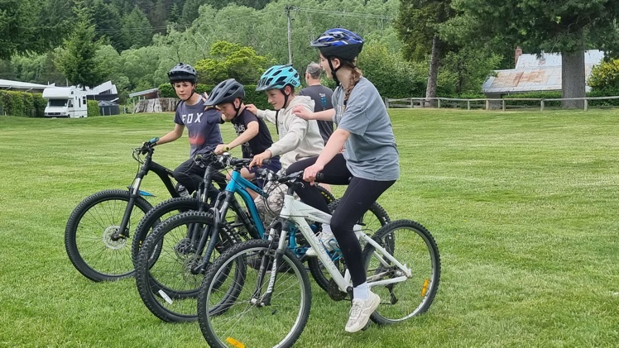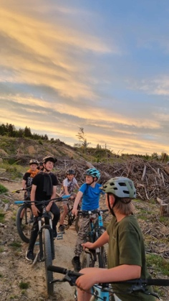
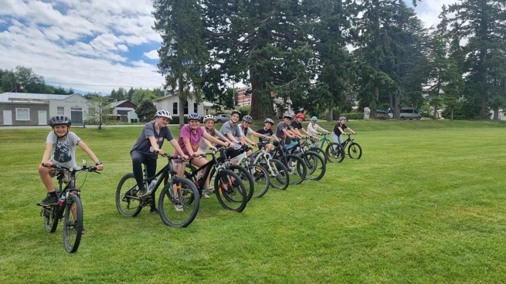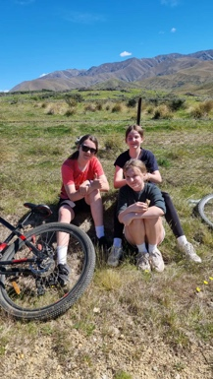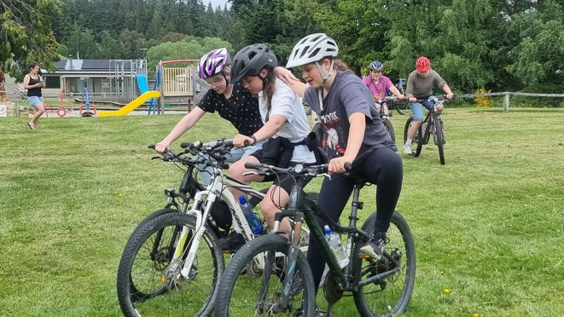
End of Year Prizegiving
A reminder that our end of year prizegiving is on TUESDAY 9th December, starting at 4:15 pm.

Have a great weekend
David Grant
Principal

