21st March 2025
Pet Day Extravaganza
What a day, I don’t know if it was good judgement, pure luck, or somewhere in the middle, but we got away with the weather, which was unreal considering how changeable everything has been. It really was a great day, with all the children actively involved in all of the games. Those that could, taking part in the homework challenges and the baking competition. I say it every year, but I honestly believe that the baking this year was of the highest quality and maybe the best we have ever had. I don’t say that lightly as the son of a baker. Thank you for taking the time and putting in the effort.
Thank you to everyone for making the day not only possible but successful., Board, staff, parents and of course the children.
The reason I want to congratulate the children is that for many, the day has the potential to be very challenging. It is unstructured, the children have the opportunity to participate in games and activities at will. Combine that responsibility with the sheer excitement levels, so many things going on and it could all get very messy. Yet, the children’s behaviour and attitude remains excellent, with very few ‘issues’ requiring teacher involvement and even then only at the end of the day. Remarkable really. Even the queues for games, popcorn etc were orderly and dignified. Well done to every child, it is your behaviour and positive attitude that makes the day possible. You rock!
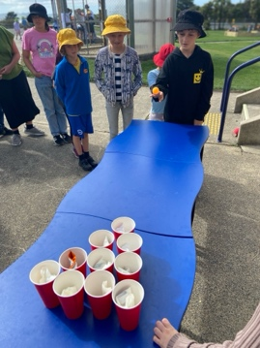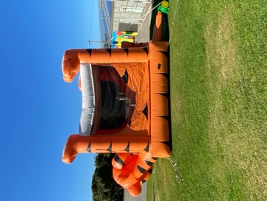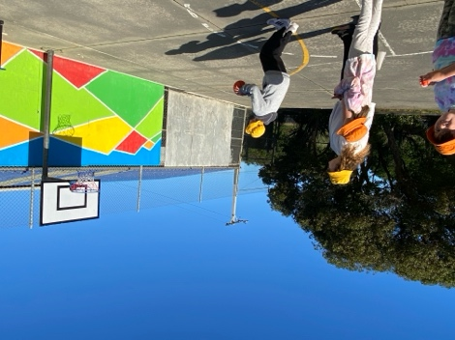
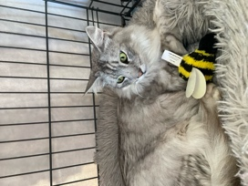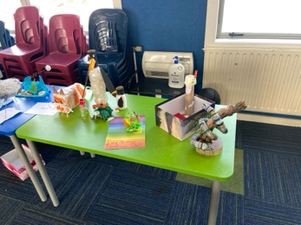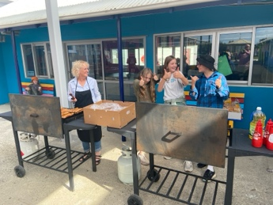
High scores on Velcro Darts were: Brianna Jones 270, Will Judd 270, Hinemoana Jiminez Maxwell 280, Fin Ramsay 310, Stella Brown 300 and Cecil Williams with a excellent 370!
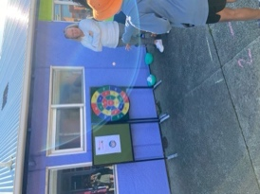
Futsal and Winter Sports
Congratulations to the following players on earning Player of the Day in the week’s round of games.
Big Rock Stingray – Will Judd (2 goals)
Big Rock Barracuda – Rowan Patterson
Big Rock Sharks – Nate Brownlie
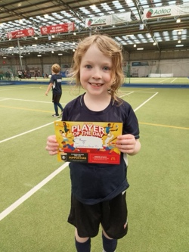
Winter Sports
Please keep all of the names coming in if your child is keen to play NETBALL or BASKETBALL next term. We require all names by next Friday so that we can arrange teams and enter the teams in the competitions. After that date, we cannot guarantee your child a place in a team. Please do not assume that we know your child or children will want to play. Please let Kelly in the office know. Can you also please let us know if you are keen to manage or coach a team, please.
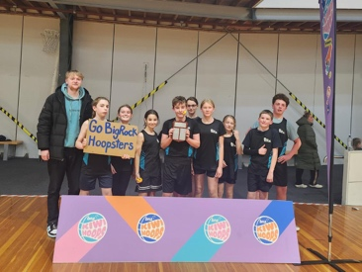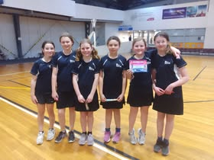
Thank you.
Greater Green Island Triathlon
Good luck to all of our young athletes competing in the Greater Green Island Triathlon on Tuesday morning. All athletes need to be at school for 8:15, ready to go. I will have sports shirts and singlets ready. If you are a swimmer, please be in your togs under your clothes.
Thank you
Senior Surfing and Boogie Boarding
Sadly, it was the last session today. It has been another great season, so cool seeing the children in the water enjoy their own environment to the maximum. A massive thank you to Ange Hancock, Susannah Yeoman, Heath Ratten, Cavan Jenkinson, Vaughan Grey, Kirsty Rackham, Kelly-Rose Murphy, Jessica Garth, Shane and Sasha Turner for all your help in the water and on the shore. Mr Murray and I couldn’t have done it with out you.
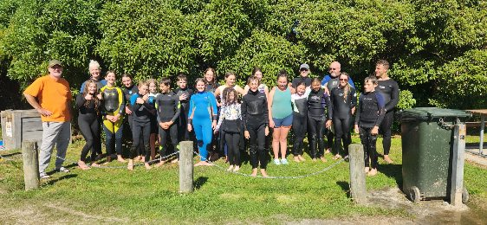
Science and Nature School
A great session on the beach yesterday. The team made hobo stoves and cooked up some sausages. Their first session at this, but the plan is for the menu to get more extensive and more survivalist
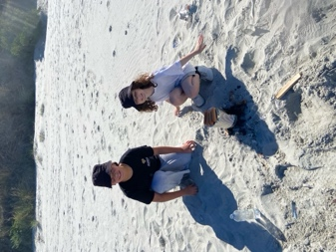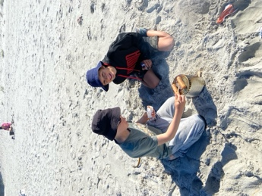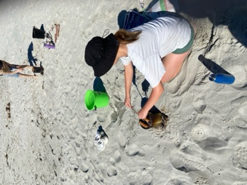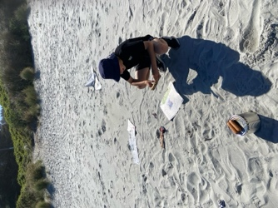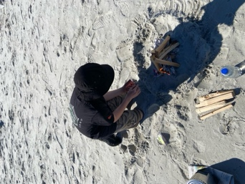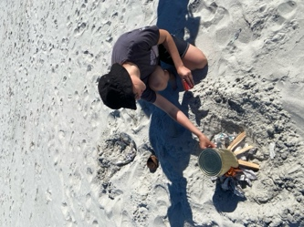
Brighton Rugby Club
The Brighton Rugby Club is having its registration day for the upcoming 2025 Junior Season on Saturday March 29th, from 10:00am to noon, at the clubrooms at The Domain.
This is for both new and returning players, and kit will be handed out at this time as well.
If you have any questions, email them at info@brightonrugby.co.nz or ask via their Facebook page.
Go Seagulls!

A reminder that school is closed on Monday for Otago Anniversary Day.
Enjoy the long weekend

David Grant
Principal

