21st June 2024
Good afternoon, I write this newsletter from my office desk, not Fiji, Canada or anywhere else. If anyone has been reading the paper or listening to ZB (in the morning or afternoon) you will know what I mean. I already work in the best place.
Welcome
It is my privilege to offer a big Big Rock welcome to Willow Parker, who joins her sister Myah, and I would also like to offer a big Big Rock welcome to Fletcher Cockburn and his family. It is great to have you all join us.
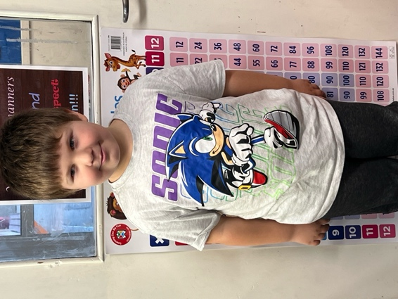
Sports-Round Up
Congratulations to Seth Elliot’ Tressler on earning Player of the Day for the Big Rock Hoopsters in their 36-4 victory over Dunedin North Intermediate. Great stuff Seth.
Bravo to Lilly Hamilton on earning Player of the Day in the Big Rock Hurricanes 15-0 netball win on Tuesday night. Awesome stuff Lilly.
Well done Cecil Williams on earning Player of the Day for the Big Rock Coasters in their 46-14 victory.
Also well done to Leon Skerratt on earning Player of the Day for the Shooters.
Earlier this week, schools received a memo from Basketball Otago reminding us about courtside behaviour, particularly towards opposition players and referees. Really sad that it is necessary to do that. However I am delighted with attitude and support Big Rock parents provide from the sideline, keep it up, you rock.
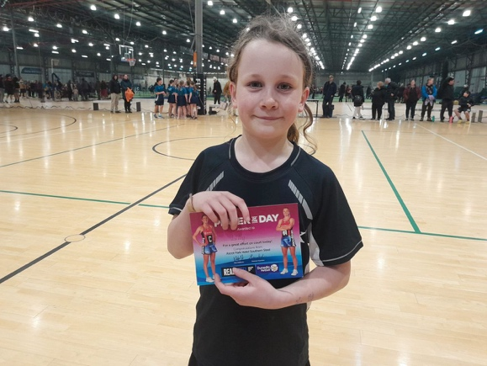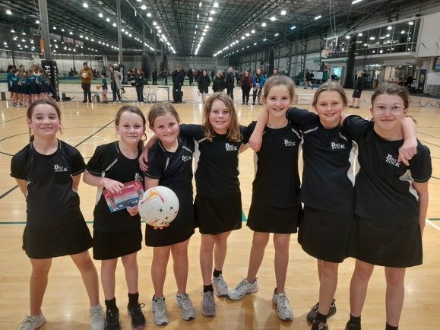
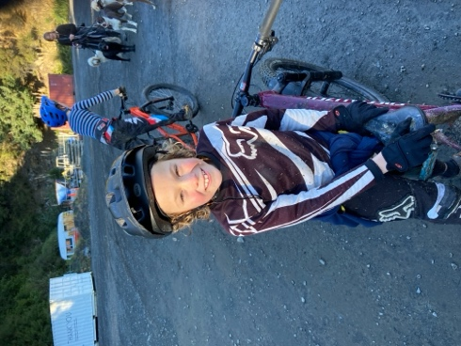
I would also like to offer a big congratulations to Adelaide Conway on earning Player of the Day for her Fairfield Gold team. Top effort Adelaide.
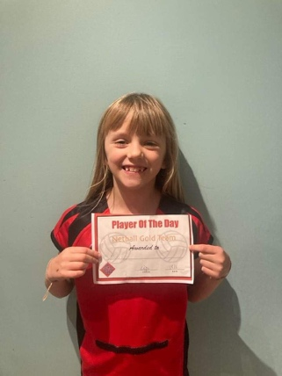
Emergency Drills
As a school we are duty bound and legislatively required to carry out a range of drills. These being Tsunami, Fire, Earthquake and ‘Lockdown’. The first three are self-explanatory but Lockdown is a bit tricky. This is when the school (Incredibly unlikely, but it has happened at other schools) ‘locks down’ due to a dangerous situation, such as a dangerous person on the premises or within the vicinity of the school. Police would always be involved. Regrettably the drill for this can cause upset for children, particularly younger ones. In the past we have used stray dogs as a reason, and have discussed using fictional scenarios such as Cookie Monster, dragons etc. If anyone has any thoughts, please let us know.
While keeping your children safe and prepared is a priority, equally we don’t want to scare anyone. Next time we are planning on a ‘Lockdown’ drill we will try and advise parents in advance.

Big Rock Primary School
Proudly Presents
2024 Matariki Celebration, Shared Meal and Aotearoa New Zealand History
When: Wednesday 26th June with a 6:00pm start
Where: Brighton Hall
Purpose/Kaupapa: A chance to celebrate Matariki, celebrate Mana Whenua, celebrate the tamariki’s hard work on Aotearoa New Zealand History, celebrate the broad range of nationalities and cutures within our school community and a chance to share food. A chance to celebrate what makes this community and its people so special. A chance top celebrate!
How: With the sharing of food, with the flying of flags, with the chatter of conversation and the cacophony of laughter. All the while enjoying children’s work and learning.
On the evening, the school will be providing two whole lambs cooked on a spit, a barbeque cooking whitebait patties, a sausage sizzle and a vegetarian curry (potentially vegan)
We ask that families bring a plate of food to share (Enough for 4-5 people). Ideally the plate of food could have a cultural significance, unique or special to a particular country. (I.e Pavlova = New Zealand) or equally, a plate of food that is special to your whanau or family, maybe for birthdays etc. Or just a family favourite.
Apart from the plate of food there is no cost to families, for what is always a great meal and a great time for young and old. (Although it can be a bit noisy, in a good way).
We would recommend that everyone brings their own plates and cutlery.
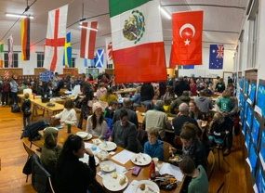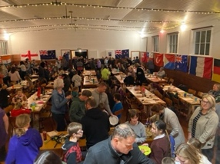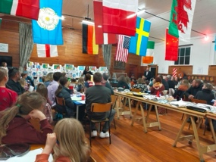
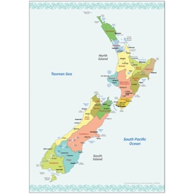

CAN ANY FAMILY WHO IS UNABLE TO ATTEND PLEASE EMAIL KELLY AT office@bigrock.school.nz (It’ll help with our planning)
For Sale
If you require quality meadow hay. Kim Rapley has small bales for sale. Pick up is a must. Please contact Kim on 027 432 5857. $8 a bale.
Mountain Biking Today
I had the pleasure today of tagging along with the Advanced Group and one the TnT Groups to Signal Hill, where for today they became ‘One Group’.
As usual the riders came home tired, muddy and happy. Many thanks to Scott and Ange as usual. Also a big thank you to Craig Scott, Max Skerratt, Sarah Ramsay and Shane Turner for help on the bikes, transport and encouraging these young riders.
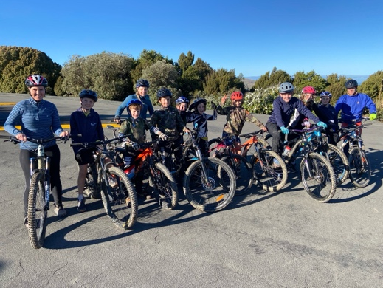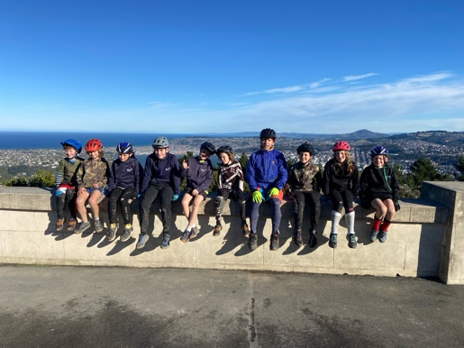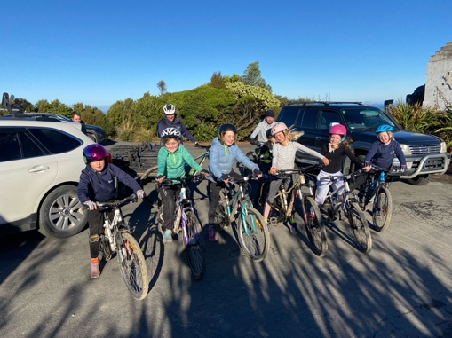

Have a great weekend
David Grant
Principal

