21st July 2023
Welcome
On behalf of everyone, I would like to welcome Mieka Coory to Big Rock, it is great to have you and your family join us. Mieka joins her cousin Quinn Hollands at Big Rock.
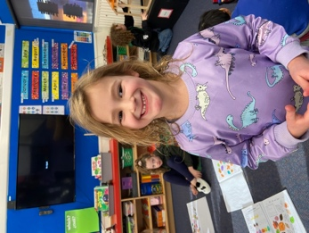
Congratulations and Sport-Round-Up
Firstly we need to congratulate Kiptyn Garner. During the holidays Kiptyn and his football team, the Mosgiel Blue Devils, (a team selected from the Mosgiel Football Club) competed in the Christchurch International tournament, with teams from all over New Zealand and the odd one from overseas. After 6 games in 3 days, Kiptyn and his Blue Devils won the Christchurch International Plate Trophy, a remarkable achievement. Any team that can travel to Christchurch for sport and come home with a trophy has done amazingly. Top work Kiptyn.
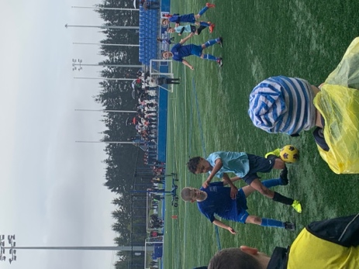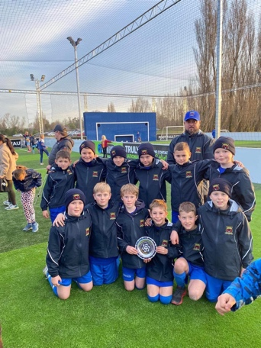
Basketball
Wow, you wouldn’t have thought there had been a break such were the performances of the Hoopsters and the Coasters.
Firstly, on Monday the Hoopsters had a hard-fought victory over Dunedin North Intermediate. What made it more remarkable is that they played with no substitutes, as they were missing two key players and some serious height and speed. A remarkable effort. Congratulations to George Weatherall for leading the way in attack and defence and earning MVP. Top work all round. 20-16
Last night the Coasters, who due to injuries were also not at full strength, came away victorious against Green Island School. Bravo to Dusty Andrews on earning MVP, outstanding Dusty. 24-18.
Congratulations to Jed Grey who earned MVP for the Big Rock Shooters. Jed’s first game after missing the first half with a broken arm. Great to see you into it Jed.
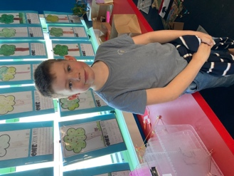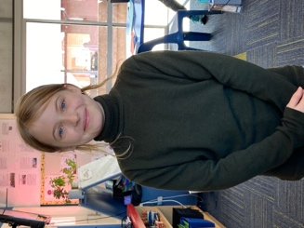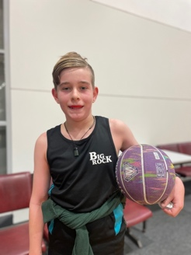
Netball
Well done to Lily Scott on earning Player of the Day for the Big rock Dolphins, well done Lily.
Congratulations to the Big Rock Rockets, a team that represents everything that is positive about being a team, all happily play in any position, then they get out there and play top netball with a smile. To top it all off, they are also successful. Great work from Taylor Matthews in earning Player of the Day in the Rockets 10-1 victory.
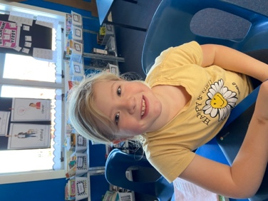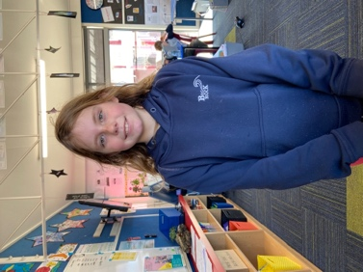
Topic Based Learning
As you are possibly aware, our major topic for this term revolves around Living World and are looking at a number of different components of this. These may include:
- Planting and Growing
- Local Flora and Fauna
- Ecosystems
- Challenges to the environment (Pollution, rubbish etc)
- Climate Change
- Tracking and Trapping
Where possible we want to utilise our local environment, including the beach and Otokia Wetllands.
At the end of last term, I mentioned that we were planning on going to the Orokonui Sanctuary but that bus prices looked a bit prohibitive. I am delighted to advise that a solution was found, and we are now all go. Hopefully, permission slips have arrived home safely for Rooms 1-4.

Parent interviews
A reminder that Parent Interviews are on Monday and Tuesday next week. As such school will close at 2:30 to provide teachers with a chance to prepare and have a wee break before they start. Children who are not picked up at 2:30 will be actively supervised in the playground.
Thank You
A massive thank you to Colin Driver and Anthony Miller of Custom Panels for sorting at a rust problem with the van. Greatly appreciated men. If you need panel beating work done, I strongly suggest you see Anthony and his team and Custom Panels. They’ll help you out, locals too.
School Community Survey
Thank you to everyone who was able to complete the School Community Survey. Below you will find a compilation completed by the Board of Trustees. You will note that some of the suggestions we have taken on Board and some had already been planned. (Painting of classes in more vibrant colours, teaching about the world around us. Swimming Pool upgrades are planned and we are currently seeking quotes)
Have a great weekend

David Grant
Principal

Response to community on Survey.
First and foremost, the BOT would like to thank those parents that responded to the recent BRS Survey. These surveys are invaluable, and they provide good discussion and platforms for change/improvements.
The following report provides an overview of the responses with commentary from the BOT regarding actions either taken or tabled for future discussion.
Q1. How engaged do you feel you are with the school? Nearly 80% of respondents scored 6 or higher which is an outstanding result. If you want to know how you can be more engaged with the school, talk to David or a member of the BOT.
Q2. Do you feel you have a good understanding of the activities your young person does at School? 70% of respondents indicated a score of 6 or greater which we think is a great result. If you want to know more about what your young person does at school, talk to their teacher or David.
Q3. Other ideas/opportunities for Education outside of the Classroom. EOTC. Lots of great suggestions were made. We cannot list them all but here are a few. Music, River and Marsh, beach, and nature walks to discuss local species, ecosystems, geography, geology, history, environmental concerns. Involvement with Otokia Trust, Agriculture, farming, public library visits, albatross and Penguin Colonies, Marae Visit, Chinese Garden, Otago Polyfest, surf lifesaving club, Brighton Garden Club, Otago Settlers Museum, Araiteuru Marae, Brighton Boat Shed, Community Garden, explore coastal and creek areas. Understanding history of the area. One person noted the importance of highlighting/publicising other areas of the curriculum, i.e. literacy and core subjects, particularly in the year 7 and 8 before they venture out into the big wide world of High School. We at the board agree this is super important and we plan to discuss this in future meetings. Watch this space. On the subject of our intermediates, we will be announcing the year 7 and 8 information evening soon which is a great opportunity to get along and find out what happens in those important pre high school years.
Q4. Communicating preferences. Overwhelming preference for Email and School Loop with 84%.
Q5. School ground and infrastructure. Do you have any suggestions and recommendations to lift the school’s physical presence? Again, lots of ideas, some possible, some not and some are already underway. Here are the top 20 or so. I have put them into a table to show what has either been completed, due to be completed this year, and/or part of our upgrade plan for 23/24. Other ideas will be tabled in future BOT meetings.
Completed since survey | Due to be completed this year | Tabled for future discussion
bold colours on the school buildings | Facelift for pool and toilet area | Pump track
produce/fruit trees | More covered areas for kids | More plants and trees
Paint refresh. Paint buildings | area for assemblies onsite | vegetable garden
 | More shade or shade sails | Sports facilities such as a line on the pool wall to practise hitting tennis balls
 | clean the pool | more basket/netball hoops
 | pool needs cleaned | Swings
 | tidy up the pool | undercover area for parents when waiting to pick up kids on wet days
 | pool and fence | New fence
 | Pool needs attention | more storage area for kids to store their bags
 | fruit trees | larger changing areas
 |  | gardens need tidying up
 |  | fence along the front
 |  | flying fox
 |  | more trees or shrubs around the perimeter
 |  | remove free milk sign as not a thing anymore
 |  | Grow natives and veges
 |  | new front fence
 |  | plant shelter fence around school
 |  | plant native trees to encourage wildlife
 |  | school garden

Q6. Extra Curriculum Opportunities (ECO). I think it is important to note that it is not the teacher’s role to organise or facilitate activities after school. While the School/BOT is very supportive of ECO, it will require some organisation and input from parents to coordinate and manage. We received lots of great suggestions, and we are keen to help where possible to offer these to the children of BRS. There were four main requests. These include Swimming lessons, Singing, Music, Dance. Other suggestions included Athletics, Maths camp, Art, Kapa Haka, Language, Surfing Lessons. If you or anyone you know is interested in teaching any of the above skills to our children, please get in touch with David or one of the BOT to discuss.
Q9. Big Rock Primary School Parents. Do you have any skills or attributes that you are willing to offer?
Several respondents said they were happy to help with fundraising, organising events and other areas but did not leave their name. If you are still interested, we would love to hear from you. Please let David or Kelly know. Thank you.
Overall, we felt the survey was extremely positive and reinforced the great work the School/Teachers/BOT is doing. It isn’t easy running a school in today’s environment with pressures coming from every direction but at BRS, we think we are doing a pretty good job. We may not get it right all the time, but we get it right most of the time.
Feel free to contact any Board member orDavid Grant (Principal of BRPS) to discuss any parts of the survey. We plan to run the survey bi-annually to ensure we continue to provide your kids with the best possible education and opportunities.
Kind regards,
Big Rock Primary Board of Trustees

