21st February 2025
Congratulations
I would like to congratulate and acknowledge two former Big Rock stars, who this week were made House Leader and an Associate Prefect at Queen’s High School. Well done to Isobel Grey and Tessa Gabbott. You were unreal with us, and I am not in the least surprised that you continue to be stars at Queens. Brilliant stuff both of you.
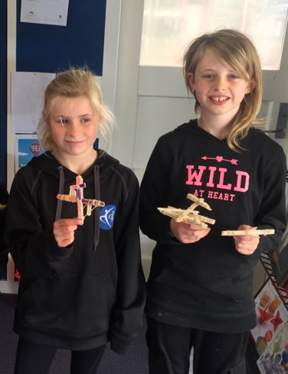
Sorry, I don’t have an up to date photo of Tessa.
Congratulations
Congratulations to the following players on earning Player of the Day for their respective futsal teams:
Big Rock Dolphins – Unnamed
Big Rock Barracuda -Quinn Hollands
Big Rock Stingray – Max Ashton
Big Rock Sharks – Leo Garth
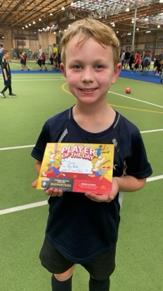
Thank you to Jo Henderson, Tania Blanchard, Lauren Mooyman and Alex Ramsay for kindly volunteering to coach this term. The Big Rock Dolphins still require a coach. If you can help, please contact me asap. Thanks.
Taieri Mouth Adventure
Earlier this week information and permission slips went home regarding our upcoming Taieri Mouth Adventure. Please keep these coming in. We especially need to know what parents can help on the day. Can you also let us know if you are able to tow a trailer of kayaks for us please. It is always a great day.


Pet Day Extravaganza
Our annual Pet Day Extravaganza is fast approaching as well. This has become a much loved school event for young and old. The bouncy castle is booked, the prizes are on there way. It promises to be another great day.
This year there will be the usual range of games including Corn Hole, Fruit Salad, Hole in One Golf, Croquet Bowling, Treasure Island, Darts and a couple of new ones. There will also be a sausage sizzle, popcorn and lots of prizes. Let’s not forget the family based baking competition.
More information will come home next week.
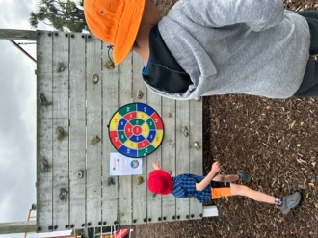

From the archives
School Attendance
Last Thursday I met with representatives from the Ministry of Education. It is an annual catch-up type meeting. Neither here nor there to be perfectly honest. They were given a guided tour of the school and were impressed by how settled and purposeful all of the classes were. They asked if we had ever been part of a Ministry programme called PB4L. (Positive Behaviour for Learning). I rather too proudly replied, no, we have never even nearly needed to. The children’s behaviours and attitude and the teacher’s programmes and skill has ensured that it was not required.
One thing that did come up was the Ministry’s drive to lift New Zealand’s attendance levels across all schools. Ours is very good, well done parents and children. I do however have to share with you the new Ministry Guidelines – Stepped Attendance Response (STAR). Belo w is the Ministry information.
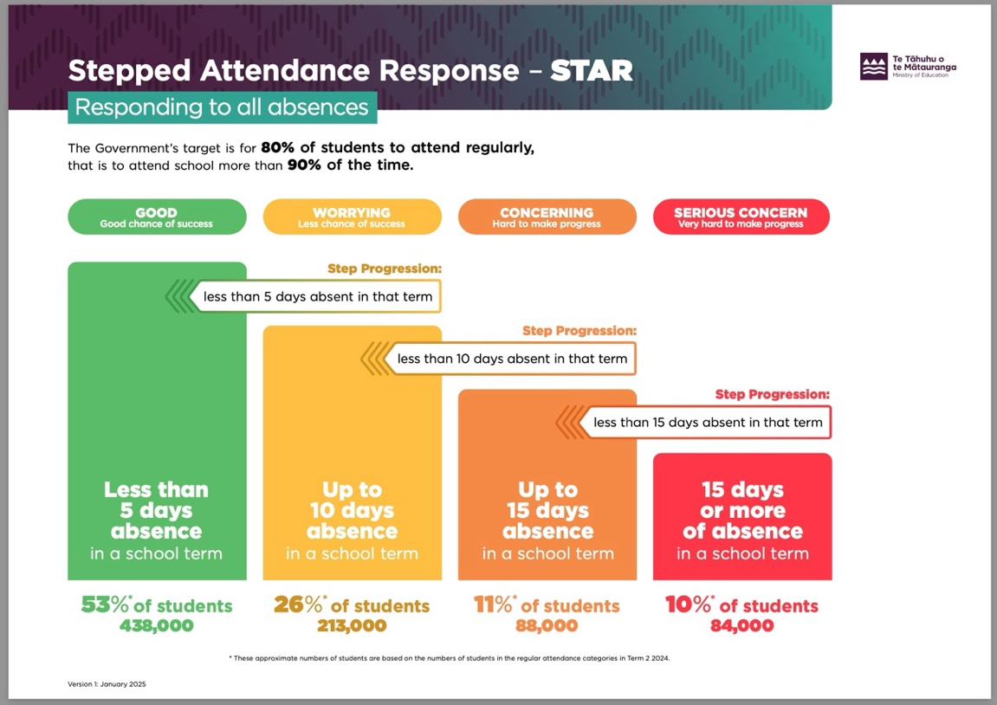
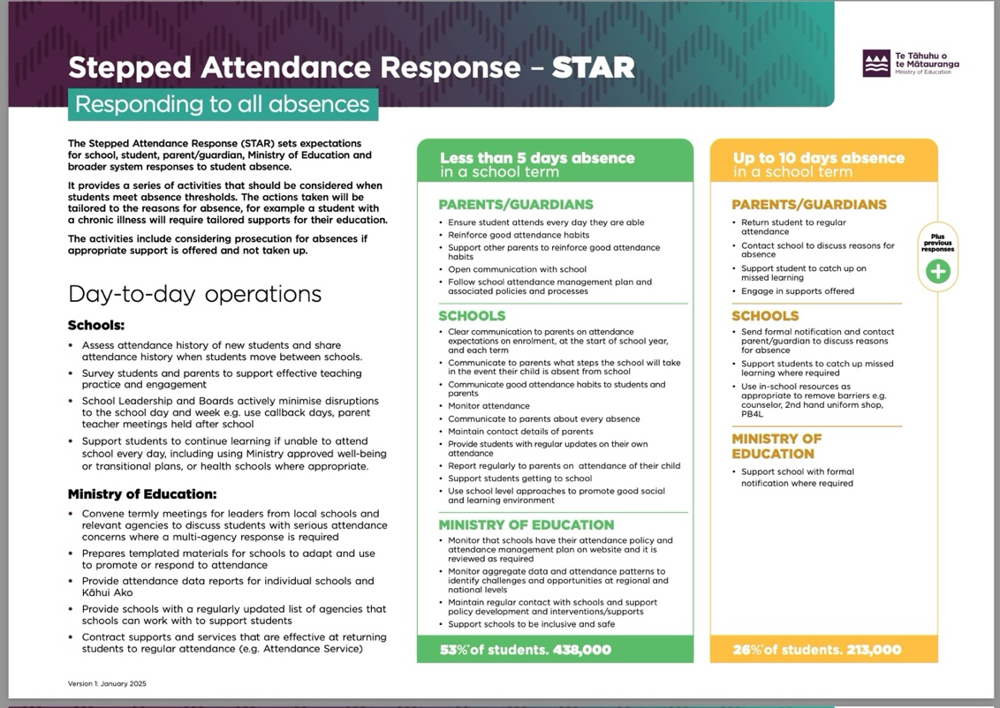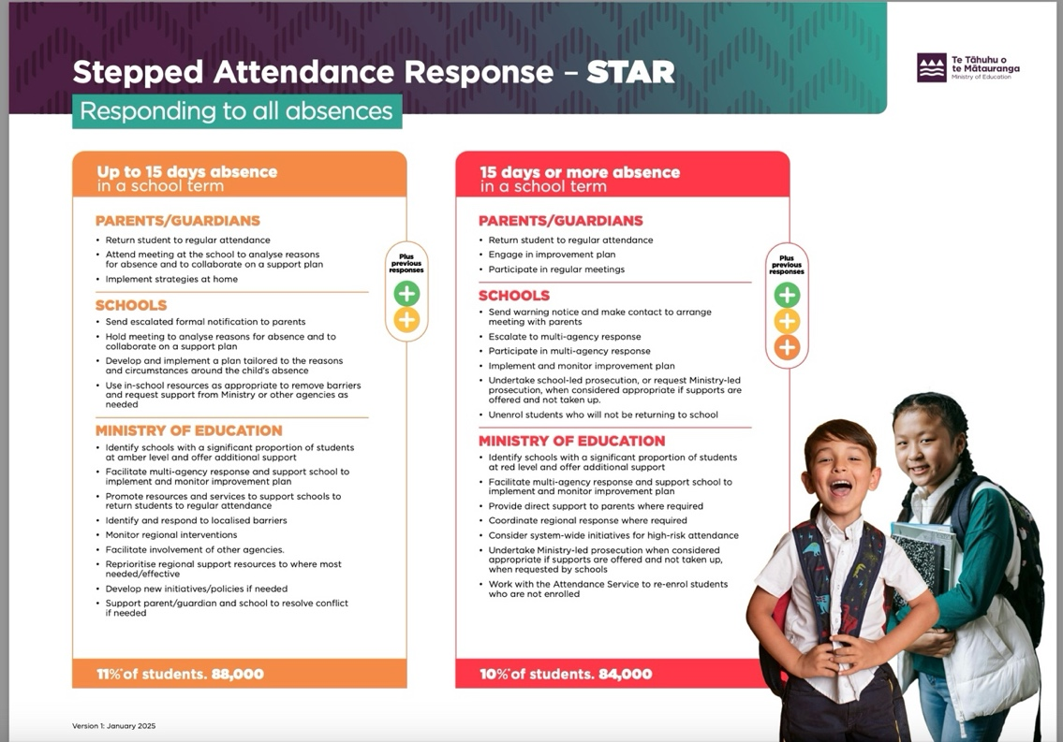
Have a great weekend

David Grant
Principal

