20th September
Whakamihi atu/ Congratulations
A massive congratulations to Kiptyn Garner on earning Player of the Year for his Mosgiel football team, the Mosgiel Dynamite. Bravo young man, you are certainly a talented young man. Sometimes it is difficult to get the recognition you deserve in the position you play, so that make the honour even more telling. Classy.
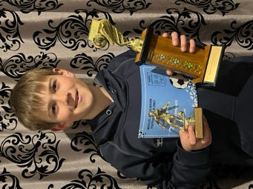
Last Sunday the Dunedin Marathon was held, as well as a range of distances for different experience levels, from 5km to the full gut busting marathon.
Firstly, well done to Malachi Turner on blasting through the 5km, also Emma Egan on doing the same. An outstanding effort.
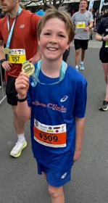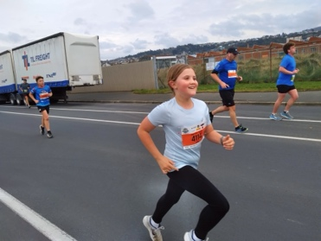
I would also like to acknowledge and congratulate our Board Chair, Scott Weatherall on completing the marathon, all 42km of it. Sterling stuff Scott.
Also, bravo to Kara Walters on running the 10km event, top work.
Marautanga hou o te reo pakeha me te pangarau/ New English and Mathematics Curriculum
You may have noticed in the news and on social media, a lot of talk about the new English and Mathematics curriculum that must be implemented at the start of 2025. I thought it prudent to advise you of what is happening at your school and what it will look like. Firstly English, the key change here is the introduction of Structured Literacy to all New Zealand schools. Structured Literacy is based on the science of learning and is a lot more than ‘phonics’. I am rather proud of the fact that we have been using Structured Literacy here at Big Rock since 2021. I never thought a lot about it because I was under the impression that most if not all schools were using it. In recent weeks, all staff have had refresher courses with professional development providers or been at the Ministry with me and have found that a great many schools are not using it. The reason I think you need to know is that when you hear that schools won’t be ready for the new curriculum, you can have confidence that your school is very ready.
This is also true for the new Mathematics curriculum, which is also based on the science of learning. There will be some subtle changes here, but that will be more linked to the new Ministry provided resources that are directly linked to the new curriculum. The reality is your school is ready and the timeline for us to implement is fine. Your child’s education will not be harmed only enhanced. We are working on it collectively as a staff during the upcoming holidays.
Also, due to the way we have designed our school curriculum, all the cool things we do, can and will still happen.
Whakamihi atu/ More Congratulations
Earlier in the week I had an email congratulating the school on our high attendance rates. That is a massive well done to everyone involved with your school, the children, the staff, and all our parents and whanau for ensuring your children come to school. As we know attendance in New Zealand schools is in crisis, it makes me very proud, and it should make you proud as well, to know that again, you are bucking a trend in a positive way. Yay you!
Nga Kaieke Po Naseby/Naseby Night Riders
In the middle of the week, thirteen intrepid Year 7-8 students headed off to Naseby as part of their mountain bike programme. What an adventure it was, riding the many tracks in the area is cool, riding them through the snow is even cooler (excuse the pun). Then to cap it off doing it at night, to become the Night Riders. It was a stunning couple of days, way beyond expectation. Well done to all the riders, thank you to Mr Murray, Scott, Ange, Rachael and Shane. Also extra thanks to Scott, Geoff Balme and Tony and Shelly Martin for helping us out with their holiday homes.
EOTC is so important, even vital, in supporting children’s mental health and self-esteem. As we know, Year Seven and Eight can be a challenging time for children as they go through adolescence. Having real and meaningful EOTC events is proven to provide great support to their mental-health and well-being, which is why I am so proud that our programmes are aimed at helping and supporting children in many ways that are proven, meaningful and fun. Of course, it helps having great children, enthusiastic helpers and capable staff.
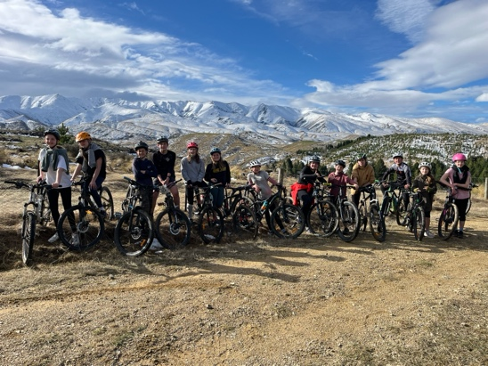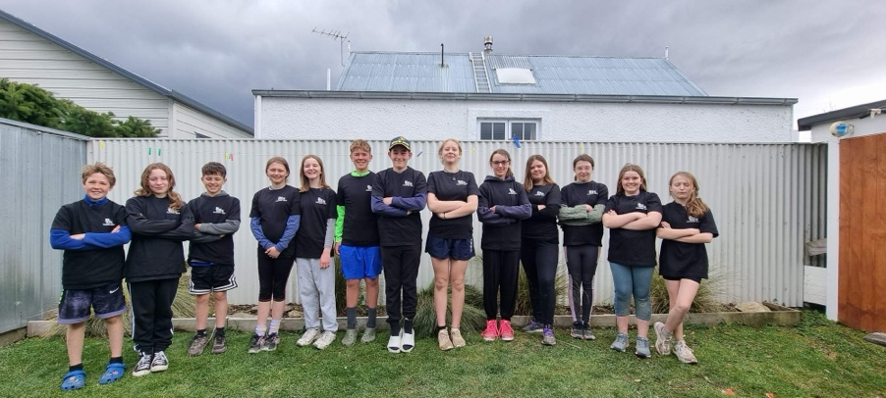
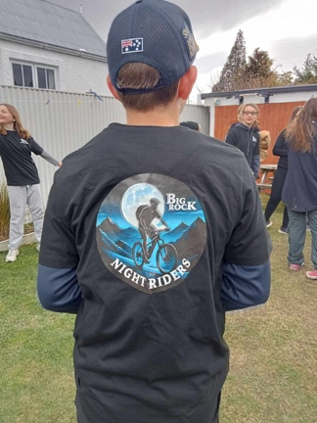
Mahi Toi /Art Extravaganza
Less than a week to go, and from what I have seen already, I know you will be impressed. It is an Art Extravaganza celebrating children’s art and research, and it would be easy to think ‘Oh yeah, a few children’s paintings with lollipop trees, cotton wool clouds and a sun in the corner’ but it is so much more than that. There will be a celebration of different artists, works by the children (not with lollipop trees), an interactive display, artists in action, academic research on different artists, digital performances to name but some of the talent on show.
The hall doors will open at 4:00pm and remain open until 6:30pm (ish). On arrival parents will be offered a glass of wine or orange juice as well as cheese and crackers. We would ask that the cheese and crackers (as well as the wine) are for adults only. The hall will again be open on Thursday from 10:00am until 1:00 (without the wine and cheese).
There is no cost to attend except your enthusiasm and admiration.
He Whakanui I Te Reo Māori
Some of the te reo we use every day at our kura, have a go yourself and celebrate calling this country home.
Kaupapa | Purpose | Kia ora | Hello/greetings
Kai | Food | Tena Koutou | Hello/Greetings to many
Whakarongo mai | Listen | Tamariki | Children
Ka pai | Well done | Mahi | Work
Tino pai | Very well done | E tu/E noho | Stand/Sit
Rāhina | Monday | Whanau | Family
Rātu | Tuesday | Rāmere | Friday
Rāapa | Wednesday | Wharepaku | Bathroom
Rāpere | Thursday | Kura | school

Kia pai te mutunga wiki
David Grant
Tumuaki

