June 21st 2025
Congratulations
Only two teams played this week, the Big Rock Dolphins and the Big Rock Hoopsters. Firstly, a massive congratulations to Lily Scott on earning Player of the Day for the Big Rock Dolphins. Well done.
Secondly, the Big Rock Hoopsters were a bit short staffed in their game, having no subs. The whole team gave it their all in a very ‘challenging’ game against Bathgate Park, before winning well 40-16. Mr Murray decided the whole team deserved Player of the Day and he was 100% correct.
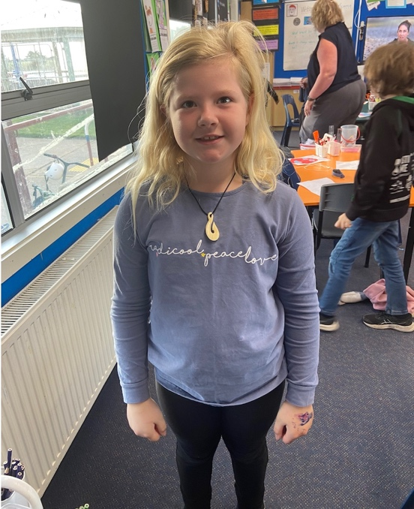
Last week I gave a shout out to Elise Blanchard on earning back to back Player of the day awards for basketball and netball. Yesterday she completed the trifecta by scoring two goals and earning Player fo the Day for her football team. Incredible Elise.
This week’s Sports Draw
Monday Basketball
Big Rock Hoopsters v Liberton on court 7 at 5:15
Tuesday Netball
Big Rock Dolphins v Wakari Mystics on court 7 at 5:00
Thursday Basketball
Big Rock Shooters v TBC
Big Rock Coasters v TBC

Equestrian Achievement
Well done to both Stella and Lexie Brown on their achievements at the recent Brighton Pony Club prizegiving. Stella coming away with the resilience trophy, attendance trophy and games trophy
Lexie winning the turnout trophy, junior dressage trophy and pre d dressage trophy.
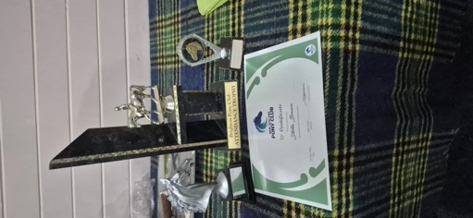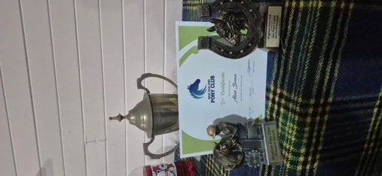
Big Rock Matariki Celebration
This is a very big and important week in the school calendar and one that the staff and children look forward to every year. On Wednesday we aim to start at 6:00pm sharp. This year we will begin with a karakia/blessing followed by 2-3 songs by the school band, one of which the children will join in with. Then everyone will be able to eat. On the night there will be a Aotearoa New Zealand Geography quiz for those who want to take part. There will be prizes up for grabs. The questions will be placing Aotearoa New Zealand places on the map as well as some places of cultural and historical significance. It is aimed at being fun and achievable.
All we ask of our whanau is that you bring a plate of food to share (enough for 4 people). This can be something that has cultural significance, a family favourite or maybe something that your family enjoys on special occasions.
The school will be providing:
- A lamb on a spit
- Whitebait sandwiches
- Sausage sizzle
- A vegan curry (Professionally made)
- Water and raro
Some of the children’s work will also be on display, with easy access for everyone to enjoy.
We would also recommend that people bring their own plates, cups and cutlery. There will be some paper plates and cups, as well as wooden cutlery. I reckon the significance of the night means a better standard of crockery and cutlery.
We look forward to seeing as may of our families and whanau there as possible.

School Reports
This term has been ludicrously short. 9 weeks with 2 long weekends included. Which may seem great, but for teachers it is a bit of a pain, trying to get everything done. (As well as major email issues)
School reports will be emailed out in the first week of the new term, with follow up interviews scheduled for week two of the term. Bookings through Skool Loop will go live in week one of next term.
Term Three
As we are rapidly approaching the end of Term Two, I thought would give you some information regarding Term Three.
Firstly, I am delighted to advise that next will have a strong focus on the Arts and in particular the Performing Arts.
Next term we will be performing at the 2025 Otago Polyfest. This year we will be delivering Māori performances and Pasifika performances, which is very exciting. I would like to thank in advance Litea Ikahihifo and Dennis Kahui for their much valued input and skill.
We are also presenting a musical production. This year we are presenting Alice the Musical. A musical production based on the beloved children’s story Alice in Wonderland by Lewis Carol.
More information will follow.
Exciting times ahead.
Thank you
David Grant
Principal

