1st November 2024
Big Rock’s Got Talent
It is just under three weeks to the inaugural Big Rock’s Got Talent event. This is being held at the Brighton Hall on Thursday 21st November. Is your child a singer, a dancer, a musician, a juggler, a magician or a mime? If so, get them on the programme to share and celebrate their talent and to wow the crowd.

Room Four Camp
This week was the Room Four camp. This year it was at the upgraded Waihola Camp and was adventure based. The children took part in a broad range of activities and experiences that both challenged and empowered them, andcelebrated their willingness. Some of the activities that took place were Bubble Ball, a zipline through the forest, air rifles, Archery Tag (every bit as cool as it sounds), Assault Course (with added mud), Initiative Course, Gaga ball, and a massive (and challenging) water slide. Everyone gave everything their best shot, and that is all you can ever ask for. Well done to them all. Thank you to Dallas Hamilton, Graeme Egan, Tania Blanchard, Cavan Jenkinson, Kimberley Ashton, Neil Brownlie, Rowan Newman Julie Tutgun, without your encouragement and support the camp would have been a lesser event. A massive thank you to Mrs Van and Miss van Aalst, without your planning, preparation and organisation and expertise, it wouldn’t have happened. I know how much time and effort goes in- Thank you.
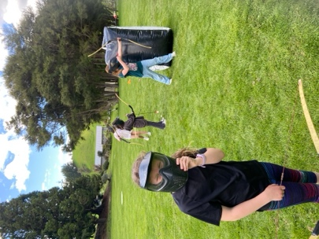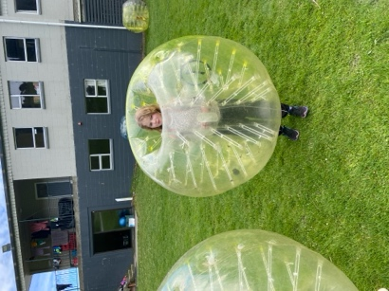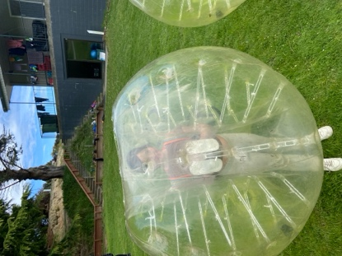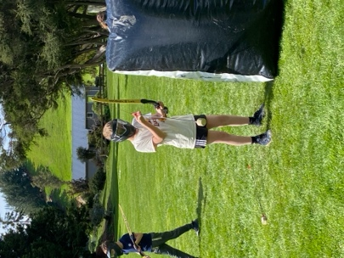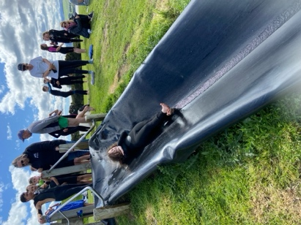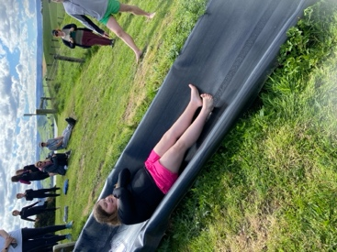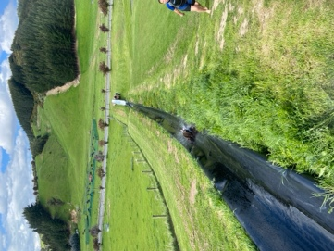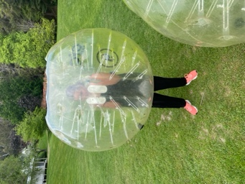
Greater Green Island Athletics
This year we sent a small contingent to the Greater Green Island Athletics, mainly due to the Year 5-6’s being on camp but also illness. The team of George Weatherall, Kade Hancock, Scarlett Hancock, Bella Yeoman, Jasmine Rose McFarlane-Pearson, Malaika Patton, Ruben van Tonder and Addison Johnston. The results are not through yet but I have it on good authority that there were many quality performances that have resulted in qualification for the Otago Championships. All in all, a pretty remarkable effort considering the lack of preparation due to weather and camp. Well done team, you did yourselves proud.
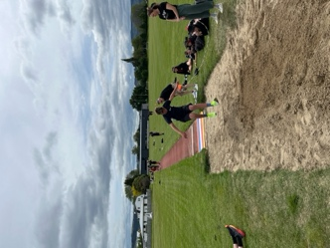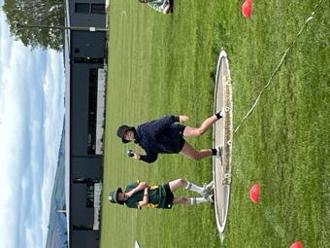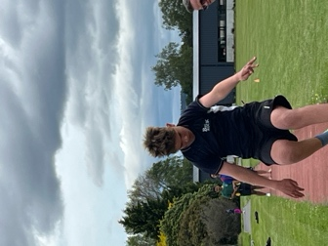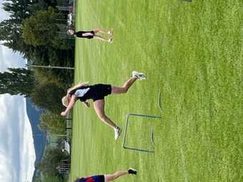

Futsal
Congratulations to the following players on earning Player of the Day for their respective futsal teams.
Big Rock Dolphins – Evie Hollands
Big Rock Stingray – Ivar Elliot’Tressler
Big Rock Barracuda – Fin Ramsay (W)
Big Rock Sharks – Cameron Walters (7-1)
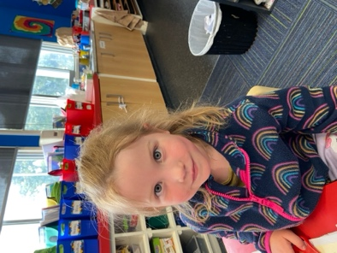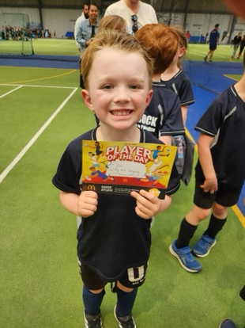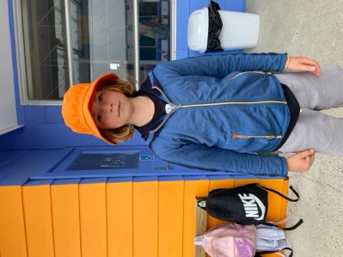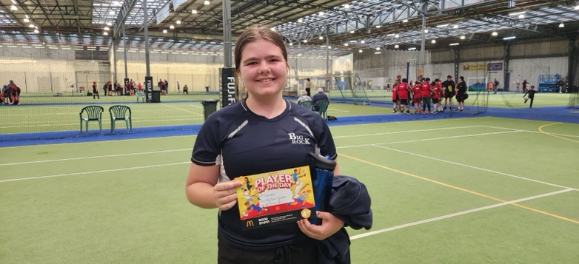
School Trophies
Can all school trophies please be returned to school asap. Thank you.


School Photos
A reminder that school photos are being held next week on Wednesday 6th November.
Dunedin Symphony Orchestra
On Tuesday the Dunedin Symphony Orchestra will be performing live here at school. If you are interested, please feel free to come along.
Brighton Gala Day
The Brighton Gala may seem like a long way off, but in school terms it is not far away at all. As you may know, traditionally we sell whitebait sandwiches, and they always go extremely well. We will be calling out for helpers nearer the time.
However, this time we are planning on adding to our ‘wild food’ theme by adding venison burgers to the menu. As such we are on the look for a total amount of approximately 6-7 kilos of venison mince for the burger patties. Please let us know if you can help with some venison mince. While we would love for it to be donated, we understand and respect that there may be some costs involved. Many thanks in advance to all the hunters out there.

School Pool
The school pool will open next Wednesday. Teacher’s will let everyone know their days and sessions. The pool will be open at lunchtimes. This will be mainly for Room 3 up. This is for safety reasons, and because of how long it takes some to get dressed afterwards. Sorry to be a grinch, but children who take too long to get changed afterwards for lunchtime sessions will need to either speed up or only go to class sessions. Not quite the Dunedin airport hug rule but in the same family. Slow dressers take too long getting back to class.
Pool keys will become available to school families on Wednesday 13th November. The price this year is slightly less than last year. It is $65 plus a $15 returnable key deposit. School accounts do need to be up to date to purchase pool keys.
Thanks.
School Barbeque
On Wednesday we will be reigniting the school bbq(s) at lunchtimes. If you want your child to have something cooked on the bbq for lunch, all you need to do is send it along, clearly named. If there are any special or particular cooking instructions, please include them. We will ensure that any dietary, cultural or any other requirements are followed, but please advise us in advance. Can we also ask that you only send enough for your own child, as it gets a bit untidy and confusing otherwise. Thanks. If you are unsure, just give us a quick call.
Secretly, I have it on good authority that our Year 7-8s are working hard on getting their one day café up and running. They are working on the menu at the moment, trying to ensure there is a good variety, food that children want to eat and that dietary and cultural requirements are met. This is tied into their maths programme and their ‘class economy’.
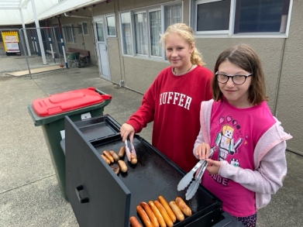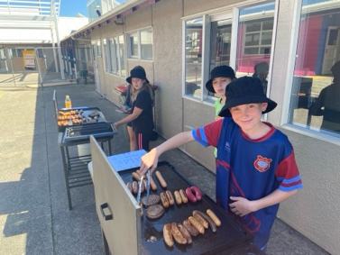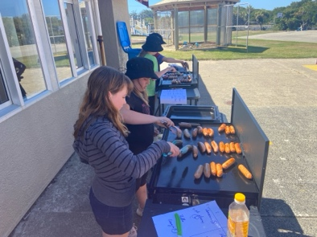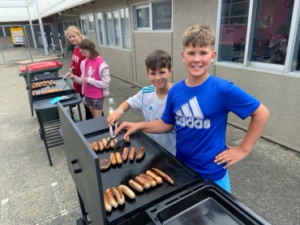
Have a great and hopefully dry weekend
David Grant
Principal

