1st March 2024
Taieri Mouth Adventure
Less than a week to go to the next big event on the Big Rock calendar. Just a few wee reminders for parents and whanau, children and parents attending will need:
- Lunch and a refillable drink bottle.
- A wetsuit (If they have one) or swimming gear or both.
- A life jacket (If they have one and clearly named)
- Jacket
- Shoes that can get wet and sandy (Optional)
Thank you to everyone who has kindly volunteered to help on the day, we will need you all. Please let us know if there has been a change of plan.
Also, thank you to everyone who has offered to let us use their kayak(s). If these could be dropped off at school on Wednesday morning, please let us know if there are any problems.
All children will be travelling by bus to and from Taieri Mouth.
There will be a sausage sizzle (Normal protocols will apply) and children will have a juicy at the end of the day.


Many thanks for the kind offer of jetskis, but these will not be required. Great news, a former Big Rock parent has very kindly offered their services as well as a speed boat. Full steam ahead….
There is no cost for this event.
Paid Union Meeting
In the coming weeks you may have friends or family who have children at other schools. They may mention that their school is closing for the day or part of the day on March 19th as teachers in Dunedin attend a Paid Union Meeting (PUM). The teaching staff at Big Rock have decided to stay at school and as such Big Rock will be open as usual on that day.
Futsal
Congratulations to the following players on earning Player of the Day for their respective teams this week. A special mention to the Big Rock Sharks who had a double header and managed to beat Green Island 12-1 and Dunedin North Intermediate 6-4 despite having only 5 players available.
Big Rock Dolphins – Alex Little
Big Rock Starfish – Dion Mooyman
Big Rock Stingrays- Charlie Hughes
Big Rock Barracuda – Courtney McNair
Big Rock Sharks- Game 1- Cameron Walters
Big Rock Sharks- Game 2- Malachi Turner
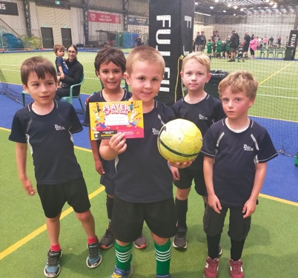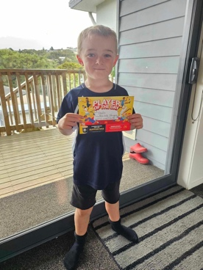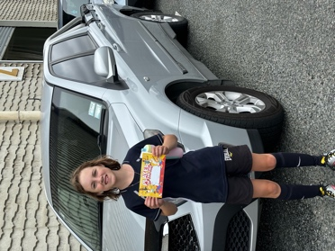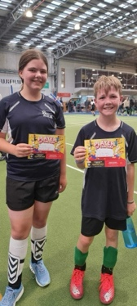
Winter Sport Terms Two and Three
While it is still a few months away, it is time to start thinking about school based winter sport. This year we are hoping to have teams playing basketball and netball. These are played in the afternoon/early evening at the Edgar Centre on weeknights. Days have not been confirmed yet. However, if your child is keen, we will be taking names as of Monday. Also, if you are able to help with coaching or managing a side, please let me know. Equally, if your child is keen on rugby or football, I would recommend the mighty Brighton Seagulls, Green Island Football Club or Mr Murray’s Dunedin City Royals.
On Sunday afternoons at the moment 4 of our senior lads are taking part in a 3x3 basketball competition and representing themselves with pride and determination. They are footing it in the same grade as teams from John McGlashan College, as well as Tahuna and Balmacewan Intermediates. Well done Hoopsters.
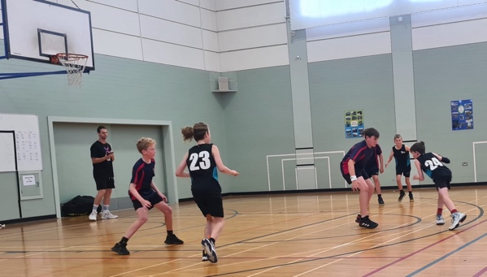
Ski Trip
Like winter sport, it might seem very early to put this out, but we are looking at another ski trip this winter, either to Ohau or Coronet Peak as overnighters with 2 days on the snow. So we can book early, we are taking expressions of interest as of Monday. Please let either myself or Kelly know if your child is keen. Children nine and under will need a parent with them or a designated adult i.e. A parent attending with another child, maybe the designated adult by prior arrangement.
Weet-Bix Tryathlon
Good luck to all of the young athletes taking part in this weekend’s Weetbix Tryathlon and all the aprents cheering them on. Good on you and go ‘Team Big Rock’! (Malachi Turner, Zach Turner, Bryn Little, Quinn Hollands, Isaac Lucking, Hinemoana Jimenez-Maxwell, Emma Egan and Will Judd. If I have missed anyone please let me know and I will adjust)
Have a great weekend
David Grant
Principal

