1st February 2024
Welcome
Welcome back and welcome to 2024. All of the staff are excited to be back and are raring to get stuck in. It was so great to see everyone back smiling, enthusiastic with back-to-school haircuts. I would also like to welcome all our new members of the Big Rock whanau and their families. It is fantastic to have you join us.
So, a big Big Rock welcome to Alice Cleaver, Teddy de la Mare, Arlie-Jae Te Waiti, Georgia Smeaton, Cecil Williams, Annabel Free, Myah Parker and Araia Te Waiti.
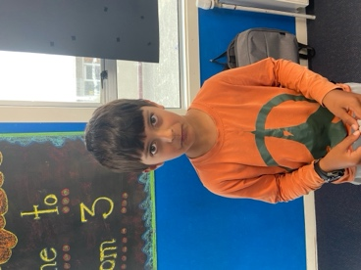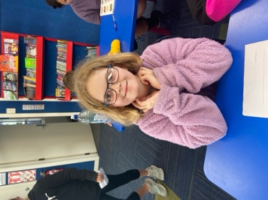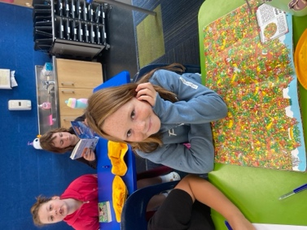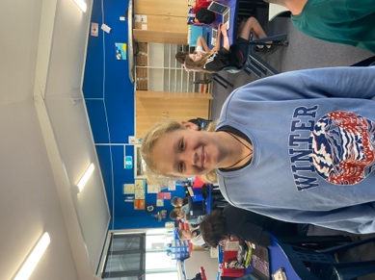
Back to School Information
Over the first few weeks a lot of information will be coming home about a range of different things. Some will come from classroom teachers, some from me, and some from the office. Equally, some will be electronic via email and Skool Loop and others will be paper, hard copy. Please keep an eye out.
Details and Information Update
If your contact details (Phone number, email or physical address) have changed can you please contact the office and let Kelly know. Thank you.
Also, if your child’s school account is to be split between parents, can you please advise the office of the situation with any relevant details. Thank you

Meet the Teacher Chats
On Monday 12th and Tuesday 13th February we are having ‘Meet the Teacher Chats’. This is an opportunity at the start of the year for parents to come and meet their child’s teacher, for the teacher to talk about the year ahead, classroom expectations, for parents to ask questions and share important information. If parents are unable to make it on either of these days, we urge you to make another time that works for everyone.
Also at these meetings we would like to hear your thoughts and ideas on possible Science curriculum content. Things that your child may like to learn about, is interested or that you think could be beneficial. While we can’t promise that everything will be covered that is requested, we will do our best. Please talk to your child about this and see what their thoughts are.
Bookings are now available on Skool Loop. If you have any problems booking, please contact the office.
Taieri Mouth Adventure
This year our Taieri Mouth Adventure is scheduled for Wednesday 6th March. Traditionally, the children get to experience kayaking, swimming, speed boat rides, sausage sizzle, bush walk amongst other things. Everything that we do on the day is age appropriate, with the first focus being on every child’s safety followed by their enjoyment.
On the day all children will need:
- Wetsuit (if they have one)
- Swimming gear and towel
- Lunch and refillable drink bottle
- Lifejacket (If they have one)
Parents are more than welcome to come along and be fully involved. We will need parents help in the water and on the shore. (More information will come home separately.)
We will travel by van and bus. There is no cost for the day.
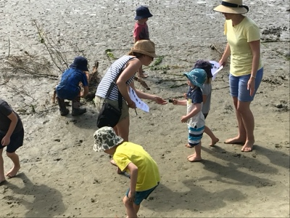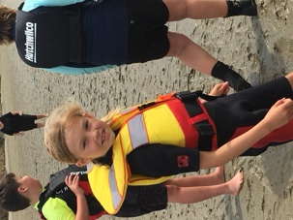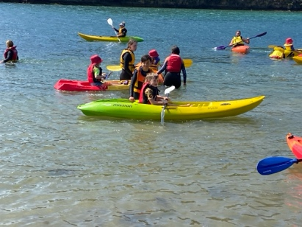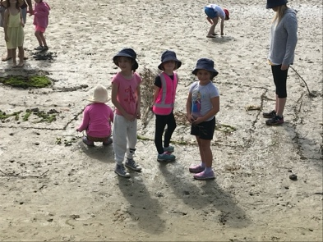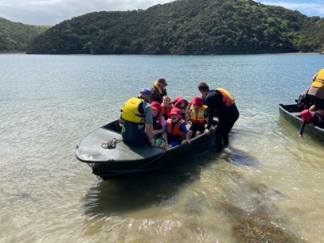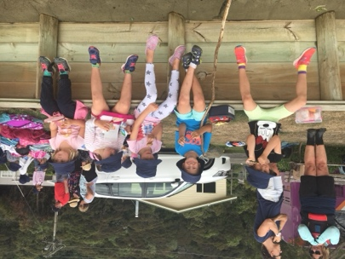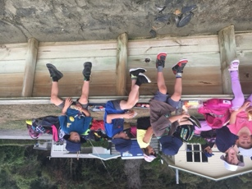
Futsal
A reminder that we need the names of all children keen to play futsal this term by tomorrow (Friday 2nd) lunchtime. After that I cannot guarantee places in a team. Years 1-4 play on a Tuesday and Years 5-8 on a Wednesday. All games are at the Edgar Centre, we will provide playing shirts. All players require black shorts (We have some) and long socks with shin pads.
We also need some help with coaches/managers for different teams. If you can help, please let me know asap. Many thanks.

Upcoming Events (These are confirmed, more events will be added when we have confirmed dates)
Tuesday 6th February Waitangi Day- School Closed
Monday 12th and Tuesday 13th February- Meet the Teacher Chats
Wednesday 21st February- Big Rock Pet Day Extravaganza
Tuesday 5th March- KVC Sports Expo (Room 5 Only)
Wednesday 6th March- Taieri Mouth Adventure (All classes- info to come)
Thursday 14th March Room 5 Goldfields Bike Trip
Wednesday 20th March Room 4 Goldfields Bike Trip
Monday 25th March Otago Anniversary Day School Closed
Tuesday 26th March Room 2 Bike Day (Info to come)
Wednesday 27th March Thursday 28th March, Wednesday 3rd April- Life Education Trust (Harold Bus!) All classes
Friday 29th March, Monday 1st April, Tuesday 2nd April. Easter Weekend. School Closed – returns Wednesday 3rd April.
Thursday April 4th and Friday April 5th – End of Season Pool Parties (All Classes)
Friday 12th April Term One finishes. School returns Monday 29th April.
Have a great weekend, it’s great to be back!
David Grant
Principal

