End of Year Prizegiving
It feels very strange to be writing about the school End of Year Prizegiving in just over a week. It seems it was only yesterday that I was excitedly writing about our Pet Day Extravaganza being in a couple of weeks, or about our Taieri Mouth Adventure and how two quality and generous people in Paddy Patterson and Brayden Mitchell were helping us out with boats, or we were organising the different mountain bike groups.
Our prizegiving is on Wednesday 11th December at 4:00pm. The prizegiving will include:
- A long list of thank yous
- Sad farewells to a few
- School sports presentations
- Class merit and achievement awards
- School community trophies (Good Egg and Newsletter Reader of the Year)
- School trophies
- Year 8 Personal acknowledgements and farewells
It is a time for reflection, sadness, but mainly a celebration of all the children’s many achievements.
Introductory Mountain Biking
On Wednesday our youngest bikers were out and about, many riding the from school down through Ocean View. It has been great to see how much their confidence and skill level has grown, mainly due to practicing at home. Many of these riders will be more than ready for a TnT Group in 2025. Thanks to the senior children, George Weatherall, Ruben Van Tonder, Scarlett Hancock, Malachi Turner and Kade Hancock for sharing your skill and wisdom.
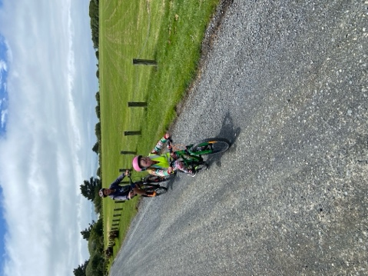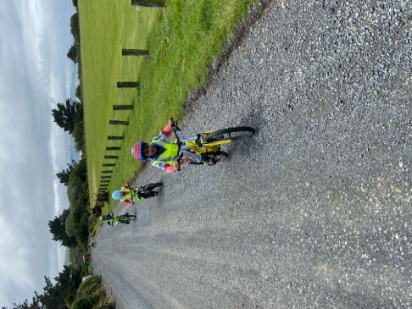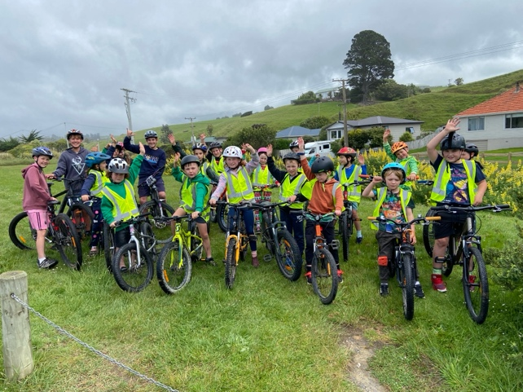
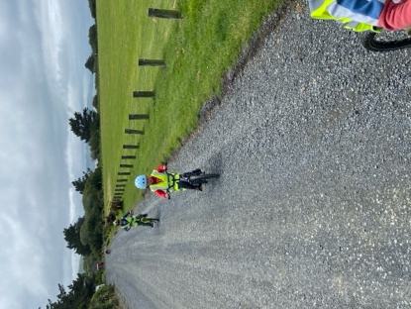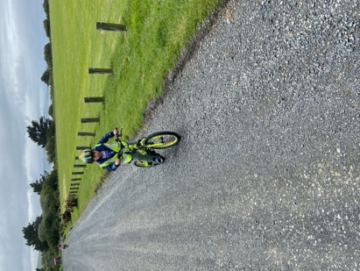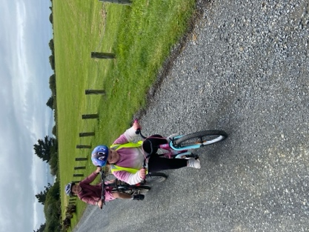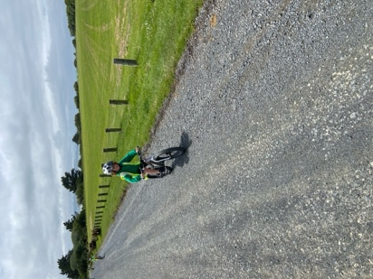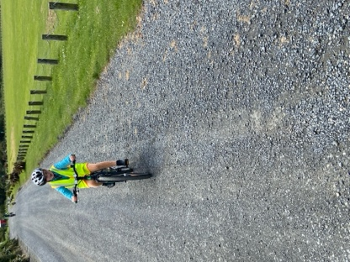
Kayaking and Supporting Mental Health
On Friday afternoon we loaded up the kayaks and headed off to Blueskin Bay/Doctor’s Point for kayaking. The weather was good, but the children were amazing. I know that I go on about how the EOTC programme supports self-esteem and mental health, as well as personal and physical resilience, but it was 100% on show. Children who 18 months ago would have tried to avoid these types of challenges, embraced them and were shrieking with joy. We hear from high schools and colleges how difficult these learning experiences are due to reluctance and anxiety, which is why as a principal I am so pleased that we can support children this way, but more importantly as a human, I am proud of the outcomes and experiences and the positive affect they have.
Many thanks to Scott, Ange, Shane, Marc, Vaughan and Shea, for helping with transport, encouragement on the water, helping them gather and cook cockles. It was a very cool day.
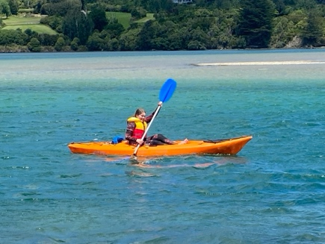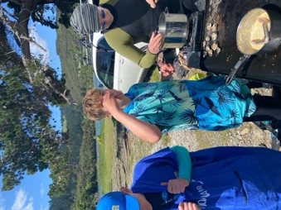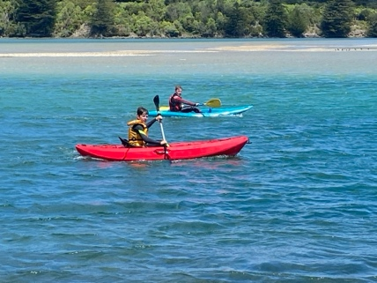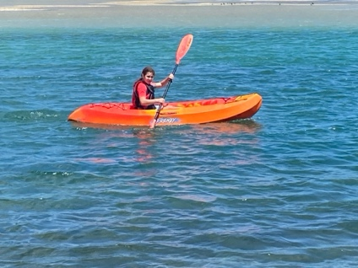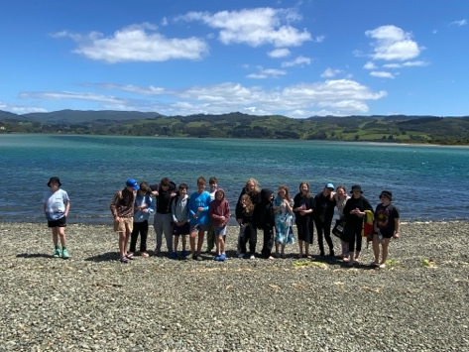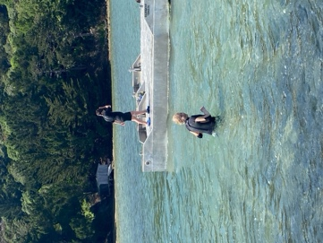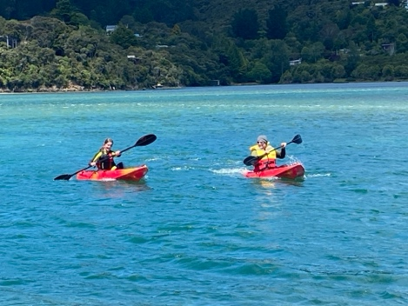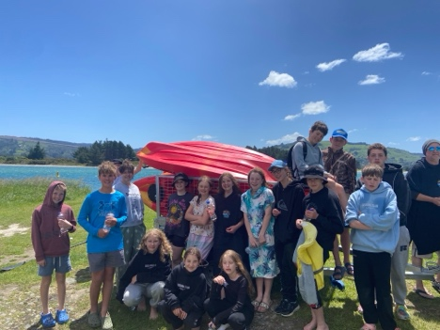
Futsal
As I understand it this is the last week of games, and for a couple of teams (Due to camp) the season is sadly over. Before I congratulate the people, who earned Player of the Day, I would like to offer my deepest thanks to the coaches, Charlee Farquhar, Tania Blanchard, Sasha and Shane Turner, Cavan Jenkinson and Urita Van Tonder for your efforts and enthusiasm as coaches.
Congratulations to the following players on earning Player of the Day:
Big Rock Dolphins – Greyson Farquhar
Big Rock Stingray – Korbyn Parata-Walters
Big Rock Barracuda – Whole team (I Think)
Big Rock Orca – Flynn Blanchard
Big Rock Sharks (Two games) – Ruben Van Tonder (12-2 W v Fairfield) and Scarlett Hancock (8-2 W v Dunedin North Intermediate)
This week’s Futsal Draw
Tuesday
Big Rock Dolphins v Pine Hill 445 on court 8
Season complete for Big Rock Stingray and Barracuda
Wednesday
Big Rock Orca v Elmgrove 415 on court 10
Big Rock Sharks v Port Chalmers 545 on court 17

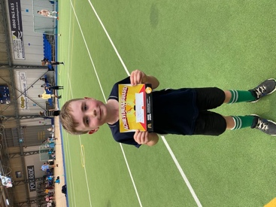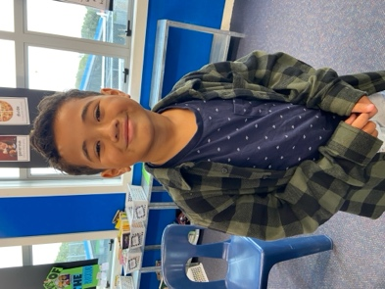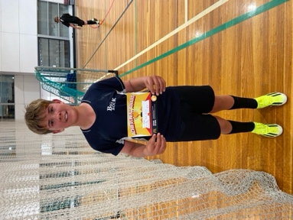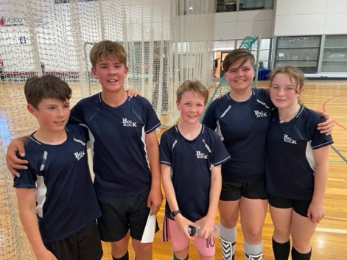
A Very Busy Week Ahead
Tomorrow Room 3 going on their end of year class camp. They are off to Tirohanga, and for many it is their first camp and their first real crack at EOTC. You will have fun and the benefits will be well worth it.
On Tuesday the senior class have their annual and traditional Survivor Camp. All the experiences and hard work led to this. They have planned their food, equipment and accommodation. Next it is a hijack scenario and into the bush.
On Friday, it is finally here, the junior classes Big Day Out. An amazing day out awaits, and all on a school day!
Also on Friday is the TnT Mountain Bike Ride. Any parents wishing to come along, we would love to have you with us, especially if you are able to help with bike transportation.
Sadly, there is no school bbq on Wednesday this week due to camps etc.
Thanks
David Grant
Principal

