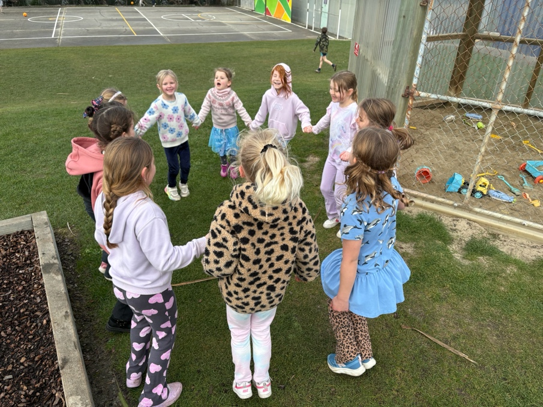
‘Mr Grant, can you please play Golden, then How it’s done, then Soda Pop, pleeeeeease’? said 10 singers and dancers.
1st August 2025
From the Board of Trustees

Kia ora koutou,
The Board of Trustees met on Monday. It’s a big term ahead, filled with some super exciting developments — none more exciting than the upcoming end-of-term production, Kapa Haka performances, and of course, LEARNING!
Super awesome.

Curriculum Progress
Our amazing teaching team has been working incredibly hard over the past couple of years in preparation for the formal introduction of the new national English and Maths curriculum changes. It’s impressive, especially considering many schools are only now beginning to think about the changes and how to manage the required professional development.

Our teachers have been ahead of the game — attending courses, visiting other schools outside the region, and putting in many extra hours over weekends and holidays. We say a huge thank you — not only from the Board of Trustees but also on behalf of our parent’s. Your early preparation helps reduce the need for Teacher Only Days (that many other schools are having), which we know supports better work/life balance for families.

The Gastronaut Programme
The Gastronaut Programme, led by David and the team, is looking fantastic. It’s exactly the kind of real-life, transferable learning that our parents have been asking for. A big thanks to the team — we know the students are going to love this new initiative.

Family Satisfaction Survey
Thank you so much to the families who took the time to provide feedback in the recent Family Satisfaction Survey. There were lots of great ideas and suggestions. We’re currently working through them, but we’re excited to share that school assemblies will be making a return!

While the details are still being finalised, we’re looking at hosting both Junior and Senior Assemblies twice a term at the Community Hall. This is a direct response to your feedback, and we’re looking forward to welcoming you back into this part of school life.

(We used to have regular school assemblies — then along came COVID. With roll growth and a packed teaching programme, we simply didn’t return to them. But now we are!)

Parent-Teacher Interviews
Our teaching staff really appreciated the recent Parent/Teacher Interviews. Thank you for making the time to attend these valuable conversations. They’re not just about learning progress — they’re also a chance to talk about classroom and playground relationships, attendance, general behaviour, and student engagement.

We understand life is busy — but if there’s one thing we know, it’s this:
Your children need you now more than ever.

Afterschool Programme
Our Afterschool Programme is continuing, though it’s currently not quite covering its own costs. The new Board of Trustees will be reviewing this later in the year. Any changes will be carefully considered — this is an important programme for our school and community — but like many things, rising costs must be managed responsibly.

Board of Trustees Elections
Just one week to go until nominations close! Being on the Board is a privilege — it’s a fantastic way to understand what’s happening behind the scenes and to have a positive influence on the direction of our school. From strategic planning to budgeting and policymaking, it’s about supporting our staff and wider school community.

Get your nominations in — we’d love to have you on board!

Ngā mihi nui,
Scott Weatherall
Chair – Big Rock Board of Trustees

Strange Week Indeed
This might go down as one of the strangest weeks I’ve ever had. From computer monitors hanging and swinging from lampposts, to Tsunami warnings. It is never dull when you are ‘Learning in Paradise’
Congratulations
A big congratulations to Korbyn and Braxton Parata-Walters on their effort and dedication to their beloved sport of Tae Kwon Do, they have been training and competing in tournaments across the South Island (along with Dad). Both boys were especially proud sharing their medals with their classes and with me. Rightly so, richly deserved boys.
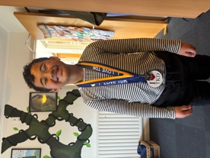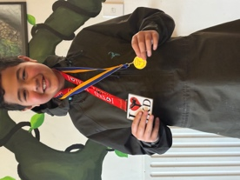
Also well done to Lexie Brown on earning the kudos of being named the outstanding forward in her recent performance for Otago Metro rugby. Great stuff Lexie.
Congratulations and faamalo to Kendrick Keki on earning Player of the day for his Green Island football team. Mr Murray, who knows his football, has noticed this youngsters ability, especially his thunderous left foot.
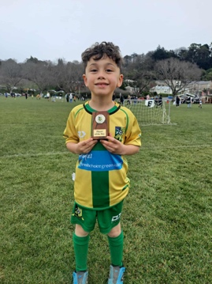

Equally well done to Ivar Elliot-Tressler and Ari Gilbert on earning Player of the Day for their Brighton Seagulls teams, Red Gulls and Mini Gulls. Having watched Ari kicking a football, rugby’s gain is certainly football’s loss. Like Kendrick and Alby McNab, genuine talent and enthusiasm on display in the playground.
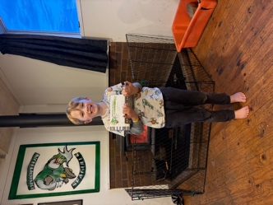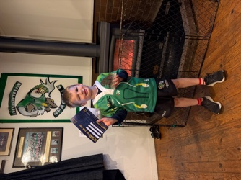
Bravo to the following players on earning Player of the Day for their respective school teams. A big shout out to the Big Rock Shooters, many playing their first season, have now had back to back wins.
Big Rock Hoopsters- Beau Mansfield (Scored all of his teams points)
Big Rock Dolphins- Amazon King
Big Rock Shooters- Maci Kippenberger

A Little Bit More Gastronauting Today.
First up on the tools were Nate, Fin, Zach, Briana, Ryder, Lilly and Amazon. Many thanks to Beau, Araia, Dusty, Baily for your leadership and support, ably assisted by Pearl and Eva. The wontons were fantastic.
After that our Year 7-8s were into making spring rolls (oven baked), and judging by the fact only crumbs were left, they must have tasted as good as they looked.
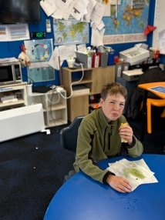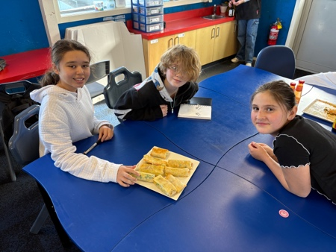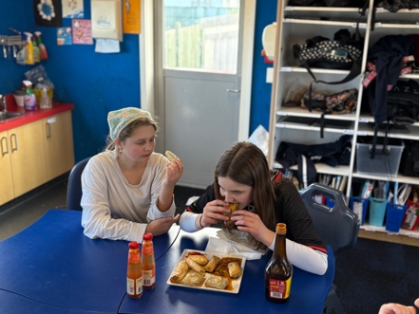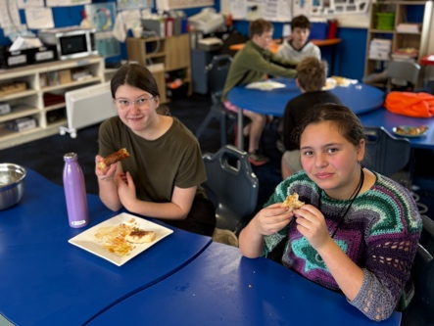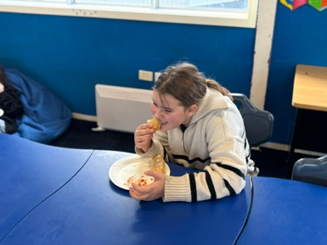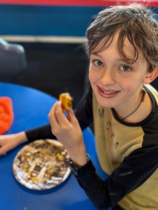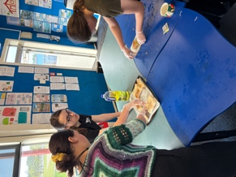

Have a great weekend
David Grant
Principal
PS – Ski trip on Monday/Tuesday, Advanced Mountain Biking on Thursday, please keep an eye out for information on our TNT Mountain bike adventures.

