19th September 2025
Alice the Musical
Congratulations to every child involved in a superb performance. As well as for their patience and effort throughout the many rehearsals. It was all worth it.
I would like to acknowledge personally, Bella Yeoman, Dusty Andrews, Jaxon Skerratt, Stella Brown, Penny O’Brien, Hinemoana Jimenez-Maxwell, Korbyn Parata-Walters, Esme Grey, Braxton Parata-Walters, Fin Ramsay, Adelaide Conway and Fletcher Graham, as well as double act Pearl Mansfield and Aliza Johnston for not only their performances but for the courage to sing a solo. That is not easy to do, regardless of your age or experience.
To the whole cast- bravo, your singing and timing was magnificent.
A big thank you to the staff- Mrs Lamb, Mr Murray, Miss van Aalst, Miss Keen, Miss Ward, Kara Walters, student teacher Livi Wells, Lexie Tomlinson, for all your work in front of house and behind the scenes.
Thank you to Kimberley Maxwell, Tania Blanchard, Nina Daniels, Lisa Daniels, Kelly Tomlinson, Jana Dorana and Jo Henderson for all your work on props and costumes.
Thank you to all family, whanau and friends- the audience is so important and the cast fed of your energy.
Lastly, thank you to Teresa Grant for your direction, enthusiasm and knowledge in making it all come together, more difficult than many would believe.
In essence, thank you everyone for an amazing journey through Wonderland.
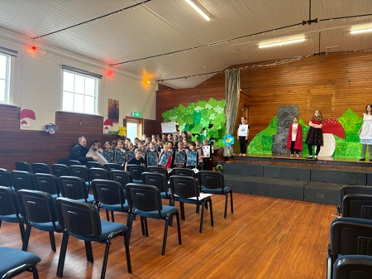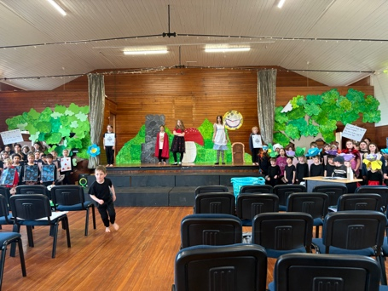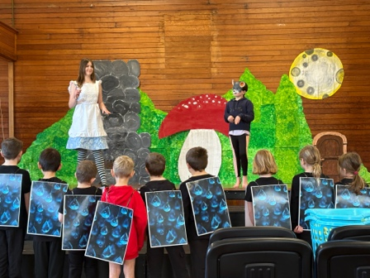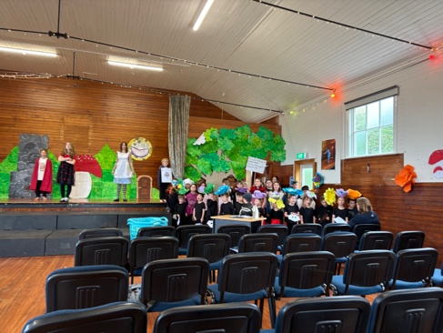
Photos from rehearsals
Congratulations
Last week I missed some of the children who earned awards at the recent Brighton Rugby prizegiving.
Congratulations to the following players on their awards.
Alex Little Player Performance
Fletcher Cockburn. Most Promising
Korbyn Parata-Walters Best and Fairest
Arlo Pfyl Most Improved
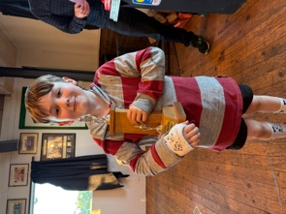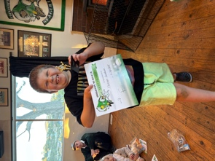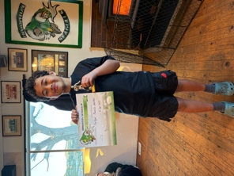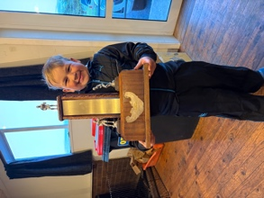
Lunches On-Line
Next term you will be able to order Sushi online for your child for lunch through the Lunches On-Line app. You will need to register to do so. I have attached all the relevant information. This is only available on Wednesday’s and will replace cheese rolls.
Lunches will be named and delivered to the school office. The sushi will be coming from Mosgiel.
Please be aware that this is separate from the school and we have no role in any of the process.
All orders must be made by 9:00am on the day.


End of Term Summary
Thank you to everyone who has made Term Three a rewarding one for the children. Traditionally, Term Three is the most challenging one, with the cold wintery days, illnesses galore and everyone not quite as chirpy as they are in the summer months. Yet through all of that, especially, with all the illness, the children, staff and all our families hung in there and battled on. When you think about it, it is a remarkable achievement that even with all of that, we still managed to perform at Polyfest and produce a remarkable musical. As well as so many children playing winter sports, and working hard in the classroom, particularly with Literacy and Mathematics. I talk about resilience a lot, and so many showed so much as to be inspiring.
I would also like to formally advise every one of our exciting new Board of Trustees and their designated roles within the Board framework.
Board Member | Position/Responsibility
Lisa Daniels  Jo Henderson  Colin Driver  Aaron Hollands  Kara Walters  Lisa Lamb (Deputy Principal)  David Grant | Board Chair/Presiding Member  Finance/Deputy Chair  Health and Safety/Property  Property/Fundraising  Property and Infrastructure  Staff Representative  Principal

Next term promises to again be an exciting one, with class camps, Big Day Out, hopefully some bike trips (Fingers crossed for the weather), as well a few more exciting additions- stay posted.
Our End of Year Prize Giving is on Thursday 11th December and school will close for the year on Friday 12th December.
Enjoy the break, and we will see you all when the sun is warmer and the days are longer.
David Grant
Principal

