18th October 2024
Welcome/Nau mai haere mai
A big Big Rock welcome to Paisley Wilson and her family who have joined us, it is fantastic to have you on board.
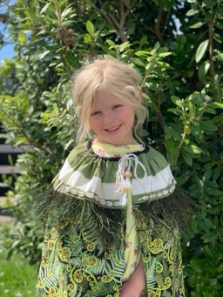
Big Rock’s Got Talent/ He taranata to Big Rock
This new event is fast approaching, please keep the entries coming in. It does not have to be a solo performance, it can be as a duo, a trio or even bigger. Places are limited, so if you are keen, get it together and get the entry form filled in. Forms are available at the office. Get in to it.
Minecraft Education
One thing I love is hearing about the broad range of hobbies and extra-curricular activities that the children get up to, whether it be sports, horses, music, drama, art lessons, martial arts, motor racing etc it is pretty impressive. Rowan Patterson in Room 2, yes Room 2 is something of an expert at Minecraft and Minecraft Education. I have attached a link. I strongly urge you to have a look, it is quite incredible. Top work Rowan.
https://youtu.be/tx7sI_5J6c4 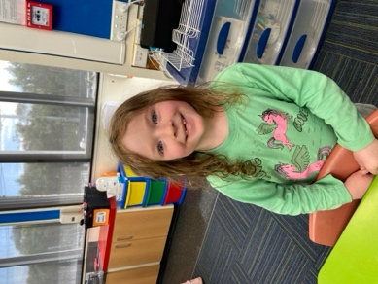
Congratulations/ Nga mihi nui ki a koe
The futsal season is up and running, with all teams underway this week. Congratulations to the following players on earning Player of the Day for their sides.
Dolphins – Rhys Shayler
Stingray – Will Judd
Barracuda— Stella Brown (8-0 victory)
Orca—Isaac Lucking (2 goals)
Sharks – Whole team after defeating Tahuna Intermediate 5-3.
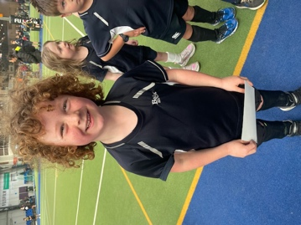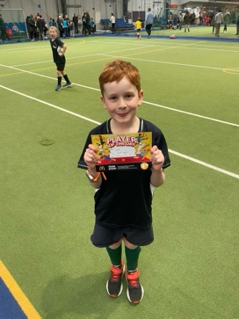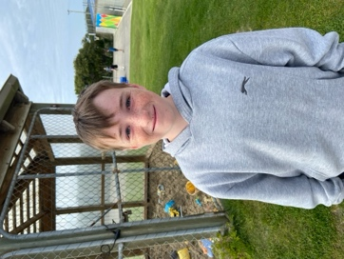
I would also like to congratulate Kade Hancock and his Green Island football team on finishing second at the recent end of season tournament in Wanaka.
Equally, a massive congratulations to Scarlett Hancock on earning Player of the YEAR for her Green Island football team. Outstanding stuff Scarlett.
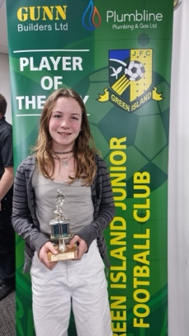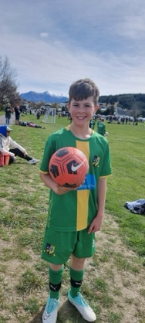
Thank You/ Mauruuru koe
A massive thank you to Blayr Findlay of iPaint for the incredible job he is doing in painting Rooms 1, 2, the office block and kitchen. The awful weather of the break caused disruptions. As soon as he could, Blayr was back into it, including working the whole weekend before school came back to get as much done so as not to disrupt school too much. We didn’t ask him to do that, it was his work ethic. Thank you Blayr, top man.
If anyone needs a painter, he’s the one you want.
I know some people might find the new colour scheme ‘challenging’ but it is vibrant and makes us look like a school and not a government department.
As a former student and prolific surfer Ruben Peyroux used to say ‘Don’t be scared of colour!’ (It was a comment he used to make during art)
End of Year Prizegiving/ Te Whakamutunga o te Tau
We have a change of date for our End of Year Prizegiving. The prizegiving is now on Wednesday 11th December.
School Trophies/ Nga taonga o te kura
Can we please have all school trophies back. The trophies that we need back are:
- 2 x Sport (Boy and Girl)
- 2 x Empathy (Boy and Girl)
- The Arts
- Citizenship
- Dux
- Futsal- Most Promising Player
- Futsal – Overall Player of the Year
Netball, basketball and some futsal ones are keepers. The large futsal ones need to come back please. If you are unsure, please check with Kelly or me.
If they are not yet engraved, we will arrange that. Thank you.
Senior Class Camp/ Te Hopuni Kaumatua
I will be away from Tuesday next week on the Senior Class Camp. If you have any concerns or issues, please see Mrs Lamb.
Indeed, I have the pleasure of attending this years Year Seven-Eight camp and it is a beauty. We will be based in Arrowtown. The camp will be a combination of history and adventure. It is in alignment with the school curriculum. The academic focus will be on the Goldfields History with visits to the Goldmining Village, Chinatown, Bendigo, Stewart Town, the adventure component will see the children go-karting at Highland Park, going on the gondola as well as plenty of rides on the luge. We will also be visiting Kingpin amongst other things. It is going to be brilliant, I am so pleased we are able to offer this in support of our other EOTC programmes. I look forward to sharing the photos.
From yesteryear
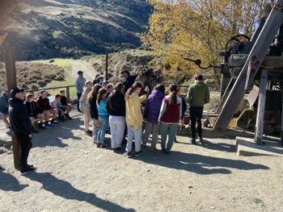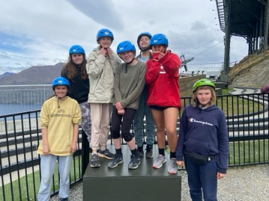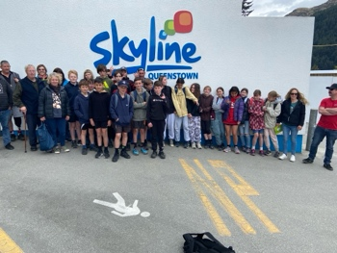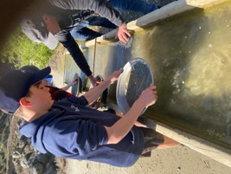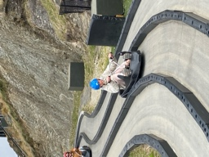
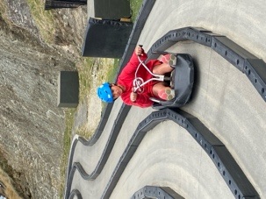
Have a great weekend

David Grant
Principal

