18th August 2023
Sports Round-Up
Firstly, congratulations to all of the children on completing their school-based winter sports season. Well done to all of the basketballers and netballers, for the effort, attitude and sportsmanship. Also well done to the rugby players who finished up on Saturday. Bravo to the hockey players who finished up on Wednesday. Good luck to the footballers who have another couple of weeks to go.
Basketball
Congratulations to the Big Rock Hoopsters who became champions of the Year 7-8 Mixed Grade. They played well all season, got stronger as a team, they also showed great sportsmanship, particularly when games got a bit niggly. They won the Gary Smythe Shield. Gary has long been a servant of Otago Basketball, mainly as a coach. He commented to me on Monday about the team and how well they played. That is high praise.
Thank you Scott for taking the team.
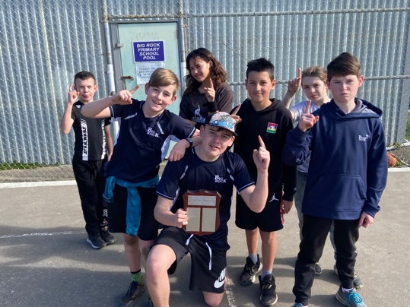
Last night the Big Rock Coasters played a very good St Clair side and gave them a run for their money. The Coasters have had a great season, winning more games than they lost, but more importantly, improving individually and as a team. For many it was their first season which makes it all the more successful.
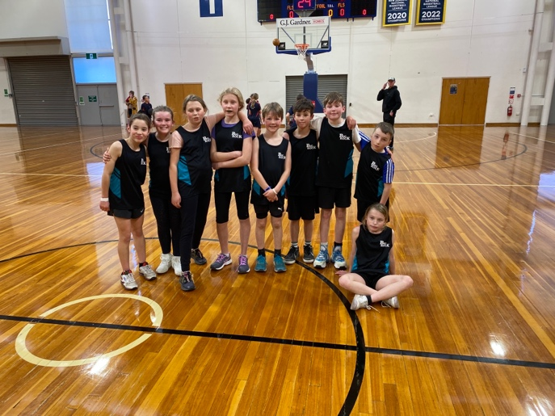
The Big Rock Shooters also had a great season, again getting better every week. Last night they had a good win against Musselburgh. Well done, Shooters, you made everyone very proud. (I don’t have a team photo, if someone has one please send it to me and I will update the newsletter)
Netball
The Big Rock Dolphins, many of whom were new to netball, stuck at it and had a good season with lots of fun. Which I believe is the reason to play. Top work Dolphins.
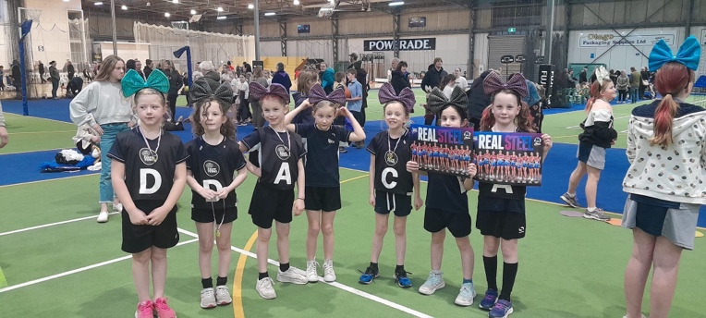
Bravo to the Big Rock Rockets on a superb season. This team, by and large have played together for a number of years and the progress in skill level and game management is very impressive, and they always finish with a smile. Lots of wins and the odd loss. Outstanding.
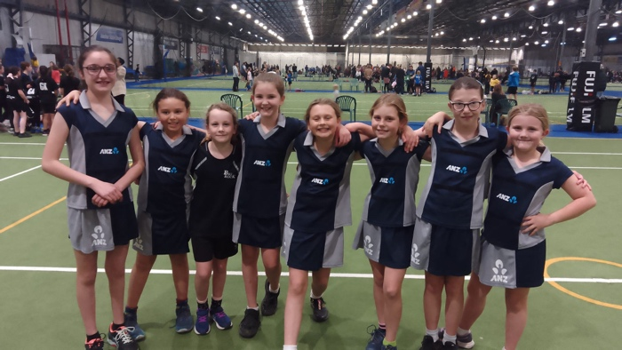
Hockey
Well done to Emma Egan on earning Player of the Day for her combined hockey team and scoring a goal! In what was a very challenging encounter.
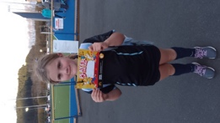
Brighton Seagulls Rugby
I had the pleasure of watching both the Baby Gulls and the Seagulls on Saturday morning. There was lots of smiles and lots of mud and some very flexible refereeing. It was great fun.
Congratulations to Alex Little on earning Most Improved for the Baby Gulls (Sorry I don’t PoD). Well done to Charlie Hughes on earning Player of the Day for the Seagulls and bravo to Quaye Driver on earning Most Improved. (It was a great pass to Fin, Quaye!)
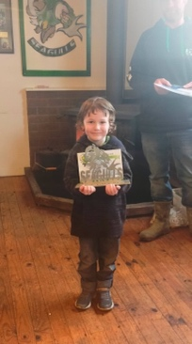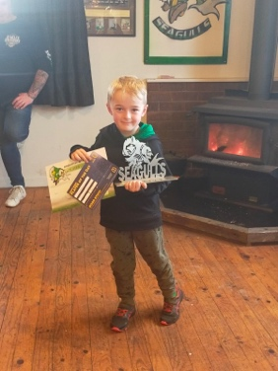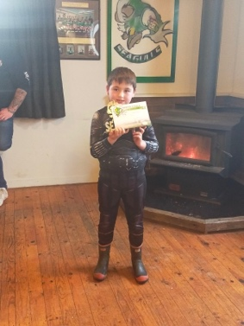

Thank You
A massive thank you to Lisa Russell, Angie and Joe Hancock, Scott Weatherall, Jasmine McNab, Tania Blanchard, Di Hamilton, Marina Conway, Amber Egan and Sophie Wheeler on all of your efforts and commitment in coaching and managing our teams. Thank you.
Thanks to all of the parents for getting the children to games and for being so positive on the sidelines.
Cross Country
Earlier today it was the Greater Green Island Cross Country Championships. The school team of Baily Jenkinson, Isaac Lucking, Leith Conway, Malachi Turner, Addison Johnston, Kade Hancock, George Weatherall, Scarlett Hancock, Leo Douglas and James Patterson gave it their all on a tough course in wet and heavy conditions. I would like to make special mention of Scarlett Hancock (2nd Year 7 Girls) Kiptyn Garner (3rd Year 5 Boys), Kade Hancock (4th Year 6 Boys), Addison Johnston (6th Year 6 Girls), George Weatherall (5th Year 7 Boys), James Patterson (4th Year 8 Boys) and Leo Douglas (5th Year 8 Boys). A wonderful effort from all of the team. Thank you to Emma Egan and Bella Yeoman for helping with placings and timekeeping.
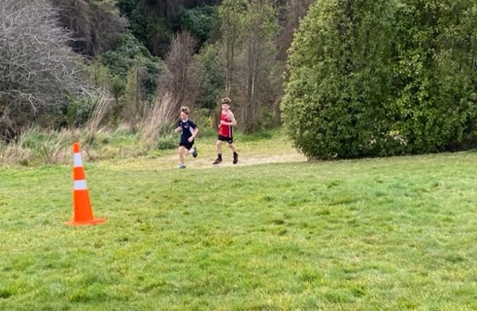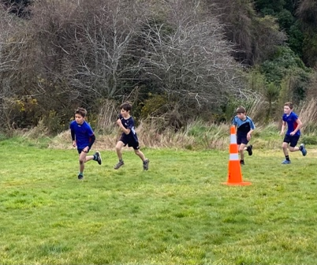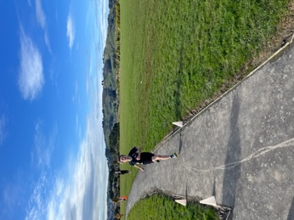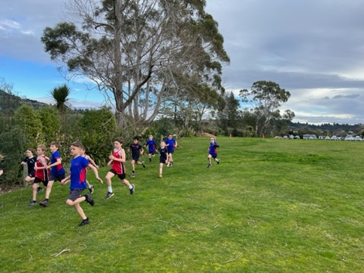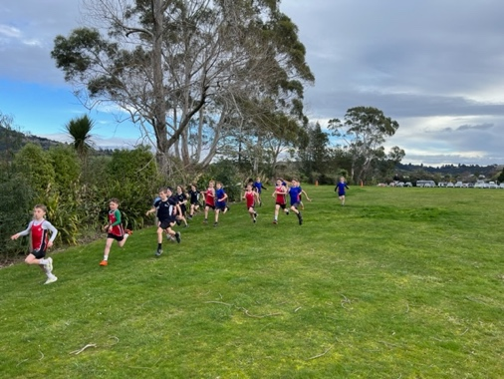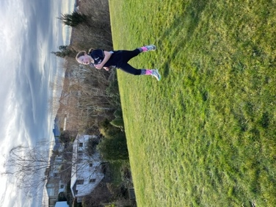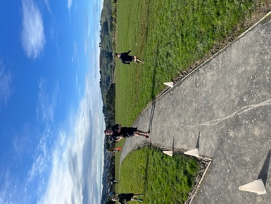
Mountain Biking
The school mountain biking programme had two sessions this week. Firstly, on Tuesday the Introductory Group were out and about in Brighton and Ocean View. They were working on not only their riding skills but also their road safety skills. They are doing really well and we are looking at a MTB track adventure for the next outing. My apologies but I forgot to take any photos. (Next time I promise)
Yesterday the Advanced Group lived up to their name. Off they tootled first thing to Signal Hill. Wow, best if I let the photos do the talking. (There are more on the school facebook page). Thank you Scott and Angie for ensuring this programme not only continues but flourishes, it is also important that I thank and acknowledge Morrie McLeod whose added support is vital. I was at a principal meeting earlier in the week (It wasn’t as exciting as it sounds) and I can assure you our MTB programme and our E.O.T.C programme are the envy of many schools.
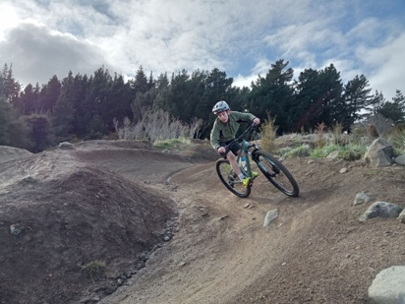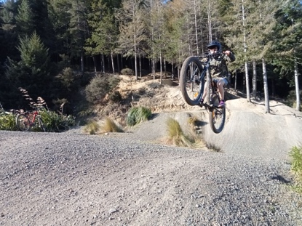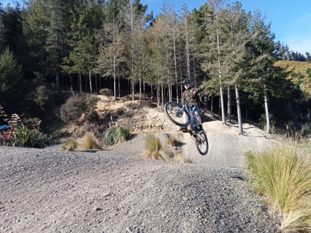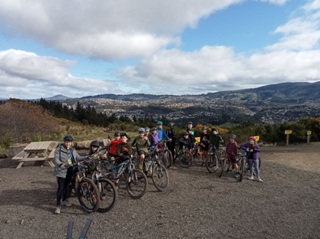
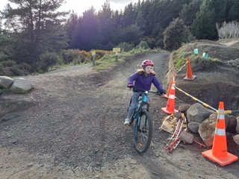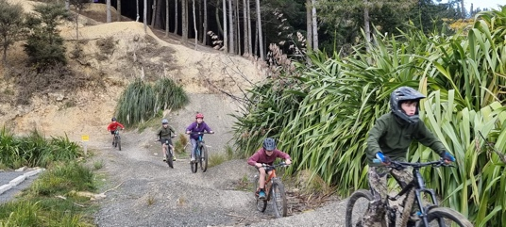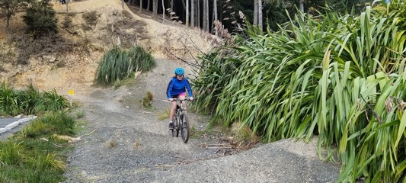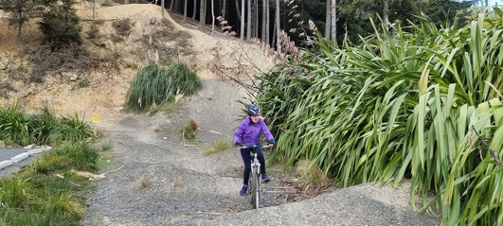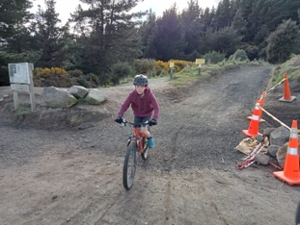
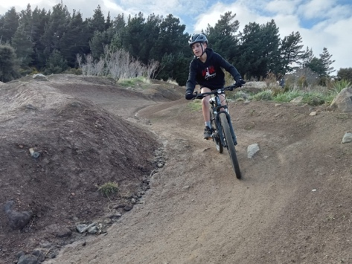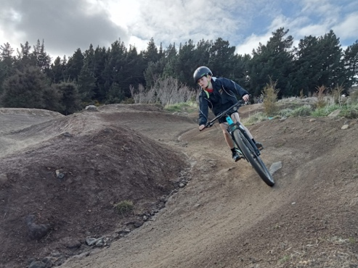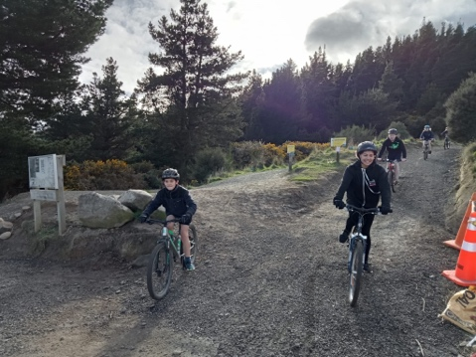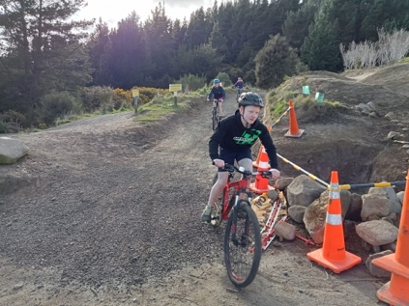
It’s Not All Sport, There’s a Bit of Music Too
As I write the New Zealand Navy Band is performing for all of the children down at the Brighton Hall. They were very entertaining, playing the theme to Star Wars, and The Simpsons amongst others. They involved the teachers much to the children’s delight. This was a very cool way to end the week. I have never needed to thank the New Zealand Navy before, now is my big moment. Thank you New Zealand Navy.
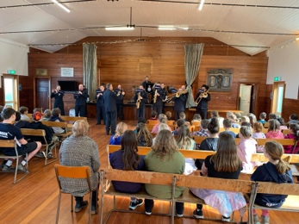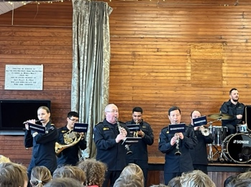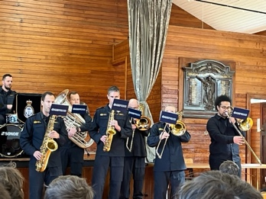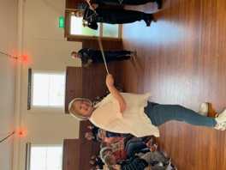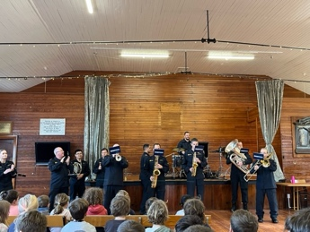
Honey Fundraiser
Thank you to everyone who has been involved in our honey fundraiser. Can we please have all of the forms and money in by Monday at the latest please. At the moment we have forms and no money, money and no forms. Thanks

Have a great weekend
David Grant
Principal

