17th July 2025
Welcome Back
Welcome back to the start of what promises to be a busy and rewarding term for all of the children at Big Rock.
We are very excited to be involved in the 2025 Otago Polyfest. Thank you to everyone who has returned their forms. It is very much appreciated. We need them back asap, so that we can ensure that all children have the correct uniform and the correct size. It will be difficult to cover this for any late additions. If your child is interested or you require more information, please get in touch asap.
As well as performing at the Otago Polyfest, we will also be putting on a musical production of Alice in Wonderland. This will be on Thursday 18th September at the Brighton Hall. Rehearsals and singing practices have already begun.
We really do need your help with costumes and set building. If you can help, please get in touch asap please.

Congratulations
The last two weeks may have been school holidays but that did not stop Big Rock tamariki achieving highly in a variety of pursuits.
Firstly, well done Malachi Turner and his team on finishing second at the recent Green Island Winter Football Tournament, which featured teams from all over Otago and Southland. A great effort.
It was also fantastic to see Lexie Brown being selected (again) for the Otago Year 7-8 female rugby team. Outstanding stuff Lexie, I know how much you love your rugby. Well done.
A team of young gymnasts had their first (I believe) competition and proudly brought their ribbons and certificates to share with me. Well done Asti O’Brien, Mila Parish-Witehira, Rowan Patterson, Meika Coory, Willow O’Brien, Georgia Smeaton, Evie Hollands, Penny O’Brien and Georgia Stewart.
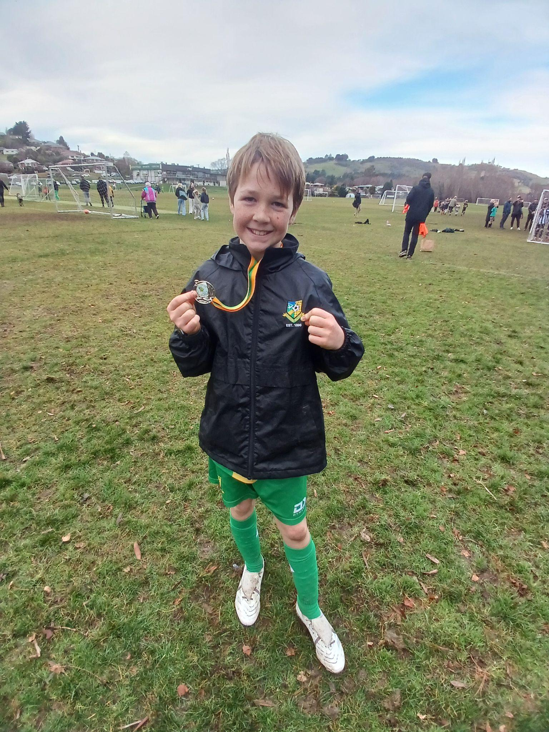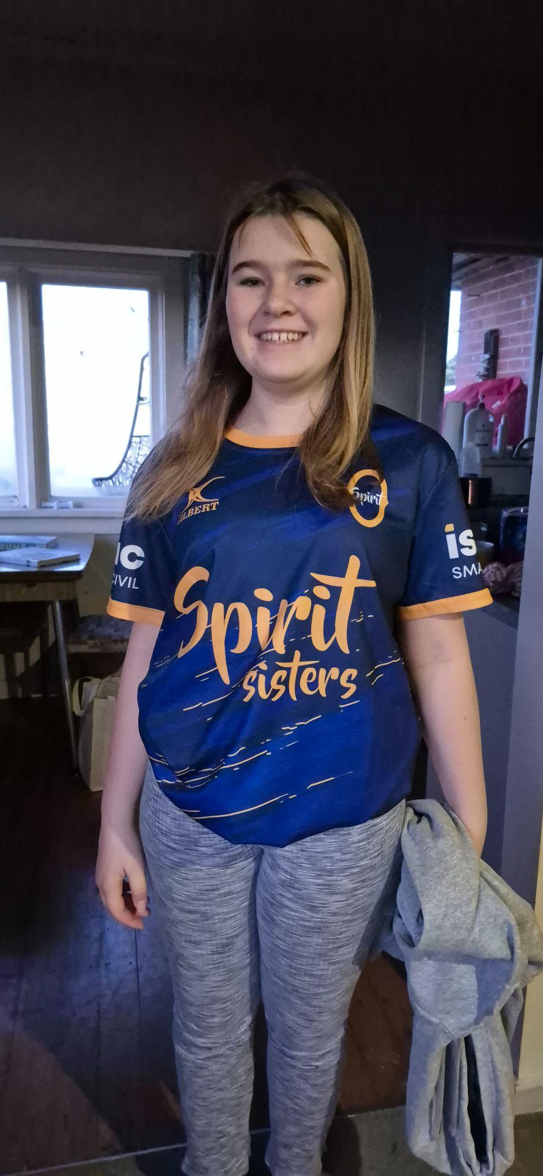
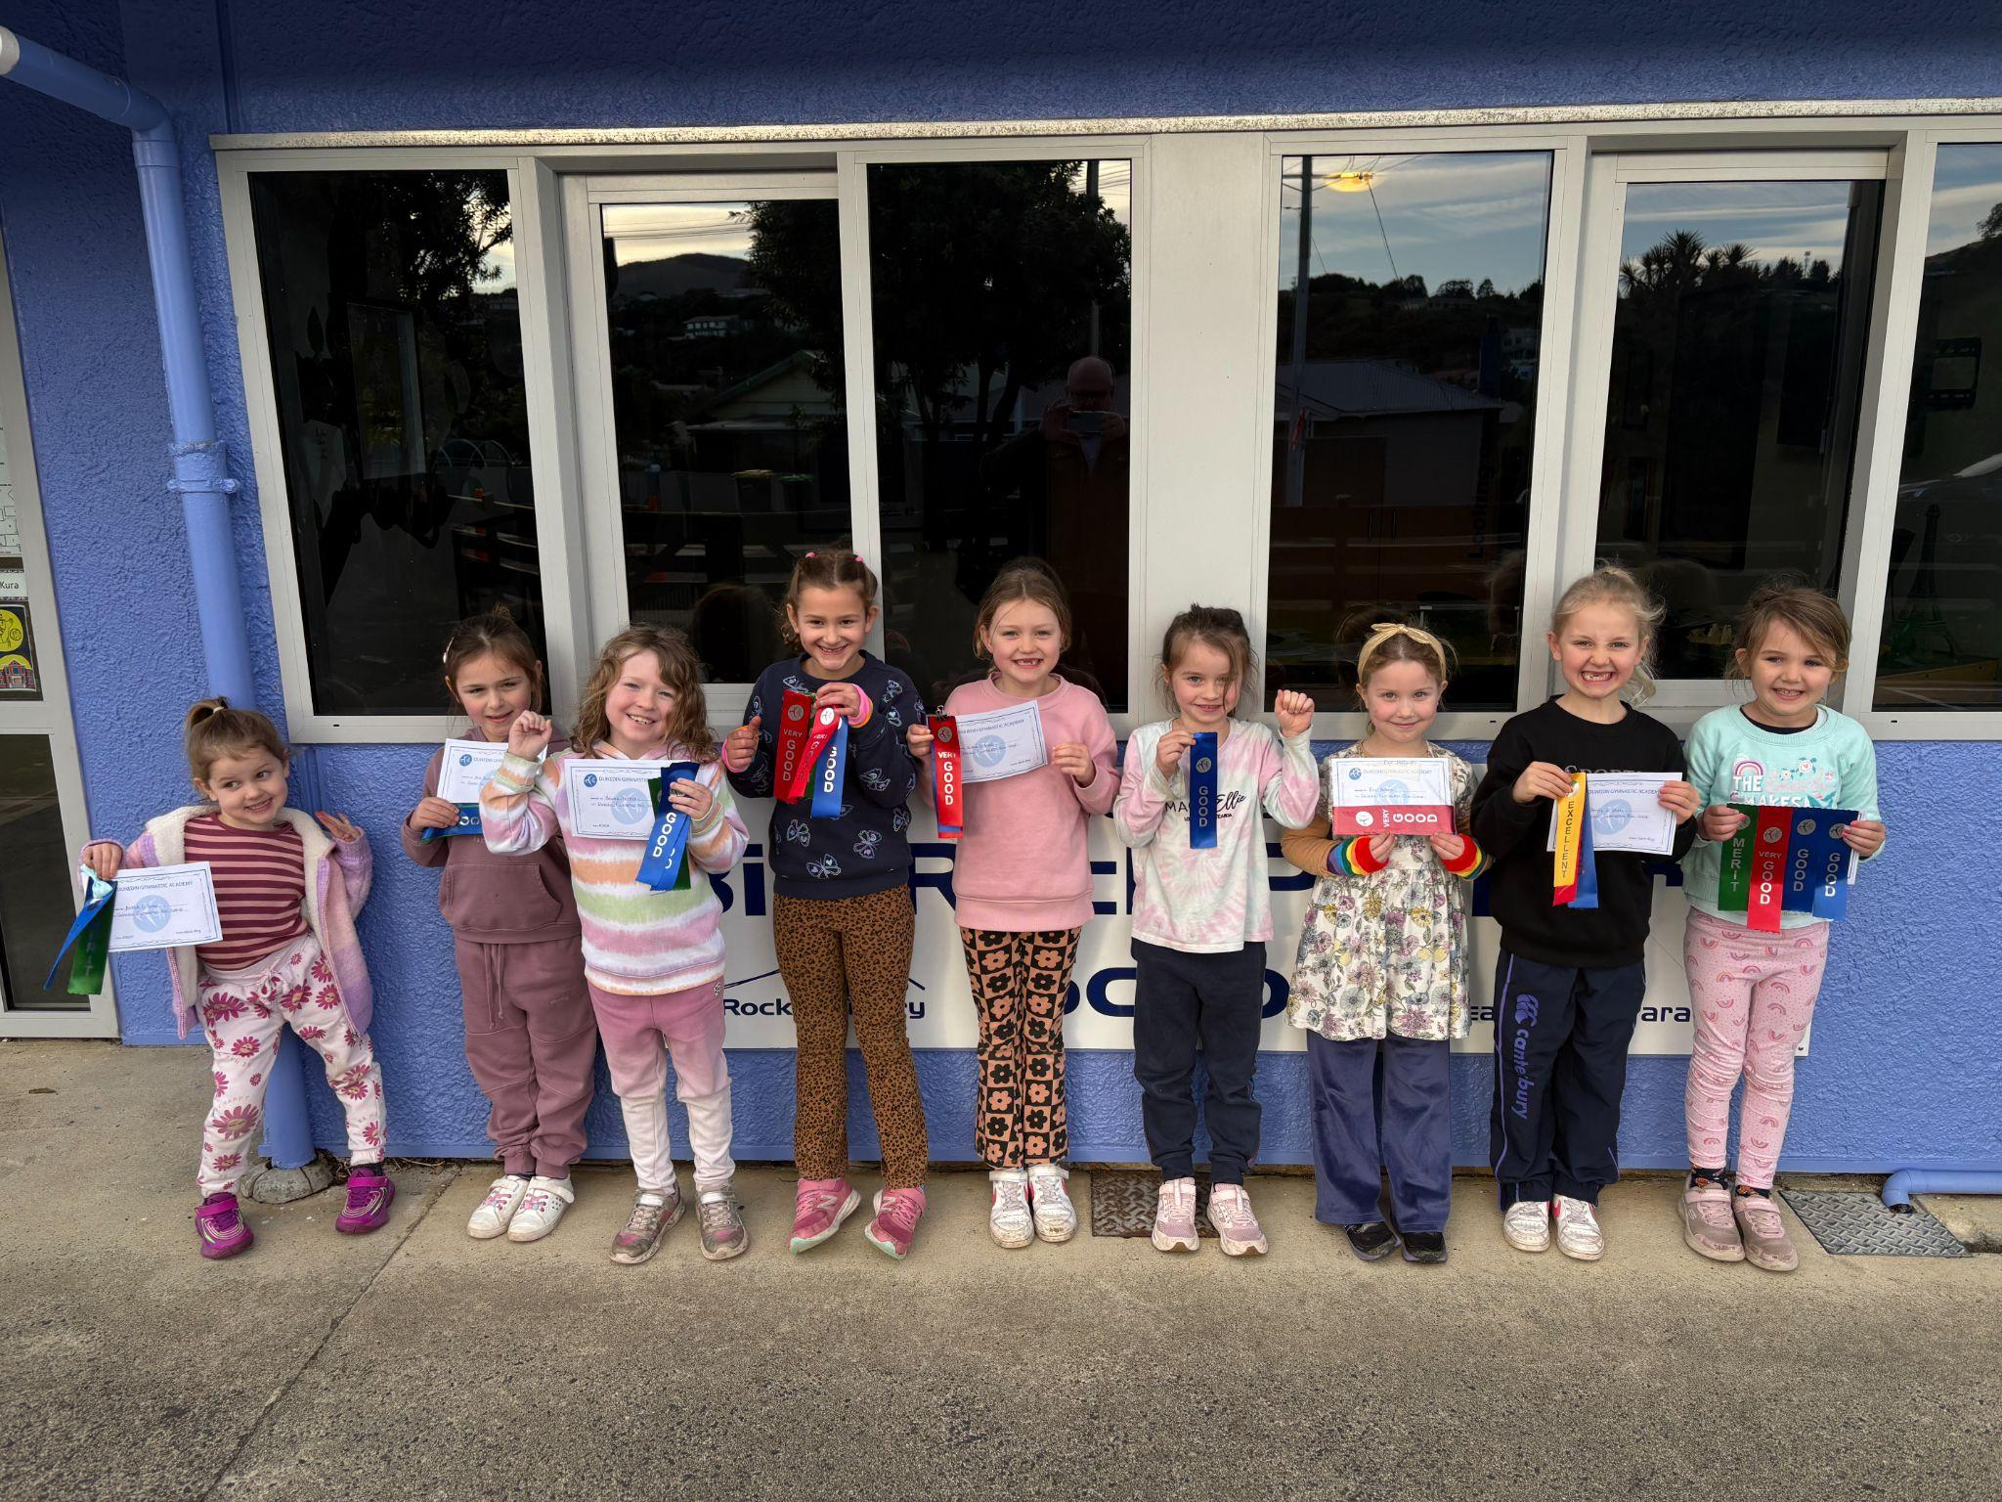
I would also like to congratulate the following people on earning Player of the Day for their different teams.
Big Rock Hoopsters – Lexie Brown
Big Rock Dolphins – Pearl Mansfield
Big Rock Shooters – Fletcher Graham
Big Rock Coasters – Braxton Parata-Walters
I would also like to congratulate the following players on earning Player of the Day for their Brighton Seagulls rugby teams.
Ted de la Mare- Mini Gulls
Fletcher Graham- Red Gulls
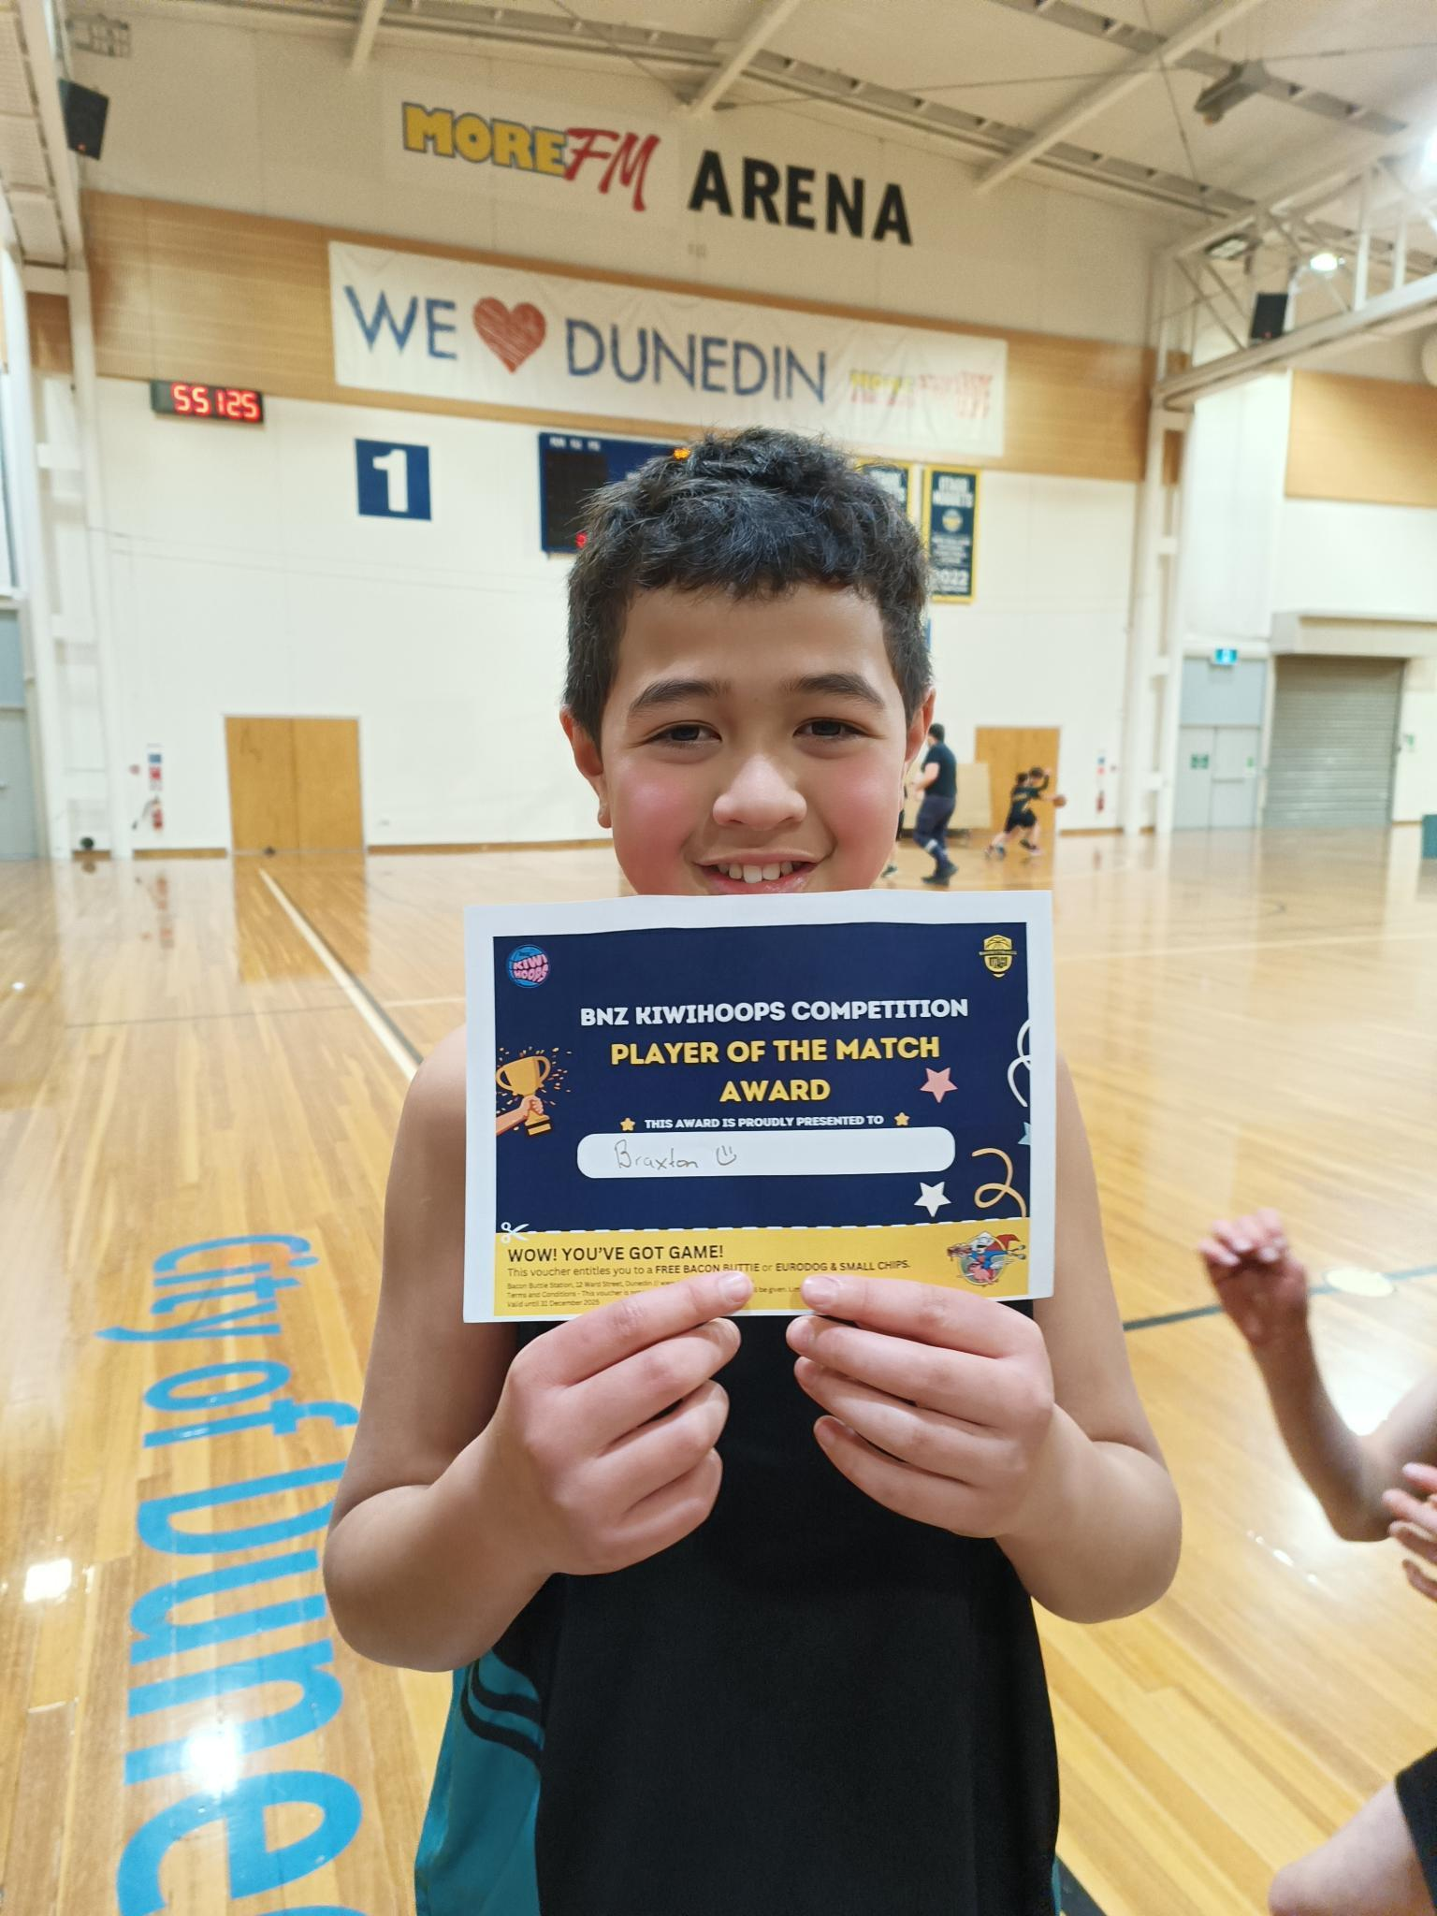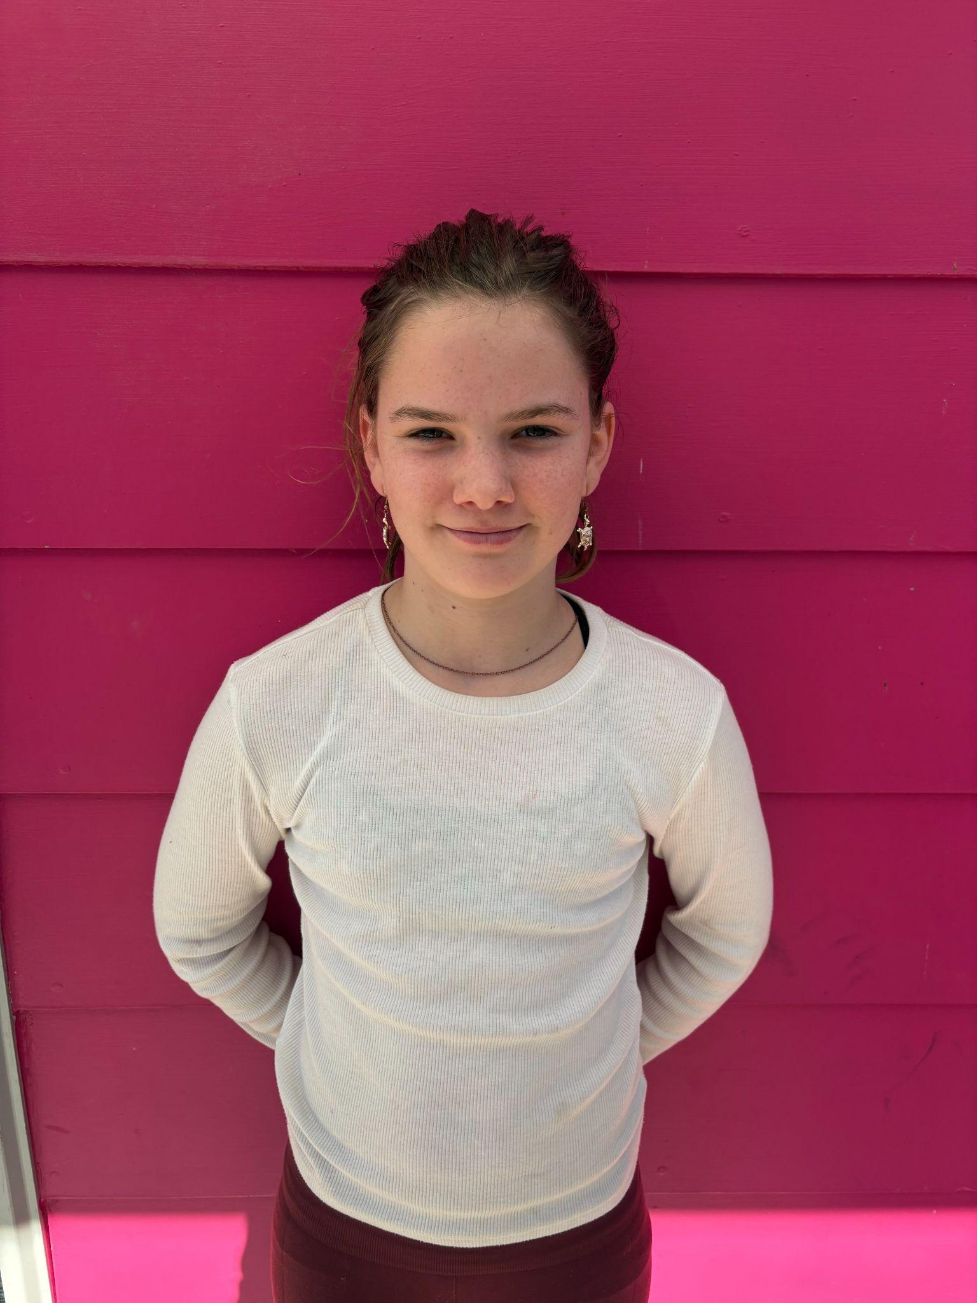
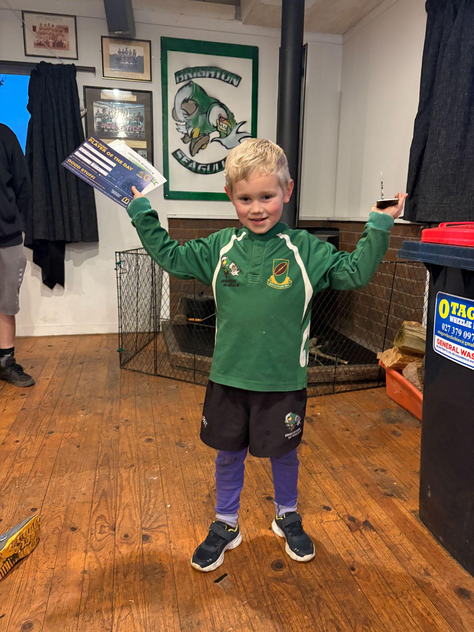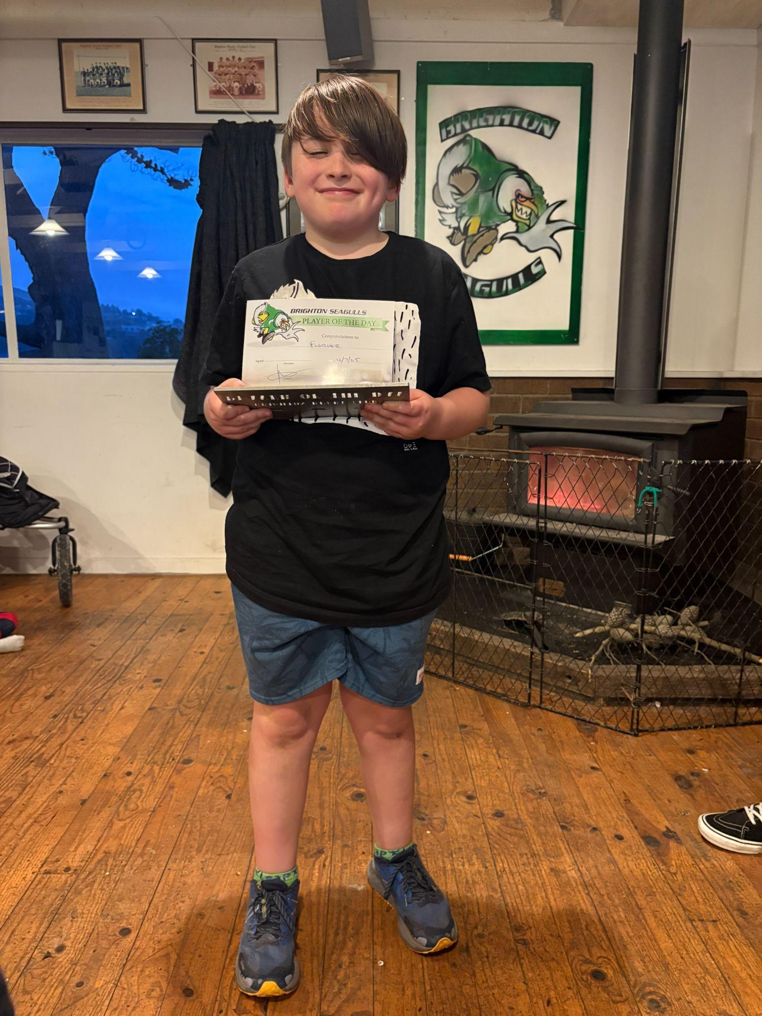
Parent Interviews
A reminder that Parent Interviews are on Tuesday and Wednesday next week. This is a great chance to discuss your child’s report and any questions that you might have. Sometimes the allocated time slot does not provide enough time. If you need more time, please make another appointment with your child’s teacher outside of the appointment time slots. We need the interviews to keep moving otherwise the backlogs can get out of control. If you have made an appointment and can no longer make it, can you please let us know, and if you want to make an appointment with the teacher for another time.
Due to the parent interviews, school will close at 2:30. Children will be actively supervised in the playground until 3:00. Parents are able to pick their children up from 2:30.

Board Elections
As you may be aware, School Board of Trustees elections across New Zealand are coming up. If you are interested, please come and talk to a current Board member, myself or Kelly. It is a very important role within the school and does have an important say on a school’s direction and governance (Policy writing and setting).
Your school has been incredibly well served over the years by different Boards of Trustees, bringing a wide variety of skills. They have always made a genuine difference, with a focus on the children and their whanau.
The Board requires a wide range of skills and experiences. You may think that you don’t have the skills or experience. You do have the skill and experiences, you are parents and have experienced the joys and challenges of that. Being a Board member is much more straightforward.
Another concern people sometimes have is the time or potential workload. If that is your concern, please don’t let it be. The workload is not immense.
I strongly encourage you, if you are even a little bit interested, come and speak to someone, or get yourself nominated.
Your school and your community needs you.

Have a great weekend

David Grant
Principal

