16th May 2025
Cheese Rolls
Thank you to everyone who helped supported our promotion/trial of cheese rolls on Wednesday. We have decided to push on with this as a fundraiser for the senior class camp.
As of this THURSDAY we will be selling cheese rolls at 2 for $4, if the less hungry or younger only need one we are happy to sell them at $2.00 each.
Many thanks to Cavan Jenkinson and Bakehouse on Bond for helping us get this going. I would also like to acknowledge Kyla Dey-Smart, Kaylyn Te Ngahue and Annabel Free for their efforts in getting the cheese rolls ready on time, hot and looking pretty tasty. Well done team.
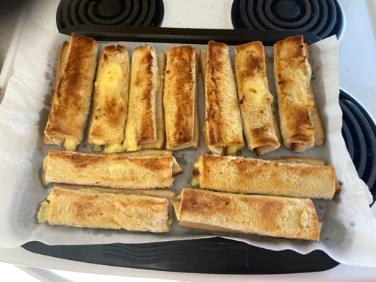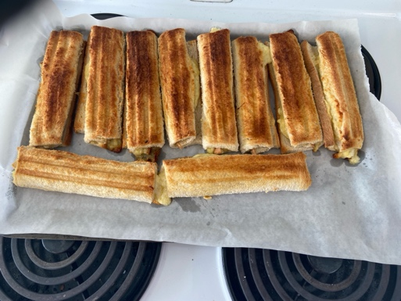
Congratulations
Congratulations to the following players for earning Player of the Day for their respective basketball teams.
Big Rock Shooters – Zachary Neilsen
Big Rock Coasters – Fin Ramsay
Big Rock Hoopsters – Malaika Patton and Araia Te Waiti
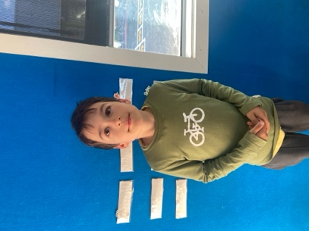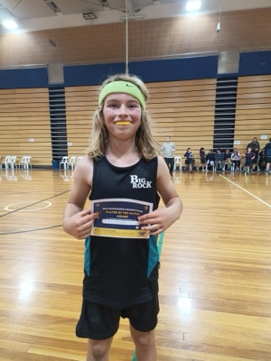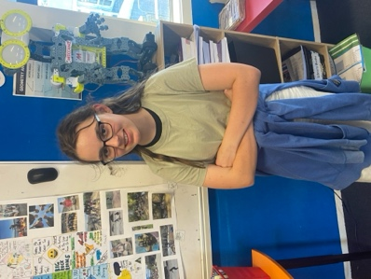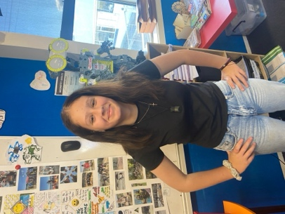

Next Week’s Basketball Draw
Monday
Big Rock Shooters v St Marys at 4:05 on court 7
Thursday
Big Rock Shooters v St Bernies at 5:15 on court 4b
Big Rock Coasters v SFX at 5:15 court 5
Netball
The netball season is fast approaching. Yesterday all players should have brought home their new netball tops, they will also have new playing bibs. We will send skirts/skorts/shorts home next week. They have been having some training sessions at school with senior girls. Next Thursday, 22nd May, they will have an after-school session with gameday coach, Marina Conway. Training will start around 310 on the bottom court.
I would also like to acknowledge and congratulate the following players on earning Player of the Day for their Green Island football teams. Well done to Dion Mooyman and Malachi Turner.

Out and About
It was a great day out in town with Room Five today, as they had their Dunedin Landmarks and things of Historical Significance Amazing Race (The race that is not a race, race). They were remarkable, positive, enthusiastic, onto it and into it. Mr Murray and I told them at the end that it was due to their great behaviour and attitude, that we were able to have days like today, out of the classroom. Amazing Race + Food Court + Timezone = Achievement, Fun and Attendance.
I can’t wait until next week for Room Four’s adventure into town. I will have information next week on the dates etc for Rooms 1, 2 and 3’s adventures. Stay posted!
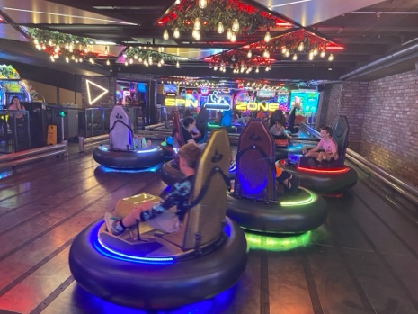
Have a great weekend
David Grant
Principal

