16th June 2023
Matariki and Aotearoa New Zealand Histories Evening
As you are (hopefully) aware, next Wednesday is our Matariki and ANZH celebration. One of my favourite days in the school calendar.
A wee reminder of the evening.
- Doors open at 5:30
- Welcome and Karakia 5:45
- The school is providing a whole lamb, vension bbq, game casserole and a vegetarian curry
- There will be an Aotearoa New Zealand Quiz with prizes to be won (A large portion of the questions have been in the newsletter)
- Can families please bring a plate of food to share (Something either culturally significant or important to your family in another way)
- We would like to encourage people to dress up for the evening either in culturally significant attire or something else that is important to you, favourite sports team maybe.
- Please bring your own plates, cutlery etc.
- Due to the management of the event, we would encourage people to bring their own drink. There will be water and drink in jerry cans available.
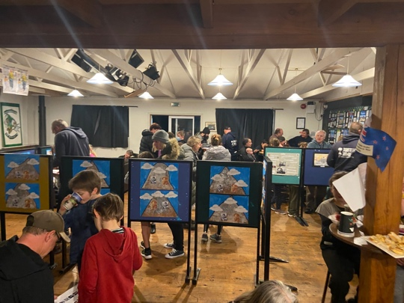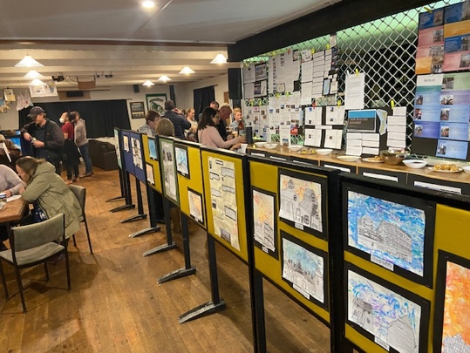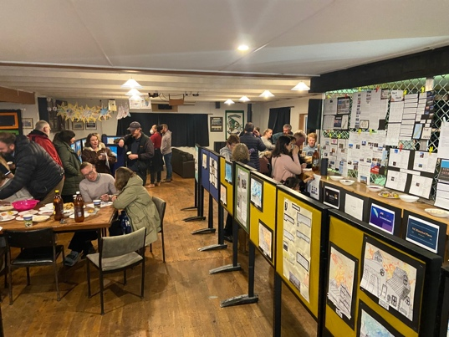
Sports Round-Up
Netball
Congratulations to Lily Scott on earning Player of the Day for the Big Rock Dolphins. Great work Lily. Many thanks to Jasmine McNab and Marina Conway for taking these young stars.
Well done to Mia smith on rightfully earning Player of the Day for the Big Rock Rockets in their victory. Excellent stuff Mia. Many thanks to Lisa Russell for taking these older stars.

Basketball
Bravo Armani Ngaia on earning MVP in a hard fought and at times challenging victory on Monday night. As the poem by Rudyard Kipling states, If you can keep your head when all around you are losing theirs… top man Armani.
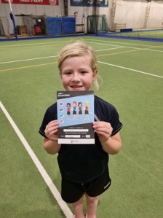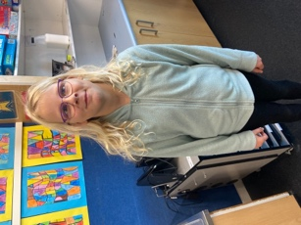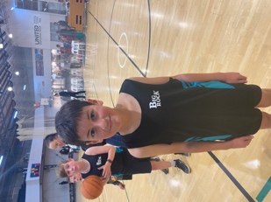
Hockey
Well done to Lucy Tapp on earning Player of the Day for her hockey team. Greats stuff Lucy, keep it up. Also well done Charlie Rackham who was Player of the Day the previous week. (Photo to come)

Football Fantails
Congratulations to Emma Egan on earning Player of the Week for her Football Ferns team. You may have noticed this is Emma’s third award in 3 weeks for 3 different sports, netball, hockey and now football. Outstanding effort and determination Emma.
Mighty Brighton Seagulls
Congratulations to Ivar Elliot’-Tressler on earning Player of the Day and well done Rhys Shayler on earning Most Improved and maybe being the happiest person ever in a photo.
Well done to Charlie Hughes on earning Player of the Day and bravo to Fletcher Graham for earning Most Improved. Brilliant stuff lads.
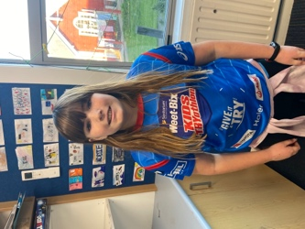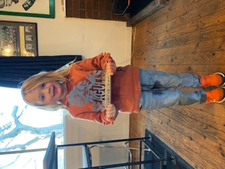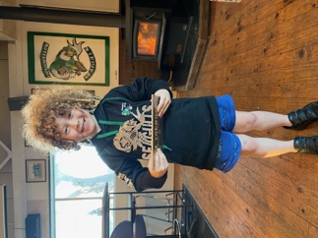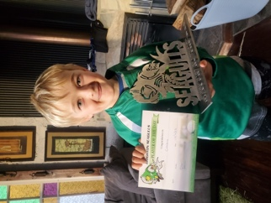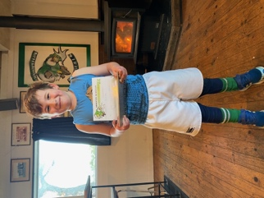
Next Term
One of the things that has come out of the recent Community Survey has been a request or suggestion for a range of things that are quite similar, these being planting and growing, ecosystems and biomes, climate change, Food Chains and Webs and environmental issues. As such our major Integrated Topic Based Learning programme will be under the title of the Living World where the children will learn and explore the things previously mentioned. We are currently putting kits together.
Also, early next term, week two, we will be holding interviews to discuss the Mid-Year Achievement Reports and next learning steps. Bookings will be available through Skool Loop before the end of the term.
Lastly
This week I have had the pleasure working small groups from my class and doing a bit of cooking. The food the children cooked, at their request was sushi (x2), sweet and sour pork (x2) but different recipes, Vension Rogan Josh, Macaroni Cheese, Chicken Fried Rice and Chicken Tikka Masala. All recipes that involved a sauce, were made from scratch and not a jar of sauce. While we were cooking I thought about my own time at school and the cooking we did. The food we cooked usually involved a very serious approach to sifting flour followed by lots of shouting from an irate teacher that the sifting was wrong, or we were making a mess or some such nonsense. If someone had suggested to the teacher that we make Chicken Tilkka Masala or sushi or any of the other dishes we’ve made, I reckon that she would have fainted, or became irate again There sure wasn’t a lot of joy in school cooking in my day, it was a very serious affair.
There’s an old saying in rugby that if you want to have a successful team, first you’ve got to have the right cattle! The food that these children prepared, cooked and ate, is testament to their enthusiasm and ability and for me having the right cattle. More cooking to come. (I’m not saying the children are cattle)
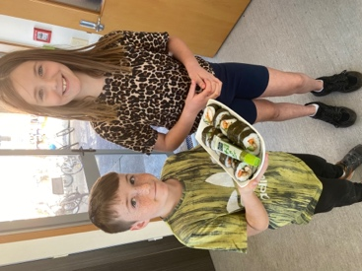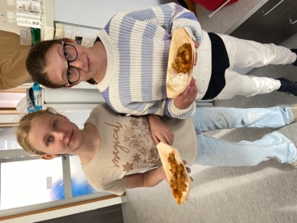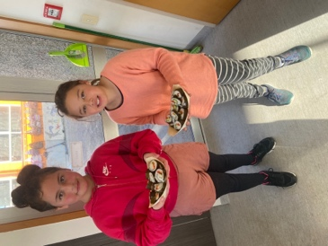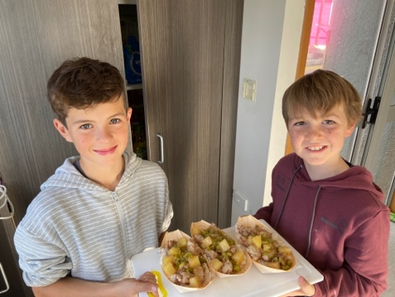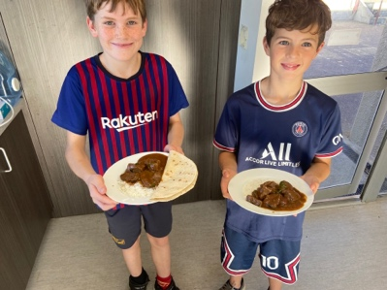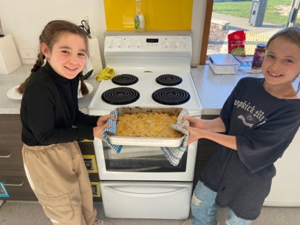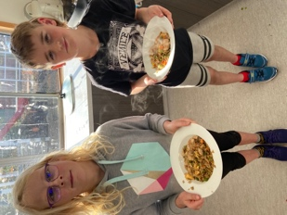

Have a great weekend and good luck to everyone playing sport or any other competitive pursuits, (That is you I’m talking about Cameron Walters)
David Grant
Principal

