16th August 2024
Education Outside the Classroom (EOTC)
Here at your school, we have always found that Education Outside the Classroom has intrinsic benefits across the whole curriculum, building confidenc and self-esteem as well as good mental health. Education Outside the Classroom is not just ‘adventures’ be it on bikes, surfboard or kayaks, but also trips to the museum, flying paper planes and measuring the distance, to reading outside. On Tuesday I received an education publication with an article entitled Leaving the Classroom to Boost Well-Being, which confirms what we have found and why we have such a comprehensive EOTC programme, particularly in our senior class, where the benefits are immense. Another article from a research study called the Quebec Study found the following benefits of EOTC for children:
- Improves mental health and increases self-esteem
- At the cognitive level improves how children retain learning
- Increases children’s ability to transfer their learning to everyday situations
- Develops social relationships between students and provides additional opportunities for collaboration amongst their peers
- Physical competence is enhanced through gaining motor skills
Our EOTC programmes have a genuine purpose and are not just for fun, even though they are fun

Mountain Bike Adventures
This week saw our Senior Girls TnT group and the Advanced Group enjoy two very different adventures. The senior girls enjoying a ride in glorious weather on the Portobello side of the harbour. On Tuesday the Advanced team were pushed and challenged at Forrester Park. Different experiences with similar benefits.
I had the pleasure of joining the Advanced group and I know Mrs Van loved riding with the senior girls. The other TnT group have their next adventure on Tuesday 27th August.
Information will come home soon regarding expressions of interest in the Introductory group. In the first instance this is aimed at Year 2-4 children, but there is a possibility for younger children, but is based on numbers. Please be aware that with the Introductory group we will not be teaching the children how to ride but developing new skills.
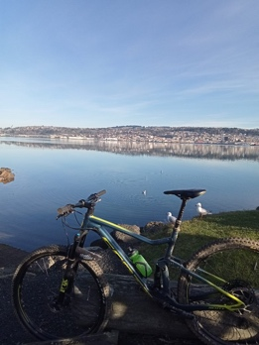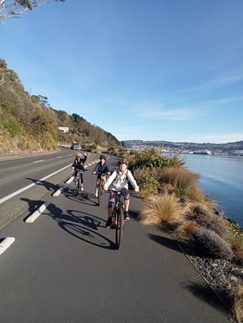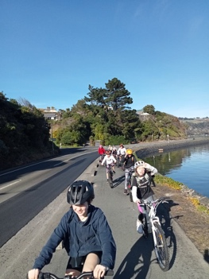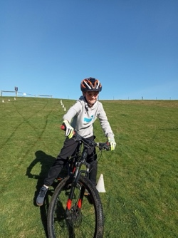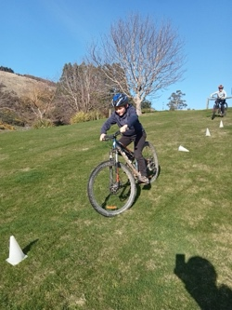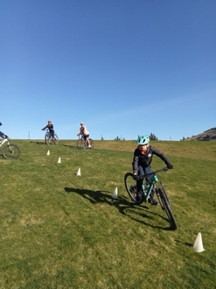

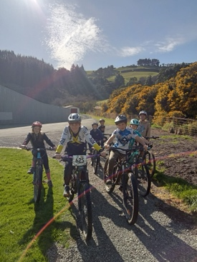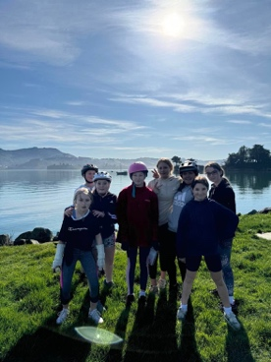
Sports Round-Up
The week got off to a flying start with the Big Rock Hoopsters claiming the Year 7-8 Mixed grade title in basketball. They were victorious against a Kaikorai Valley College side in the final, 44-24. All credit to the KVC side, they never gave up and played with great spirit. It was great reward for the Big Rock Hoopsters who worked hard for each other all season and not only reclaimed the title but went undefeated. Thanks to the players, the supportive parents and the coach, former Big Rock student and one of the original Big Rock Hoopsters, George Grant.
Well done to Flynn Blanchard on earning Player of the Day for the Big Rock Shooters. Again, they have had a great season, a few wins, a few defeats, but lots of fun. Thank you again to players, supporters and to coach Fiona Skerratt.
Sadly, the Big Rock Coasters had to default due to illness. Again a great season, again, thank you to the players, supporters and coach Teresa Grant.
On Tuesday night the Big Rock Hurricanes were decimated by illness, but they showed great character to narrowly lose 5-4, in a game where they gave it everything. Congratulations to Emma Egan on earning Player of the Day.
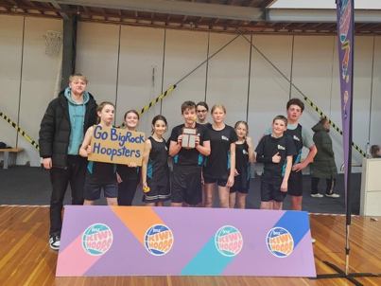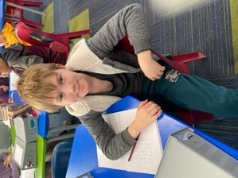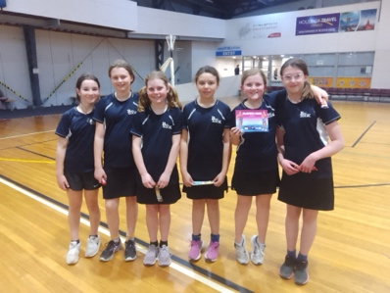
Congratulations to the following people.
Adelaide Conway- Player of the Day for shooting lots of goals for netball team
Ada McIver- Most Improved – Brighton Mini Gulls rugby
Lexie Brown- Player of the Day – Pirates Rugby Club
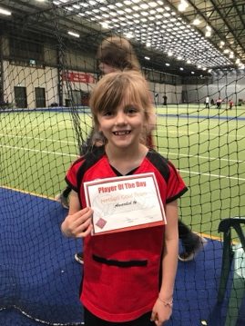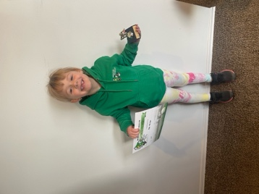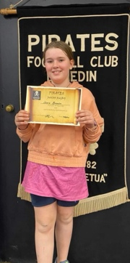
Futsal
We are now taking names of anyone who is interested in playing futsal next term. At this stage I have no information on what days, different grades are on. We like to keep our teams to a maximum of 7 players so that all players get as much court time as possible. If your child is interested in playing, can you please let the office know. Even if your child has always played, we need to know, we can’t assume children want to play. Also, if you are keen to coach/manage a team, please let us know. Previous coaches will have first right of refusal.
EOTC in Room Four
Room Four have spent a bit of time this week outside as part of their maths and art programmes. Firstly, making paper planes and measuring their flight distances. Well done Kiptyn Garner and Taylor Matthews for recording the longest flight.
They also spent time learning about photography with local professional photographer, Justine Weatherall. Many thanks Justine. Then they were outside and into it, using the recently purchased class set of cameras. Out there doing it. Great work Room Four, Miss van Aalst and Mrs Van.
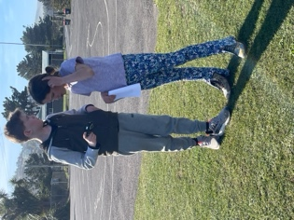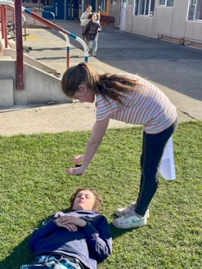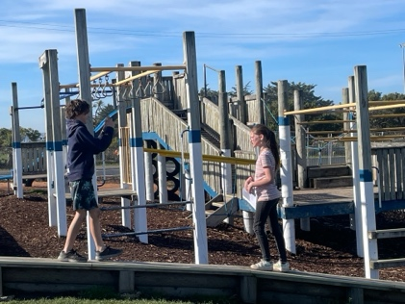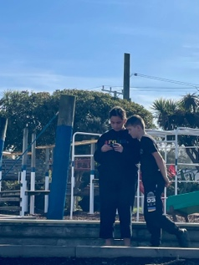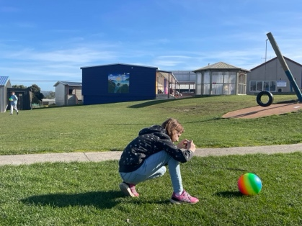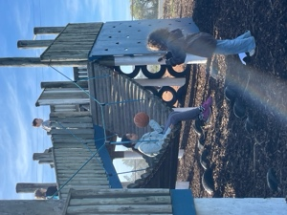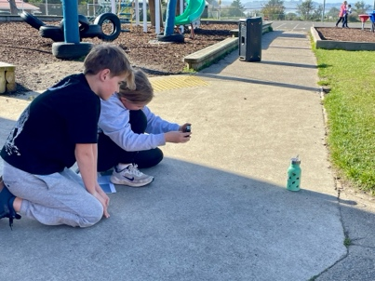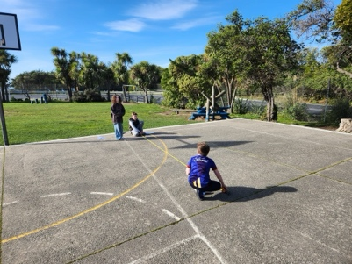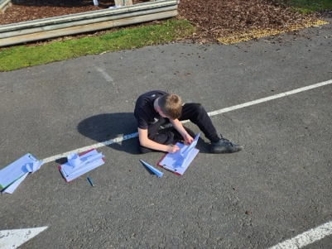
Structured Literacy
Thank you Mrs Lamb and Mrs Grant for $7000 worth of new Structured Literacy resources. Fantastic.
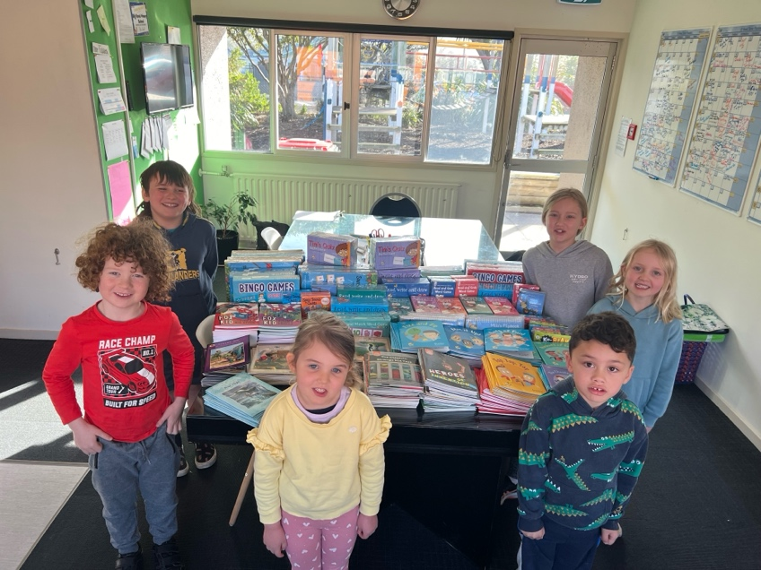
The Big Rock Café (They were going to call it the Hard Rock Cafe, but it’s taken)
Currently Room Five (Year 7-8) as part of many curriculum areas are looking at introducing a lunch time café at school. Possibly next term. Below you’ll see the beginnings of the plan. Watch this space!
Big Rock Cafe Proposal
Curriculum Areas:
Numeracy - Financial (Budgets), Timelines, Stocktaking, cooking time and temperature
Literacy - Creating and designing menus, reading recipes
Health - Food/ Personal Hygiene, Cooking/ Baking
The Arts - Package Design
Other:
Time Management, Ordering, Customer Service, Google sheets
Proposal:
Aligning with our Curriculum, we wish to run an in school cafe once a week or fortnight.

Rationale:
As well as offering students the opportunity to prepare, cook/bake, clean, it also brings financial literacy alive, making it real to the kids. They can budget, see
Food Handling Certificate?

Roles:
Designing menus in advance - presenting menus (canva)
Creating ingredient lists off menus.
Budgeting - Pricing, Income, expenditure, margins, profits
Ordering ingredients
Food Preparation
Cooking/ Baking
Service - orders/ money, food.
Cleaning
Designers - package/ product design

Possible food items:
Mac and cheese
Chips
Butter chicken and naan bread
Taco or nachos or fajitas or wraps
Burger
Pasta and Salad
Soup + toasties
Art Extravaganza
As you know we have our Art Extravaganza coming up soon. Currently we have art works on show that are part of the school that have been created and displayed by Year 8 artists over time.
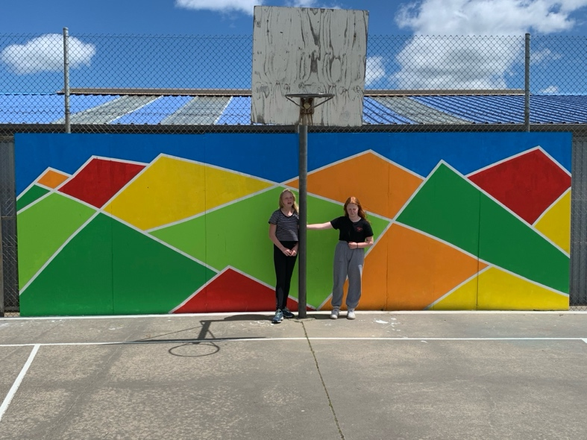
Imogen Lucking
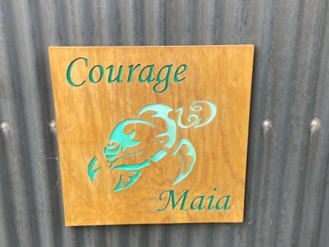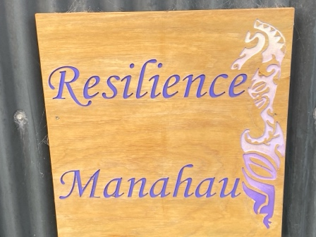
Isabella Coatsworth
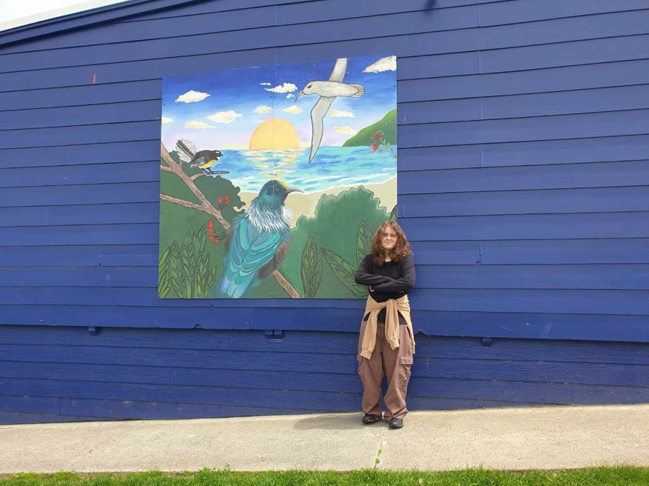
Ayshe Tutgun, Libby Mooyman, Stevie Kahui and Chloe Velenski
Have a great weekend
David Grant
Principal

