15th November 2024
Swimming Pool
As you are possibly aware the school pool is now open for the season with keys available to school families at this stage.
Firstly, I want to thank Kerry for all of the work that she puts in getting it ready, often in her own time. I know that she gets a real buzz out of the joy the children get out of it.
While we know that the pool is not perfect we work hard to maintain it as good as we can with incredibly limited funding. We get no funding at all to operate the pool from the Ministry of Education, in fact we get the same funding as a school the same size that does not have a pool. The power to heat it, cleaning products etc are expensive, the Board need to be commended for keeping it open, when many schools have closed theirs.
Having it available to all classes is important. We live in a beach community, in an island nation. Water safety, water enjoyment and swimming are important. This also leads into our senior aquatics programme that includes not only swimming but also surfing, kayaking, snorkelling and SCUBA (basic). This makes the pool such a wonderful learning resource. Having it open at lunchtime is also pretty cool and provides another playground option. (I don’t know any other schools that have the pool open at lunchtimes).
Thank you, Kerry and the Board, for the work and the resourcing to make it happen.

Futsal
Congratulations to the following players on earning Player of the Day for their respective teams.
Big Rock Dolphins – Rowan Patterson
Big Rock Stingray – Quinn Hollands
Big Rock Barracuda – Zach Turner
Big Rock Orca – Whole team
Big Rock Sharks – Kade Hancock (W 17-1 v Kaikorai Valley College)
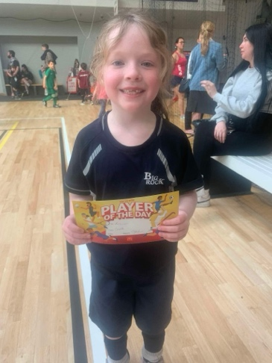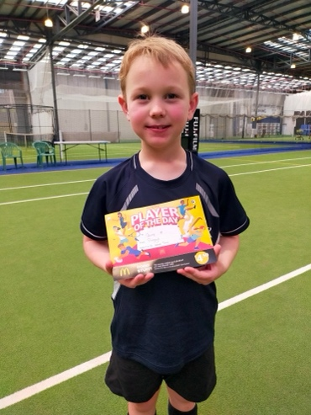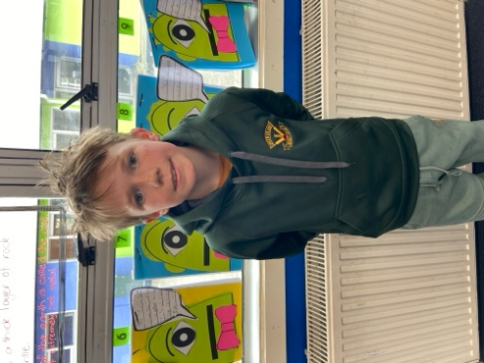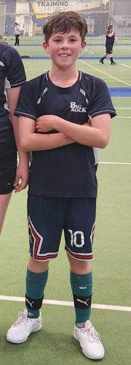
Big Rock’s Got Talent
Our very first Big Rock’s Got Talent show is now on next Friday with the first act on stage at 2:00pm sharp. The performances are now going to be at school outside the library. Lunchtime will be earlier than usual so as to allow the stars to get ready etc. Parents are of course very welcome to attend. Well done to Shane Turner for making this event happen.
Ladies and gentlemen, boys and girls, please welcome to the stage… It is going to be amazing.

Well Done and Thank You
I would like to acknowledge Annette Hogg and her team of helpers for their amazing generosity, as well of course to the people who were able to help with donations or purchases. Also thank you to the good people at the Brighton Club for their support. To support one of our mum’s who is facing some health challenges. Impressive stuff, as I always say, I believe that this community represents the best of New Zealand’s values by looking after it’s own and being there to support locals and the local community. Truly beautiful.

Introductory Mountain Biking Programme
On Wednesday I had the pleasure of working with two groups of our young riders. We focused on basic bike maintenance checks, basic road safety and courtesy and riding skills. The level of enthusiasm is contagious. The skill level is developing fast, there is some work to be done on safety and awareness of others . They are young and it will come. A big thank you to Scarlett Hancock, George Weatherall and Kade Hancock for your help. The next session is on 27th November, please keep practicing on your riding skills and building up the bike fitness.
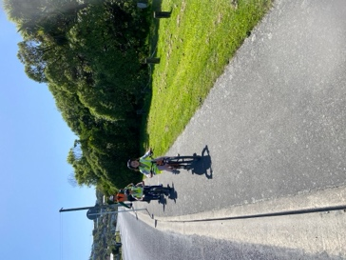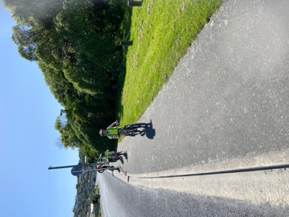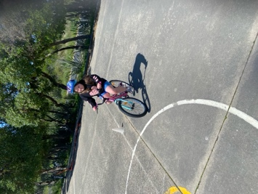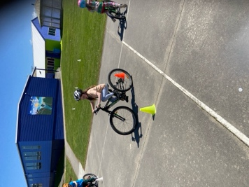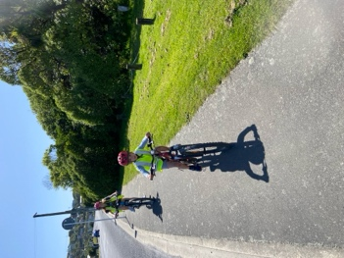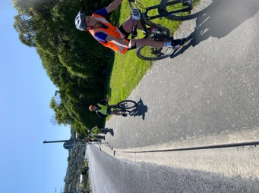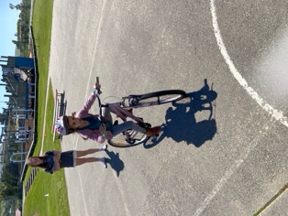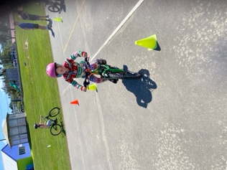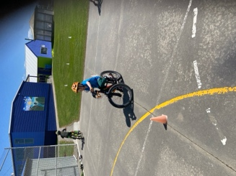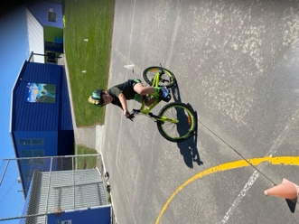
Year Seven and Eight Information (For next week)
On Tuesday half of the class are going SCUBA diving. While they are doing that the other half will be having another cooking session. This week it will be Asian influenced. There is no cost for this. We will also be working on the BBQ Masterclass sessions. The menu for Thursday will include bbq ribs, tomahawk steak, marinated chicken thigh kebabs and lamb chops. (Not a sausage in sight). There is also no cost for this. Prep will begin on Tuesday with cooking on Thursday.


Important Dates and Information
Individual photos and order forms are coming home today. Class photos are on display in the foyer.
End of Year prizegiving is on WEDNESDAY DECEMBER 11th at 4:00pm
Last day of After School Care for the year is Friday 13th December.
School closes at 12:30 on Monday 16th December. There will be no staff on sight after 1:00pm.
Have a great weekend
David Grant
Principal

