15th March 2024
Absences and Attendance
Last week I asked that if children are ill, particularly with flu/covid symptoms (runny nose, sore throat, coughing, aches etc) that they are kept at home until the symptoms pass. Can we also ask that when children are off school that:
- The Skool Loop absentee portal is used.
- Please give the genuine reason for the absence (If it is private or personal just put family reasons), we understand that families and whanau have lives outside of school and that children are not always off school because they are ill.
Currently in New Zealand there is a school attendance crisis. I am proud, and you should be too, that your school has very high rates of attendance, amongst the top across the country. (Over 91% last year and the Ministry of Education goal is 70%!). All Big Rock children come to school most of the time. However, when children are off school for different illnesses, we have certain protocols we need to follow in alignment with the Ministry of Health guidelines, please be up front with us. Also, your children are incredibly honest and tell us why they were off. This can put us all in a very awkward position.
Goldfields Bike Trip
Yesterday I had the privilege of tagging along on the Room Five Goldfields Bike trip, where they ride from Roxburgh Dam back to Miller’s Flat, with a few hardy souls stopping for a swim at Pinder’s Pond. It really was a wonderful day. This is a key part of the senior children’s Education Outside of the Classroom programme, that also includes surfing, kayaking, and Amazing Races (Literacy and Maths problem solving races on bike and foot) as well as class camp and Survivor Camp. These things are so important to children and their development as it builds self-esteem and personal resilience that transfers to confidence across all curriculum areas. Yes, bike adventures do help your child to be more confident as a person but also achieve better in Literacy and Mathematics.
Despite the challenge of the ride, particularly the start, the riders showed grit and determination, finishing with smiles of satisfaction. Many thanks to Mr Murray, Ange Hancock, Craig Walters, Justine Weatherall and Ant Brown for transporting and riding with children.
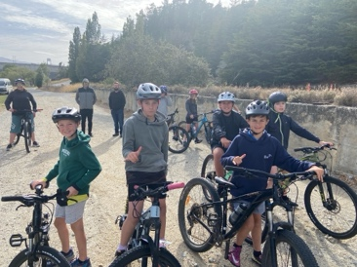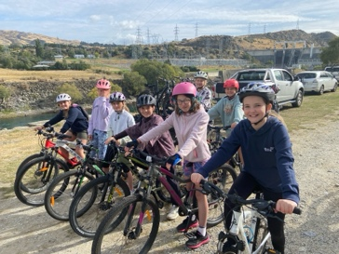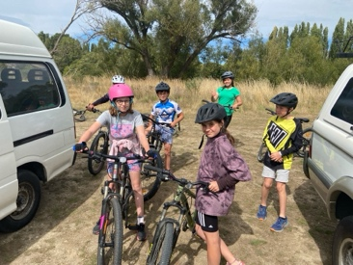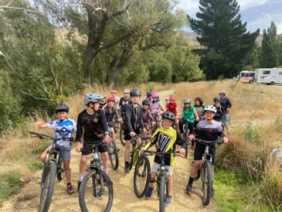
Can’t wait for Room Four’s ride on Wednesday.
Futsal
Congratulations to the following players who earned Player of the Day for their futsal teams.
Big Rock Dolphins – Penny O’Brien
Big Rock Starfish – Dion Mooyman
Big Rock Stingray – Bryn Little
Big Rock Barracuda – Flynn Blanchard
Big Rock Sharks – Scarlett Hancock
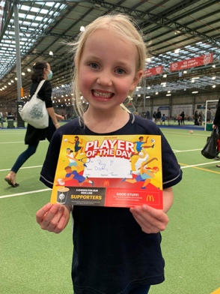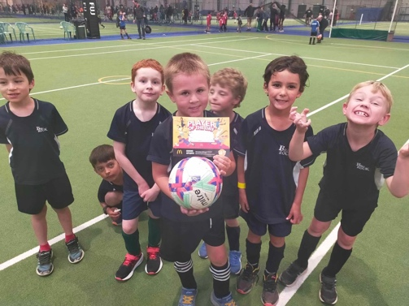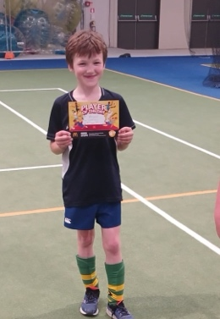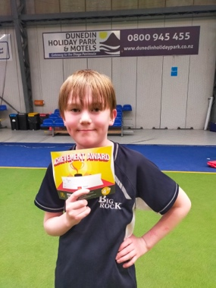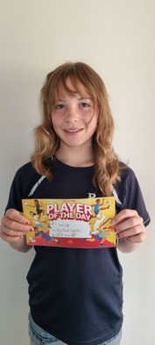
Congratulations
Well done to Lexie and Stella Brown, who at a recent West Harbour Gymkhana came away with a host of ribbons. Lexie having her first go at show jumping. Well done girls.
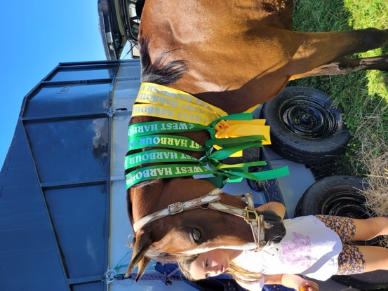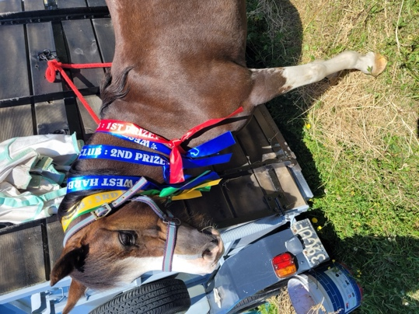
School Winter Sports
Thank you to everyone who has registered their child’s interest in basketball or netball. Please keep these coming. We try to keep numbers reasonably small so that all of the players get plenty of court time. We will need all names by next Friday please.
If you are keen or willing to help out with coaching or managing a team, can you please let us know asap.
Thanks.

Structured Literacy
Over the next few weeks there will be relievers in different classrooms as the teachers undertake up top date professional development in Structured Literacy. This will be very significant to the children’s learning across the school.
School Closures
In the coming weeks, school will be closed on a number of days as we observe the Easter Holidays and Otago Anniversary. Please note below the dates of the days that school is closed
Monday 25th March Otago Anniversary Day
Friday 29th March Easter Friday
Monday 1st April Easter Monday
Tuesday 2nd April Easter Tuesday (This is unique to New Zealand schools when Easter falls outside of term holidays)
Other Key Dates Coming Up
Monday 18th March Room 5 Best Barbeque Burger competition
Tuesday 19th March Fern Fever
Wednesday 20th March Room Four Goldfields Bike Adventure
Tuesday 26th March Room Two Bike Skills at school
27th – 28th March and April 3rd Life Education Trust Bus (Harold the Giraffe and Pip)
April 4th and April 5th End of Season Class Pool Parties
April 10th Room Five Amazing Race – The Gardens
April 12th Last day of school for the term
Have a great weekend
David Grant
Principal

