15th February 2024
Meet the Teacher Chats
Thank you to everyone who was able to make it to the Meet the Teacher Chats. If for any reason you were unable to make it, and would still like to have one, please contact your child’s teacher to arrange a suitable time.
Also thank you for all the excellent ideas for our refresh of the Science Curriculum. While we are waiting for more information on the new Science Curriculum and its release. Your suggestions, thoughts and ideas will prove to be very useful and important. If you didn’t share any thoughts but would now like to, please do not hesitate to let me know. Your feedback on this is very valuable.


Pet Day Extravaganza
Less than a week to go. I hope everyone is looking forward to it as much as I am. It is always an excellent and important part of the school calendar. The more people are involved the more they enjoy it.
The purpose isn’t just fun and the children sharing their pets, baking etc. It is also about managing their behaviour, independence (in a safe environment) socially interacting with their friends as well as children from other classes. Even a little bit of patience and tolerance as they que for games and don’t always win a prize. It is meant to be fun as well and a little bit different.
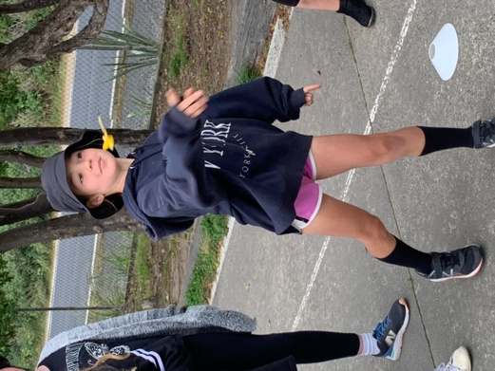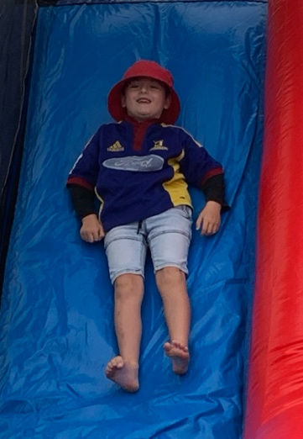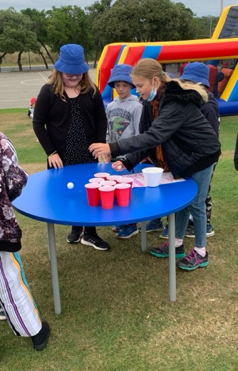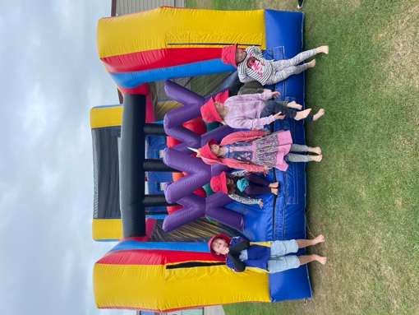
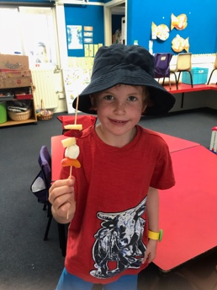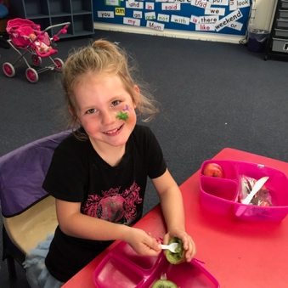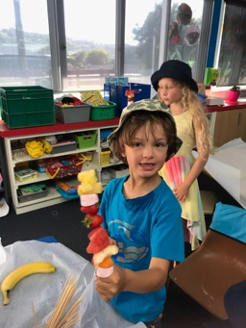

Taieri Mouth Adventure
Like our Pet Day Extravaganza, this too is an important day. Earlier in the week you should have received information and a permission slip. The more parents we have, the better it is. Parents only need to come for their child’s time slot. You are more than welcome to stay and help out with the different classes.
If you have a kayak or paddle board that we could use on the day, could you please let me know. Also, it would be fantastic if children who have their own lifejacket could bring them. (Clearly named please)
With regards to the sausage sizzle, all of our normal protocols will be followed.
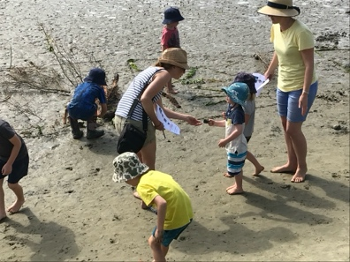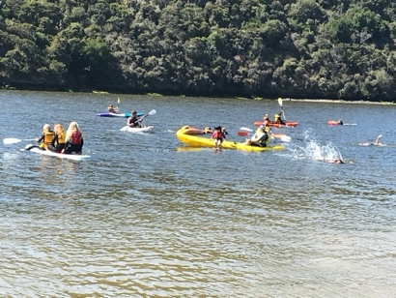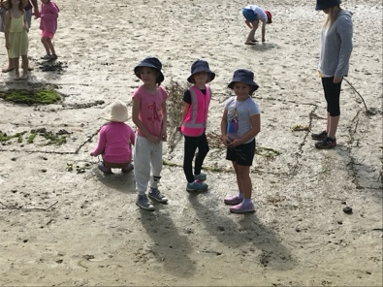
Futsal
Well done to the following players who earned Player of the Day for their respective teams.
Ollie McNair for the Big Rock Dolphins
Quinn Hollands for the Big Rock Starfish
Lily Scott for the Big Rock Stingrays
Isaac Lucking for the Big Rock Barracuda
Slade Marsh for the Big Rock Sharks
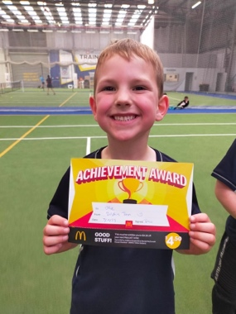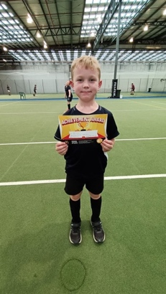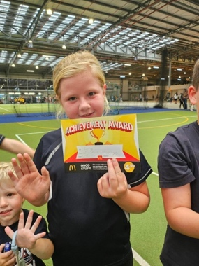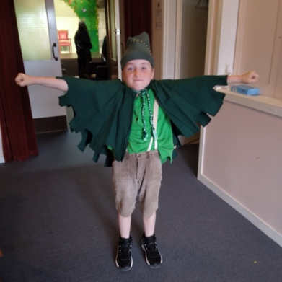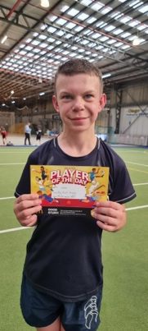

Senior Class Surfing
It was a perfect day today for our first surfing and boogie boarding session today. Beautiful day, nice consistent waves, enthusiastic children and great parental support. It really was superb. It is an important part of our school curriculum, with many advantages, not just surfing. Watching the surfers and boogie boarders confidence grow as well as the squeals of laughter when they (or a friend) wipes out. Thank you to Ange Hancock, Shane Turner, Ange Elliot, Scott Weatherall, Marc Yeoman and Vaughan Grey for helping on shore and getting in the water with us. Learning in paradise anyone?
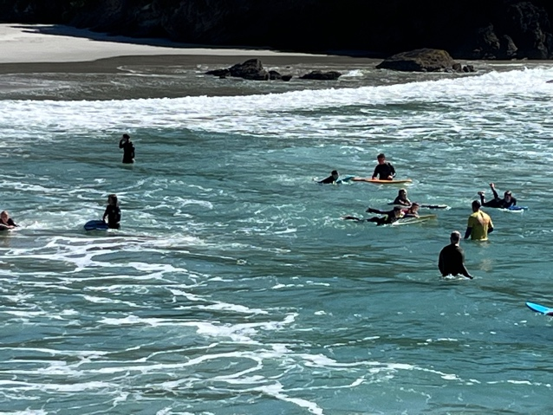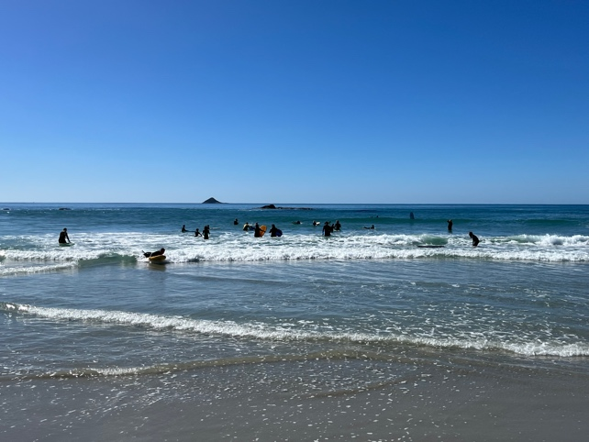
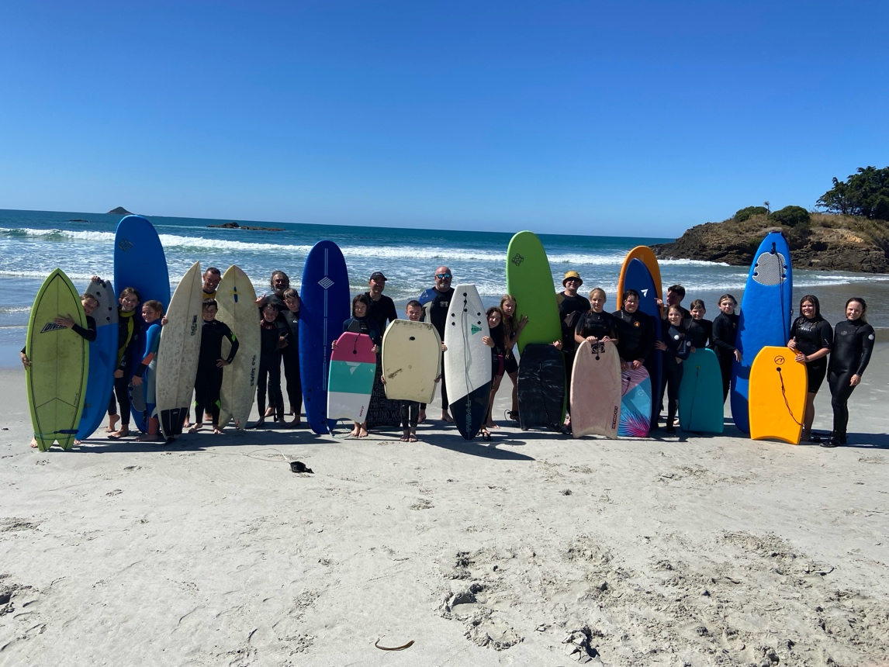

Sponsorship
A massive thank you to all of the sponsor listed below. Their help is immense as it means that our Skool Loop app and new soon to be open website are fully funded, and the school doesn’t have to pay and the children benefit. I urge you to use these businesses’ if they have the services you require. Thank you for the support.


Have a great weekend.

David Grant
Principal

