15th August 2025
Paid Union Meeting
You may have heard from friends or family with children at other schools that there may be some disruptions next week due to school staff attending union meetings during the day. I can advise you that there will be no disruptions here and it will be ‘business as usual’. We will not be closing or having a shortened day etc.
Flu and other Winter Illnesses
You are probably aware that there is a nasty bout of flu going around, one that is not only quite debilitating, leaves you feeling very unwell and tends to stick around. Most schools have had high numbers of unwell children and staff, some with up to 50% off ill at any time. It is yucky. Can we please ask that if your child has the usual symptoms, runny nose, sore throat, headaches, aches and pains, that you please keep them home. When they do come to school, they are very miserable, contagious and we will need to send them home. It does seem to come with a barking cough that takes a while to go away. While I am no doctor, if the cough is the only symptom (I am speaking from personal experience here), it seems that the worst of it is over. If you are unsure, please give us a call.
Sports Round-Up
Monday will see the last game of basketball for the season for the Big Rock Hoopsters, while the Big Rock Shooters, Coasters and our Big Rock Dolphins netball teams all had their last games this week.
Firstly, congratulations to all the players for giving it your heart and soul all winter, and usually with a smile on your faces.
A massive thank you to our wonderful coaches and managers for your dedication every week. Thank you to Tania Blanchard, Fiona Skerratt, Teresa Grant, Richard Murray and Marina Conway, your efforts are much appreciated.
I also want to acknowledge all our parents. Sadly, every year, children’s sport seems to bring out the worst in some people, with negative comments towards players, opposition and referees, which is tragic. Players make mistakes, referees make mistakes, it’s called sport. Sadly, when the negative stuff happens, it is no longer about children or children’s sport. I am always delighted but not surprised by the wonderful sportsmanship and encouragement shown from the sidelines by families and whanau from Big Rock, not just towards our players but also the opposition and referees. Take a bow.
It is now time to start thinking about futsal…
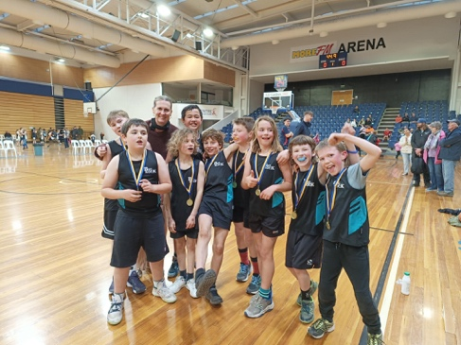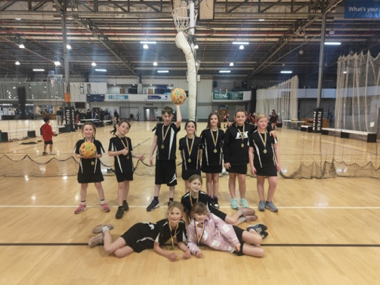
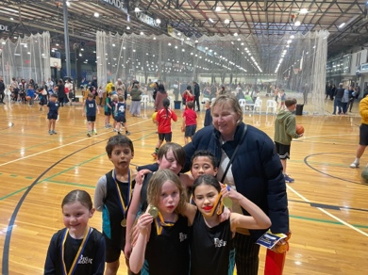
Congratulations to Alex Little and Willow Parker on earning Player of the Day for their Brighton Seagulls rugby teams.
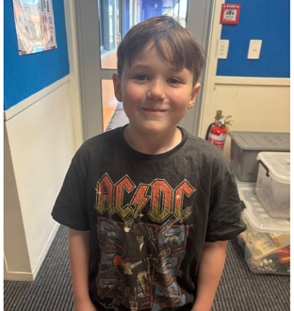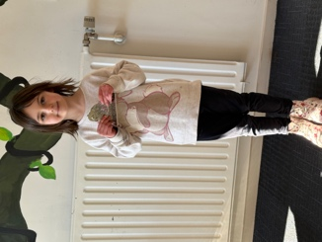
A massive well done to Lilly Hamilton and her Wild 1’s Dance Mega Crew who competed in the ‘Regionals’ at the weekend. They finished second, which is a great achievement. It also means that they qualify for the National Championships in September. Outstanding stuff Lilly and the Wild 1s.
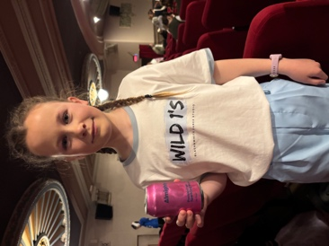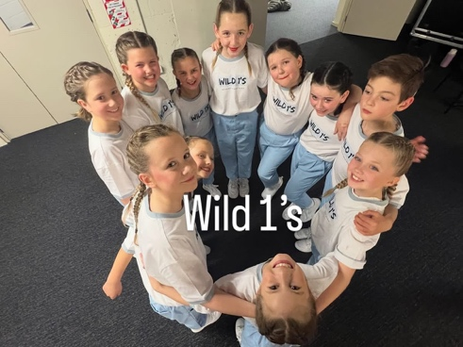


Skool Loop Sponsors
I would like to thank the following businesses for their much-valued support. Their support means that we don’t have to fund the Skool Loop app for families or the school website. We encourage you to support the people and the businesses.
- Kumon
- Justin Time Plumbing
- Letitia Louise Photography
- McClelland Heat Pumps & Refrigeration LTD
- Chew Dental
- Kinetic Construction Limited
- KidsCalm
- Brighton Store
- Flex Fitness Gym Green Island
- Denise Casey - NZ Property Solutions
Have a great weekend, if you or yours are crook with the flu I wish you a speedy recovery, if not I hope it stays that way.
David Grant
Principal

