14th November 2025
Congratulations
I would like offer a massive congratulations to Rowan Patterson who recently won the INTERFACE Student Minecraft Competition 2025. Rowan won the Year 1-6 section. This is a nationwide competition, and Rowan is a Year 4, which makes the achievement all the more remarkable. The challenge was to build an environment that protects fish, keeps fishing sustainable and ensures clean and pollution-free seas that are full of marine life. We had a record number of entries and we were blown away by your ideas, creativity and building skills. (From INTERFACE magazine).
Outstanding Rowan, we are all very proud of your effort and achievement.
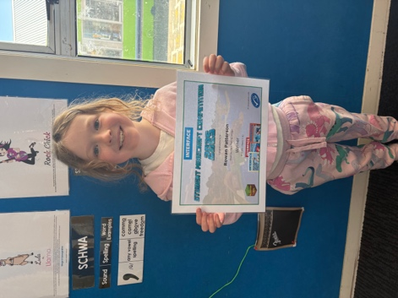
Thank You
A massive thank you to Annette Hogg and Colin Driver. You may have noticed a rather large blue and orange inflatable in the playground this week. It is called Hungerball and is an inflatable games arena with 6 goals and lots of fun. This is usually available for schools to hire much like you might hire a bouncy castle. Somehow, and I am not really sure how, we have it for another three weeks at the cost of nothing to the school. So thank you Colin and Annette for organising it and for helping set up and put away each day. It has been an amazing addition to the playground.
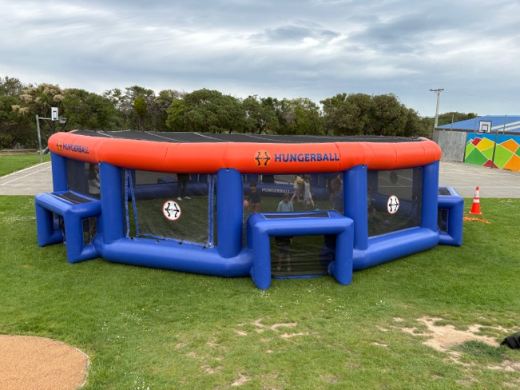
Futsal
Well done to the following players on earning Player of the Day for their respective futsal teams.
Big Rock Dolphins— Mieka Coory
Big Rock Orca—Will Judd
Big Rock Stingray—Zachary Nielsen
Big Rock Sharks- Charlie Hughes (Last week)
Big Rock Sharks- Korbyn Parata-Walters
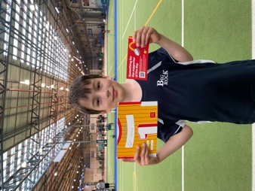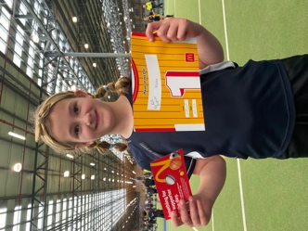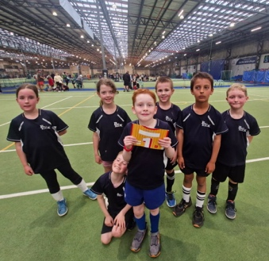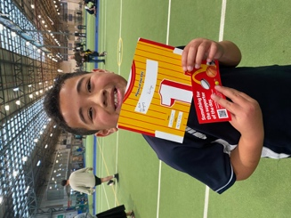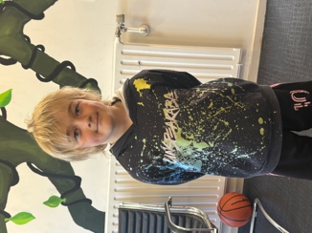
Brighton Trail Ride
Earlier in the year the school was lucky to play a part in the Brighton Trail Ride and received $12,000 towards the pool. This enabled us to not only keep the pool open but carry out expensive but necessary maintenance.
There is another trail ride on Saturday February 7th 2026, and we need your help. We need people on the day to help with carparking, taking registrations and marshalling. If you can help, can you please get in touch asap.
It might seem like a long way away but by the time the school holidays roll through it will be upon us.
Next year’s event promises to be bigger and better, and will raise much needed funds to support the children’s learning and development.


Bush Banquet- Gastronauts
Yesterday as part the senior Gastronaut programme and part of the Science and Nature School programme, the children were challenged to plan and cook a ‘bush banquet’. In essence plan and cook a meal over up to three hobo stoves. While the results were varied, mainly due to the wind making it difficult, the aspiration was great. From pork and beef wrapped in smoky bacon, to filled crepes, crispy chicken on rice, chicken kebabs, banana toffee pudding, omelettes and of course a range of burgers.
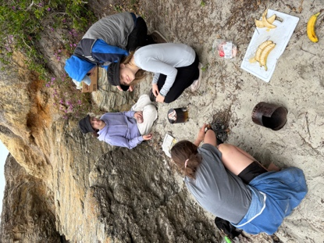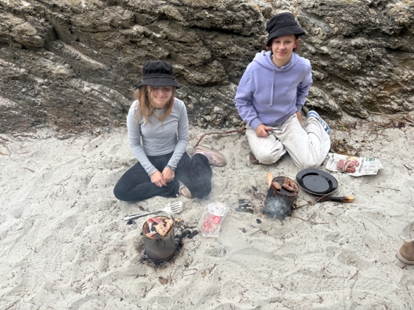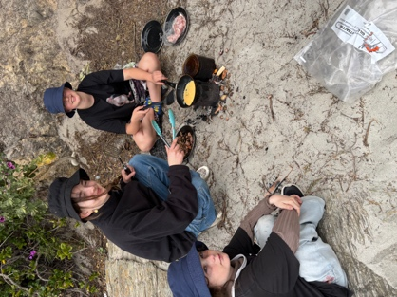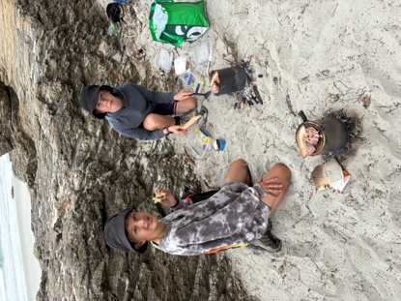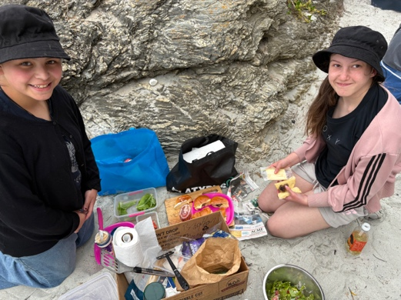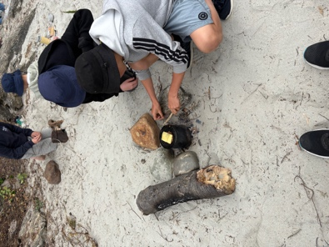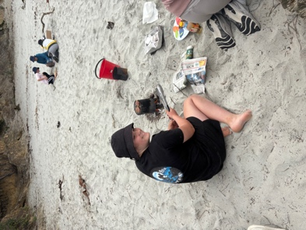
Rising Star – Bella Yeoman
This week’s Rising Star is a stunning performer on stage, whether it be singing acting or playing the guitar- or doing all three at the same time. Isabella (Bella) Yeoman is the lead singer in the school band as well as one of the two guitarists, she also played Alice in our recent musical production of Alice. She has also performed/sang at the World Choir Games, is a regular performer at the Brighton Muso Day, and recently took part in a busking competition with lots of success. Bella has an easy grace to her performances, is incredibly humble and has that rare ability of being able to laugh at herself and not take herself too seriously. A rising star? Absolutely, she may already be one. Watch this space…
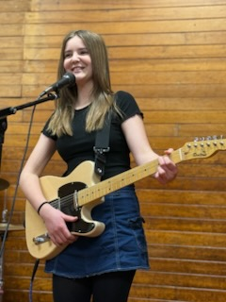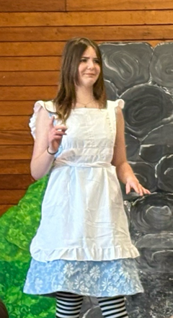

Assembly
Thank you to everyone who came our first assembly in a while. It was great to see how enthusiastic the children were and how encouraging of each other.
Our next assembly is on Wednesday 3rd December at 2:10 outside the library. It will also feature a Homework Heroes Superdraw.
PTA Meeting
From the newly formed PTA;
PTA Formation Announcement
A huge thank you to everyone who attended our recent PTA meeting!
We’re excited to share that we now have 10 enthusiastic members, which means we can officially form our PTA!
We’d love to welcome more members — anyone can join, including parents, caregivers, grandparents, and community members who want to support our school.
If you’re interested in joining or would like more information, please contact:
Jo Henderson or Annette Hogg
Together, we can make a real difference for our school community!

Have a great weekend
David Grant
Principal

