14th March 2025
Pet Day Extravaganza
Not long now. This is definitely, one of the most popular days of the school year and with good reason. Children get to show how proud they are of their pets. Everyone loves the baking competition, which is always amazing. The children get fully involved in all the games. There is a genuine atmosphere of fun and togetherness. Watching the younger and older children mixing and having fun together is a very powerful force and so important in everyone’s development. It is a day we should all be very proud of, because it takes everyone’s involvement to make it work.
I know from other principal’s and schools that they don’t really understand how we are able to have day like it, that works so well. When you have the children we have, with the great attitude and behaviour, it makes everything else possible.
A little bit of information before the big day.
Firstly, all dogs need to be tethered down on the bottom field. All dogs must be registered with the DCC or for a few I believe, the CDC. Registration tags must be clearly visible. No dangerous or aggressive breeds please. The children’s safety is paramount.
The Baking Competition. Baking can be entered in three categories; Sweet, Savoury or Decorated. These can be entered individually or as families and whanau.
The homework challenges need to be taken to Room Four.
All games are free, some do have sweet treats as prizes. If you do not want your child to partake, please let us know.
If any parents are keen to help on the day, please let us know. An extra pair of hands is always welcome.


Achievement Report End of Year 2024 (All children)
 | Working Towards Expectations | Achieving Within Expectations | Achieving Above Expectations
Reading | 9% | 63% | 28%
Writing | 18% | 68% | 14%
Mathematics | 13% | 62% | 25%
All assessment is carried out using Ministry of Education approved, formalised assessment tools. It is also based on the children’s actual classroom work, learning conversations and overall teacher judgement.
When I present these results to the Board of Trustees, the Ministry of Education and Auditor General, they are broken down further into the cohorts of Māori, Pasifika, Male and Female, as well as all children. Due to the size of some of those cohorts I have chosen not to share. (They are very good but do allow for personal identification)
We are very pleased with these results, and they are considerably higher than national averages. We are working hard at getting them even higher. There is much more to a school though than just academic performance. There are things like social development, well-being, attendance, a sense of belonging and being happy All of which, of course support achievement. That is why I believe days like our Taieri Mouth Adventure, Pet Day, bike trips, Matariki celebrations are so important. They are real experiences that make a difference.
It is about teaching and developing the whole child.
Futsal and Winter Sports
Congratulations to the following athletes who earned Player of the Day for their respective futsal teams.
Big Rock Stingray – Fletcher Cockburn
Big Rock Barracuda – Elise Blanchard
Big Rock Sharks –
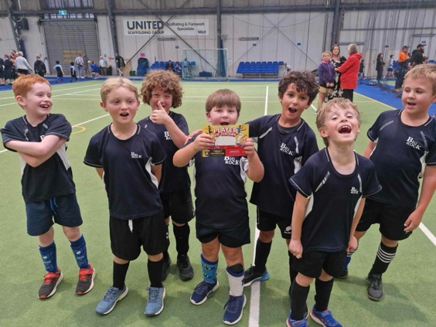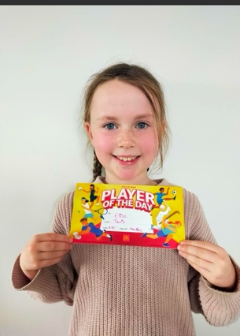
TERM TWO and THREE BASKETBALL
If your child is keen on playing basketball, please let the office know. Year 7-8’s play on a Monday afternoon evening, all other age groups play on a Thursday afternoon/evening. Can you please let us know if you are keen to help manage or coach a team.

TERM TWO and THREE NETBALL
If your child is keen on playing netball, please let us know. Also, if you are keen to coach or manage a side, please us know that as well.
All BIG ROCK player registrations need to be received at school by Wednesday 28th April so that we can conform teams etc.
Taieri Mouth Adventure
Another great day, sadly this time only for the 3 older classes. (I am working on getting the younger ones out on a boat trip up the river). As always it takes many people to make it work. Whether it be transporting kayaks, being in the water, on the shore, encouraging the less confident to cooking sausages.
For me, after the work putting it altogether in the weeks leading up to it, watching it all come together, seeing the smiles, hearing the shrieks of joy, is immense. I know that it’s a pretty special and unique day.
Thank you to all the parents who came along and helped. Thank you Ange Hancock for leading the kayaking, ably supported by Scott, Daniel, Tania, Alex, Lauren and Pete.
Thank you, Scott, and your mum and dad for the usage of the crib, helping with the transport of kayaks, getting us the Surf Club trailer and taking a day away from your busy schedule. Much appreciated.
Thank you to Aaron Hollands, Brayden Mitchell and Paddy Patterson for giving up your time, boats and fuel to make the day memorable. 2 of 3 don’t have children here and 1 never did. Unreal.
Lastly, thank you to the teachers for making everything flow.
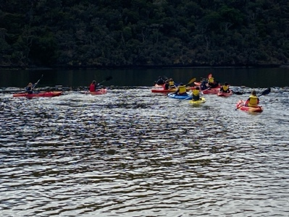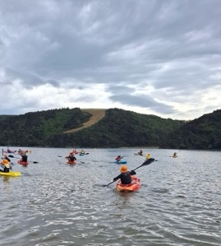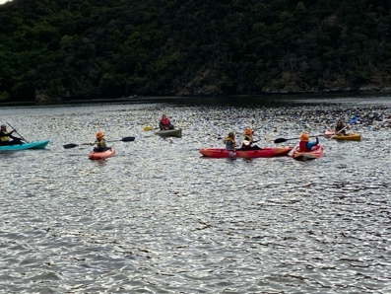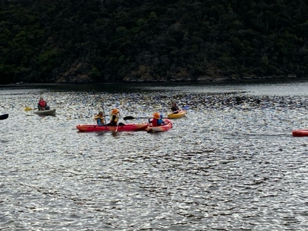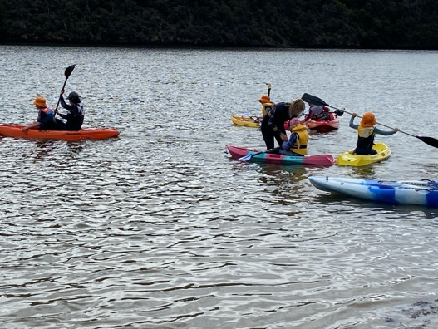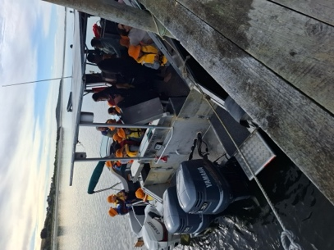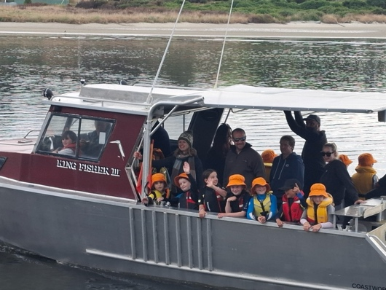

Science and Nature School
Another great session with Room Five today. This time we were out and about in the Ross Creek Reserve and Reservoir. A very nice way to spend a morning.
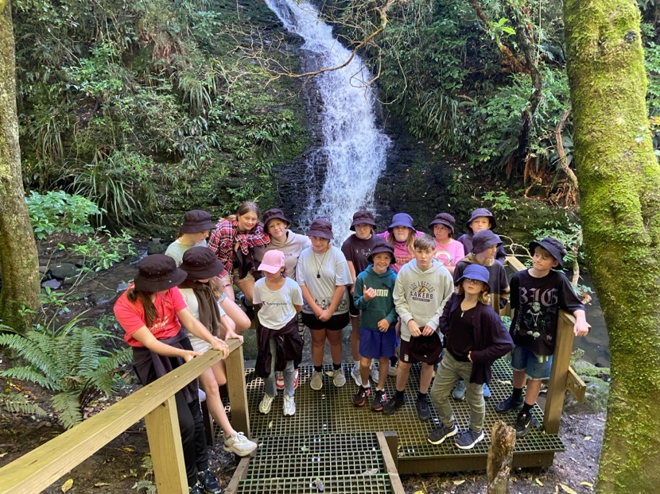
Have a great weekend

David Grant
Principal

