14th February 2025
Welcome
Last week I welcomed Octavia Whelan, this time I have a photo. I would also like to welcome Arlo Pfyl (Photo to come). It is great to have you on board.
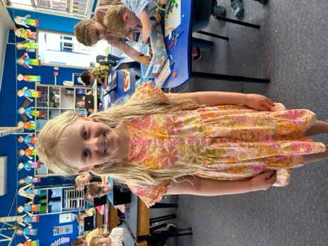
I would also like to welcome Mr Heath Ratten who has also joined us to help with our Science and Nature School and our Senior Surf Programme for the term.
Sad Staffing Announcement
It is my sad duty to advise that Mrs Mel van de Klundert (Mrs Van) has tendered her resignation to the Board, and it was accepted with regret.
Mel has been a wonderful member of staff, joining us when we opened a new class back in 2018. Immediately being thrown in the deep end to organise a camp at Waihola, then having to manage it with Mrs Cambridge in the worst camp weather I have ever witnessed. That is, until I jointly ran a senior camp in Fiordland with Mel and the weather was even worse. Mel also ran great camps with great weather at Berwick and Waiora on more than one occasion, as well being a part of early Survivor Camps. I had the pleasure of sharing a class with Mel for a number of years and it was a lot of fun for everyone. Mel brought an incredible energy and enthusiasm to the classroom. I could fill the newsletter with attributes, both personal and professional. One of the many standouts for me though was during the first Lock-Down Mel’s commitment to her classes learning programme, one that was shared across the school. Mel ensured that she had ‘Zoom’s with every child daily as well as collective class catch ups, daily. This ensured that the vital social connection ensued, all combined with quality at home learning programmes.
Mel, the energy and ability to the classroom that you brought will be missed, as will the enthusiasm and commitment to things like our Pet Days, Matariki celebrations, Art Extravaganzas, Amazing Races and camps.
On behalf of the Board, staff, school community and most importantly, the children, thank you and we wish you, Con, Ana and Lola all the very best for the future. You will be missed.
Senior Class Out and About
Today was the first day of our new senior Science and Nature School programme. This is a programme designed to get the children out of the classroom and into the local and wider environment. The programme is aimed at learning in, learning about and learning for the environment. The overarching philosophy is that if the children learn in the environment, understand it, have fun doing so they will love it and be more likely to care for it. Let’s be honest, it’s more fun than recycling, and before anyone gets cross yes recycling is important but not exactly exciting.
Today we spent the morning in Fraser’s Gully and in the afternoon enjoyed our first surfing session. What a session it was in that weather. The water was beautiful, the children were enthusiastic and courageous, doesn’t get better than that. Unless you are learning in paradise. Ohhh that’s right they were
Many thanks to Kirsty Rackham, Ange Hancock Cavan Jenkinson, Vaughan Grey, Susannah Yeoman and Shane Turner for all of your help with the children and assisting Mr Murray, Mr Ratten and myself in the water and on the beach.
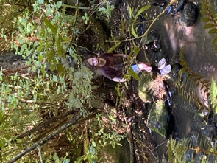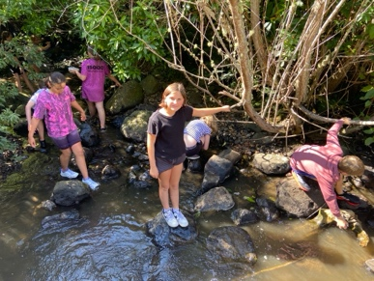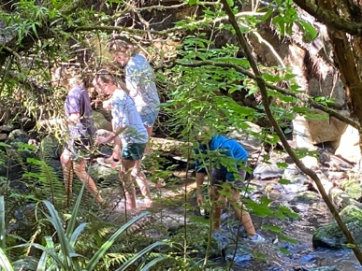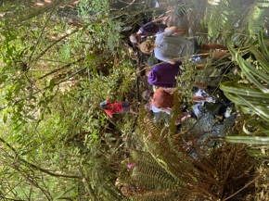
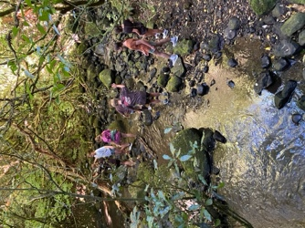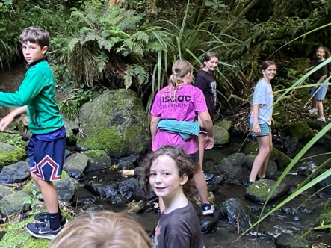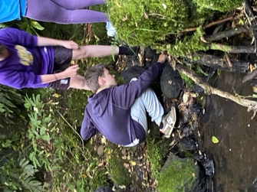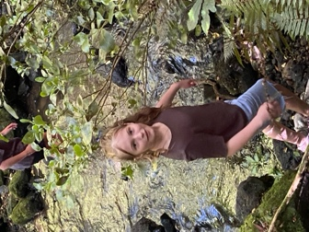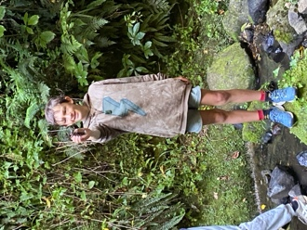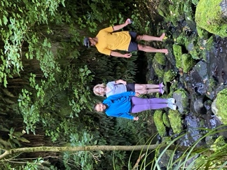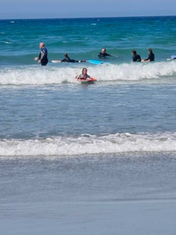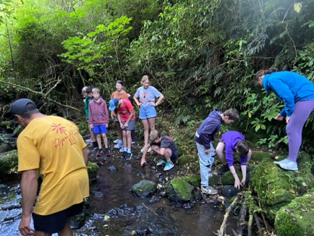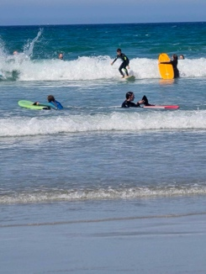
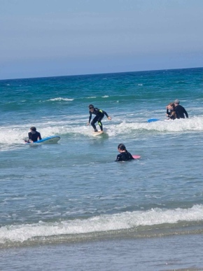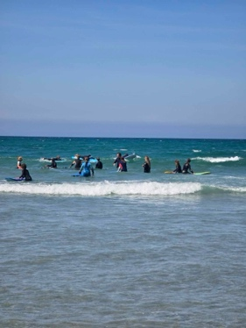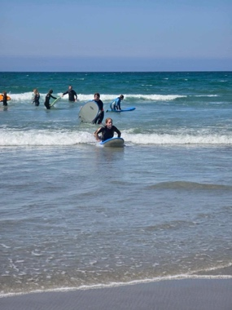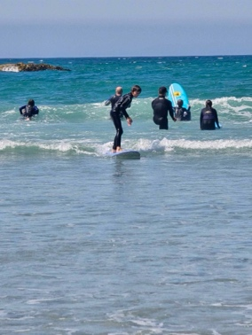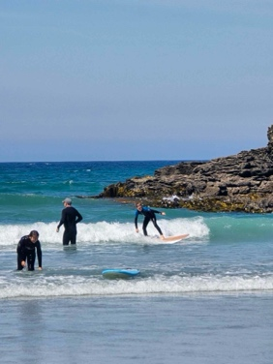
As former student and outstanding surfer Ruben Peyroux used to say: “Why catch a bus when you catch a wave!’
Meet the Teacher
Thank you to everyone who was able to catch up with their child’s teacher earlier in the week. For many it would have been your first opportunity with your child’s new teacher. If you couldn’t make it and would still like one, please contact your child’s teacher.
Brighton Trail Ride
Earlier in the week a form went home seeking help for an incredible fundraising opportunity on April 5th. If you can help, please complete the form and get it back to us. If you are unsure, or even a wee bit nervous or shy, don’t be. These fundraising events are usually a bit of fun.
The funds raised will benefit all children as it will go to some much needed (and expensive) swimming pool maintenance and upgrade.
Playground Addition
Next week I will have some exciting news regarding a new addition to the playground. It is a game that is much loved by children who have attended Mrs Grant’s camps, and it is coming soon to a Big Rock near you.
A massive thank you to Clarke and Jasmine McNab, with the support of Mitre 10. Watch this space.
Have a great and hopefully sunny weekend. If you are heading off to Lobofest, sunscreen, hat and stay hydrated, it’s going to be warm.
Enjoy the sun
David Grant
Principal

