Good afternoon Big Rock families/whānau.
Visitors to School this Week
All the classes have had two different sets of visitors this week. On Tuesday and Wednesday all the classes were involved in age-appropriate levels of first aid with Jacqui Henderson from Hato Hone St John Ambulance. It was an excellent experience for the children and their enthusiasm and engagement were superb.
Today all the classes have had four Nursing students working with them in a range of activities with Q and A session at the end. The Nursing students were outstanding. So much so that if Nursing doesn’t work out, try teaching. Their approach and enthusiasm when working with the children was outstanding.
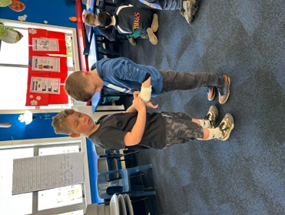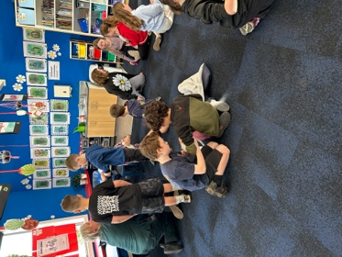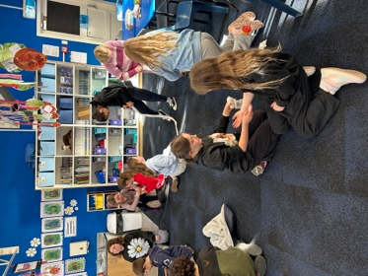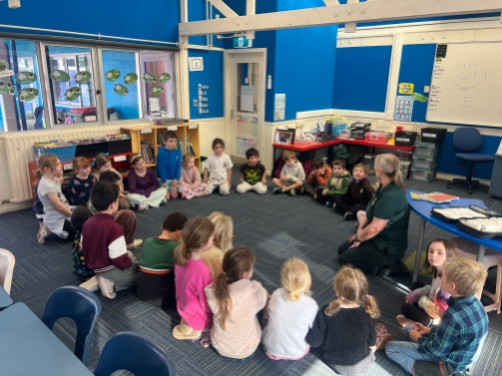
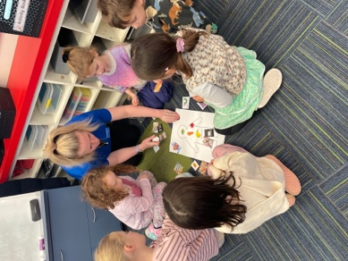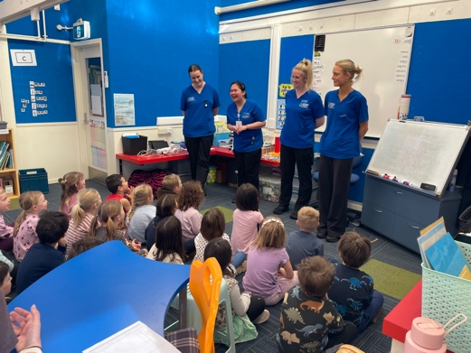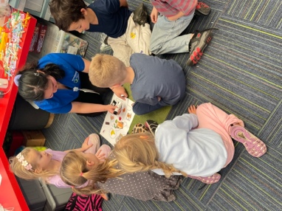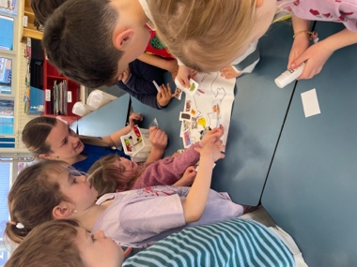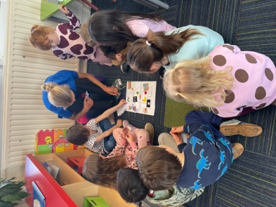

Sports Round-Up
From the basketball sidelines:
It was a tough decision for player of the day, so we had two – Quaye Driver and Fin Ramsay
Outstanding game, amazing Teamwork by all the team, they have come a long way this season bringing home 10 Wins and 2 losses for the season for Big Rock School.
Unfortunately, Jed was out due to illness and the Twins Jaxon and Leon being away, but they all deserve a shout out for being great sports stars.
We did have to borrow from another team last night , Massive Thank you to Kaiser Millar from Balaclava school year 6!
A massive shout out to Alex and Sarah Ramsay for making the team hoodies, they are great, and very much appreciated
A shout out and thank you to coach Colin Driver for doing an amazing job.
A shout out and thank you to Stanley Parata for also being a part of the coaching team

I 100% agree with all that is written above.
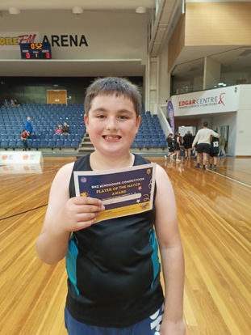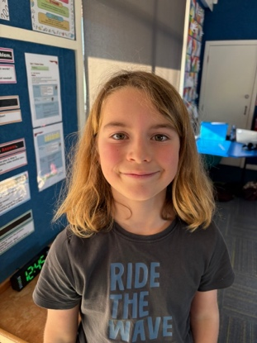

Out and About
As part of the Science and Nature School senior programme, the senior class visited the Botanic Gardens, where they had to locate 20 different attractions, including flora and fauna, take photos, mark each location on the map and present in digital form, back to the class. All unaided and in the form of an Amazing Race. It was lots of fun and a little bit competitive, but they all got it done. Thank you Mr Murray.


A New (Actual) Use for Ooshies
Sadly a lot of schools have gone down the road of banning Ooshies from schools. I am pleased to say that we have not had to go down that road and for the most part the children been remarkably sensible with them. As you know these things come and go, historically we have had the Disney cards, Pokemon cards, Yu Gi Oh cards etc. I guess it can be frustrating as a parent, the wee obsessions the children develop over them, but they love them and they are pretty harmless.
Today in Room Two we built catapults using rubber bands and ice-block sticks and played a game using the Ooshies as projectiles- it was very scientific(ish) with varying degrees of success. Who knew that the Hulk would fly further than Yoda?

One of the children has misplaced there Ooshie Collection. They are in a Winnie the Pooh tin. If anyone has any clues, please let us know asap. Thank you

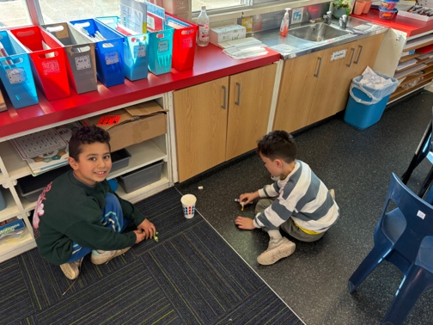

SAUSAGE SIZZLE TUESDAYS
As of Tuesday 11th August, the senior students will be running a sausage sizzle. These will be on every Tuesday until at least the end of the term. Sausage and bread with complimentary sauce a mere $2 each. We are also capable of looking after any specific dietary requirements, whether they be cultural, health or personal lifestyle choices. Please let us know. Where necessary they can and will be cooked separately.

ONLY ON TUESDAY AT BIG ROCK
Food for Thought
‘That’s the real trouble with the world; too many people grow up!’ Walt Disney
Have a great weekend
David Grant
Principal
Keith from Project Excavation Landscape is responsible for our school looking so smart. If you have any
landscaping or excavation projects we highly recommend using his services.
Reminders
Sushi
Sushi is available for lunch every second Wednesday. You can order this by using the Kindo/Ezlunch app.
Term 3 sushi.
Wednesday 22 nd July. 5 th , 19 th August. 2 nd , 16 th September.
Knowing if your child is well enough to go to school — guidance for parents and caregivers.
If you are not sure if your child is well enough to go to school, the Ministry of Health have a quick guide where you can check your child’s symptoms to make an informed decision.
Google – knowing if your child is well enough to go to school.
After School Care
Bookings or cancellations for After School Care can be made by texting 021 082 50863 or by emailing
asc@bigrock.school.nz.
Office Hours
Monday and Wednesday – 8.45am – 3.15pm
Tuesday, Thursday and Friday – 8.45am – 12.15pm
Kelly is only in the office between these hours.
Please note that if your call goes to the answer phone, leave us a message. Staff may not be able to answer the phone at that timebut will check the machine as soon as they can.
Lunch Orders
These can be made at the shop on a Friday or dropped at the school office before 9.00am.
Lost Property
This is located in the library.
2 Bath St • Brighton • Dunedin 9035
Ph 03 481 1781
email: office@bigrock.school.nz
Absences
Thank you for getting your absences and late notifications in before 8.50am on Skool Loop.
It saves us a lot of time if we don’t have to chase these up.
The new Stepped Attendance Response Regulations from the Ministry of Education and what they mean.
An automatic email will be sent from EDGE, as per Ministry requirements, when absences reach 4.5 half days
in a term.
Any absence must be recorded in accordance with the Ministry of Education attendance guidelines.
You can find further information about this on the Big Rock Primary School website under policies.

