13th September 2025
Alice the Musical
Less than a week to go until the big show. The children and staff have worked so hard putting it together. For anyone that has been involved in putting stage performances together you will understand the challenges, people get grumpy with waiting, everyone needing to be silent in the wings, lots of frustration builds, yet it is always worth it for the performance.
The Thursday evening performance is officially full. We have no seating left. Please ensure on Thursday when you come that you have your tickets with you. We cannot let you in without your tickets. There can be no exceptions. It might seem a bit harsh, but due to it being a full house it is the way it must be.
Tickets are also required for the Wednesday matinee. If you are planning on attending the Wednesday matinee, please ensure that you have acquired tickets from the office in advance.
The doors will close for the performance 5 minutes before the ‘Lights go down’. 6:10 on Thursday and 10:55 on Thursday. As the White Rabbit would say ‘Don’t be late, for a very important date!’.

School and Class Photos
School and class photos will be on Wednesday 15th October. That is the second Wednesday of the term. This year’s photos will be taken by Trev Hill. Trev is an experienced, professional photographer. Some of you may remember Trev in his past life, when he was a morning breakfast dj on Classic Hits.

Congratulations
A massive congratulations to Aliza Johnston on her remarkable gymnastics results at the weekend. Aliza finished 1st on floor, 3rd on vault and 5th Overall. This made Aliza the top gymnast in Otago. A wonderful achievement Aliza.
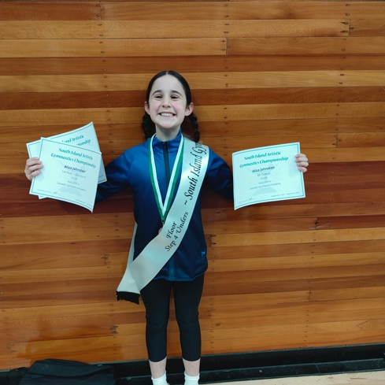
An equally massive congratulations to Lilly Hamilton and her hip hop crew, The Wild Ones finished third and won the bronze medal at the Nationals held in Christchurch at the weekend. Outstanding stuff Lilly, well done.
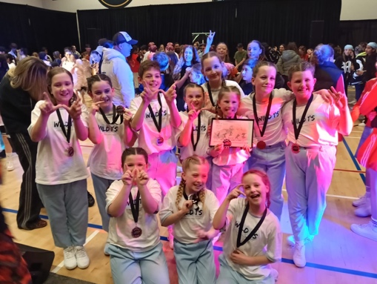
Bravo to the following rugby players on their achievements at the recent Brighton Seagull’s prizegiving.
Maci Kippenberger. Most Promising
Ada McIvor- Best and Fairest
Willow Parker Most Improved
Ari Gilbert Most Diligent Age Grade Player
Well done to you all.
Futsal
A reminder that if your child is interested in playing futsal next term, please let Kelly know asap. Thank you
Have a great weekend and I look forward to seeing you all at the show.
David Grant
Principal

