14th June 2025
Big Rock Matariki Celebration
It is just over a week until we have our annual Matariki celebration. It starts at 6:00pm at the Brighton Hall on Wednesday 25th June.
All we ask of our whanau is that you bring a plate of food to share (enough for 4 people). This can be something that has cultural significance, a family favourite or maybe something that your family enjoys on special occasions.
The school will be providing:
- A lamb on a spit
- Whitebait sandwiches
- Sausage sizzle
- A vegan curry (Professionally made)
- Water and raro
We would also recommend that people bring their own plates, cups and cutlery. There will be some paper plates and cups, as well as wooden cutlery. I reckon the significance of the night means a better standard of crockery and cutlery.
There will be a basic New Zealand Geography quiz for people to complete to win Kiwiana prizes as well the debut of the school band.
Please, if you are not sure if we have your country’s flag, please check in with me.
I am looking forward to it as one of our very significant school events.
If you can help please let me know asap. Thank you.
Congratulations
I want to congratulate all our players of the day for the last week. Well done to the following players:
Big Rock Shooters – Elise Blanchard
Big Rock Coasters – Zach Turner
Big Rock Hoopsters – Esme Grey
I would like to give a special shout out to Elise Blanchard on back to back player of the day awards, for netball and basketball. What makes this special is that Elise is amongst the youngest in both teams but plays with such enthusiasm, grit and energy. Keep it up.
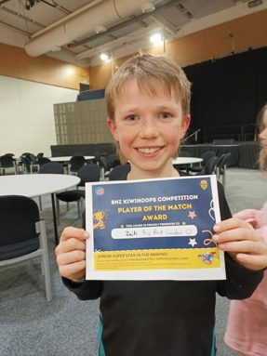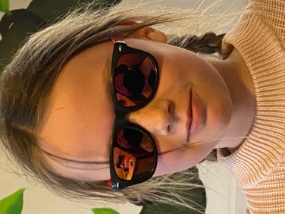
Over the last couple of weeks, I have received a few concerns about negative language towards our players on the court (swearing, abuse etc) at basketball. I have expressed my concerns with Basketball Otago and the relevant schools. Keep up the great attitude Big Rock children and whanau.
I would also like to congratulate Greyson Farquhar on earning Player of the Day last week for the mighty Brighton Seagulls.
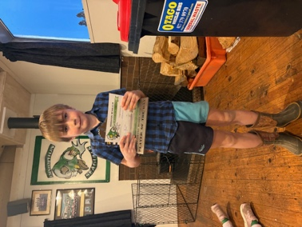
This week’s Sports Draw
Monday Basketball
Big Rock Hoopsters v BGP on court 8 at 4:40
Tuesday Netball
Big Rock Dolphins v Columba on court 7 at 5:00pm
Thursday Basketball
There are no games this week due to the Nuggets playing.
A Proud Moment
On Friday afternoon at a special Kings High School prizegiving, Mr Murray and I were asked to present scholarships to two of last year’s Year Eight boys. Seth Elliot-Tressler and Ruben van Tonder achieved Year 9 Academic Scholarships. To put the achievement in perspective, six academic scholarships were presented amongst 190 boys. Two of those six went to two former Big Rock lads. A remarkable achievement. It is important to note that Kings High School is currently one of the highest achieving boys schools in the country. A proud moment for their families and for Mr Murray and myself.
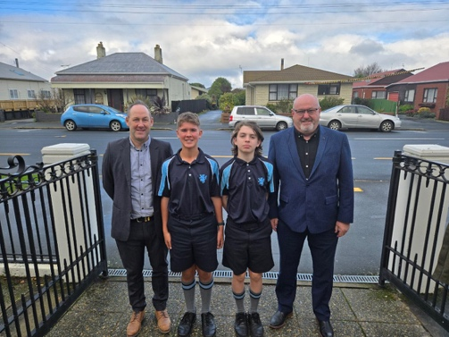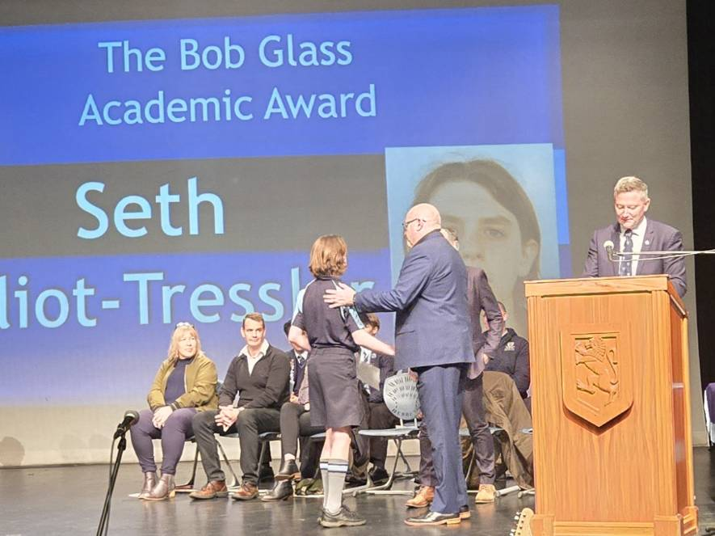
Room One and Two History Detectives
Last Monday it was great to be out and about with Rooms One and Two at Toitu and the Chinese Garden, and the weather nearly played ball the whole time. I must commend the children for their behaviour and attitude in the museum and the Chinese Garden. It would be easy for children in this age group to just want to run around etc. They didn’t, they stayed focused on the task at hand (for the most part) which was impressive. Thank you, Blair, Chelsea, Cass, Lindsey, Mon, Lewis, Annabel, Clara, Isak, Amanda, Lisa and Leah.
Thank you to Mrs Lamb and Ms Keen for letting me join the fun.
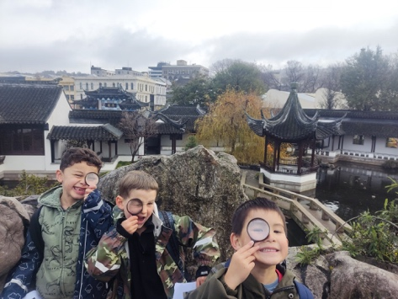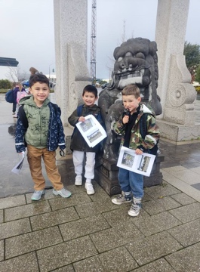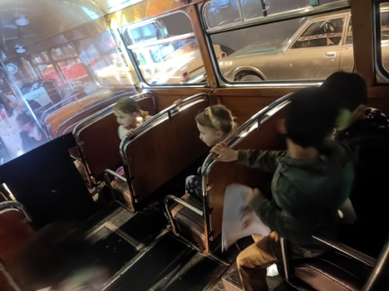
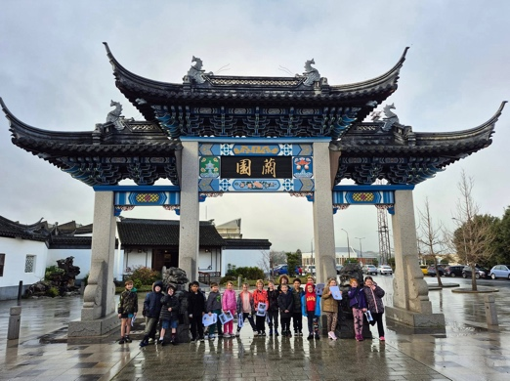
Please be advised that there is no school on Friday as we celebrate Matariki.
David Grant
Principal

