12th December 2025
From our Board Chair/Presiding Member
Kia ora koutou
Our school board met this week for our last meeting of the year. We reviewed and
discussed several school policies, which is part of our usual meeting process. We also held
an initial discussion about after-school care and will be reviewing the current contracting
arrangements and costs. Communication about this will be shared with whānau in the new
year.
We’re pleased that the PTA has now been established. A big thank-you to everyone who has
put their hand up to be involved, and for the impressive quick start to fundraising. Your
support is greatly appreciated.
Our next Board meeting will be held on Monday, 16 February at 3:30 pm, in the staffroom.
Ngā mihi nui
Lisa Daniels (Presiding Member)

Congratulations
A massive well done to Evie Hollands, Georgia Stewart, Mieka Coory and Mila Parish-Witehira on their success and effort at their recent end of year gymnastics competition. Their excitement when they came to tell me about their medals and ribbons was very infectious. Well done to you all.
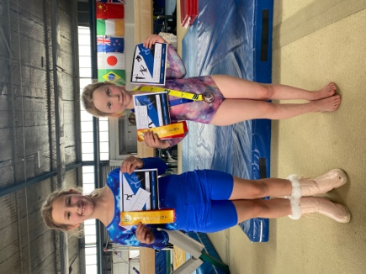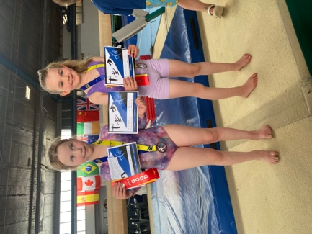
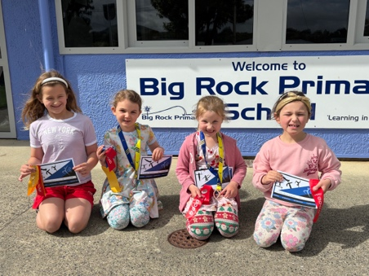
Congratulations
It is with a sense of pride that I acknowledge and congratulate two of last year’s Year 8 Big Rock students, Seth Elliot-Tressler and Ruben van Tonder. Earlier in the week Seth was named the top Year 9 Mathematics student at King’s High School, and Ruben was named Top Overall Student for Year 9. A remarkable achievement for both boys and our whole school community should be proud of their achievements.
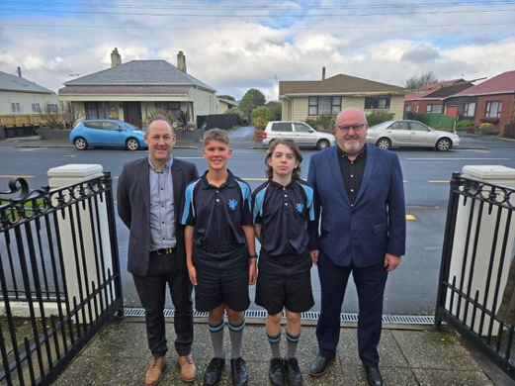
Photo from Scholarship presentation earlier in 2025
End of Year Summary
2025 has been a very challenging year for many and as schools tend to be a reflection of society, well they certainly should be, Big Rock has been no exception.
The pressure from the Ministry on an ever changing new curriculum, pressure on schools to police children’s attendance to disturbing levels, increase in costs, and some pretty challenging illnesses, particularly in Term three.
Yet through it all our achievement rates remained excellent, in Reading, Writing and Mathematics, we were still able to have our Pet Day Extravaganza, some of our Taieri Mouth Adventure, our wonderful Matariki Celebration celebrating mana and tangata whenua alongside the many cultures within our school and community, the Musical production of Alice, a return to Polyfest, our first school band, school camps to Stewart Island, Naseby, Tirohanga, Berwick and Survivor Camp. The Big Day Out. We also introduced our new Science and Nature School as part of our senior programme and our Gastronaut cooking programme, With help from Tangata whenua, we honoured the treaty in curriculum design and will continue to do so.
While our EOTC programme is still very good, with the new curriculum expectations, and terrible luck with weather 2025 was less adventurous than 2024. 2026 should have normal service resuming.
So, while 2025 was a challenging year, your children still achieved a great many things. There was excitement, frustration, celebration and endeavour, but more than that, there was and is:
Learning in Paradise

Looking Forward to 2026
As we come to the end of the 2025 year, we need to start looking forward to 2026.
As you are aware (hopefully), for the first two terms I will be on sabbatical. The purpose of the sabbatical is to carry our research on the benefits of Education Outside the Classroom in building children’s self-esteem, supporting mental-health and transferring those benefits to support learning and achievement in the classroom. I will also be using the time to work on the school curriculum to ensure that aligns with Ministerial requirements, as well as reflecting the needs and requirements of the children and whanau of our community. My goal is to ensure that our school is able to deliver the best curriculum we can to all of the children at Big Rock.
In my absence, Lisa Lamb will be Acting Principal with all of the responsibilities and authority that any school principal has. I know that Lisa has already begun preparations for 2026, including dates for the Pet Day Extravaganza, Taieri Mouth Adventure, Meet the Teacher Day and other traditional term one events.
Lisa has also been working on a couple of exciting staffing initiatives and will make those announcements in the new year. They sound very exciting and beneficial to the children.
I want to wish Lisa all the very best, knowing that she will be superb, with outstanding support, from staff, Board and the school community.
Brighton Gala Day
Early in the new year a message will go out looking for helpers for the school Whitebait stall. If you are free to help, you will be very welcome. It is always a bit of fun and I am looking forward to it.
Brighton Trail Ride
On Saturday 7th February the Brighton Trail Ride is on again. We need your help please. We need people to help with road and crossing marshalling, car parking and helping on the barbeque. Please contact either myself on 021 2134316 or Aaron Hollands on 021 195 5885.
Finally…
Thank you to everyone who has contributed to Big Rock this year, from all of the children, all of our wonderful families and whanau, local businesses, Board of Trustees. Your ongoing support is greatly appreciated. I have said it many times, that I genuinely believe that the Brighton/Ocean View/Taieri Mouth communities reflect the very best of this wonderful country.
Have a safe and happy holiday season and I am sure I will see many at the Brighton Gala Day, one way or the other.
Thank you
David Grant
Principal

