11th August 2023
Moneys in the Honey
We are once again having a honey fundraiser for curriculum resources across the school. Forms are coming home tonight. The forms should be self-explanatory.
Orders and cash need to be back at school by next Friday- Friday 18th August, along with the money or the money can be deposited into the school account (info on form). All of your orders can be under one bulk payment. Please reference the order with your family name and HONEY.
Many thanks in advance for your support with this.

Congratulations
Congratulations to Meadow Hamilton, Lilly Hamilton and Bella Yeoman who performed with the Dunedin Children’s Choir in a farewell concert for Olivia Pike who has left Dunedin to join the Boston Conservatory to study music. One day for you girls too? Why not?
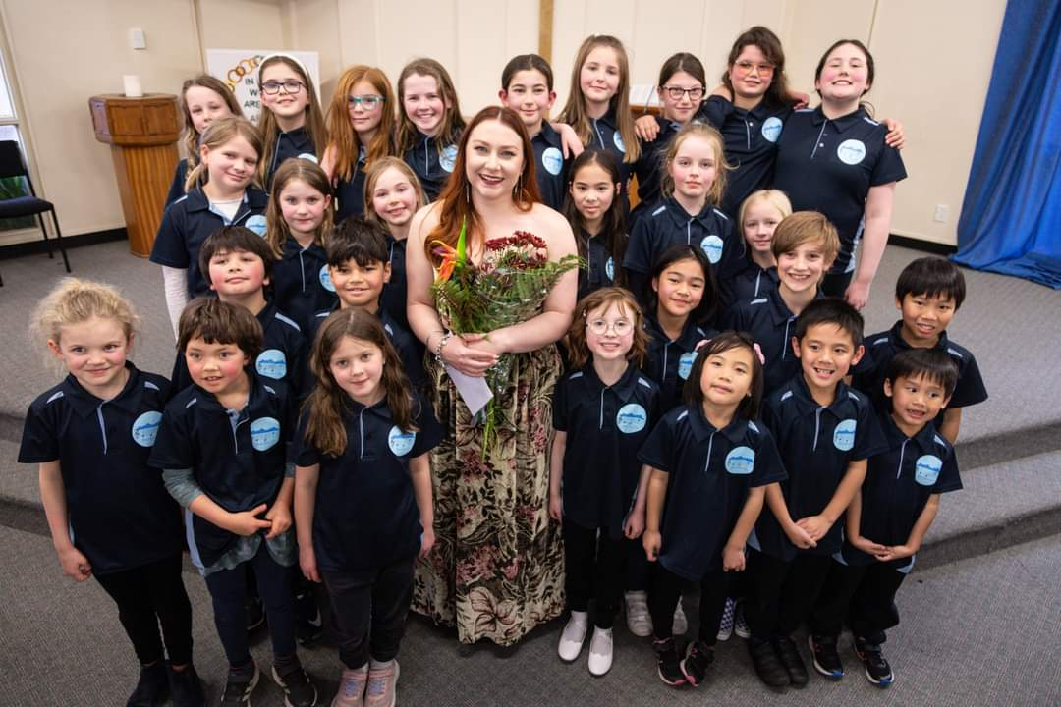
School Disco
As you are aware, on Friday 25th August we are having a school disco. The disco is at the Brighton Hall and will run from 6:00pm to 8:00pm. There is a $2 entry fee. On the night there will be drinks, lollies and ‘glow products’ for sale.
The disco is open to children Year 8 and under. This year we have a no re-entry policy. Children will be expected to stay in the hall. Regrettably, over the years there have been unfortunate incidents, outside or down the back of the hall that have resulted in upset or hurt children and we are going to avoid that. There will be adults on the door ensuring this.
We also ask that children who are under 7 have a parent attend or an adult who is responsible for them. i.e their friend’s parent has taken them along.
There will games with prizes, prizes for best dressed etc. Categories for best dressed are Superheroes, Wizards and Fairies for younger children and favourite actor for senior children. Parents are free to dress up if they are keen.

Sports Round-Up
Basketball
I have had the very real pleasure of seeing the Hoopsters, Shooters and Coasters this week. Wow!
First up, the Big Rock Hoopsters on Monday night played Dunedin North Intermediate in the Year 7-8 Mixed Grade semi-final. The Hoopsters were nervous but determined. What an incredible performance they put in to come away with a 26-12 win. Correctly there was no MVP this week, however George Weatherall dropping three 3s, must have gone close.
I thought that was exciting. Then last night the Coasters took on St Bernadettes, a team that had beaten them early in the season. The Coasters have played great all season and got better and better as a team. Last night was perfect evidence of this. The ball they played was superb, great attack, big D and working hard for each other. They came away with a 26-23 victory. Bravo to Jasmine-Rose on earning MVP, in truth it could have gone to any of the team. It is important to acknowledge St Bernadettes’, who played with great enthusiasm, ability and sportsmanship.
Next up, the Shooters v North East Valley. Unreal again. This team played a blinder, with Bentley Marsh and Briana Jones shooting, Flynn Blanchard’s shooting, dribbling and defence, Fin Ramsay’s shooting and dribbling, Leon Skerrat’s terrier like defence and Jaxon Skerrat’s dribbling and passing, they came away with a very good result. Congratulations to Leon Skerrat on earning MVP. (The photo says it all)
Sadly due to illness there was no netball this week.
You are probably wondering why I have given such an in-depth report this week. It is the first time I have been able to watch all of the games and was genuinely impressed. However, the parental support from the sideline and acknowledgement and support towards the opposition was outstanding. I was reading an article in the New Zealand Herald about parental behaviour on the sidelines of children’s sport. It was ugly reading, actually tragic. It made me proud of the support and encouragement the children at Big Rock are receiving from the sideline from Big Rock whanau. That attitude gets transferred to the court and that was plainly evident this week. A quick example is James Patterson’s consistent fairplay approach and he is only one of many, if not all. I must stress that this is always the case with our netball and futsal teams as well. Sadly it is not the case everywhere else. Big Rock families and whanau- take a bow, you rock.
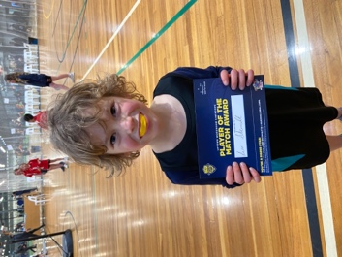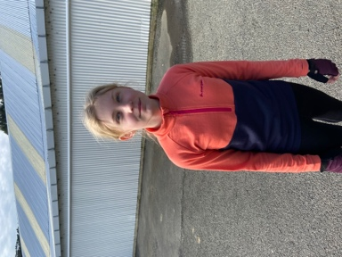
Brighton Seagulls
Congratulations to Quinn Hollands on earning Player of the Day for Brighton Seagulls, great work Quinn. Also, well done to Stella Brown on earning Most Improved.
Bravo to Elise Blanchard on earning Player of the Day for the Baby Gulls, well done Elise. A top effort saw Ivar Elliot’Tressler earn Most Improved for the Baby Gulls.
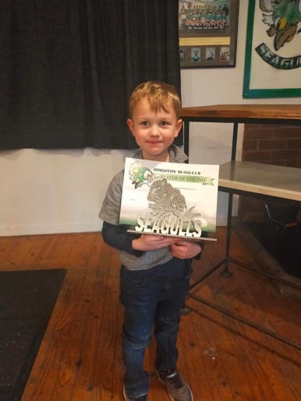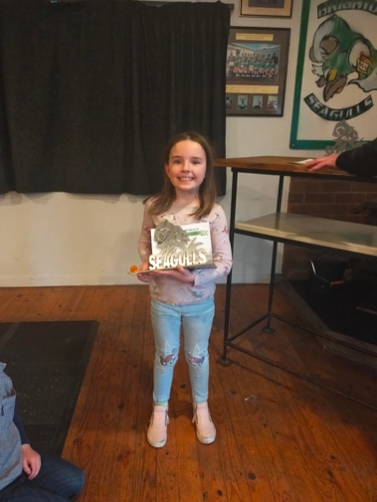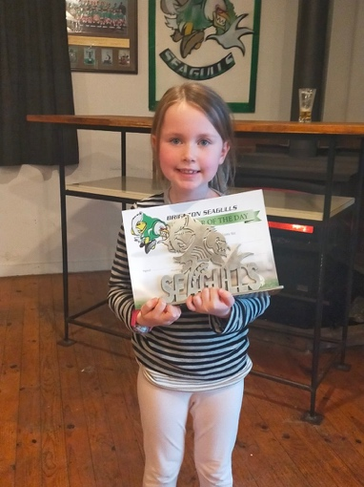
Mountain Biking at Big Rock
Today I had the joy of joining the TNT Mountain Bike group as they attacked the tracks of Forester Park. As you can probably guess, it was very cold this morning but that did deter them. The skill level and confidence is growing all of the time, as are the smiles.
Many, many thanks to Angie Hancock and Scott Weatherall for taking time out of their workdays to lead this. I know that they both love it, but we are still very grateful, and the skills and knowledge they pass on is greater than just a riding a bike.
Next week the Introductory Group are out and about on Tuesday and the Advanced Mountain Bike Group have their catch-up ride on Thursday. More info will come out on Sunday.
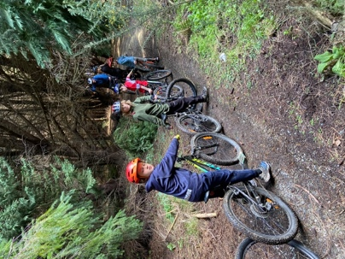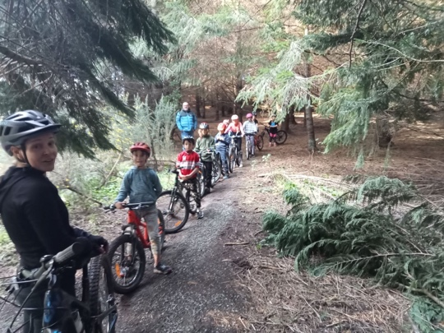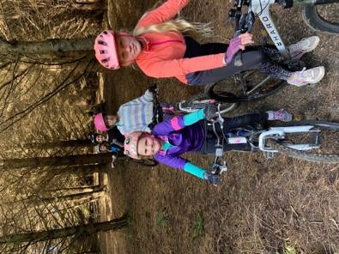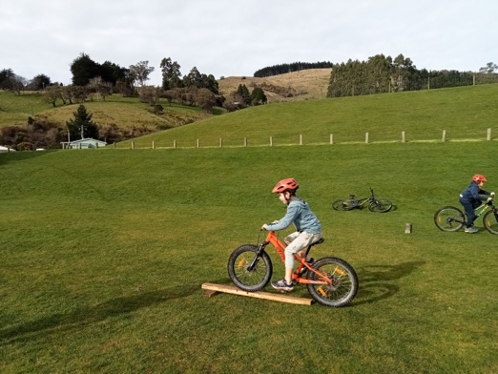
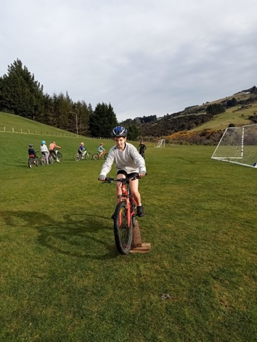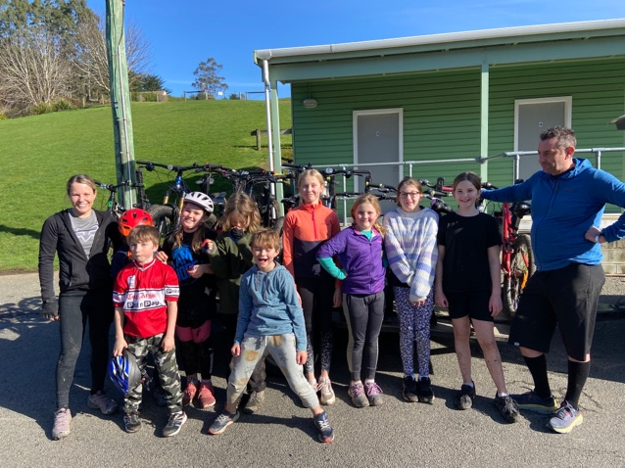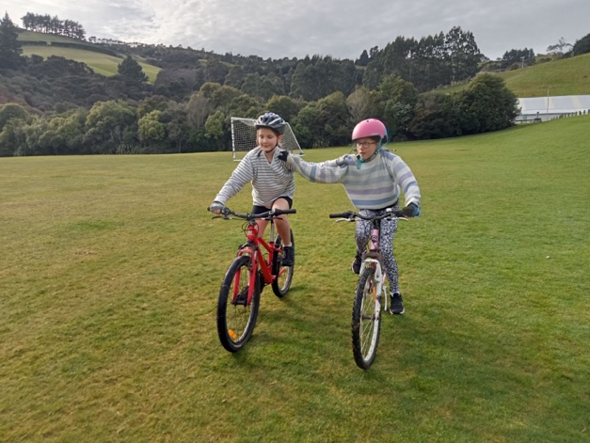
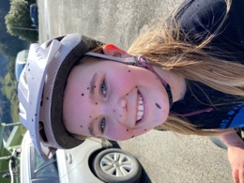
Have a great weekend.
David Grant
Principal

