11th April 2024
Welcome
On behalf of everyone I would like to give a big Big Rock welcome to Ada McIver, Georgia Stewart and Mathias Ratten, all to Room One. It is wonderful to have you and your family and whanau join us.
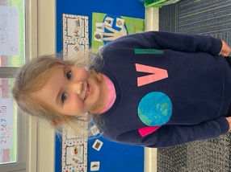
Congratulations
Congratulations and well done to Max Ashton who claimed first place in his grade for the season at his BMX club and also recorded the fastest lap time. Outstanding work Max, you should be very proud.
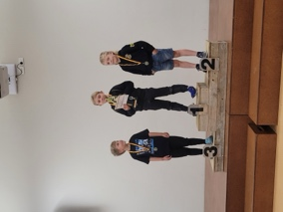
I would also like to congratulate our Board Chair, Scott Weatherall on winning his celebrity race at Beachland’s Speedway last weekend. This event was in support of the I am Hope Foundation. Also, congratulations and thanks to King’s High School on their support in earning over $8000 to support the I am Hope programmes.
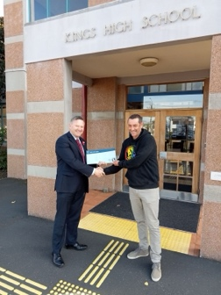
Big Rock Website
The new Big Rock website is up and running. While there are still a few subtle changes being made, if you have time, check it out. Thank you Kelly for all of your work on it.
https://www.bigrock.school.nz/

Pool Keys
As the pool officially closes tomorrow for the winter months, can all keys please be returned to the office asap. Thank you.
Sports Equipment Funding
I would like to advise you that last week we received a $3000 grant for sports equipment from the Bendigo Valley Sports and Charity Foundation. Sadly ‘Bendigo’ is now closed. I would like to offer our thanks and gratitude to the team at Bendigo, they have been incredibly supportive over the years of Big Rock. They have helped us out with thousands of dollars’ worth of library books, thousands of dollars’ worth of sports equipment, sports uniforms and equipment for the kitchen. They will be deeply missed. A big thank you to Mike Brosnan and the late Lance Pearson, they gave way more than they got.
Year Seven and Eight Amazing Race (Number One)
Yesterday I had the pleasure of spending a reasonable chunk of the day at the Botanical Garden’s with Mr Murray’s class. They took part in their first Amazing Race of the year. These races are aimed at having the children solving clues and moving around different locations. They are linked back to the school curriculum and classroom learning, this includes Reading, Writing and Maths. Yesterday in small groups, they had to find different locations around the Gardens, then plot them on a map while also securing photographic evidence which is then turned into a multimedia slideshow. These types of learning experiences are so important, especially for Year Seven and Eights, to be out in the world supporting their learning and social development and not doing it all in a classroom. Thank you Mr Murray and Kara for your help.
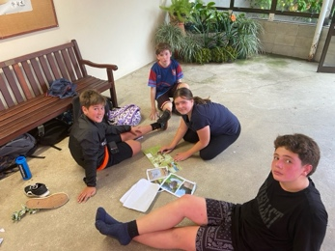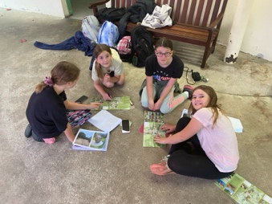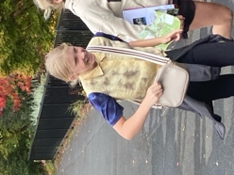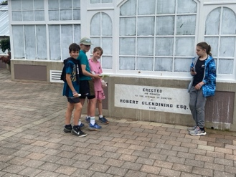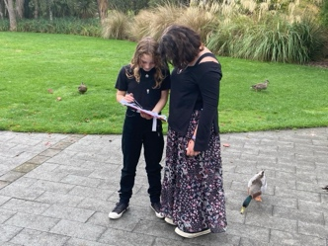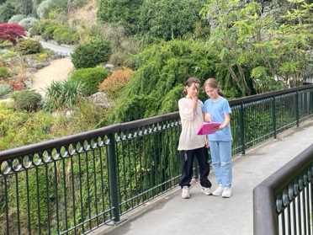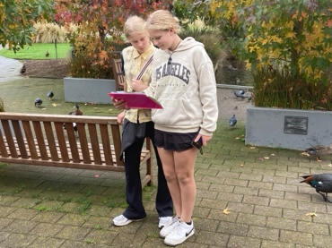
Futsal
Congratulations to all of the players who earned Player of the Day in the last game and a massive well done to everyone who played. A special thank you to Tania Blanchard, Lauren Mooyman, Jo Henderson, Shane Turner, Cavan Jenkinson and Ange Hancock for all of your time and effort in coaching the teams this season, massively appreciated.
Big Rock Dolphins— Willow O’Brien
Big Rock Starfish –- Will Judd
Big Rock Stingray— Bryn Little
Big Rock Barracuda— The Whole Team
Big Rock Sharks—Malachi Turner
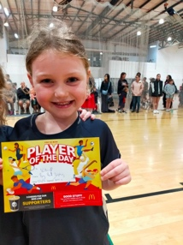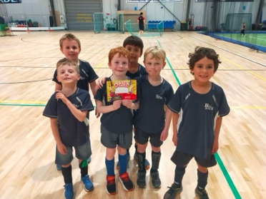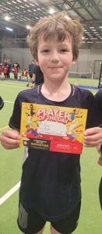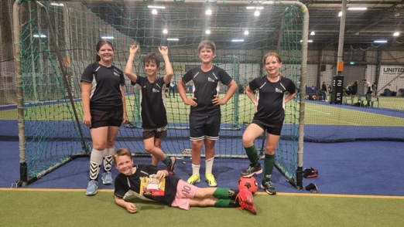
Summary
I believe it has been a great start to the year, with lots of quality teaching and learning happening, the children getting to swim at school, the pool being open at lunch times, Pet Day, Pool Parties, lunch time bbq, Taieri Mouth Day, biking trips and experiences, older children working with the younger ones on reading, Minecraft and biking. Reading, Writing and Maths are the cornerstones of any quality school, but we also need things like trips, Pet Days, pool parties, amazing races etc as they help make school special and fun. I know that is one of the reasons why we have high attendance rates, high engagement rates and great behaviour across the school. Thank you everyone for your help, support and at times patience in making it happen.
Next term will again be a busy one, with our major focus (apart from Reading, Writing and Maths) being Aotearoa New Zealand History (ANZH), culminating in a shared dinner when we celebrate and recognise mana whenua, as well as welcoming all of the many different cultures within our school community on our Matariki evening. (Lambs on the spit and whitebait already sorted).
We will also have more biking experiences and adventures across the school, ANZH trips, children cranking into winter sport with rugby, netball, football, basketball and hockey. At the ‘Meet the Teacher’ interviews at the start of the year we sought your ideas on science, you will hopefully see some of those ideas beginning to be implemented next term. There will be plenty more things to be announced.
Lastly, and with a little bit of luck our building development will be finished and we will again have full access to the school and the library (Which we stocked up with $4000 worth of books at the end of last year)
For now, thank you everyone and have a great break.
David Grant
Principal

