11th April 2025
Congratulations
Well done to the following players who earned Player of the Day for their respective futsal teams.
Big Rock Stingray- Josh (Pool Party in Socks) de Thierry
Big Rock Barracuda- Evie Hollands
Big Rock Sharks- Whole Team
I would also like to thank and acknowledge the coaches for their time and effort. Thank you Jo Henderson, Lauren Mooyman, Tania Blanchard and Alex Ramsay. Greatly appreciated.
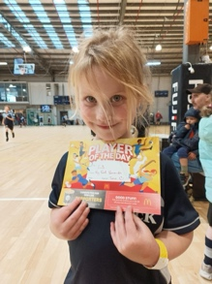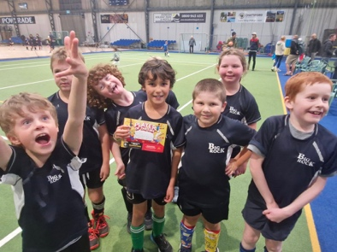
BMX Star
A massive congratulations to our very own BMX star Max Ashton who claimed and earned top rider for his grade at his recent BMX club awards. You are a star Max.
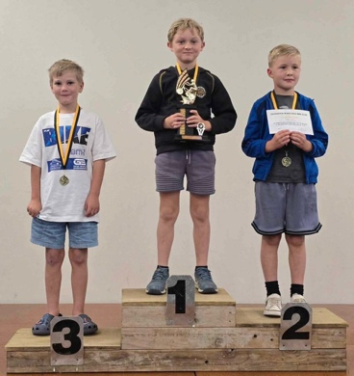
Otago Secondary Schools
I would also like to offer my congratulations to the Otago secondary schools, who, it was revealed this week had the highest NCEA results across the country. Which confirms what we are seeing and hearing. There is of course more to a school than academic results, but it is still fantastic for the province and great recognition to those teachers and schools.

Brighton Trail Ride
The school had the privilege of being part of an incredible event and fundraiser with the Brighton Trail Ride. The event was excellent in many ways. It was superbly planned, organised and then run on the day. It was well supported by members of the school community, rugby club and fire brigade. The wider community being shown off with such an amazing event being held in the Brighton area. The generosity of Ross McLeary and his farming colleagues to allow their land to be used, was remarkable and much appreciated. The feedback from the riders and their support crews was 100% positive. Considering all of the above, it really was a remarkable event. Thank you firstly to Aaron Hollands, who, when he approached me 6 months ago, I may have been slightly hesitant. Luckily not for long. The time and energy you put into ironing out all of the details, making track markers, marking and remarking the track, allocating jobs etc etc wow, unreal. Thank you Nina Daniels for all of your work and support of Aaron. Thank you Hamish Graham for your organisation in the lead up and on the day. Thank you to every volunteer, for turning up and doing your bit on the day that ensured it was successful.
Lastly, and this no understatement, your effort and time, has meant that the pool will not have to close, which was a very real challenge we were facing. Every child who is here now and in the future and their families need to be very grateful and appreciative. I know I am.
Term Summary
There have been many highlights this term, as there always are in Term One. Many which are unique to Big Rock, certainly on the scale that they occur. Our different classroom mountain bike rides, Pet Day Extravaganza, Taieri Mouth Adventure (to be continued), Hungerball for all classes and the addition of GaGa Ball to the playground. Pool Parties, success at the local triathlon as well as the Weetbix Tryathlon, surfing, Science and Nature School, excellent results in Literacy and Mathematics across the school. On top of all of that, all of the teachers have been delivering the new curriculum expectations in Reading, Writing and Mathematics in complete alignment with best practice and legislative requirements.
It has been a very successful term, we opened early, never had a teacher only day where we were closed, amazing new resources across the classrooms and a staff committed to ensuring quality teaching and learning in a fun and happy environment.Thank you to the Board for ensuring that we are able to offer so much without punishing costs placed on families and whanau.
Lastly, and most importantly, happy, engaged children turning up to school consistently ready to learn and ready to engage, ready to do their best and ready to rock!
Thank you to all of our wonderful families and whanau for your on-going support.
Term One as they say is done! We now look forward to break and then Term Two.
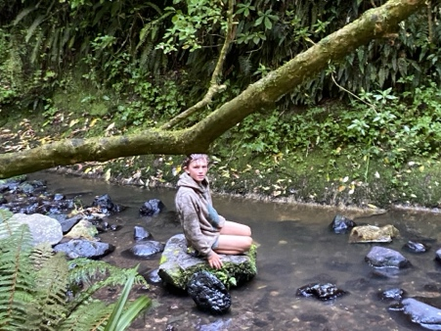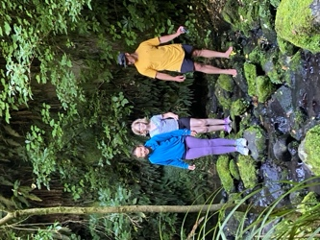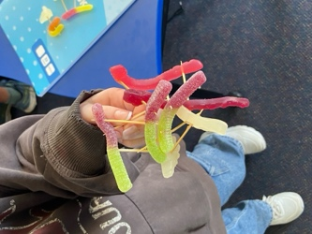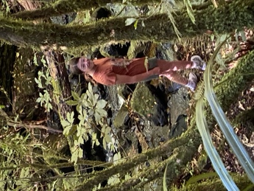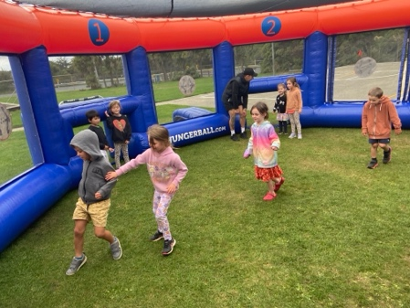
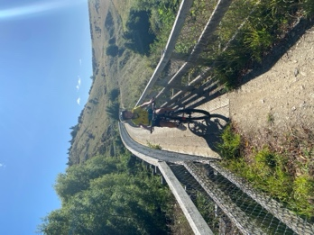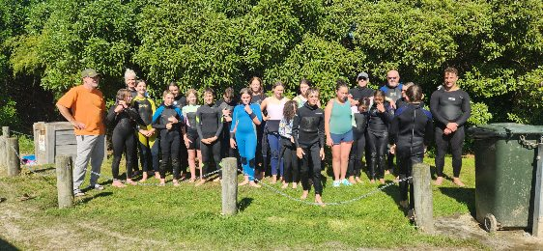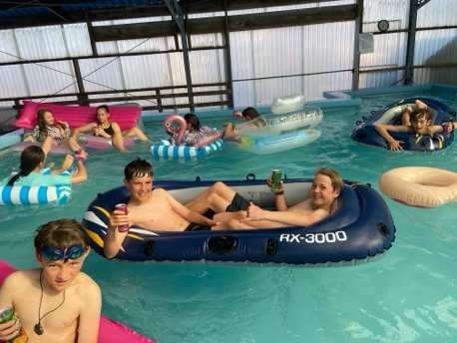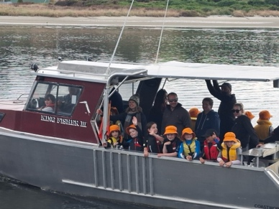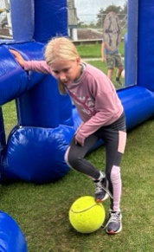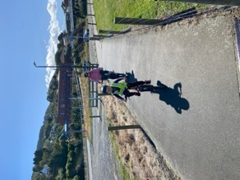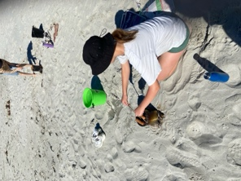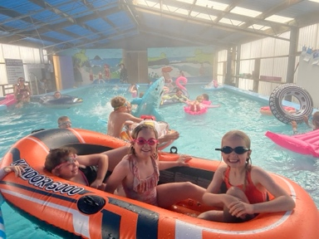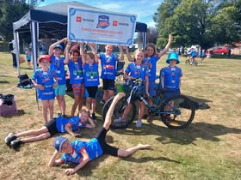
Term Two will again be busy and promises to be just as exciting. One of our key foci for the term is Aotearoa New Zealand History culminating in our Matariki celebration at the Brighton Hall. Where we will acknowledge and celebrate Mana Whenua and Tangata Whenua as well as celebrating all of the different nationalities and cultures within your amazing community. Traditionally, and it is a tradition now, this is always a remarkable event and one that I am immensely proud of for all of the reasons above and also that I don’t know of another school Matariki celebration that even comes close. Nga Tangata Nga Tangata Nga Tangata.
This year the school will again be providing lambs cooked on a spit, whitebait sandwiches, sausage sizzle. I am currently formulating a plan for the seniors to cook something special.
Science and Nature School will really start to crank up with different learning experiences and challenges, including the bush banquet challenge, as well as finding out who will be the first Pie Minister. (Watch this space).
The History Detectives will be back in action, as will Dunedin History Amazing Races.
Structured Literacy and Mathematics will crank up another gear as we settle into the winter terms.
It will be busy but ultimately rewarding, and I can’t wait.
Have a happy and safe break
David Grant

Principal

