10th November 2023
Congratulations
Well done to Aliza Johnston on being named Junior Gymnast of the year at the recent Dunedin Gymnastics Academy prizegiving. You have had an outstanding year Aliza and really lit up the local gymnastics’ world. Outstanding.
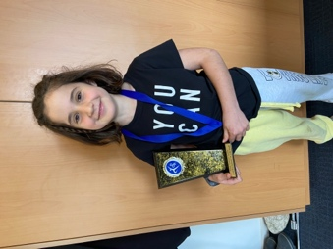
School Attendance
Yesterday and again today (and rightly so) there has been some really concerning data released showing that nationally in Term Two of this year school attendance rates were at 47%. That means that children are staying home more than going to school.
This alarms me for several reasons, firstly children need to be at school, not just for education but also for the social development that is so important, both in the class and in the playground. Secondly, what is preventing children from attending school or wanting to be there? Lastly, the numbers signal a crisis in New Zealand schools. In saying all of that, I think it is important to give it a local perspective. In Term Two of 2023 attendance at your school was 91%, Big Rock children and families, take a bow. Not only are the attendance numbers well above the national average, but above the Ministry expectation. I think we should all be very pleased and a bit proud as well. Remembering of course that Term Two can be a term with lots of illness. Happy, resilient, lifelong learners is our goal.
Introductory Mountain Biking
On Monday I had the pleasure of joining the Introductory Mountain Bike group on the MTB adventure at Redwoods. It was lots of fun for children and adults alike. Thanks to Mr Murray, Shane Turner, Michael Johnston, Daniel King and Kimberley Ashton for all of your help riding with the children and transporting bikes and people. Thanks to Malachi Turner from the Advanced Group for taking lead.
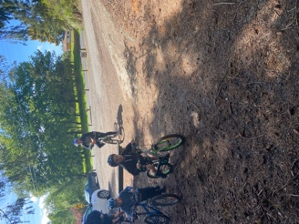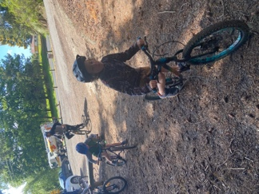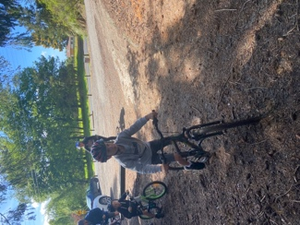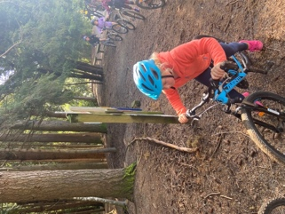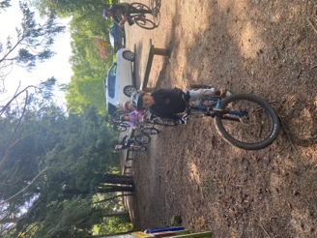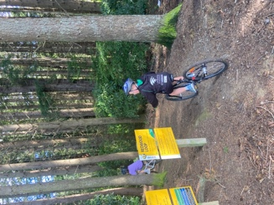

Last week I mentioned that I may have some exciting biking news. Well, I do now. Last term Scott Weatherall and I worked on an application to the Tu Manawa fund via Sport Otago for bikes, trailer etc to support a Junior Biking programme while adding to other EOTC resourcing. Last week we found out that we had been granted $4,666.68, which will be put to good use. We also received an additional $500 from Bikes in Schools who helped with the bike programme in the beginning. Watch out for a new bikng initiative.
Futsal Round-Up
Well done to Ollie McNair on earning Player of the Day for the Big Rock Dolphins. I think the photo sums up the effort he put in. Top work Ollie.
Greta work from Stella Brown saw her earn Player of the Day for the Big Rock Stingray. Well done, Stella!
Bravo to Lily Scott on earning Player of the Day for the Barracuda, excellent stuff Lily.
A great win for the Marlin, with loads of goals. A hat trick saw Flynn Blanchard earn Player of the Day. Well done Flynn.
It was all action for the Big Rock Orca, after trailing 2-0, they came roaring home to win 3-2, with a last second goal from Malachi Turner to not only win the game but complete his hat trick as well. Stunning effort.
Congratulations to Leo Douglas on earning Player of the Day for the Big Rock Sharks. Although Leo kindly volunteered to play for the opposition as they were short. He scored as well! The Sharks did come away as 3-1 victors.
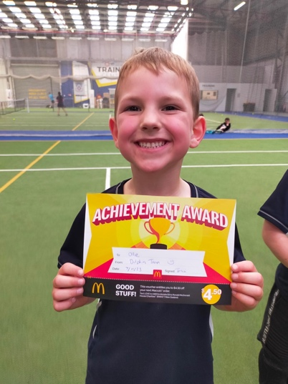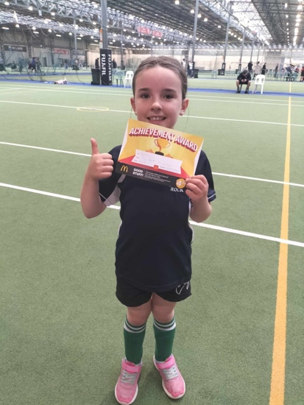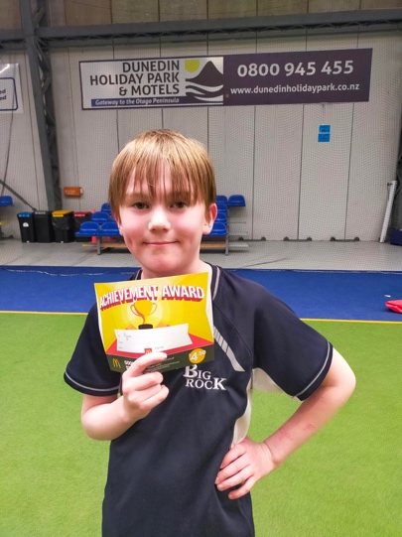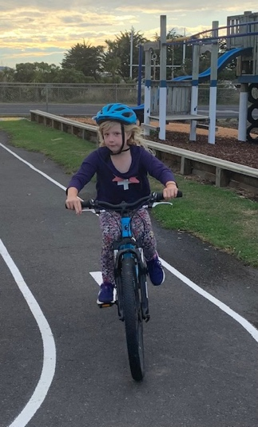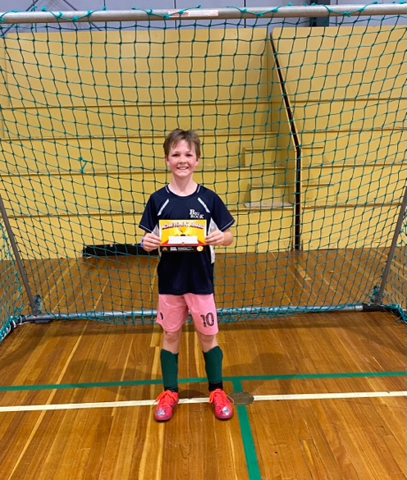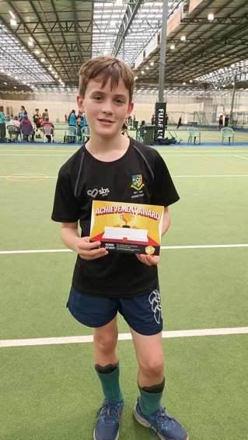
Swimming Pool
The pool will definitely open next week. The paint took longer to cure than we thought it would and we wanted to be sure.
Pool keys will become available to school families on Wednesday 22nd November and to the wider school community from Wednesday 6th December. We have a limited supply, and it is important that current school families receive preference.
On Monday night the Board met, and part of the agenda was pool key costs for 2023/2024. Regrettably, as you are aware, everything has risen dramatically in price, power, cleaning products, etc. This is reflected in pool key costs. Please see the table below for the costing structure.
 | Pool Key | Key Deposit  (Returnable) | Total
School Family (Including pre-enrolled 4 year olds) | $75 | $15 | $90
Former School Family | $100 | $15 | $115
Wider Community Members  (No history with school) | $125 | $15 | $140
Please note for school families to purchase keys, school accounts must be up to date.
Fundraising Concert
On Sunday afternoon the good people of the Brighton Bowling Club have organised a fundraising concert to support Kelly’s family and the cost of Olivia’s surgery. The concert starts at 1pm at the bowling club. There is a $5 entry fee. Children 15 and under are free. There will be raffles, so bring cash
Be ready to be entertained by local bands the Marc Yeoman Allstars, The Craps (Featuring Big Rock’s very own Riley ‘Sticks’ Henderson on drums) and Hot Dog.
Have a great weekend.
David Grant
Principal

