10th May 2024
Teacher Only Days
Within the fortnight of the Monday 27th May – Friday 7th June, the Ministry of Education has made it possible for schools to close for instruction for one day so that schools across New Zealand can have a Teacher Only Day as part of the slow introduction of the refreshed New Zealand curriculum. Some of your friends or family members may already talked about this with you, and you may have been thinking about care arrangements. The teaching staff at Big Rock have agreed that we will not be having a Teacher Only Day as we do not believe, that for us at this stage, it is required, as well as wanting to do what we can to support the children and families of Big Rock. Mr Murray and I will attend a Ministry led seminar on June 4th.
I can also assure you that your school is well placed for the curriculum refresh and has been steadily developing our localised curriculum for a number of years and we are in a strong position.
Congratulations
Congratulations to Lexie Brown on winning (for the second year in a row) the Junior Dressage title and winning the full attendance award (Shared with her sister)at the recent Brighton Pony Club prizegiving. Also well done to Stella Brown, not to be outdone by her sister, winning the top Competitor prize as well as games and show jumping. Well done girls.
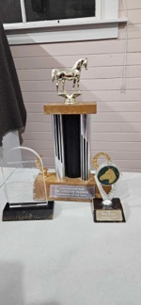
Basketball
The school basketball season tipped off this week with the Hoopsters and the Coasters getting off to flying starts. The Hoopsters had a tough 16-10 victory over our perennial rivals Outram and the Coasters had a commanding win against Anderson’s Bay.
Bravo to Mikah Reihana on earning Player of the Day for the Big Rock Hoopsters. Top work.
No Player of the Day was awarded for the Coasters this week.
Well done to all of our parents who attend their children’s sport each week, whether it be futsal, football, netball, rugby, hockey or basketball and actively encourage all of the children playing. Sadly, and it does seem more common in the winter sports, there is a lot of negativity coming from the sidelines directed at players and referees. I am proud that the parents of this school do not fall into that nonsense and instead cheer and that reflects well on their children, themselves and the school. Keep it up.
Congratulations to Zach Turner on earning Player of the Day for his Green Island Football team at the weekend. Great stuff Zach.
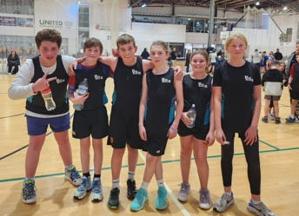
If your child earns Player of the Day for their club sports team, please let us know so that we can celebrate with them.
Well done to Leith Conway on being invested into the cubs this week. Well done Leith.
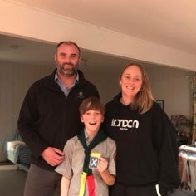
Thank You
A big thank you to everyone who was able to support our two recent fundraisers, the bulbs and the bakery on Bond St ones. Really appreciated. The funds raised will be used to support Structured Literacy and EOTC.
Aotearoa New Zealand History (ANZH)
As you are hopefully aware, our major topic focus for the term is Aotearoa New Zealand History. As part of this we encourage you to share any family stories you have with your children. They could be iwi or hapu stories, immigration stories, granny and grandad stories, quirky or funny things that have happened. It is important to keep the stories alive.
Also, traditionally at Big Rock we celebrate Matariki by having a shared meal at the Brighton Hall, where we not only celebrate Matariki and acknowledge Mana Whenua, we also celebrate all of the cultures and nationalities within our school community, as well as sharing all of the children’s work on ANZH.
This year is no different. It will be on Wednesday 26h June. The school will be putting on lambs on the spit, whitebait patties, a sausage sizzle and hopefully a vegan/vegetarian curry.
We ask that families bring a plate of food to share that is of significance to their family or whanau. It may be of cultural significance or just something that is had on special occasions within your family. Or anything at all really.
Our goals are that everyone gets to enjoy the children’s work, celebrate your great community, share each other’s company and have a great meal at minimal cost.
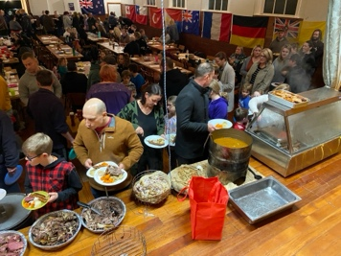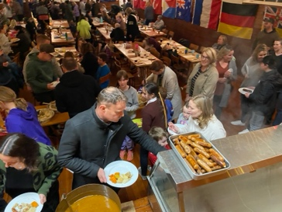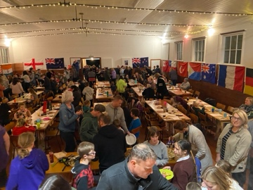

Mother’s Day
A big shout out to all the mums, grandmothers, aunties, and any other important women in your lives. Hopefully you all have a great day on Sunday. We appreciate you everyday, but Sunday is the celebration day.
Things mums have taught us:
Mums taught us LOGIC -- "Because I said so, that's why."
Mums taught us FORESIGHT -- "Make sure you wear clean underwear, in case you're in an accident."
Mums taught us STAMINA – ‘You’ll sit there until you have eaten all of your vegetables!’
Mums taught us about CONTORTIONISM – ‘Look at that dirt on the back of your neck’
Mums taught us about MEDICAL ISSUES – ‘If you fall out of the tree and break your legs, don’t come running to me’
Mums taught us about WAR – ‘Your room looks like a bomb went off!’
Mums taught us about ENVY – ‘There are millions of less fortunate children than you who don’t have such an amazing mother!’
Happy Mother’s Day Mums and thank you for all the things you taught us.
Have a great weekend, good luck to everyone playing sport.
David Grant
Principal

