13th December 2024
Last Newsletter of 2024
As this is the last newsletter of 2024 it is important that I start by thanking everyone who has contributed to the school. To the staff, the Board, coaches, fundraisers, supportive parents and whanau and most importantly the reason we all do what we do, the children of Big Rock. As I said on Wednesday night;
‘Thank you to every single child in this hall right now and to those who couldn’t be here. Your endeavour and your ever-increasing resilience, both personal and physical, your kiwi willingness to ‘have a go!’ and to dust yourself off and have another crack. Your humour, achievement and smiles make us all smile every day, and remind me certainly, of how lucky I am to work here, and for you making Big Rock rock! The many things that we can do, come back to your extraordinary attitude and behaviour, and that should never be underestimated or taken for granted.’
It has always been and remains an absolute honour and privilege to work here. Thank you everyone for making it such a great learning and working environment.
School Closes
School closes on Monday at 12:30. All children will need to be picked at this time. Thank you.
End of Year Reports
End of Year Achievement Reports will come out via email on Monday. We planned to have them go out today but there has been a small technical issue.
Sports Uniforms
Can people please have a check for sports uniforms and when you find them can they please be washed and returned to school. Thank you.
School Accounts
Can we please ask that all school accounts be paid asap. It is greatly appreciated and will keep the accountants at the Ministry happy.
Pool Keys
There are some pool keys still available (very limited numbers) and our preference is for school families to use them. Nothing against community members but I would hate for our school families and whanau to miss out. Monday is the last day for these.

Lost Property
It is not an understatement to say that there is a mountain of lost property still at school. Try as we might, children do not seem to want to take it home.
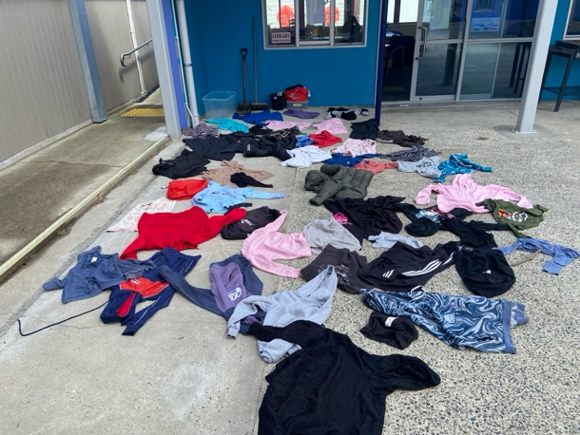
Library Books
Can all school library books please be returned asap. Book bus books will now need to be returned to the town library or the Book Bus when it visits on Tuesdays.
Brighton Gala Day January 19, 2025
Personally, I know that the Brighton Gala Day is an extraordinary event that showcases brilliantly the wider Brighton/Ocean View area and demonstrates why Brighton is Dunedin’s favourite playground. We will again be selling whitebait sandwiches; we will also be adding venison burgers to the menu. Thank you to Clarke and Jasmine McNabb for kindly donating the burger patties. We will need parental help with set-up, cooking and serving, clean-up. It is usually very busy and bit of fun. I will be putting a post out in early January seeking helpers. Please bear it in mind as many helpers from previous years have moved on.
Start of 2025
School starts back next year on Thursday 30th January. We will be having Teacher Only Days from Monday 27th January.
Thank you again for another remarkable year. To everyone who is moving on, we wish you all the very best for the future and look forward to hearing of your success.
Have a great break, if you are going away, please travel safe. Have a great break and I hope you get to do everything you wish.
See you in the New Year.
Kindest regards
David Grant
Principal

