December 2024
Wow, that was some year that just flew by, but as they say, time flies when you are having fun. It has been an extremely busy and productive year at Big Rock primary School.
Structured Literacy and Mathematics are becoming compulsory for all New Zealand schools in 2025, here at Big Rock they have been in place since 2022 for Literacy and 2023 for Mathematics. Our achievement rates confirm the effectiveness, with 91% of all children at or above the expected level in Reading and 89% at or above the expected level in Mathematics. These are very pleasing achievement rates, but our goal is 100%.
The high levels of achievement in Literacy and Mathematics only tell part of the story, these are supported by extremely high attendance rates at a time when the media is reporting attendance rates plummeting. For 2024 our attendance rate was 89%, if you consider justified absences (Illness etc) it rises to 96%. Achievement and attendance go hand in hand, no real surprise there.
There are many things to share with the community that have been happening at your local school, things we should all be very proud of. Our first major event that involved the children and their families was the annual Pet Day Extravaganza, which also included a baking competition, gala type games, loads of prizes and a sausage sizzle, all at no cost to families. This was followed by our Taieri Mouth Adventure, which saw all the children kayaking, going on speed boat rides and enjoying the magic of Taieri Mouth.
Term Two culminated in our massive Matariki and Aotearoa New Zealand History celebration with families enjoying children’s research and presentation over shared food. The school provided 2 spit-roasted, locally sourced lambs, whitebait patties, vegan curry, with our families bringing different food to share that is special to them. All the while celebrating Mana Whenua as well as all the different cultures within our community. It truly is a special event on the school calendar.
One of the major highlights of Term Three was our Art Extravaganza, again at the Brighton Hall, where all our families and community members got a chance to enjoy not only the children’s art displays but also their research into famous artists or art pieces. The hall was stunning as was the feedback from parents and community members alike. It is so powerful and so important to share the children’s work with the community in this meaningful way.
Education Outside the Classroom again featured prominently in our school calendar, which was exciting as we know how powerful this is in supporting self-esteem and mental health and witnessed the benefits across the school. This year we had camps in Central Otago, Waihola and Tirohanga, as well as Survivor camp and a ski trip. Five mountain bike groups, our Advanced Group, two Tracks n Trails groups (TNT), and for the first time, two Introductory Mountain bike groups, with riders as young as five. The different groups rode all over Dunedin including Redwoods, Whare Flat and Forrester Park as well as an overnight adventure to Naseby that included the Naseby Nightriders. We also had two Goldfields Bike trail trips.
As well as the mountain biking our EOTC programme again featured surfing, kayaking and SCUBA diving, amazing races and crime solving on wheels and history detectives, not forgetting swimming extension programmes at Te Puna o Whakaehu.
All of the things mentioned, as well as many others, such as Big Rock’s Got Talent, played a key role in the high levels of achievement in Literacy and Mathematics, as well as high attendance rates, which we are very proud of.
2025 promises to be another busy and exciting year, but ultimately, meaningful and successful. In 2025 we will be showcasing the musical production Alice in Wonderland, performing at Polyfest, visiting Stewart Island, introducing our new Science and Nature school programme, Learning In, For and About the Environment - Ako ki roto, ot e taiao as well maintaining and improving high standards in Literacy and Numeracy.
Of course, there are many people to thank. Firstly, I want to thank all the staff for their hard-work, dedication and commitment to making a difference and raising children’s achievement levels. Thank you to the Board of Trustees for ensuring we have the resources we require as well as supporting all new curriculum initiatives.
Thank you to our Board Chair Scott Weatherall and Ange Hancock for all your work in leading our mountain bike programmes.
Thank you to our wonderful sports coaches for giving up your time, you make a difference. Proof is our Senior Mixed Grade Basketball and Futsal teams both winning Division One, and our senior netball team only dropping one game. That success starts with the work in the younger teams.
Thank you to our wonderful parents and whanau for supporting your local school, for encouraging your children to work hard and take on new challenges.
Thank you to every single child at Big Rock. Your endeavour and your ever-increasing resilience, both personal and physical, your kiwi willingness to ‘have a go!’ and to dust yourself off and have another crack. Your humour, achievement and smiles make us all smile every day, and remind me certainly, of how lucky I am to work here, and for you making Big Rock rock!
In short, 2024 saw Big Rock Primary School have high rates of achievement in Literacy and Mathematics, high attendance rates across the school, EOTC programmes that support self-esteem and mental health as well as getting children learning in the outdoors, about the environment, for the environment and in the environment. Through our Art Extravaganza, Matariki celebration and Big Rock’s Got talent celebrated the children’s creative and cultural talents. Successful sport’s teams, however you measure success, whether it be pure fun or by the scoreboard or both. Most importantly we continue to have happy, successful, resilient children.
On behalf of everyone involved with the school, we would like to wish everyone a safe and happy summer and we look forward to Gala Day, 2025 and all the excitement and wonder that it holds.
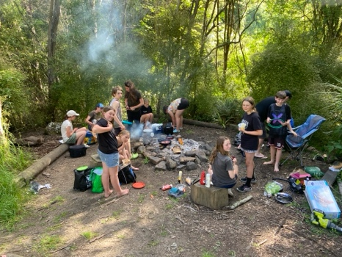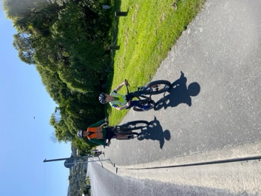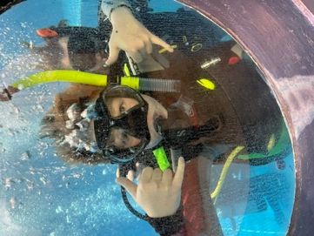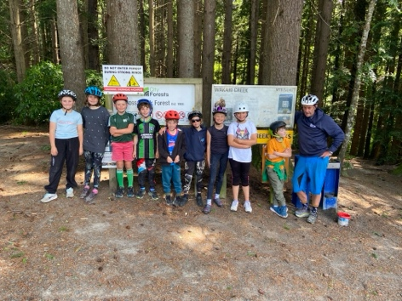
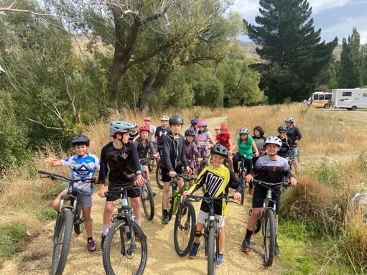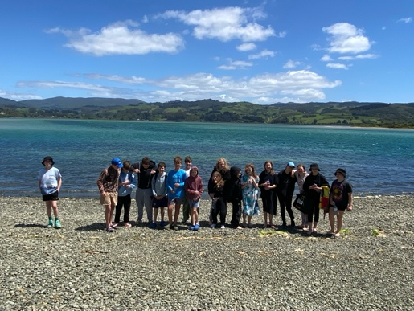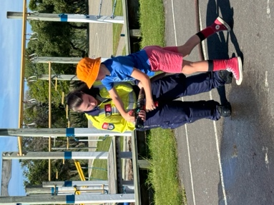
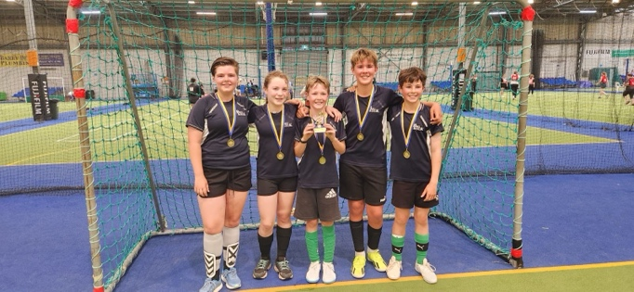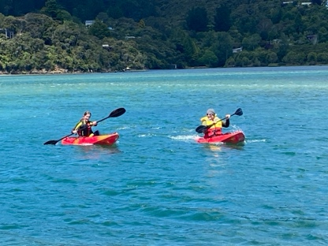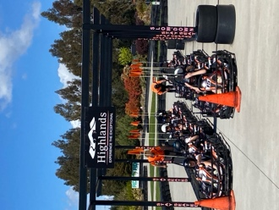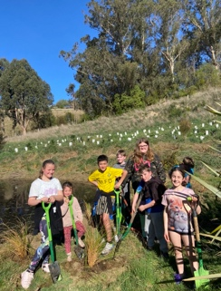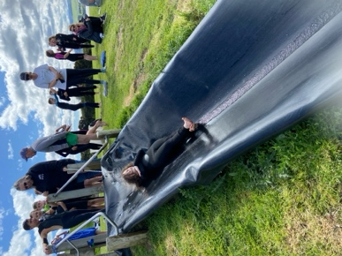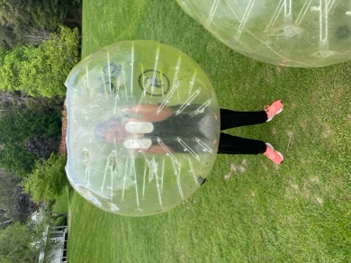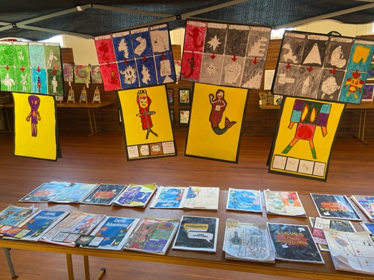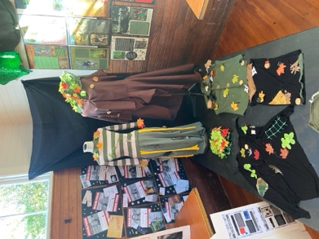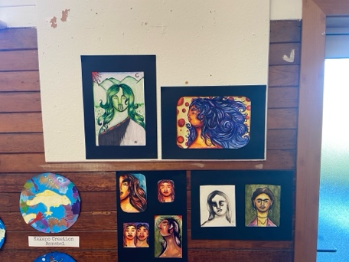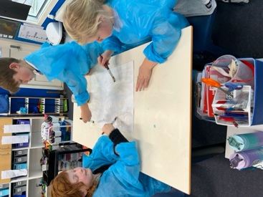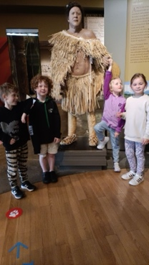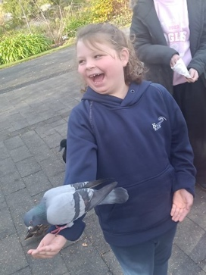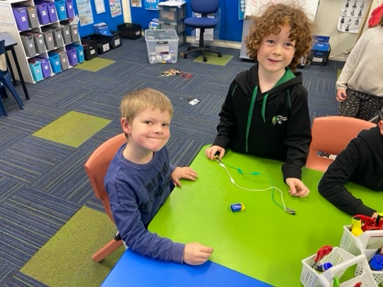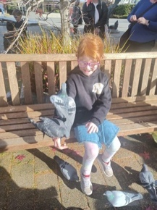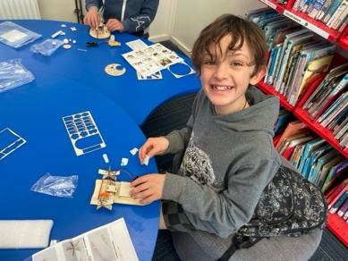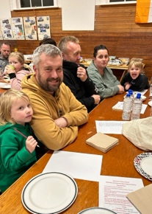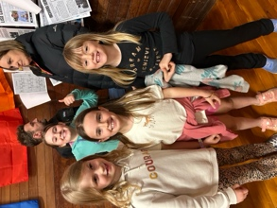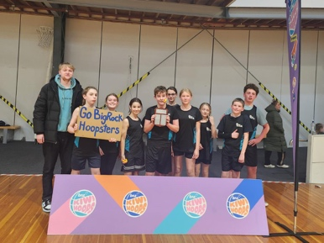
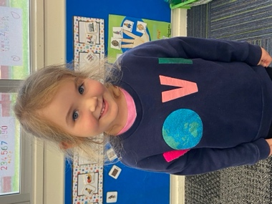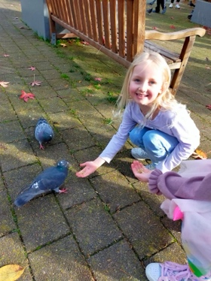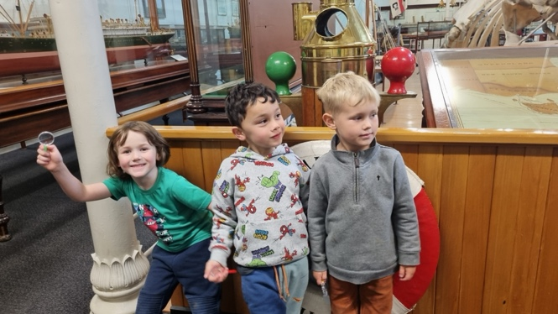
Big Rock Children = Happy, Successful, Resilient Children

