Good afternoon Big Rock families/whānau.

You may have noticed the Life Education truck parked in the school playground. We are lucky enough to have Pip and Harold visting us again as part of the Health Curriculum.  Quaye was excitied to get up close to Harold and show him his Harold soft toy. | 

Rooms 3, 4 and 5 have been bringing their bikes to school on Fridays to practice and improve their skills. We have also been checking them to make sure they are ready for school bike trips. Don’t forget them tomorrow!
Big Rock has had a donation of a 3D printer! Thank you to Richard and Debbie Goldsmith for this wonderful addition to the school.
School Accounts
School accounts were sent home this week.
We would appreciate payment of any outstanding accounts.
Thank you for your support.
Pool Keys
Thank you to those of you who have returned your keys.
There are still a few outstanding.
Please return these to the office.

Knowing if your child is well enough to go to school — guidance for parents and caregivers.
If you are not sure if your child is well enough to go to school, the Ministry of Health have a quick guide where you can check your child’s symptoms to make an informed decision.
Google – knowing if your child is well enough to go to school.
Upcoming Events
Life Education – 6th May to 8th May.
Support Staff Appreciation Week – 11th to 15th May
Assembly – 27th May.
3rd Year Teaching Students on placement – 25th May to 12th June.
King’s Birthday – 1st June – School closed.
Board of Trustees Meething – 9th June – 3.30pm in the staffroom.
Aotearoa New Zealand Histories Trips – Dates to be advised.
Year 6, 7 and 8 Bike Trip – Date to be advised.
Matariki Celebration – 1st July – Brighton Hall.
End of Term – 3rd July.

Listenting Laughing Learning Looking After Others
Some Big Rock students who were ‘caught’ displaying our school values this week were –
Rhys Shaler – Learning – thinking carefully and putting his hand up to answer questions.
Elise Blanchard – Learning – showing an interest in and offering ideas during Life Education.

Reminders
After School Care
Bookings or cancellations for After School Care can be made by texting 021 082 50863 or by emailing asc@bigrock.school.nz.

Office Hours
Monday and Wednesday – 8.45am – 3.15pm
Tuesday, Thursday and Friday – 8.45am – 12.15pm
Kelly is only in the office between these hours.
Please note that if your call goes to the answer phone, leave us a message. Staff may not be able to answer the phone at that time but will check the machine as soon as they can.
Sushi
Sushi is available for lunch every second Wednesday. You can order this by using the Kindo/Ezlunch app.
The dates for sushi lunches for the rest of the term are:
Wednesday: 20th May, 3rd June, 17th June and 1st July

Lunch Orders
These can be made at the shop on a Friday or dropped at the school office before 9.00am.

Lost Property
This can be located in the library.

Absences
Thank you for getting your absences and late notifications in before 8.50am on Skool Loop.
It saves us a lot of time if we don’t have to chase these up.

The new Stepped Attendence Responce Regulations from the Ministry of Education and what they mean.
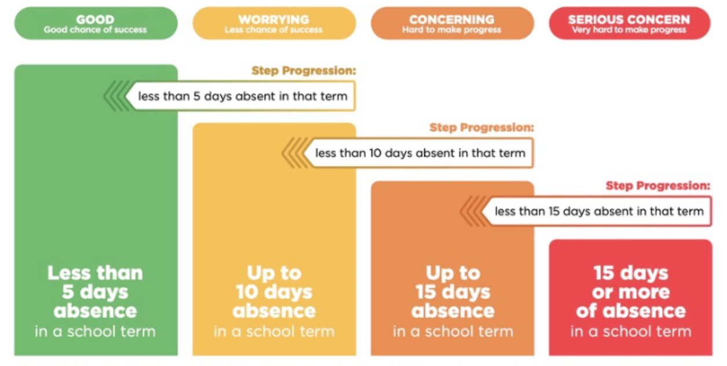
An automatic email will be sent from EDGE, as per Ministry requirements, when absences reach 4.5 half days in a term.

Lisa Lamb
actingprincipal@bigrock.school.nz
Ph 020 432 6657 available between 7.30am and 4.30pm Monday to Friday.

