Good afternoon Big Rock families/whānau.
How often do you ask your children “what did you do at school today?” and then get the answer “nothing.”? Let me reassure you that there is a lot happening in every classroom. So today I went around each classroom to talk to the children about what they are learning.
What’s Been Happening Around the School?
Room 1 – The fabulous students in Room 1 were learning about making number bonds. Working together on their whiteboards to solve the problem presented by their teacher. It was wonderful to see them all engaged in their learning and excited to show their work.
Room 2 – As part of their inquiry topic, Aotearoa New Zealand Histories, Room 2 have been learning about ‘Who is on our money and why?’ This week they were learning about a personal favourite of mine, Sir Edmund Hillary. They were amazed that anyone could climb a mountain as big as Everest and were full of very thoughtful questions. Fun fact, did you know that Sir Edmund Hillary’s father was an apiarist, beekeeper, Sir Ed helped his father tend up to 1600 hives often receiving several bee stings per day.
Room 3 – The Gold Rush was a important part of New Zealand’s history. Stella, Ivy and Kenzie worked hard to produce and perform an amazing role play based on what they have learnt.
Room 4 – How many of us could describe the different types of angles? Well the Room 4 Maths group can! They were busy with Mr Clark when I went in there today measuring different angles and describing their attributes.
Room 5 – As part of their inquiry topic, Room 5 have been learning about Chinese Immigrants and the Gold Rush. I saw some fantastic research by the students and was told some interesting facts –
- The Chinese settlers were the victims of extreme racism. European children were told they would be kidnapped and boiled and made into preserved ginger if they went up Haining Street near the Chinese settlements in Wellington.
- A lot of Chinese settlers came to New Zealand because their homeland was overpopulated and corrupt.
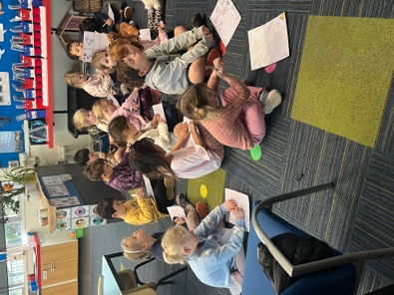 | 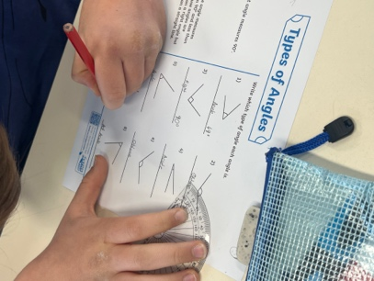 | 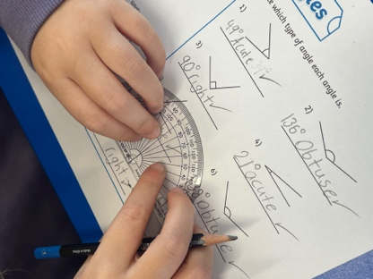

Minecraft Education
One of the many special educational opportunities available at Big Rock is our Minecraft Education Programme lead by Kara. This week Room 2 designed a historic Māori world including a Pā and the Pink and White Terraces. Room 3 designed their own Desert Island and had to think about what they would need to survive if they were marooned there. They were very lucky to be buddied up with Room 5 experts.
Absences
A reminder that all absences need to go through the Skool Loop app even if you have emailed the classroom teacher directly to inform them of an upcoming absence.
Teachers have a lot to do and remember every day and may not recall an email from 2 weeks ago informing them of an upcoming trip etc. However if you use the Skool Loop app, Kelly can enter this information directly onto the EDGE attendance register.
Pupil Attendance Policy
Recently I have had a few emails in response to caregivers receiving an email regarding their child’s absences. These emails are generated automatically through our student management system (EDGE). As part of the Ministry of Education requirements, schools are required to make contact with a caregiver when a student has been absent for four and a half days, regardless of the reason for the absence.
Any absence must be recorded in accordance with the Ministry of Education attendance guidelines.
You can find further information about this on the school website under policies.
School Gates Reminder
To help keep all of our students safe, particularly the new students who have recently joined our school, we kindly ask that everyone closes any school gate behind them when entering or leaving the school grounds at any time of the day.
Thank you for helping us maintain a safe and secure environment for all students.
School Sores/Impetigo
Although we have not seen any new cases over the last week, please be aware that the bacteria can survive on surfaces for up to 2 weeks and is highly contagious.
We still need you to be vigilant about taking children to the doctor with any unusual spots or crusty, cold sore like lesions.
We appreciate your cooperation.

Listenting Laughing Learning Looking After Others
Some Big Rock students who were ‘caught’ displaying our school values this week were –
Evie Hollands – keeping our playground tidy by picking up sports gear.
Merryn Middleton - keeping our playground tidy by picking up sports gear.
Atiana Reihana – outstanding work on her inquiry topic.
Charlie Rackham – outstanding work on his inquiry topic.
Dion Mooyman – excellent work during reading.

Sports Roundup

Player of the Day for the Big Rock Hoopsters was Fin Ramsay. | 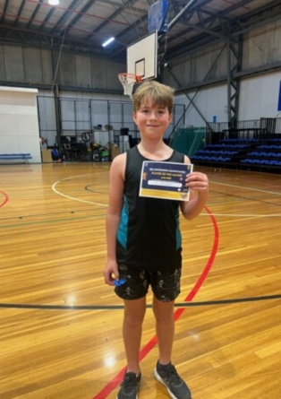

Upcoming Events
Board of Trustees Meeting – 9th June – 3.30pm in the staffroom.
Aotearoa New Zealand Histories Trips – Rooms 3, 4 and 5 – 11th June
- Rooms 1 and 2 – 23rd June
Year 6, 7 and 8 Bike Trip – Date to be advised.
Matariki Celebration – 1st July – Brighton Hall.
End of Term – 3rd July.

Keith from Project Excavation Landscape is responsible for our school looking so smart. If you have any landscaping or excavation projects we highly recommend using his services.



Reminders
School Accounts
Please ensure that your school accounts are up to date. Thank you.
With school camps coming up later in the year, families often opt to start a direct credit now to pre pay for this. If you wish to start a direct credit for camp or to pay your school account, the school bank account details are – Big Rock School – 02 0900 0000225 00
Please let Kelly know if you do start a direct credit payment.
Knowing if your child is well enough to go to school — guidance for parents and caregivers.
If you are not sure if your child is well enough to go to school, the Ministry of Health have a quick guide where you can check your child’s symptoms to make an informed decision.
Google – knowing if your child is well enough to go to school.

After School Care
Bookings or cancellations for After School Care can be made by texting 021 082 50863 or by emailing asc@bigrock.school.nz.

Office Hours
Monday and Wednesday – 8.45am – 3.15pm
Tuesday, Thursday and Friday – 8.45am – 12.15pm
Kelly is only in the office between these hours.
Please note that if your call goes to the answer phone, leave us a message. Staff may not be able to answer the phone at that time but will check the machine as soon as they can.

Sushi
Sushi is available for lunch every second Wednesday. You can order this by using the Kindo/Ezlunch app.
The dates for sushi lunches for the rest of the term are:
Wednesday: 17th June and 1st July

Lunch Orders
These can be made at the shop on a Friday or dropped at the school office before 9.00am.

Lost Property
This can be located in the library.

Absences
Thank you for getting your absences and late notifications in before 8.50am on Skool Loop.
It saves us a lot of time if we don’t have to chase these up.

The new Stepped Attendence Responce Regulations from the Ministry of Education and what they mean.
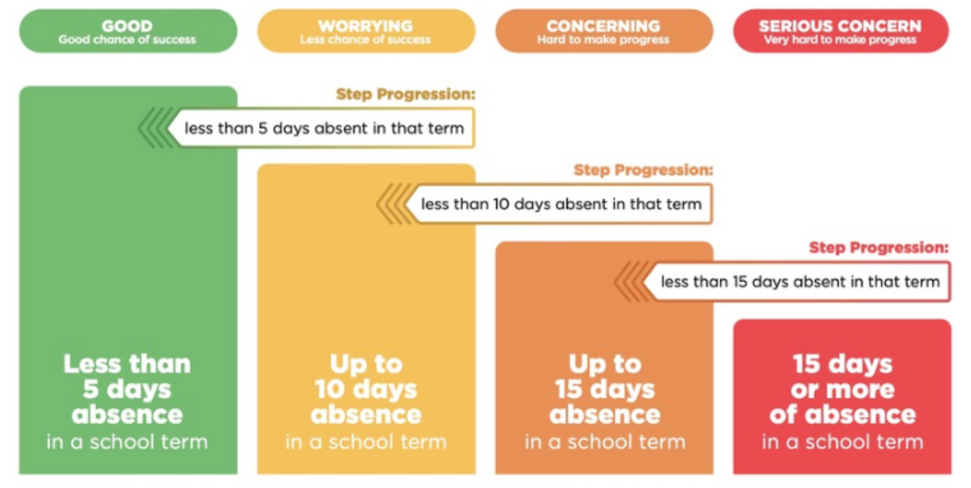
An automatic email will be sent from EDGE, as per Ministry requirements, when absences reach 4.5 half days in a term.

Lisa Lamb actingprincipal@bigrock.school.nz
Message 020 432 6657 available between 7.30am and 4.30pm Monday to Friday.

