Good afternoon Big Rock families/whānau.
Last week Tim Green, from Hearing Support Otago, came to talk to school about the Dangerous Decibels/Safe Sounds School Programme. The students learnt about how the ear works. The outer ear collecting sounds, the middle ear amplifying it, to the amazing cochlea in the inner ear turning sound waves into signals that our brain can understand. They also looked at what happens when sound is too loud and how it can damage the tiny hair cells in the inner ear that don’t grow back once they are dammaged. They also learnt about ways to protect their hearing.
The children were very interested in what Tim had to say, and had a lot of questions for him.

World Vision Junior Youth Conference
On Thursday 23rd April, 6 students from Big Rock Primary were lucky enough to take part in this event. The World Vision Junior Youth Conference is a leadership event for students in years 6-8, designed to spark a passion for justice in young Kiwis, and equip them with leadership tools to create change.
Throughout the day, students:
- Learnt about global inequality and how it relates to them.
- Became equipped with the skills to become leaders and inspire their school.
- Heard from inspiring guest speakers.
- Participated in thought-provoking, interactive sessions.
What a great initiative for these students to take part in.
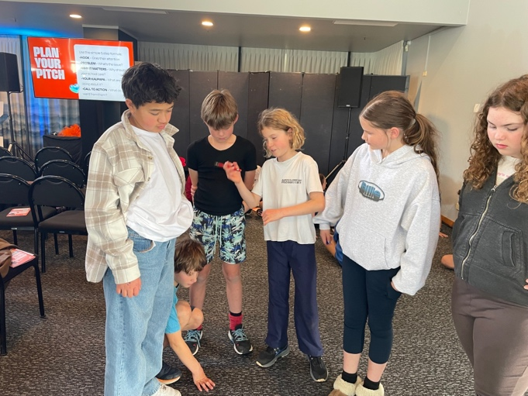 | 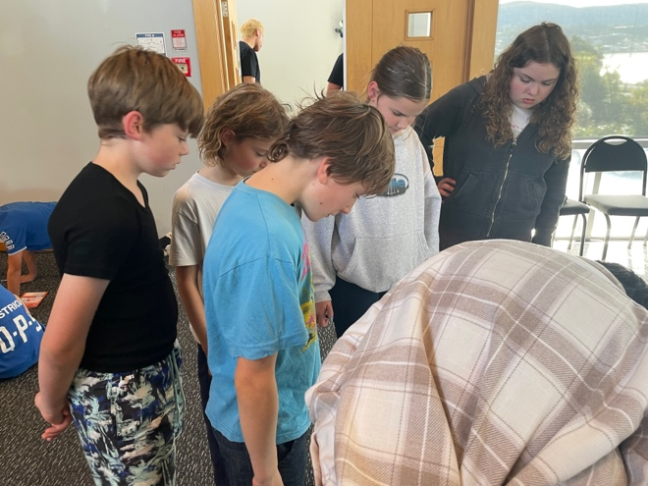

Pool Keys
Thank you to those of you who have returned your keys.
There are still a few outstanding. A reminder email has been sent to you.

Sports News

Netball
If your child is keen to play netball, please come in and see me.
We need some Year 4, 5 or 6 players to make a team.

Upcoming Events
2nd Year Teaching Students on placement – 4th May to 22nd May.
Board of Trustee Meeting – 5th May – 3.30pm in the staffroom.
Life Education – 6th May to 8th May.
Assembly – 27th May.
3rd Year Teaching Students on placement – 25ht May to 12th June.
King’s Birthday – 1st June – School closed.
Board of Trustees Meething – 9th June – 3.30pm in the staffroom.
End of Term – 3rd July.

Listenting Laughing Learning Looking After Others
Some Big Rock students who were ‘caught’ displaying our school values this week were –
Charlie Hughes – Looking after our school.
Kolton Haggerty-Walker – Looking after our school

Reminders
After School Care
Bookings or cancellations for After School Care can be made by texting 021 082 50863 or by emailing asc@bigrock.school.nz.

Office Hours
Monday and Wednesday – 8.45am – 3.15pm
Tuesday, Thursday and Friday – 8.45am – 12.15pm
Kelly is only in the office between these hours.
Please note that if your call goes to the answer phone, leave us a message. Staff may not be able to answer the phone at that time but will check the machine as soon as they can.
Sushi
Sushi is available for lunch every second Wednesday. You can order this by using the Kindo/Ezlunch app.
The dates for sushi lunches for the rest of the term are:
Wednesday: 6th May, 20th May, 3rd June, 17th June and 1st July

Lunch Orders
These can be made at the shop on a Friday or dropped at the school office before 9.00am.

Lost Property
This can be located in the library.

Absences
Thank you for getting your absences and late notifications in before 8.50am on Skool Loop.
It saves us a lot of time if we don’t have to chase these up.
The new Stepped Attendence Responce Regulations from the Ministry of Education and what they mean.
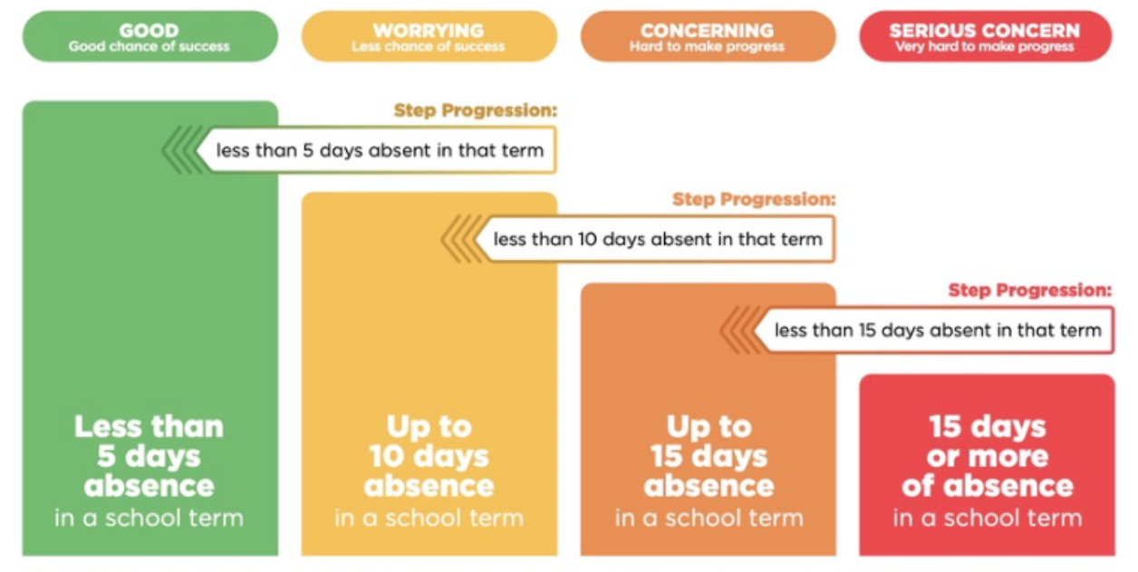
An automatic email will be sent from EDGE, as per Ministry requirements, when absences reach 4.5 half days in a term.

Lisa Lamb
actingprincipal@bigrock.school.nz
Ph 020 432 6657 available between 7.30am and 4.30pm Monday to Friday.

